ASSUMPTION OF THE VIRGIN MARY UKRAINIAN ORTHODOX CHURCH
ECUMENICAL PATRIARCHATE OF CONSTANTINOPLE AND NEW ROME
1301 Newport Avenue, Northampton, Pennsylvania 18067
Rev. Fr. Oleg Kravchenko, Rector
Protodeacon Mikhail Sawarynski, Attached
Websites: holyassumption.org and ukrainianorthodoxchurchusa.org
Facebook: Assumption of the Virgin Mary Ukrainian Orthodox Church
YouTube: AVM UOC Church
Contacts:
Fr. Oleg Kravchenko - (484) 834-7261; olegkravchenko2212@gmail.com
Protodeacon Mikhail – (H) (610) 262-3876); pravoslavni@rcn.com
Office – (610) 262-2882; avmuoc@gmail.com
Webmaster, John Hnatow – john.hnatow@gmail.com

Click HERE for Prayer in Time of Corona Virus
Tune in to our news, announcements, and online Facebook Livestream Liturgies HERE!

Sun. 21 Nov. 22nd SUNDAY AFTER PENTECOST. Tone 5. SYNAXIS of the BODILESS POWERS of HEAVEN: ARCHANGELS MICHAEL, GABRIEL, RAPHAEL, URIEL, SALAPHIEL, JEGUDIEL, BARACHIEL and JEREMIEL.
Epistles: Galatians 6: 11-18 & Hebrews 2:2-10
Gospels: Luke 8: 41-56 & Luke 10: 16-21

Moleben of Thanksgiving after the Divine Liturgy

GLORY TO JESUS CHRIST! СЛАВА ІСУСУ ХРИСТУ!
Liturgical Meneion & Scripture Readings
Mon. 22 Nov. Martyrs Onesiphorus and Porphyrius of Ephesus (284).
1 Thess. 1:1-5 Lk. 12: 13-15, 22-31
Tue. 23 Nov. Martyr Orestes of Cappadocia (304).
1 Thess. 1:6-10 Lk. 12:42-48
Wed. 24 Nov. Great-Martyr Menas of Egypt (304). Martyr Victor at Damascus (160)
1 Thess. 2:1-8 Lk. 12:48-59
Thu. 25 Nov. St. John the Merciful, patriarch of Alexandria (620).
1 Thess. 2:9-14 Lk. 13:1-9
Fri. 26 Nov. St. John Chrysostom, archbishop of Constantinople (407).
Heb. 7:26–8:2 Jn. 10:9-16
Sat. 27 Nov. Holy and All-praised Apostle Philip. Last day before Philip’s Fast-Advent.
2 Cor. 8:1-5 Lk. 9:37-43
No Great Vespers.
Sun. 28 Nov. 9:00 AM Divine Liturgy.

Fr. Alexander Schmemann's prayer after his last liturgy
Father Alexander Schmemann celebrated his last Divine Liturgy on Thanksgiving Day, Nov. 24, 1983, in the St. Vladimir's Seminary Chapel. At the end of the Liturgy he called upon all of us to give thanks to God:
Everyone capable of thanksgiving is capable of salvation and eternal joy.
Thank you, O Lord, for having accepted this Eucharist, which is offered to the Holy Trinity, Father, Son and Holy Spirit, and which filled our hearts with "the joy, peace and righteousness in the Holy Spirit."
Thank you, O Lord, for having revealed Yourself unto us and for giving us the foretaste of Your Kingdom.
Thank you, O Lord, for having united us to one another, in serving You and Your Holy Church.
Thank you, O Lord, for having helped us to overcome all difficulties, tensions, passions, and temptations and for having restored peace, mutual love and joy in sharing the communion of the Holy Spirit.
Thank you, O Lord, for the sufferings you bestowed upon us, for they are purifying us from selfishness and remind us of the "one thing needed: your eternal Kingdom."
Thank you, O Lord, for having given us this country where we are free to worship You.
Thank you, O Lord, for this school, where the name of God is proclaimed.
Thank you, O Lord for our families, husbands, wives and, especially, children, who teach us how to celebrate Your holy Name, in joy, movement and holy noise.
Thank you, O Lord, for everyone and everything. Great are you, O Lord, and marvelous are Your deeds, and no word is sufficient to celebrate Your miracles.
Lord, it is good to be here !
Amen.

PROPERS FOR THE LITURGY ST. JOHN CHRYSOSTOM
Tropar of the Resurrection, Tone 5
Let us, the faithful, praise and worship the Word, co-eternal with the Father and the Spirit, born for our salvation of the Virgin. In His Good Will He was lifted up on the Cross in the flesh to suffer death and to raise the dead, by His glorious Resurrection.

Tropar of the Dormition of the Mother of God, Tone 1
In giving birth, you preserved your virginity. In falling asleep, you did not forsake the world, Birth-Giver of God. You were translated to Life, Mother of Life, and through your prayers you deliver our souls from death.

Tropar to the Archangels, Tone 4
Commanders of the heavenly hosts, we who are unworthy entreat You, by your prayers surround us beneath the wings of your immaterial glory, and faithfully preserve us who fall down and cry to you: “Deliver us from all harm, for you are the leaders of the Hosts on High.”

Kondak of the Resurrection, Tone 5
You descended into Hell, my Savior, destroying the gates as the Almighty, resurrecting the dead, as Creator and destroying the sting of death. You have delivered Adam from the curse, Lover of all Mankind. Therefore, we all cry out to You: “Lord, save us.”

Glory to the Father and to the Son and to the Holy Spirit.

Kondak to the Archangels, Tone 2
Commanders of God’s armies and ministers of the divine glory, princes of the bodiless angels and guides of mankind, ask for great mercy and what is good for us, for you are the Supreme Commanders of the Bodiless Hosts.

Now and ever and to the ages of ages. Amen.

Kondak of the Dormition, Tone 2
Neither the tomb nor death had power over the Birth-Giver of God, she is ever watchful in her prayers, and in her intercession lies unfailing hope, for as the Mother of Life, she has been translated to Life, by the One Who dwelt within her ever virginal womb.

Prokimen of the Resurrection, Tone 5
You, Lord, shall protect us and preserve us from this generation forever.

Verse: O Lord, save me for there is no longer any righteous man.

Prokimen of the Archangels, Tone 4
You made Your Angels spirits and Your ministers a flaming fire.

Epistles: Galatians 6: 11-18 & Hebrews 2: 2-10

Alleluia Verses, Tone 5

Of Your mercies, O Lord, I will sing forever; unto generation and gene-ration I will proclaim Your truth with my mouth.
You have said: Mercy will be established forever and My truth will be prepared in the heavens.
Praise Him, all His Angels. Praise Him, all His Hosts.

Gospels: Luke 8: 41-56 & Luke 10: 16-21

Communion Hymn: Praise the Lord from the heavens. Praise Him in the Highest. You make Your Angels spirits and Your Ministers a flaming fire. Alleluia (3X).

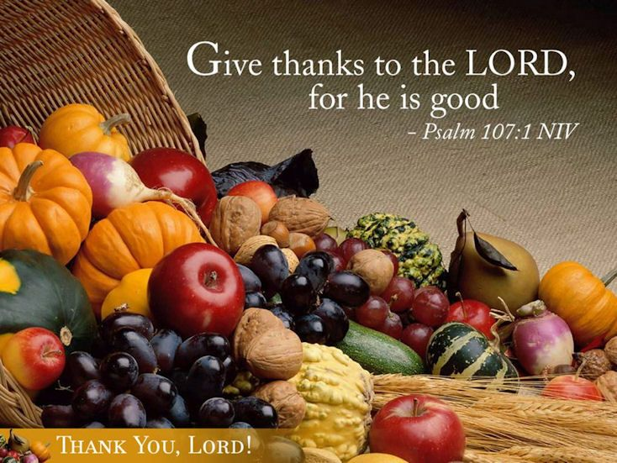
Holliday basket raffle. Drawing Sunday December 19 (don’t have to be present). Tickets downstairs.
Sunday School schedule: Mrs. Mary Ost (Preschool/Elementary) Sundays 8:55-9:20 AM. Mrs. Karen Osmun (Secondary) Sundays at 8:45-9:15 AM.
HOLIDAY NUT ROLL SALE. Fillings: Apricot, Lekvar(Prune), Nut, Poppyseed, Red Raspberry, Pumpkin/Cheese, Coconut Cream and Apple. $16.00 each. Last date for orders: November 28, 2021. Call for orders: Marty 610-682-4458.

The Brotherhood of Ukrainian Clergy in the Lehigh Valley presents a special screening – MR. JONES – the movie dedicated to the annual commemoration of Holodomor (Famine) in Ukraine. There also will be a presentation by survivors of the Holodomor following the film. The date: Sunday, 28 November, 2021, 1:30 PM. The address: St. Nicholas Greek Orthodox Church, 1607 W. Union Blvd. Bethlehem, PA 18018. No charge for admission.
Saint Constantine Academy will host an Orthodox Teacher Appreciation Breakfast on Monday November 29th from 9 to 11 AM. To all educators in our Parish, whether currently teaching or retired. This is an opportunity to see the school and connect with each other. The address is: 395 Bridle Path Road, Bethlehem, PA 18017. RSVP: please call 610-427-2758.
Concert of the worldwide popular a cappella group Pentatonix – 09 December, Giant Center, Hershey PA.
For the food bank: We were assigned baby foods, but they also need cans of potatoes, tuna fish, canned meats, pasta, spaghetti sauce, mac & cheese.
Varenyky schedule: December 2, December 16. 300 dozen limit. We strongly need your help as a volunteer. Please call Helen: 610-261-4575.
BIRTHDAYS:
23 Nov…Vladimir Krasnopera
28 Nov…Janet Woyewoda, Anne Marie Kroboth
MNOHAYA LITA! MANY YEARS!
NECROLOGY:
21 Nov…Michael Crayosky ‘03
23 Nov…Michael Micio (infant) ’22, Anna Haniak ‘96
24 Nov…Helen Krayowsky ’63, Mary Strohl ’74, Helena Szymonivka ‘14
25 Nov…Larue Strohl ’92, Zoya Busch ’15
26 Nov…Nicholas Porchyshyn ’24, Philemon Yaremchuk ’36,
Stanley Schur ’60, Sophia Kowalchuk ’77
27 Nov…Gregory Winters ‘12
VICHNAYA PAMYAT! MEMORY ETERNAL!
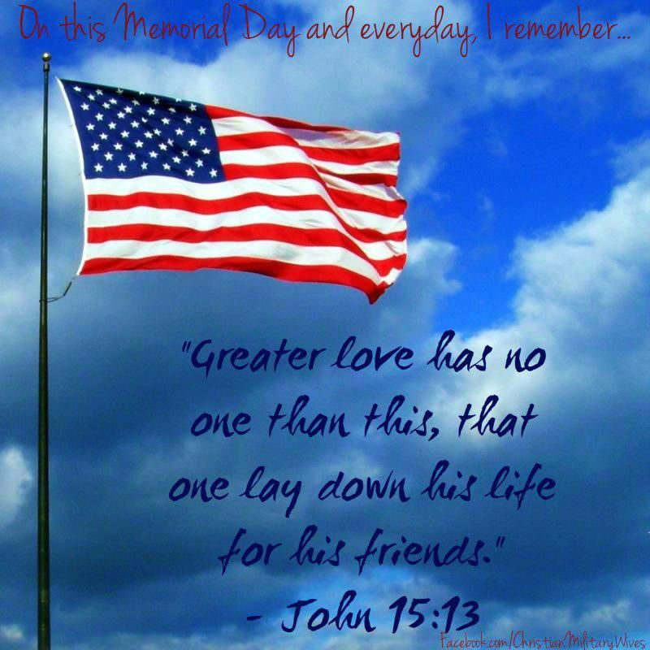
PRAYER FOR THE HEALTH & SALVATION OF THE AFFLICTED: priest Vasyl Dovgan, Stephanie Donnelly, Nicholas Alexander, Paulette Mecherly, Steve Sivulich, child Alexandria, Elizabeth Pastushenko, Philippe Chasseuil, Halyna Kucharchuk, Joan Molnar, Bill Ketterer, Brandon and Stacy Snyder, Aaliyah Osmun, Ihor Broda, James Osmun, William Savitz, Vladimir & Emma Krasnopera, Brendan Phillips, Jessie Hnatow, Jessica Meashock, Adam Hewko, Andrew Thaxton, Susan Ferretti, Judy Albright, Rob Hewko, Daniel Kochenash, Christopher Mack, Norman Betrous, Justine Schubert.

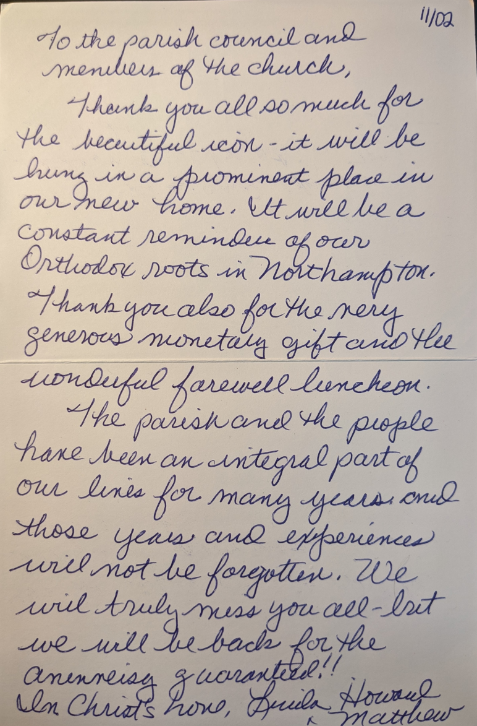
A thank you note from the Winters:

