ASSUMPTION OF THE VIRGIN MARY UKRAINIAN ORTHODOX CHURCH
ECUMENICAL PATRIARCHATE OF CONSTANTINOPLE AND NEW ROME
1301 Newport Avenue, Northampton, Pennsylvania 18067
Rev. Fr. Oleg Kravchenko, Rector
Protodeacon Mikhail Sawarynski, Attached
Websites: holyassumption.org and ukrainianorthodoxchurchusa.org
Facebook: Assumption of the Virgin Mary Ukrainian Orthodox Church
YouTube: AVM UOC Church
Contacts:
Fr. Oleg Kravchenko - (484) 834-7261; olegkravchenko2212@gmail.com
Protodeacon Mikhail – (H) (610) 262-3876); pravoslavni@rcn.com
Office – (610) 262-2882; avmuoc@gmail.com
Webmaster, John Hnatow – john.hnatow@gmail.com

Click HERE for Prayer in Time of Corona Virus
Tune in to our news, announcements, and online Facebook Livestream Liturgies HERE!
LET’S PRAY FOR THE PEACE IN UKRAINE!

Sun. 20 Nov. 23rd SUNDAY after PENTECOST. TONE 6. The 33 Martyrs of Melitene (290). Ven. Lazarus the Wonderworker of Galesius (1053). Martyr THEODOTUS of Ancyra (303). Martyrs MELASIPPUS, CASSINA and their son, ANTONIUS (363). Martyrs AUCTUS, TAURION & THESSALONICA.
Ephesians 2: 4-10 Luke 8: 41-56
Holodomor Memorial Litiya UOL meeting.
All are invited to coffee hour sponsored by Vladimir Krasnopera in honor of his 97th birthday.

The bulletin is sponsored by Vladimir Krasnopera in memory of the first anniversary of the repose of his loving wife, Emma
The bulletin is sponsored in loving memory of Thomas A. Petro Sr. from son Thomas Petro Jr. and granddaughter Sylvia

Liturgical Meneion & Scripture Readings

Mon. 21 Nov. Synaxis of the Archangel Michael and the other Bodiless Powers.
Heb. 2:2-10 Lk. 10:16-21
Tue. 22 Nov. Martyrs Onesiphorus and Porphyrius of Ephesus (284). Ven. Matrona.
1 Thess. 3:9-13 Lk. 12:42-48
06:30 PM Moleben for the peace in Ukraine (St. Josaphat, Bethlehem).
Wed. 23 Nov. Commemoration of the torture of Great-martyr George (303) (Georgia).
1 Thess. 4:1-12 Lk. 12:48-59
05:00 PM Akathist of Thanksgiving “Glory to God for all things”
Thu. 24 Nov. Great-Martyr Menas of Egypt (304). Martyr Victor at Damascus (160).
1 Thess. 5:1-8 Lk. 13:1-9
Fri. 25 Nov. St. John the Merciful, patriarch of Alexandria (620). Ven. Nilus of Sinai.
1 Thess. 5:9-13,24-28 Lk. 13:31-35
11:30 AM Youth Ice Skating (ask Mary Ost for details)
Sat. 26 Nov. St. John Chrysostom, archbishop of Constantinople (407).
Heb. 7:26–8:2 Jn. 10:9-16
05:00 PM Great Vespers.
Sun. 27 Nov. 09:00 AM Divine Liturgy. Adult education. Thanksgiving lunch and Zapusty before the Charismas Fast. bring your favorite Thanksgiving dish.

PROPERS FOR THE LITURGY OF ST. JOHN CHYRSOSTOM
Tropar of the Resurrection, Tone 6. The angelic powers were at Your tomb. The guards became as dead men. Mary stood by Your grave, seeking Your Most Pure Body. You captured Hell, not being tempted by it. You came to the Virgin, granting Life. Lord, risen from the dead, glory to you.
Tropar of the Dormition of the Mother of God, Tone 1. In giving birth, you preserved your virginity. In falling asleep you did not forsake the world, Birth-Giver of God. You were translated to life, Mother of Life, and through your prayers you deliver our souls from death.
Tropar to the 33 Holy Martyrs of Melitene, Tone 4. Your thirty-three holy martyrs, O Lord, through their sufferings have received incorruptible crowns from You, our God. For having Your strength, they laid low their adversaries, and shattered the powerless boldness of demons. Through their intercessions, save our souls.
Kondak of the Resurrection, Tone 6. When Christ God, the Giver of Life, with His Life-giving Hand raised all of the dead from the valleys of misery. He bestowed Resurrection on the human race. He is the Savior, the Resurrection, the Life and the God of all.
Glory…Kondak to the Holy Martyrs, Tone 8. The radiant choir of martyrs, the light-bearing company, spiritually descends to us, enlightening the Church with brilliant rays. Therefore, as we celebrate their honored memory, we ask You, our Savior: through their prayers deliver us from misfortunes so that we may sing to You: “Alleluia.”
Now and ever… Kondak of the Dormition, Tone 2. Neither the tomb nor death had power over the Birth-Giver of God; she is every watchful in her prayers and in her intercession lies unfailing hope. For as the Mother of life, she has been translated to life, by the One Who dwelt within her ever-virginal womb.

Prokimen of the Resurrection, Tone 6. Save Your people, O Lord, and bless Your inheritance.
Verse: O Lord, to You will I call. O my God, be not silent unto me.
Epistle: Ephesians 2: 4-10
Alleluia Verses Tone 6. He Who dwells in the aid of the Most High will abide in the shelter of the God of Heaven.
He will say to the Lord: You are my Helper and my Refuge. He is my God and I will hope in Him.
Gospel: Luke 8: 41-56
Communion Hymn: Praise the Lord from the Heavens. Praise Him in the Highest. Alleluia (3X).

- HOLIDAY NUT ROLL SALE. Fillings: Apricot, Lekvar(Prune), Nut, Poppyseed, Red Raspberry, Pumpkin/Cheese. $17.00 each. Last date for orders: November 22, 2022. Call for orders: Marty 610-682-4458.
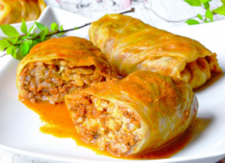
-Pani Olha is making holubki for sale. Pick up day: Sat. Dec. 10th from 10-12. Advance orders only! Call Pani if interested 862-707-9763.
- For the Food Bank: TURKEYS AND 5 POUND HAM! baby foods, canned potatoes and meats, tuna, pasta, sauces, mac. & cheese.
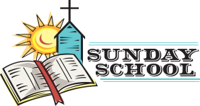
- Sunday School schedule: Mrs. Mary Ost (Preschool/Elementary) Sundays 8:55-9:20 AM. Mrs. Karen Osmun (Secondary) Sundays at 8:45-9:15 AM.
- Our Church will not be making pierogies due to construction issues. Will keep you posted on the date we will resume production. Thank you for understanding.
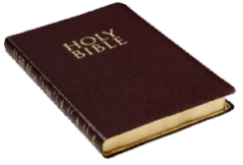
- Wednesday Evening Bible Study via Zoom with a professor of Saint Sophia Seminary Fr. Demetrios. Ask Fr. Oleg for the link.
- Wednesday 12 PM Pan-Orthodox Virtual Bible Study via Zoom. Meeting ID: 576 301 6482. Passcode: 238492.
- NEW List of needed Winter support for Ukraine: winter 0•F sleeping bags (non-bright colors only), new thermal underwear, new thermal socks, balaclavas, winter tactical mittens, toe warmers, men winter/ski warm light boots (9-11sizes), emergency survival kits, emergency burncare dressings, chest seals (Halo), Israeli compression bandages, Celox rapid hemostatic gauzes, any pain relief and antibiotics (pills and IV), NAR CAT tourniquets, Nasopharyngeal airway tubes, high protein bars, military MREs (meals-ready-to-eat), personal water filters (like LifeStraw), Amazon gift cards for buying all needed stuff are welcome.
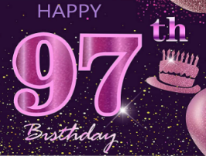
- Welcome to contribute articles or pictures to the bulletin. Let's make bulletins together!
BIRTHDAYS:
23 Nov…Vladimir Krasnopera
МНОГАЯ ЛІТА! MANY YEARS!
NECROLOGY:
Ukrainian civilians and soldiers killed in the Russian invasion.
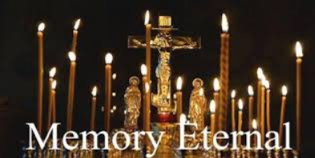
20 Nov…Parania Mislicky ’63, Ihumen Gregory ‘08
21 Nov…Michael Craosky ’03
23 Nov…Michael Micio (infant) ’22, Anna Haniak ’94
24 Nov…Helen Krayowsky ’63, Mary Strohl ’74, Helena Szymonivka ‘14
25 Nov…Larue Strohl ’92, Zoya Busch ’15
26 Nov…Nicholas Porchyshyn ’24, Philemon Yaremchuk ’36, Stanley Schur ’60, Sophia Kowalchyk ‘77
MEMORY ETERNAL! ВІЧНАЯ ПАМ’ЯТЬ

FATHERS AND SPIRITUAL WRITERS ON GUARDIAN ANGELS
Do not be surprised that you fall every day, do not give up, but stand your ground courageously. And assuredly, the angel who guards you will honor your patience. While a wound is still fresh and warm, it is easy to heal; but old, neglected and festering ones are hard to cure, and require for their care much treatment, cutting, plastering and cauterization. Many from long neglect become incurable, but with God all things are possible.
In the presence of an invisible spirit, the body becomes afraid; but in the presence of an angel, the soul of the humble is filled with joy. Therefore, when we recognize the presence from the effect, let us quickly hasten to prayer, for our good guardian has come to pray with us.
If you feel sweetness or compunction at some word of your prayer, dwell on it; for then our guardian angel is praying with us.
(St. John Climacus, The Ladder of Divine Ascent)
The angel who is always near us is by nothing so distressed and made indignant as when, without being constrained by some necessity, we deprive ourselves of the ministration of the Holy Mysteries and of reception of Holy Communion, which grants remission of sins. For at that hour the priest offers up the sacrifice of the Body of Him Who gives us life, and the Holy Spirit descends and consecrates the Body and Blood and grants remission to creation. The Cherubim, the Seraphim, and the angels stand with great awe, fear, and joy. They rejoice over the Holy Mysteries while experiencing inexpressible astonishment. The angel who is always by us is consoled, because he also partakes in that dread spectacle and is not deprived of that perfect intercourse. (St. Isaac the Syrian)
When you close the doors to your dwelling and are alone you should know that there is present with you the angel whom God has appointed for each man...This angel, who is sleepless and cannot be deceived, is always present with you; he sees all things and is not hindered by darkness. You should know, too, that with him is God, who is in every place; for there is no place and nothing material in which God is not, since He is greater than all things and holds all men in His hand. (St. Antony the Great)

We thank to all our parishioners, all church organizations – Parish Board, Sisterhood, UOL chapter, the Sunday School teachers, all who sing, read, pray, work, clean, donate, sell, serve in the Altar, decorate the church, to all who built this temple, all who served and prayed here from the beginning, that is more than a 100 years! May God bless you all and repay for everything you do in this life as well as in the Future Life!
Thank God For everything we have! “Everlasting King, Your will for our salvation is full of power. Your right arm controls the whole course of human life. We give You thanks for all Your mercies, seen and unseen: For eternal life, for the heavenly joys of the Kingdom which is to be. Grant mercy to us who sing Your praises, both now and in the time to come. Glory to You, O God, from age to age”.
(From Akathist Of Thanksgiving “Glory To God For All Things”)
ORTHODOXY AROUND THE WORLD
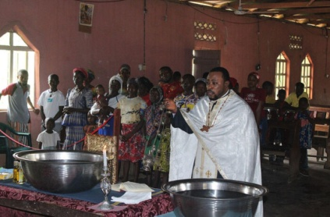
18 children were baptized in the Church of Archangel Michael in Uli Anambra, Nigeria on Nov 5th by Archimandrite Cornelius.

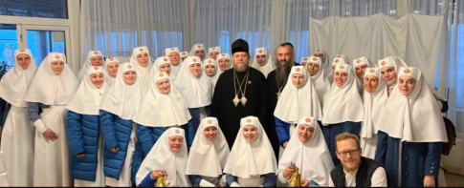
An All Ukrainian Conference of the Sisters of Mercy was held at the Martha-Mary Monastery in Odessa, commemorating the 175thann-iversary of the convent. The sisters have done extensive missionary work to the war victims, poor, and refugees.
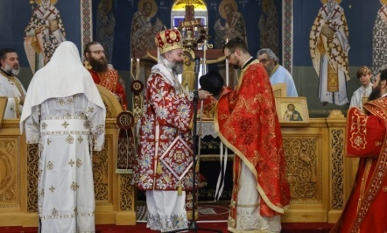
Archbishop Makarios of Australia ordained Dn. Edward Waters, the first priest of Ukrainian descent, in the Church of the Holy Apostles, New South Wales on Nov. 13th. Recently, the Ecumenical Patrirarchate brought all Ukrainian parishes in Australia under its omophorion, “that wasn’t his best decision” (remark of Ukrainian Hierarchs).
The “Moscow Patriarchate”(remark by Fr. Oleg) parish of All Saints of the Pechersk Lavra recently opened in Brussels, Belgium, celebrated it first patronal feast day led by the Priest Oleksandr Klymenko.
Patriarch Theophilos of Jerusalem visited the Arab parishes in the West Bank on Nov. 13th where he laid the foundation stone for a housing project in Beit Jala for 450 families. Similar projects are underway in Bethlehem and Shepherd’s Village.
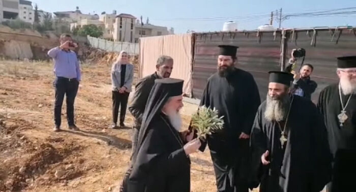
Relics of the Venerable St. Makariy of Ovrukh were transferred to Zhytomyr, the city of his birth, where he is widely venerated. The relics were sent by Metropolitan Theodosius of Cherkassy from the Cathedral of the Holy Archangels.
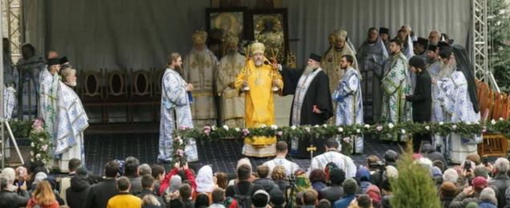
At the Neamt Monastery in Romania the 300th anniversary of the birth of the Venerable Paisiy Velichkovsky was celebrated. Born in Poltava, Ukraine, he was abbot of the monastery and was responsible for the revival of hesychastic monasticism in the 18th century. The outdoor Liturgy was celebrated by Metropolitans Teofan of Moldova, Philip of Poltava, and Bishop Benedict of Bistrita, Romania.

