September 29 2019

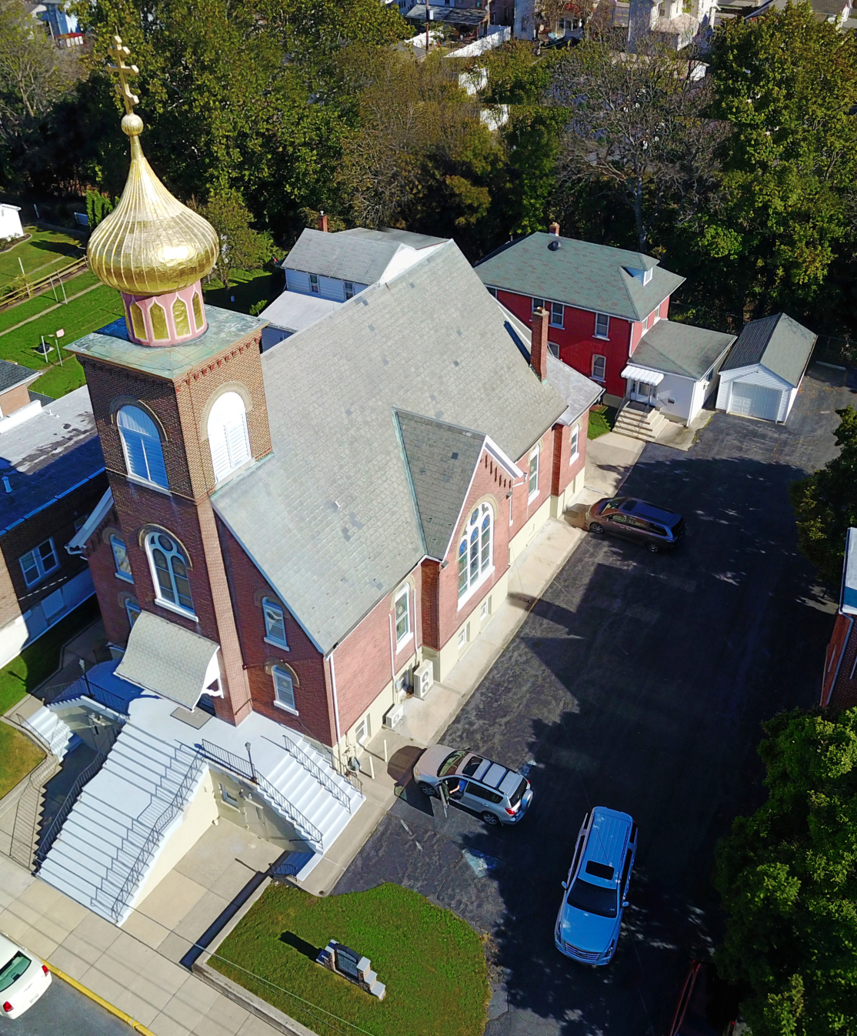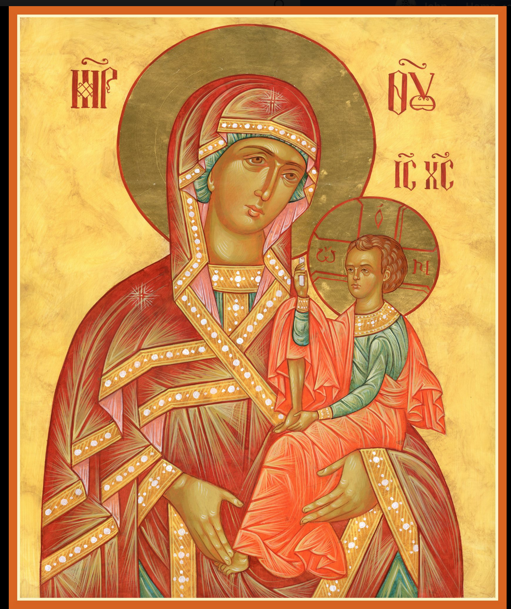

ASSUMPTION OF THE VIRGIN MARY
UKRAINIAN ORTHODOX CHURCH
ECUMENICAL PATRIARCHATE OF CONSTANTINOPLE AND NEW ROME
1301 Newport Avenue
Northampton, Pennsylvania 18067
Rev. Fr. Oleh Kravchenko
Protodeacon Mikhail Sawarynski, Attached
Telephones: Church Office… (610) 262-2882
Fr. Oleh Kravchenko – (732) 507-2274
Protodeacon Mikhail’s Residence… (610) 262-3876
Websites: holyassumption.org
ukrainianorthodoxchurchusa.org
E-mail: Parish… avmuoc@gmail.com
Fr. Oleh...olegkravchenko2212@gmail.com
Protodeacon Mikhail…pravoslavni@rcn.com
Webmaster, John Hnatow… john.hnatow@gmail.com

29th September (16th Sept.) 2019

Fifteenth Sunday after Pentecost. Tone 6. Sunday after the Exaltation of the Cross. Great Martyr EUPHEMIA, All-Praised of
Chalcedon (304) SEBASTIANA (86). Martyr MELITINA (2nd C.) Martyr LUDMILA (927) grandmother of Prince Wenceslaus.
Galatians 2:16-21 Mark8:34-9:1 2 Corinthians 4:6-15 Matthew 22:35-46

PROPERS FOR LITURGY OF ST. JOHN CHRYSOSTOM

Tropar of the Resurrection, Tone 6
The angelic powers were at Your tomb. The guards became as dead
men. Mary stood by Your grave, seeking Your Most pure Body. You captured Hell not being tempted by it. You came to the Virgin granting life. Lord, Who rose from the dead: Glory to You.

Tropar of the Dormition, Tone 1
In giving birth, you preserved your virginity. In falling asleep you did not forsake the world, Birth-Giver of God. You were translated to Life, Mother of Life, and through your prayers you deliver our souls from death.

Tropar of the Holy Cross, Tone 1
Lord, save Your people and bless Your inheritance. Grant victories to the Orthodox Christians over their adversaries. And by virtue of Your Cross, preserve Your community.

Tropar to Great Martyr Euphemia, Tone 4
Your lamb Euphemia calls out to You, O Jesus, in a loud voice: “I love You my Bridegroom and in seeking You I endure suffering. In baptism I was crucified so that I might reign in You, and I died so that I might live with You. Accept me as a pure sacrifice, for I have offered myself in love.” Through her prayers save our souls, since You are merciful.

Glory to the Father and to the Son and to the Holy Spirit.

Kondak of the Martyr Euphemia, Tone 4
You completed your struggle well, all praised Euphemia; even after death, you pour out healing on us for our sanctification. We stand beside your venerable relics to honor your falling asleep, that in faith we may be delivered from the weaknesses of our nature and to obtain the grace of your miracles.
Now and ever and unto ages of ages. Amen.

Kondak of the Holy Cross, Tone 4
As You were voluntarily raised upon the Cross for our sake, grant mercy to those who are called by Your Name, Christ God. Make all Orthodox Christians glad by Your power, granting them victories over their adversaries, by bestowing on them the invincible trophy, Your weapon of Peace.

Prokimen of the Cross, Tone 7
Exult the Lord our God and worship at His footstool for He is Holy.

Verse: The Lord reigns, let the people exult.

Prokimen of the Saint, Tone 4
Wondrous is God in His saints, the God of Israel.

Verse: In the congregation bless God, the Lord from the fountain of Israel.

Alleluia Verses in Tone 1
Remember Your congregation which You have gathered up from old.

God is our King of old. He has fashioned salvation in the midst of the earth.

With patience I waited for the Lord and He was attentive to me.

And He brought me out of the pit of misery out of the mire of day.

Communion Hymn:
Praise the Lord from the heavens, praise Him in the Highest.
Illumine us, Lord, with the light of Your Countenance. Alleluia (3X)

LITURGICAL MENEION & SCRIPTURE READINGS
FOR THE SIXTEENTH WEEK AFTER PENTECOST

Mon. 30 Sept. Martyrs SOPHIA & daughters Faith, (VIRA),
Hope (Nadia) & Love (LYUBOV) at Rome (137).
Galatians 4:28-5:10 Luke 3:19-22

Tue. 01 Oct. Ven. EUMENES, Bishop of Gortyna. Martyr
ARIADNE of Phyrygia.
Galatians 5:11-21 Luke 3:23-4:1

Wed. 02 Oct. Martyrs TROPHIMUS, SABBATIUS & DORY-
FAST DAY MEDON of Synnada. THEODORE, Prince of
Oil Smolensk & children DAVID & CONSTANTINE.
Galatians 6:2-10 Luke 4:1-15

Thurs. 03 Oct. Great Martyr EUSTATHIUS. PLACIDAS & wife
THEOPISTES, children AGAPIUS & THEOPISTUS of Rome (118).
Ephesians 1:1-9 Luke 4:16-22

Fri. 04 Oct. Leave Taking of the Exaltation of the Cross.
FAST DAY Apostle QUADRATUS of the 70. Uncovering of
Oil the relics of ST DIMITRI of Rostov (1752).
Ephesians 1:7-17 Luke 4:22-30

Sat, 05 Oct. Prophet JONAH (9th C. BC). Hieromartyr
PHOCAS, Bishop of Sinope (117). St. PETER
the Tax Collector of Constantinople (6th C.)
1 Corinthians 10:23-28 Luke 4:31-36
3:00 PM BAPTISM & CHRISMATION of infant ALEXANDER HARNAHO

5:00 PM GREAT VESPERS
5:30 PM GENERAL CONFESSION & ABSOLUTION

Sun. 06 Oct. 16th Sunday after Pentecost. Tone 7. Conception
of JOHN THE BAPTIST.
8:30 AM THIRD & SIXTH HOURS
9:00 AM DIVINE LITURGY of JOHN CHRYSOSTOM

NECROLOGY:
30 Sept.. Stephen Kowalyshyn ’66, Nancy Wulchak ‘88
01 Oct… Iliah Schneider (infant) ’22, Anna Mazepa ’66,
Stella Reznick ’71, Mary Mauser ‘97
02 Oct… Anna Dorosh ‘02
05 Oct… John Werbicky ’34, Nadia Yaremchuk ’50, Ahafia
Kury’66, Anna Seremula ’94, Stephen Kowalchuk ’97,
John Werbicky ‘08

VICHNAYA PAMYAT! MEMORY ETERNAL

BIRTHDAYS:
30 Sept… Angela Meashock
01 Oct… Olga Dorosh
06 Oct… Paul Dworakivsky

ANNIVERSARIES:
05 Oct… Keith & Yulia Rippey

MNOHAYA LITA! MANY YEARS!

WE PRAY for the health and well-being of the ill-afflicted: William Savitz, Catherine Kochenash, Vladimir & Emma Krasnopera, Tessie Kuchinos, Brendan Phillips, Jessie Hnatow, Jessica Meashock, Adam Hewko, Betty Hendrickson, Andrew Thaxton, Michelle Pierzga, Susan Ferretti, Carole Zarayko, Marianna Goshow, Judy Albright, Rob Hewko.

THE HARNAHO FAMILY would like to invite all parishioners to the BAPTISM & CHRISMATION of infant son, ALEXANDER, on Saturday, October 5th in our church beginning at 3 PM.

BENE NOTE: ON HOLY COMMUNION
Please be advised that according to the Canons of the Orthodox Church, the Sacrament of Holy Communion can only be administered to Orthodox Christians ( Baptized & Chrismated, making them living members of the Body of Christ). One must be prepared to approach the Holy Chalice by fasting, prayer and confession.

OUR DEEPEST SYMPATHY is extended to the Seremula Family on the repose in the Lord of Reader Evhen (Roger) Seremula on September 17th. To his wife, Karen, children Beth and Mark, granddaughter, brothers John, Walter, and Joseph our condolences. May his soul dwell with the Righteous. MEMORY ETERNAL!

OUR MOST SINCERE GRATITUDE AND APPRECIATION to MITERED ARCHPRIEST MYRON ORYHON who has faithfully served this parish since the falling asleep of Fr. Bazyl. Despite his retirement from a permanent parish Fr. Myron has continued his commitment to Christ’s Holy Church, now for more than 40 years. We pray for him and his family with good health, happiness and all God’s blessings for many years. Mnohaya Lita!

OCMC “AGAPE CANISTER” DONATIONS were $.00; thank
you for your generous support of our Missions around the globe.

NORTHAMPTON FOODBANK is still in need of foodstuffs, especially tuna, canned potatoes and baby food.

VOLUNTEERS NEEDED FOR THE PYROHONYA MINISTRY. If you can spare an hour or two on Tuesday, afternoon at 3:30 PM to cut potatoes or Thursday, mornings after 7:30 AM to pinch, your help would be greatly appreciated. See Linda Vitushinsky. We begin this fund-raising project on October 8th. Please note the change in starting time, since the packing room project is not completed.

MANY THANKS TO THE SISTERHOOD for donating flowers to adorn the Holy Cross on the FEAST OF THE EXALTATION.

