September 22, 2019

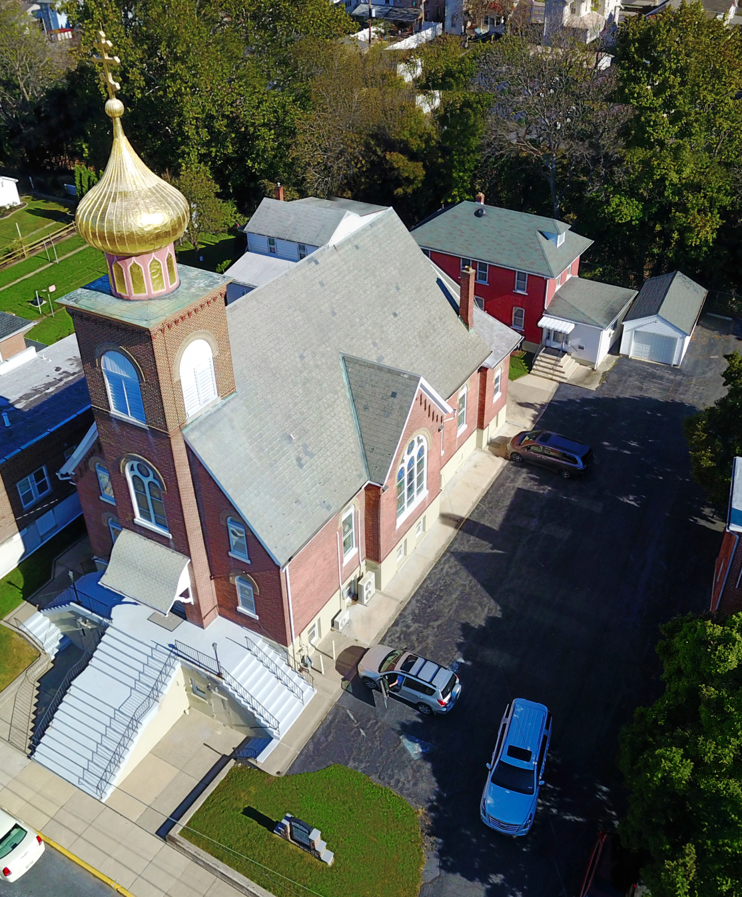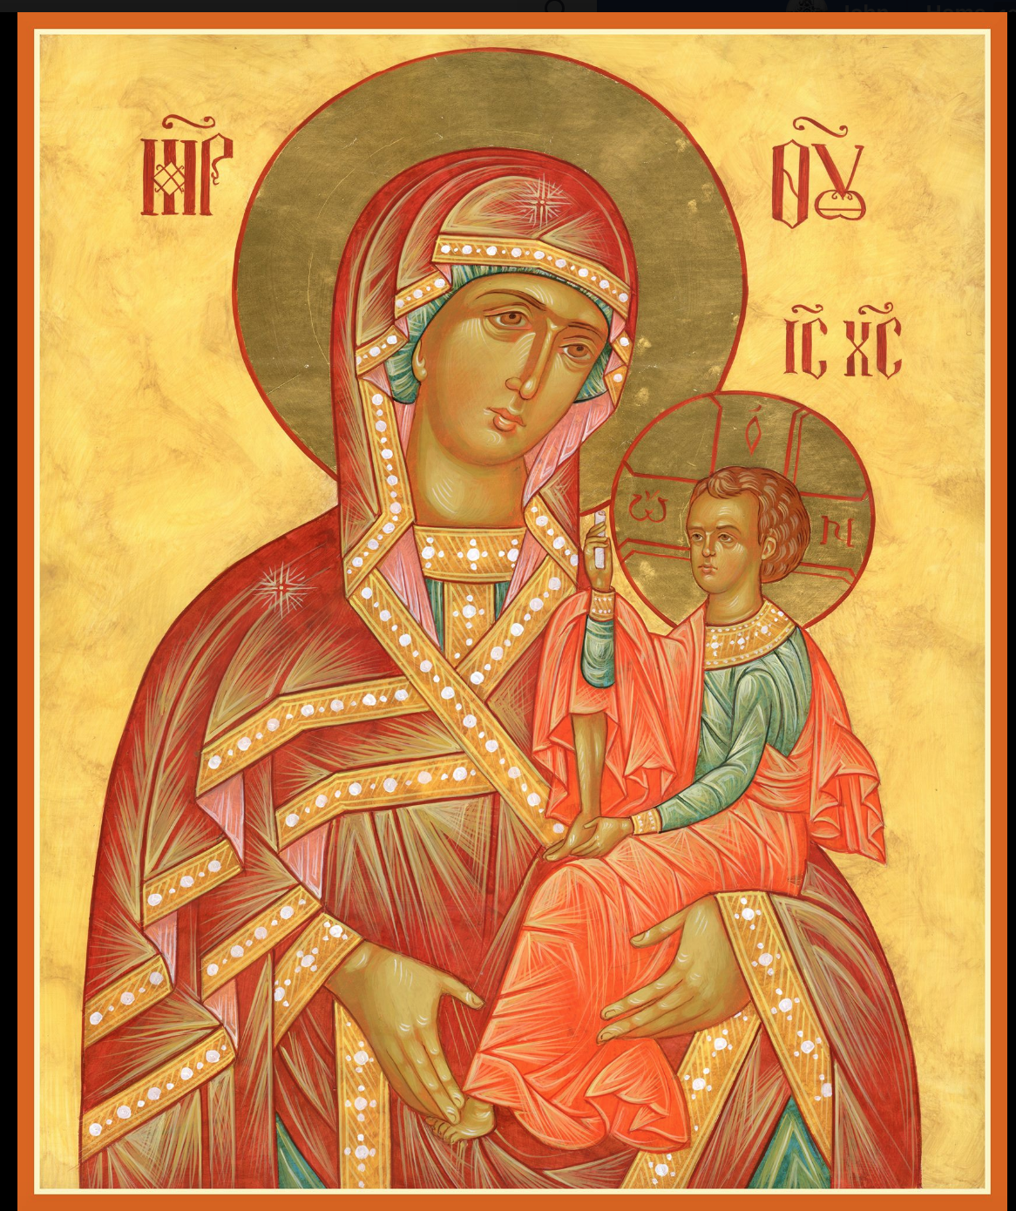

ASSUMPTION OF THE VIRGIN MARY
UKRAINIAN ORTHODOX CHURCH
ECUMENICAL PATRIARCHATE OF CONSTANTINOPLE AND NEW ROME
1301 Newport Avenue
Northampton, Pennsylvania 18067
Rev. Fr. Oleh Kravchenko, Rector
Mitered Archpriest Myron Oryhon, Attached
Protodeacon Mikhail Sawarynski, Attached
Telephones: Church Office… (610) 262-2882
Fr. Oleh Kravchenko – (732) 507-2274
Fr. Myron Oryhon – (607) 752-1999
Protodeacon Mikhail’s Residence… (610) 262-3876
Websites: holyassumption.org
ukrainianorthodoxchurchusa.org
E-mail: Parish… avmuoc@gmail.com
Fr. Oleh…olegkravchenko2212@gmail.com
Protodeacon Mikhail…pravoslavni@rcn.com
Webmaster, John Hnatow… john.hnatow@gmail.com

22nd September (9th Sept.) 2019

Fourteenth Sunday after Pentecost. Tone 5. Sunday before the EXALTATION of the CROSS. Afterfeast of the Nativity of the Virgin Mary. Righteous Ancestors of God JOACHIM & ANNA.
Galatians 6:11-18 & Gal. 4:22-31 John 3:13-17 & Matthew 22:1-14

PROPERS FOR LITURGY OF ST. JOHN CHRYSOSTOM

Tropar of the Resurrection, Tone 5
Let us the faithful, praise and worship the Word, co-eternal with the Father and the Spirit, born for our salvation of the Virgin. In His Good Will He was lifted up on the Cross in the flesh to suffer death and to raise the dead by His glorious Resurrection.

Tropar of the Dormition, Tone 1
In giving birth, you preserved your virginity. In falling asleep you did not forsake the world, Birth-Giver of God. You were translated to Life, Mother of Life, and through your prayers you deliver our souls from death.

Tropar of the Nativity of the Virgin Mary, Tone 4
Your Nativity, Virgin Birth-Giver of God, has proclaimed joy to the universe. The Sun of Righteousness, Christ our God, has shone forth from you. By annulling the curse, He gave a blessing. By destroying Death, He has granted us Life Eternal.

Tropar to Joachim and Anna, Tone 1
Since you were righteous under the law of grace, Joachim and Anna,
you gave birth to the God-given infant for our sake. Therefore, the Divine Church radiantly keeps feast today, joyfully celebrating your honorable memory and giving glory to God, Who has raised up the glory of salvation from the House of David.

Kondak of the Nativity of the Virgin Mary, Tone 4
By your birth, Most pure Virgin, Joachim and Anna were freed from childlessness, and Adam and Eve from the corruption of death. We, your people celebrate this, delivered from the guilt of sin, as we chant to you: “a barren woman gives birth to the Birth-Giver of God, the Mother of our life.”

Glory to the Father and to the Son and to the Holy Spirit.

Kondak of the Righteous Ancestors of God, Tone 2
Anna is now no longer barren and nurses the All Pure One. She rejoices and calls us all to sing a hymn of praise to Christ, Who from her womb gave mankind the only ever Virgin Mother.

Now and ever and unto ages of ages. Amen.

Kondak of the Dormition, Tone 2
Neither the tomb nor death had power over the Birth-Giver of God; she is ever watchful in her prayers and in her intercession lies un-failing hope. For as the Mother of Life, she has been translated to life by the One Who dwelt within her ever-virginal womb.

Prokimen of the Sunday before the Exaltation, Tone 6
Lord, save Your people and bless Your inheritance.

Verse: Lord, to You will I call. My God, be not silent to me.

Prokimen of the Righteous Ancestors of God, Tone 4
Wondrous is God in His saints, the God of Israel.

Verse: Bless God in the congregation, the Lord from the fountains of Israel.

Alleluia Verses in Tone 1
I have exalted the Holy One chosen out of My people.

For My Hand shall defend him and My Arm will strengthen him.

The salvation of the righteous is from the Lord, and He is their defender in time of affliction.

The Lord shall help them and shall deliver them and He will rescue them from sinners and will save them because they hoped in Him.

In place of “It is right in truth…”
Magnify, my soul, the Virgin Mary, the glorious Nativity of the Mother of God.
Irmos, Tone 8
Virginity is alien to motherhood and childbearing is foreign to virgins. Yet, in you Birth-Giver of God, both are found. Therefore, all the nations of the earth unceasingly magnify you.

Communion Hymn:
I will take the cup of salvation and call upon the name of the Lord.
Rejoice in the Lord, you righteous; praise befits the upright. Alleluia (3X)

LITURGICAL MENEION & SCRIPTURE READINGS
FOR THE FIFTHTEENTH WEEK AFTER PENTECOST

Mon. 23 Sept. Martyrs MENODORA, METRODORA &
NYMPHODORA (305).
Galatians 2:11-16 Mark 5:24-34

Tue. 24 Sept. Ven. THEODORA of Alexandria (490).
Galatians 2:21-3:7 Mark 6:1-7

Wed. 25 Sept. Hieromartyr AUTONOMUS, Bishop in Italy (313).
FAST: Leave taking of the Nativity of the Virgin Mary.
Oil Galatians 3:15-22 Mark 6:7-13

Thurs. 26 Sept. Founding of the Church of the Resurrection at the
(Holy Sepulcher) in Jerusalem (335).
Hebrews 3;1-4 Matthew 16:13-19
5:00 PM FESTAL VESPERS EXALTATION OF CROSS

Fri. 27 Sept. UNIVERSAL EXALTATION OF THE LIFE-
STRICT FAST GIVING CROSS.
1 Corinthians 1:18-24 John 19:6-11, 13-35
8:30 AM THIRD & SIXTH HOURS
9:00 AM DIVINE LITURGY OF JOHN CHRYSOSTOM
Sat, 28 Sept. Great Martyr NICETAS the Goth (372)
1 Corinthians 1:26-29 John 8:21-30
5:00 PM GREAT VESPERS AT CANAL ST. PARK

Sun. 29 Sept. Sunday after the Exaltation. Tone 6
8:30 AM THIRD & SIXTH HOURS
9:00 AM DIVINE LITURGY of JOHN CHRYSOSTOM

NECROLOGY:
22 Sept… Metro Bach’75
23 Sept… Stephen Micio (infant) ‘21
25 Sept… John Hewko ‘13
26 Sept… Marie Sobchak ‘59
27 Sept… Andrew Micio ’50, William Turick ‘82
28 Sept… Michael Syvenky ‘74

VICHNAYA PAMYAT! MEMORY ETERNAL

BIRTHDAYS:
22 Sept… Joseph Nazar
23 Sept… Allison Pypiuk, Martha Dowling
25 Sept… John Burk
27 Sept… Meredith Misko

ANNIVERSARIES:
22 Sept… Frederic & Stephanie Burk

MNOHAYA LITA! MANY YEARS!

WE PRAY for the health and well-being of the ill-afflicted: Reader Evhen (Roger) Seremula, William Savitz, Catherine Kochenash, Vladimir & Emma Krasnopera, Tessie Kuchinos, Brendan Phillips, Jessie Hnatow, Jessica Meashock, Adam Hewko, Betty Hendrickson, Andrew Thaxton, Michelle Pierzga, Susan Ferretti, Carole Zarayko,
Marianna Goshow, Judy Albright, Rob Hewko.

BENE NOTE: ON HOLY COMMUNION
Please be advised that according to the Canons of the Orthodox Church, the Sacrament of Holy Communion can only be admin-istered to Orthodox Christians ( Baptized & Chrismated, making them living members of the Body of Christ). One must be prepared to approach the Holy Chalice by fasting, prayer and confession.

ANNUAL CHURCH PICNIC at Canal St. Park next SATURDAY, SEPTEMBER 28th from 12 noon to 7 PM. Sign up sheet for you to bring your favorite picnic dish is located in the church hall. Vespers will be served at 5 PM in the park.

OCMC “AGAPE CANISTER” DONATIONS were $35.00; thank
you for your generous support of our Missions around the globe.

NORTHAMPTON FOODBANK is still in need of foodstuffs, especially tuna, canned potatoes and baby food.

SISTERHOOD MEETING TODAY following Divine Liturgy.

On Sept. 21st a dedication ceremony of a Slavic Memorial took place at the Northampton Municipal Park, under the guidance of Rev. Jerry Mraz of Holy Trinity Slovak Church in remembrance of Northampton residents of Slavic heritage. The Slavic peoples are an Indo-European family who migrated to Europe beginning in the 2nd century. They are divided into three groups: East Slavs (Ukrainians, Belarussians, Russians); West Slavs (Poles, Czechs, Slovaks) and South Slavs (Bulgars, Serbs, Croats, Slovenians, Montenegrans).

PIEROHI SALES will begin on October 3rd. Deadline for orders is September 29th. Call Helen @610-261-4575.

MANY THANKS TO THE SISTERHOOD for the flowers decora-ting the ICON OF THE NATIVITY OF THE VIRGIN MARY and for their generous donation of $15,000 to the Church.

