SEPTEMBER 15, 2019

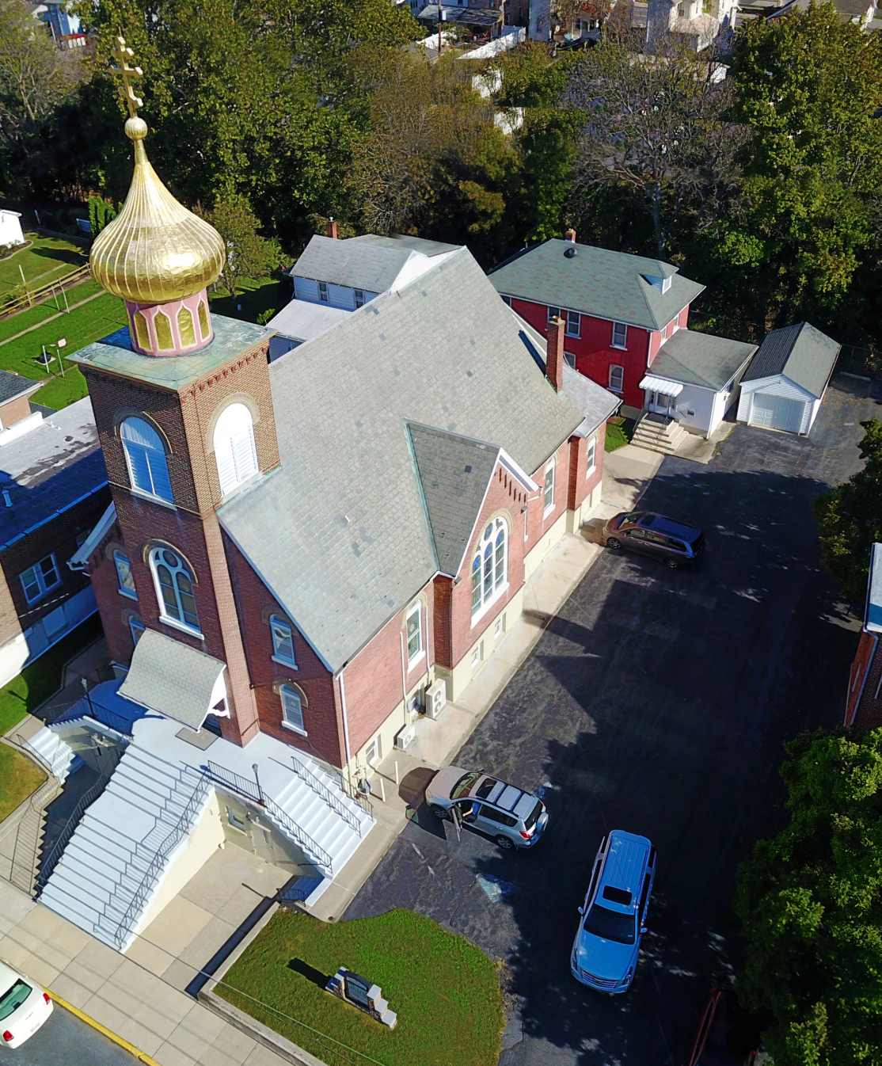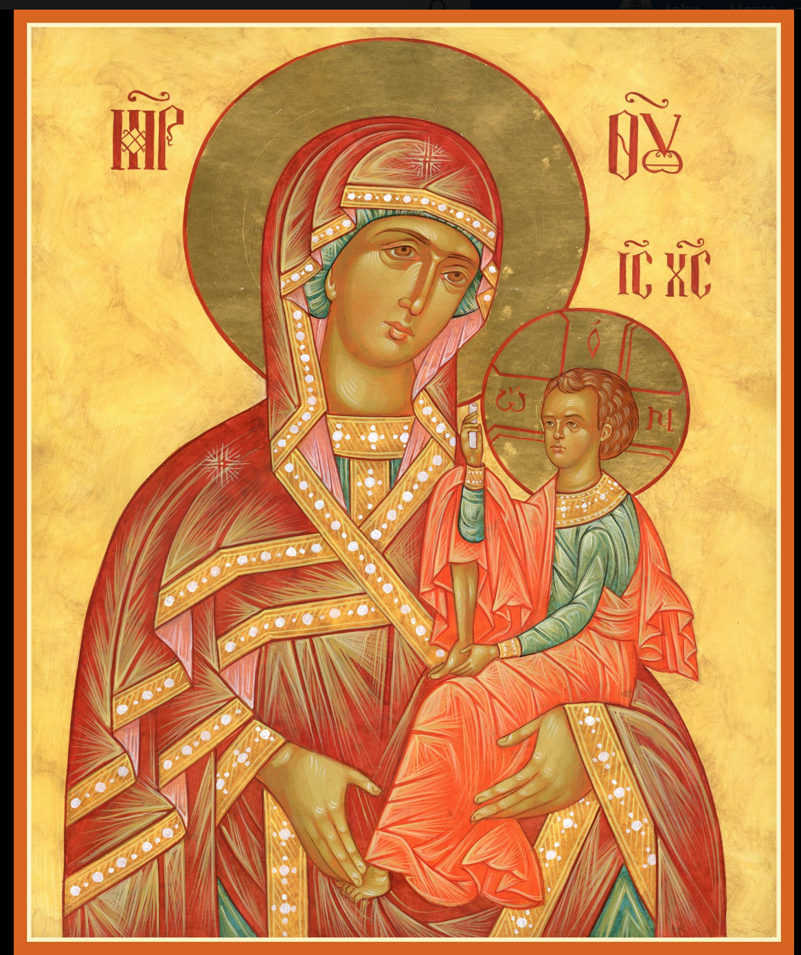

ASSUMPTION OF THE VIRGIN MARY
UKRAINIAN ORTHODOX CHURCH
ECUMENICAL PATRIARCHATE OF CONSTANTINOPLE AND NEW ROME
1301 Newport Avenue
Northampton, Pennsylvania 18067
Rev. Fr. Oleh Kravchenko, Rector
Mitered Archpriest Myron Oryhon, Attached
Protodeacon Mikhail Sawarynski, Attached
Telephones: Church Office… (610) 262-2882
Church Fax/Kitchen/Hall… (610) 262-0552
Fr. Oleh Kravchenko – (732) 507-2274
Fr. Myron Oryhon – (607) 752-1999
Protodeacon Mikhail’s Residence - (610) 262-3876
Websites: holyassumption.org
ukrainianorthodoxchurchusa.org
E-mail: Parish… avmuoc@gmail.com
Fr. Oleh…olegkravchenko2212@gmail.com
Protodeacon Mikhail…pravoslavni@rcn.com
Webmaster, John Hnatow… john.hnatow@gmail.com
==============================================================
15th September (2nd Sept.) 2019

Thirteenth Sunday after Pentecost. Tone 4. Martyrs MAMAS & his parents, THEODOTUS & RUFINA (3rd C.). JOHN THE FASTER, Patriarch of Constantinople (595). 3,628 Martyrs at Nicomedia.
1 Corinthians 16:13-24 Matthew 21:33-42

PROPERS FOR LITURGY OF ST. JOHN CHRYSOSTOM

Tropar of the Resurrection, Tone 4
When the women disciples of the Lord learned from the angel the joyous message of Your Resurrection, they cast away the ancestral curse and with gladness told the apostles: death is overthrown. Christ God is risen, granting the world great mercy.

Tropar of the Dormition, Tone 1
In giving birth, you preserved your virginity. In falling asleep you did not forsake the world, Birth-Giver of God. You were translated to Life, Mother of Life, and through your prayers you deliver our souls from death.

Tropar to Martyr Mamas , Tone 4
Your holy martyr Mamas, Lord, through his suffering has received an incorruptible crown from You, our God. For having Your strength, he laid low his adversaries and shattered the powerless boldness of demons. Through his intercessions, save our souls.

Tropar to St. John the Faster, Tone 4
In truth you were revealed to your flock as a rule of faith, an image of humility and a teacher of abstinence; your humility exalted you; your poverty enriched you, Hierarch Father John, entreat Christ our God that our souls may be saved.

Kondak of the Resurrection, Tone 4
My Savior and Redeemer as God arose from the tomb and delivered the earthborn from bondage. He has shattered the gates of Hell and, as Master, He arose on the third day.

Glory to the Father and to the Son and to the Holy Spirit.

Kondak to Martyr Mamas, Tone 4
Holy Mamas lead your people as a flock to life-giving pastures, with the staff God has given you, crush the invisible and fierce enemies beneath the feet of those who honor you. For all of those who are in danger have received you as their fervent intercessor.

Now and ever and unto ages of ages. Amen.

Kondak of the Dormition, Tone 2
Neither the tomb nor death has power over the Birth-Giver of God; she is ever watchful in her prayers and in her intercession lies un-failing hope. For as the Mother of Life, she has been translated to life by the One Who dwelt within her ever-virginal womb.

Prokimen of the Resurrection, Tone 4
How marvelous are Your works, O Lord, in wisdom You have made them all.

Verse: Bless the Lord, my soul. O Lord my God, You are very great.

Prokimen of the Saints, Tone 7
The righteous man shall be glad in the Lord and shall hope in Him.

Verse: Harken to my prayer when I make supplication to You.

Alleluia Verses in Tone 4
Bend your bow and proceed prosperously and reign because of truth, meekness and righteousness.

You have loved righteousness and hated iniquity.

The righteous man shall flourish like a palm tree and like a cedar in Lebanon shall he be planted.

They who are planted in the house of the Lord, in the courts of our God, they shall blossom forth.

Communion Hymn:
Praise the Lord from the heavens, praise Him in the Highest.
Rejoice in the Lord, you Righteous; praise befits the upright. Alleluia (3X)
LITURGICAL MENEION & SCRIPTURE READINGS
FOR THE FOURTEENTH WEEK AFTER PENTECOST

Mon. 16 Sept. Hieromartyr ANTHIMUS, Bishop of Nicomedia.
Martyrs THEOPHILUS deacon, DOROTHEOS,
MARDONIUS, MIGDONIUS, PETER, INDES,
GORGONIUS, ZENO, Virgin DOMNA & EUTHY-
MIUS (302) THEOCTISTUS (467).
2 Corinthians 12:10-19 Mark 4:10-23

Tue. 17 Sept. Hieromartyr BABYLAS, Bishop of Antioch. Martyrs
URBAN, PRILIDIAN, EPOLONIUS & mother
CHRISTODULA. Prophet & God-seer MOSES.
2 Corinthians 12:20-13:2 Mark 4:24-34

Wed. 18 Sept. Holy Prophet ZACHARIAS & Righteous ELIZA-
FAST DAY: BETH, parents of St. John the Forerunner (1st C.)
OIL 2 Corinthians 13:3-13 Mark 4:35-41

Thur. 19 Sept. Commemoration of the Miracle of ARCHANGEL
MICHAEL at Colossae (4th C.) Martyrs EUDOX-
IUS, ZENO, MACARIUS (311)
Galatians 1:1-10, 20-2:5 Mark 5:1-20

Fri. 20 Sept. Forefeast of the Nativity of the Virgin Mary.
FAST DAY; Martyr SOZON of Cilicia. Martyrdom of
OIL MACARIY, Archimandrite of Ovruch (1678)
Galatians 2:6-10 Mark 5:22-24, 35-6:1

5:00 PM FESTAL VESPERS & LITYA

Sat. 21 Sept. NATIVITY OF THE HOLY VIRGIN MARY
Philippians 2:5-11 Luke 10:38-42; 11:27

9:00 AM DIVINE LITURGY
5:00 PM GREAT VESPERS

Sun. 22 Sept. 14th Sunday after Pentecost. Sunday before the
EXALTATION of the Cross. Ancestors of God JOACHIM & ANNA. Tone 5.

8:30 AM THIRD & SIXTH HOURS
9:00 AM DIVINE LITURGY of JOHN CHRYSOSTOM

BENE NOTE: ON HOLY COMMUNION
Please be advised that according to the Canons of the Orthodox Church, the Sacrament of Holy Communion may only be administered to Orthodox Christians (Baptized & Chrismated, making them living members of the Body of Christ). One must be prepared to approach the Holy Chalice by fasting, prayer and confession.

NECROLOGY:
15 Sept… Mary Lubianechi ‘57
16 Sept… Volodymyr Nazar (infant) ’25, Anna Lelo ’00,
Zenovia Martincek ’05, Vasyl Poshter ’02,
Nicholas Parchomenko ‘16
17 Sept… Mykola Oleksa ’44, Frances Warner ’75.
Joseph Nazar ’79, Pavlo Papaylo ‘52
18 Sept… Mary Malanitch ‘34
20 Sept… Daniel Kurey ’27, Joseph Gulka ’93,
Kathryn Pontician ‘07
21 Sept… Paul Kuzyk ’44, Anna Bochnok ’79, Yulia Rud ‘11

VICHNAYA PAMYAT! MEMORY ETERNAL

BIRTHDAYS:
16 Sept… Gabriel Sawarynski
19 Sept… Alexa Carlantone
21 Sept… Paul Sawarynski

MNOHAYA LITA! MANY YEARS!

OUR SINCERE GRATITUDE TO THE SISTERHOOD OF FAITH, HOPE AND LOVE for their generous donation of $15,000 to the church in honor of their patronal feast day on September 30th.

IN MEMORY OF + DR. THEODORE KOWALYSHYN
$500 was donated to the Memorial Fund by Mrs. Olga Dorosh

WE PRAY FOR THE HEALTH AND WELL-BEING of the ill afflicted: Reader Evhen (Roger) Seremula, William Savitz, Catherine Kochenash, Vladimir & Emma Krasnopera, Tessie Kuchinos, Brendan Phillips, Jessie Hnatow, Jessica Meashock, Adam Hewko, Betty Hendrickson, Andrew Thaxton, Michelle Pierzga, Susan Ferretti, Carole Zarayko, William Fischer, Marianna Goshow, Judy Albright, Rob Hewko

ANNUAL CHURCH PICNIC will be held at Canal St. Park with a “PIG ROAST”. SATURDAY, SEPTEMBER 28th: 12 noon to 7 PM. Sign-up sheet for your favorite picnic dish is in hall. UOL will supply the pork and hot dogs. Vespers will be served at 5 PM in the park.

OCMC “AGAPE CANISTER” DONATIONS were $21.00; thank
you for your support of our Missions around the globe.

NORTHAMPTON FOODBANK is still in need of foodstuffs, especially tuna, canned potatoes and baby food.

SISTERHOOD MEETING, Sunday, Sept. 22nd following Liturgy.

SUNDAY SCHOOL SCHEDULE
Mrs. Mary Ost – Pre-K to 3rd grade. All Sundays at 9 AM.

Mrs. Linda Winters – 4th to 6th grade. Sept. 15th -9 AM; 22nd 11 AM;
Oct. 6th 11 AM; 13th – 9 AM; 20th – 11 AM; 27th – no class; Nov. 3rd –
11 AM; 10th – 9 AM; 17th 11 AM; 24th – 9 AM; Dec. 1st -11 AM

Ms. Bettyann Woyewoda – 7th to 12th grad. All Sundays @ 9 AM

In Memory of + Wasyl Hewko $25 was donated to the church memorial fund given by John & Jessie Hnatow.

SR. UOL MEMBERSHIP DUES OF $20 are due by Sept. 20th
payable to Linda Winters or Janet Woyewoda.

Our senior Reader Evhen (Roger) Seremula suffered a terrible accident on the church grounds last week. He is in intensive care at St. Luke’s Trauma Center. Pray for his speedy recovery.

Please save your Redner’s receipts using “Redner’s Rewards Card.”

Today we remember Great Martyr Mamas who born in Asia Minor in the 3rd Century to pious Christian parents, Theodotus and Rufina. They were arrested for their open confession of faith. Theodotus died in prison and soon after Rufina died giving birth to a premature son, Mamas, who was raised by a wealthy Christian widow, Ammia, as her own son in a Christian home. The young lad was educated and converted many of his peers to Christianity. The governor, learning of this, had the 15-year-old arrested and sent off to Emperor Aurelian, who tried to bring him back to paganism. Refusing to surrender his faith, the young man was subject to cruel torture but to no avail. He fled to the mountains in the wilderness where he built a church and led a life of strict temperance, of prayer and fasting. Wild beasts even gathered at his abode to listen to the reading of the Holy Gospels. He lived off the milk of wild goats and deer and freely gave food to the poor. His fame spread throughout Caesarea. A detachment of soldiers went to arrest him and knowing that death was near, Mamas entered the city accompanied by a lion. After intense and prolonged torture which could not break his will, he was struct by a pagan priest with a trident and mortally wounded. He gave up his spirit in a small cave and was buried by believers. Christians soon began to receive intercession from him in their afflictions and sorrow. St. Basil spoke about the holy martyr in his sermon, “let us all come together as one, and praise the martyr.”

