September 8, 2019
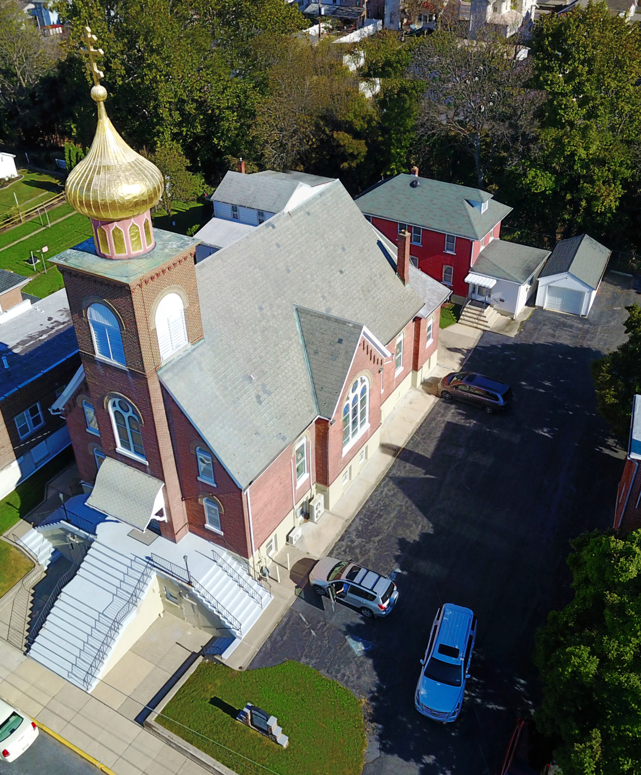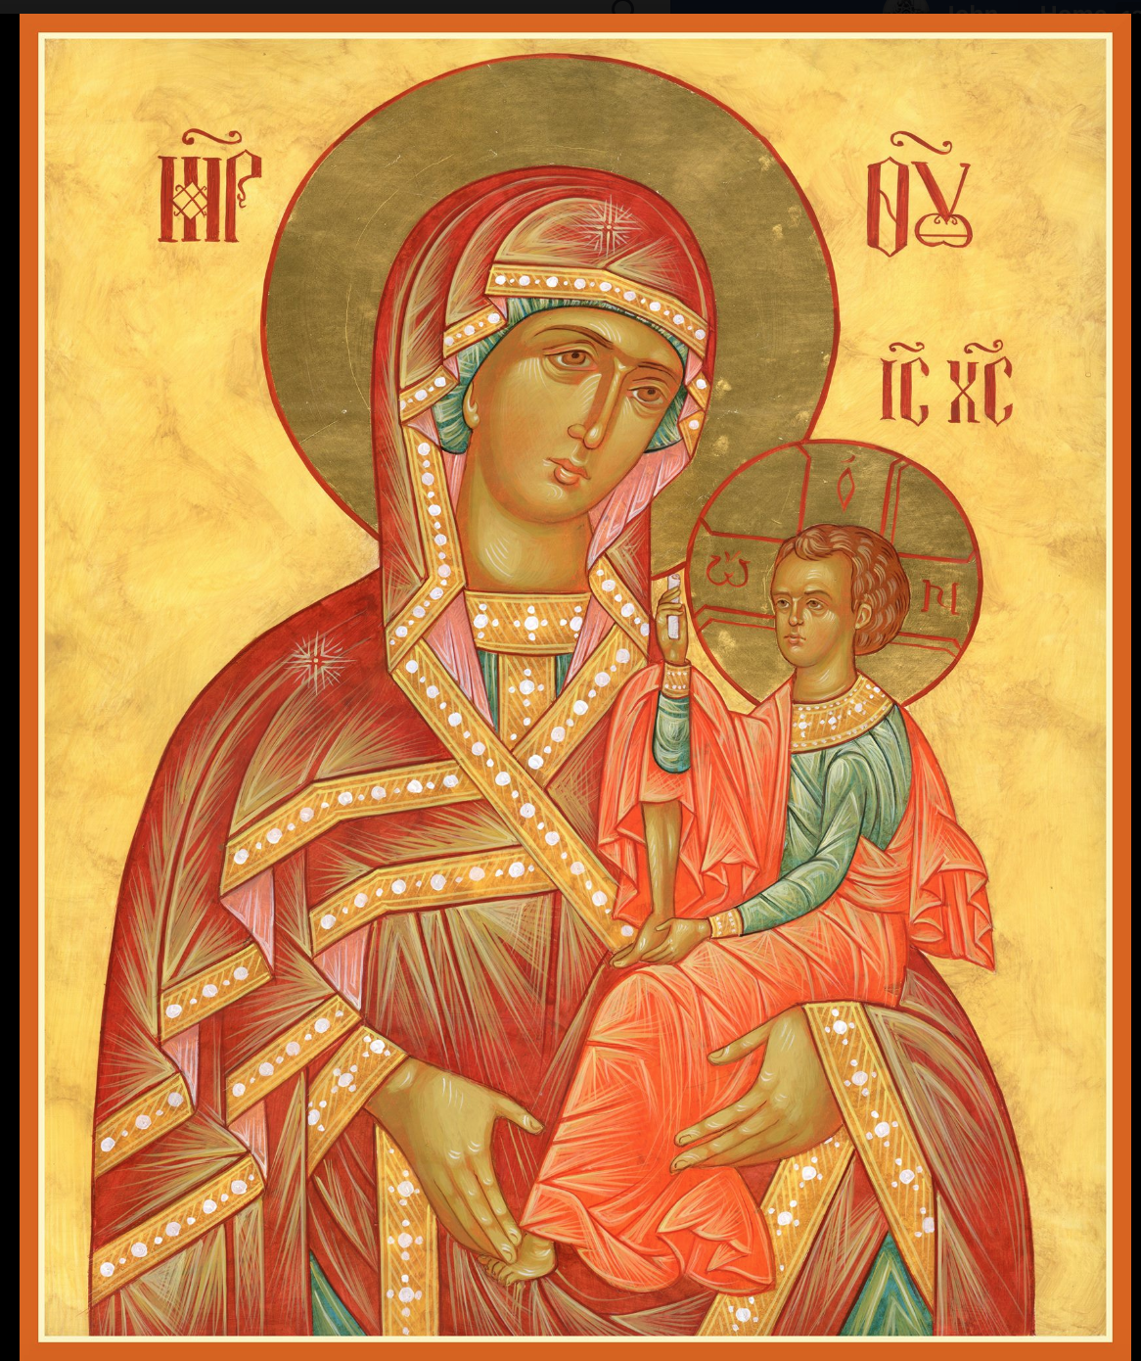

ASSUMPTION OF THE VIRGIN MARY
UKRAINIAN ORTHODOX CHURCH
ECUMENICAL PATRIARCHATE OF CONSTANTINOPLE AND NEW ROME
1301 Newport Avenue
Northampton, Pennsylvania 18067
Rev. Fr. Oleh Kravchenko
Mitered Archpriest Myron Oryhon, Attached
Protodeacon Mkhhail Sawarynski, Attached
Telephones: Church Office… (610) 262-2882
Church Fax/Kitchen/Hall… (610) 262-0552
Fr. Oleh Kravchenko – (732) 507-2274
Fr. Myron Oryhon – (607) 752-1999
Protodeacon Mikhail’s Residence… (610) 262-3876
Websites: holyassumption.org
ukrainianorthodoxchurchusa.org
lvorthodox.wordpress.com
E-mail: Parish… avmuoc@gmail.com
Protodeacon Mikhail…pravoslavni@rcn.com
Webmaster, John Hnatow… john.hnatow@gmail.com
==============================================================
8th September (26th Aug.) 2019

Twelfth Sunday after Pentecost. Tone 3. Martyrs ADRIAN and NATALIA and 33 companions of Nicomedia (4th C.)
1 Corinthians 15:1-11 Matthew 19:16-26
TODAY’S BULLETIN, in loving memory of brother, + MICHAEL SMALLEN JR., on the first anniversary of his falling asleep, is sponsored by Steve and Melanie Unger. MEMORY ETERNAL!
HAPPY GRANDPARENT’S DAY
PROPERS FOR LITURGY OF ST. JOHN CHRYSOSTOM

Tropar of the Resurrection, Tone 3
Let the heavens rejoice. Let the earth be glad. For the Lord has shown strength with His Arm. He has trampled down death by death. He has become the First-Born of the Dead. He has delivered us from the depths of Hell and has granted the world great mercy.

Tropar of the Dormition, Tone 1
In giving birth, you preserved your virginity. In falling asleep you did not forsake the world, Birth-Giver of God. You were translated to Life, Mother of Life, and through your prayers you deliver our souls from death.

Tropar of the Martyrs Adrian & Natalia, Tone 4
Your holy martyrs Adrian and Natalia, O Lord, through their sufferings have received incorruptible crowns from You, our God. For having Your strength, they laid low their adversaries and shattered the powerless boldness of demons. Through their intercessions, save our souls.

Kondak of the Resurrection, Tone 3
On this day You rose from the tomb, Merciful One, leading us from the gates of death. On this day Adam exults as Eve rejoices. With the prophets and patriarchs, they unceasingly praise the divine majesty of Your Power.

Glory to the Father and to the Son and to the Holy Spirit.

Kondak of the Martyrs, Tone 4
Martyr of Christ, Adrian, you kept the words of your godly wife Natalia in your heart. With her you accepted every kind of suffering and obtained the crown of victory.

Now and ever and unto ages of ages. Amen.

Kondak of the Dormition, Tone 2
Neither the tomb nor death had power over the Birth-Giver of God; she is ever watchful in her prayers and in her intercession lies un-failing hope. For as the Mother of Life, she has been translated to life by the One Who dwelt within her ever-virginal womb.

Prokimen of the Resurrection, Tone 3
Sing praises to our God, sing praises. Sing praises to our King, sing praises.

Verse: Clap your hands, all you peoples. Shout to God with a joyful voice.

Alleluia Verses in Tone 3
Lord, in You have I hoped; let me never be put to shame.

Be a God of protection for me, a house of refuge, to save me.

Communion Hymn:
Praise the Lord from the heavens, praise Him in the Highest.
Alleluia (3X)

LITURGICAL MENEION & SCRIPTURE READINGS
FOR THE THIRTEENTH WEEK AFTER PENTECOST

Sun. 08 Sept. Blessing of children and teachers following Liturgy.

Mon. 09 Sept. Ven. POEMAN the Great (450). HOSIUS, Bishop of
Cordova. LIBERIUS, Pope of Rome (366).
2 Cor. 8:7-15 Mark 3:6-12

Tue. 10 Sept. Ven. MOSES the Black of Scete (400). Righteous
ANNA the Prophetess , daughter of Phanuel (1st C.) Uncovering relics of JOB of Pochaiyev (1651).
2 Cor. 8:16-9:5 Mark 3:13-19

5:00 PM FESTAL VESPERS & LITYA

Wed. 11 Sept. BEHEADING OF ST. JOHN the Baptist.
STRICT FAST Acts 13:25-32 Mark 6:14-30
8:30 AM THIRD & SIXTH HOURS
9:00 AM DIVINE LITURGY

Thurs.12 Sept. ALEXANDER, JOHN and PAUL the New, Patriarchs of Constantinople. CHRISTOPHER of Pales-
Tine (6th C.) Ven. FANTINUS of Calabria (9th C.)
2 Cor. 10:7-18 Mark 3:28-35

Fri. 13 Sept. Placing of the Sash of the HOLY MOTHER of God
FAST DAY (408). Hieromartyr CYPRIAN Bishop of Carthage
Oil GENNADIUS, Patriarch of Constantinople (471)
2 Cor. 11:5-21 Mark 4:1-9

Sat, 14 Sept. SYMEON STYLITES (459) & his mother,
MARTHA. Righteous JOSHUA, son of Nun.
Beginning of the Church New Year.
1 Cor. 2:6-9 Matthew 22:15-22
5:00 PM GREAT VESPERS

Sun. 15 Sept. 13th Sunday after Pentecost. Tone 4
8:30 AM THIRD & SIXTH HOURS
9:00 AM DIVINE LITURGY of JOHN CHRYSOSTOM

NECROLOGY:
08 Sept…Michael Micio (infant) ‘26
09 Sept…Peter Kochenash ’56, Walter Kuchinos ‘17
10 Sept…Olha Sabadash (infant) ’23, Barbara Sawka ’42,
John Yost ’98, Katherine Steidinger ‘10
11 Sept…John Magerka ’61, Paul Kuchinos ’04,
Pauline Woyewoda ’07, Michael Smallen Jr. ‘18
12 Sept… Peter Vitushinsky ’72, Maria Kap ‘01
13 Sept… Elizabeth Faryna (infant) ’23, Peter Bochniak ‘60
14 Sept… Andrew Martnick ‘84
VICHNAYA PAMYAT! MEMORY ETERNAL
BIRTHDAYS:
09 Sept… Katerina Seremula
14 Sept… Linda Winters
MNOHAYA LITA! MANY YEARS!

WE PRAY FOR THE HEALTH AND WELL-BEING of the ill afflicted: William Savitz, Catherine Kochenash, Vladimir & Emma Krasnopera, Tessie Kuchinos, Brendan Phillips, Jessie Hnatow, Jessica Meashock, Adam Hewko, Betty Hendrickson, Andrew Thaxton, Michelle Pierzga, Susan Ferretti, Carole Zarayko,
Marianna Goshow, Judy Albright, Rob Hewko, Barry Hamlin

BENE NOTE: ON HOLY COMMUNION
Please be advised that according to the Canons of the Orthodox Church, the Sacrament of Holy Communion can only be administered to Orthodox Christians ( Baptized & Chrismated, making them living members of the Body of Christ). One must be prepared to approach the Holy Chalice by fasting, prayer and confession.

ANNUAL CHURCH PICNIC at Canal St. Park with a “PIG ROAST” catered by Fr. James Cairns on SATURDAY, SEPTEM-BER 28th from 12 noon to 7 PM. Sign-up sheet to bring your favorite picnic dish. Vespers will be served beginning at 5 PM at the park.

OCMC “AGAPE CANISTER” DONATIONS were $48.00; thank
you for your generous support of our Missions around the globe.

NORTHAMPTON FOODBANK is still in need of foodstuffs, especially tuna, canned potatoes and baby food.

Please continue to save Redner’s tapes; use your Reward’s Card.”

MANY THANKS TO RICHARD STECH for his donation of bouquets of flowers for our patronal feast day, Dormition of the Mother of God on August 28th. Mnohaya Lita!

SISTERHOOD MEETING, Sunday, Sept. 22nd following Liturgy.
Pierohi Sales to begin October 3rd. Please call Helen Crayosky @ 610-261-4575 to order. Deadline is Sunday, Sept. 29th. $8 per dozen.

Today we commemorate Martyrs ADRIAN and his wife NATALIA & their 33 companions of Nicomedia. Both came from noble and wealthy families during the reign of Emperor Maximian (305-311). Adrian was a pagan and his wife was Christian. They were married only 13 months before their martyrdom. Christians, hiding in a cave near the city, were seized and tortured. Adrian observed the cruelty to these Christians who endured with serenity, meekness and patience and such courage for their faith that he asked that his name be added to the list of Christians. Natalia rejoiced with this news and came to minister to those imprisoned. The emperor ordered them that the prisoner’s arms and legs be broken with a hammer. Adrian and the others gave up the spirit under the greatest of tortures. Natalia took their relics to Argyropolis and buried them honorably. A few days later, Adrian appeared to Natalia in heavenly radiance and called out to her to come to God, she peacefully.

SUNDAY SCHOOL SCHEDULE

Classes begin today:
Mrs. Mary Ost – Pre-K to 3rd grade at 9 AM
Mrs. Linda Winters -4th to 6th grade; Sept. 8th – 9 AM; 15th – 11 AM
Ms. Bettyann Woyewoda – 7th to 12th grade all classes at 9 AM

