ASSUMPTION OF THE VIRGIN MARY UKRAINIAN ORTHODOX CHURCH
ECUMENICAL PATRIARCHATE OF CONSTANTINOPLE AND NEW ROME
1301 Newport Avenue, Northampton, Pennsylvania 18067
Rev. Fr. Oleg Kravchenko, Rector
Protodeacon Mikhail Sawarynski, Attached
Websites: holyassumption.org and ukrainianorthodoxchurchusa.org
Facebook: Assumption of the Virgin Mary Ukrainian Orthodox Church
YouTube: AVM UOC Church
Contacts:
Fr. Oleg Kravchenko - (484) 834-7261; olegkravchenko2212@gmail.com
Protodeacon Mikhail – (H) (610) 262-3876); pravoslavni@rcn.com
Office – (610) 262-2882; avmuoc@gmail.com
Webmaster, John Hnatow – john.hnatow@gmail.com

Click HERE for Prayer in Time of Corona Virus
Tune in to our news, announcements, and online Facebook Livestream Liturgies HERE!

LET’S PRAY FOR THE PEACE IN UKRAINE!

Sun. 04 Sep. 12th SUNDAY A.P. TONE 3. AFTERFEAST of the DORMITION. Martyrs AGATHONICUS, ZOTICUS, THEOPREPIUS, ACIDYNUS, SEVERIAN, & ZENO (4th C.) Hieromartyr ATHANASIUS, Bishop of Tarsus. ANTHUSA of Syria & Martyrs CHARESIMUS & NEOPHYTUS. Virgin-Martyr EULALIA of Barcelona (303).
Epistle: 1 Corinthians 15: 1-11 Gospel: Matthew 19: 16-26
Blessing of the youth for the new Academic Year

Make a list of the living and deceased and bring to the Altar. We’ll pray for them during Liturgy.
For pastoral visits at home or in a hospital, please let Fr. Oleg know.

Today’s Bulletin is sponsored by Kathy Kuchinos in loving memory of Walter Kuchinos.

DAILY LITURGICAL CALENDAR, SCRIPTURE READINGS AND MENAION

Mon. 05 Sep. Martyr Lupus (306), slave of St. Demetrius of Thessalonica.
2 Cor. 8:7-15 Mk. 3:6-12
Tue. 06 Sep. Hieromartyr Eutychius (1st c.), disciple of St. John the Theologian.
2 Cor. 8:16–9:5 Mk. 3:13-19
6:30 PM Moleben for Ukraine (St. John the Baptist UCC, Northampton)
Wed. 07 Sep. Holy Apostle Titus of the Seventy (1st c.). Sts. Barses and Eulogius (386),
2 Cor. 9:12 – 10:7 Mk. 3:20-27
Thu. 08 Sep. Martyrs Adrian and Natalia.
2 Cor. 10:7-18 Mk. 3:28-35
Fri. 09 Sep. Hieromartyrs Pimen, Kuksha.
2 Cor. 11:5-21 Mk. 4:1-9
Sat. 10 Sep. Saints of the Kyiv Caves whose relics in the Far Cave.
1 Cor. 2:6-9 Mt. 22:15-22
5:00 PM Great Vespers

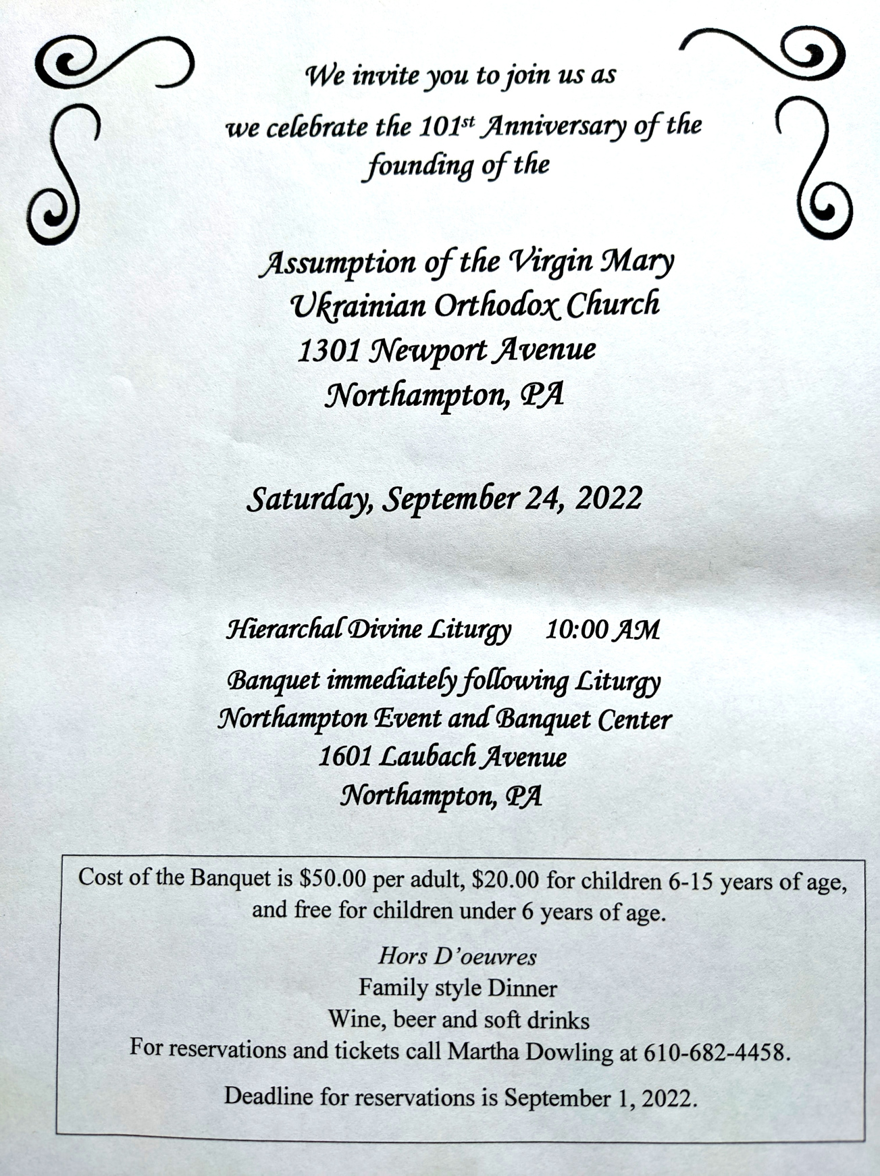

PROPERS FOR THE LITURGY OF ST. JOHN CHYRSOSTOM
Tropar of the Resurrection, Tone 3. Let the Heavens rejoice. Let the earth be glad. For the Lord has shown strength with His Arm. He has trampled down death by death. He has become the First-born of the Dead. He has delivered us from the depths of Hell and has granted the world great mercy.
Tropar of the Dormition, Tone 1. In giving birth, you preserved your virginity. In falling asleep you did not forsake the world, Birth-Giver of God. You were translated to life, Mother of Life, and through your prayers you deliver our souls from death.
Tropar of the Holy Martyrs, Tone 4. Your holy martyrs Agathonicus and his companions, O Lord, through their sufferings have received incorruptible crowns from You, our God. For having Your strength, they laid low their adversaries, and shattered the powerless boldness of demons. Through their intercessions, save our souls.
Kondak of the Resurrection, Tone 3. On this day You rose from the tomb, Merciful One, leading us from the gates of death. On this day Adam exults as Eve rejoices. With the prophets and patriarchs they unceasingly praise the divine majesty of Your Power.
Glory to the Father and to the Son and to the Holy Spirit.
Kondak of the Martyrs, Tone 1. Having received the good calling, divinely-wise One, you abandoned the cult of evil men, not fearing their tortures, glorious Agathonicus. Therefore, you have inherited good things and worthily received the incorruptible crowns with your fellow martyrs.
Now and ever… Kondak of the Dormition, Tone 2. Neither the tomb nor death had power over the Birth-Giver of God; she is ever watchful in her prayers and in her intercession lies unfailing hope. For as the Mother of Life, she has been translated to life by the One Who dwelt within her ever-virginal womb.
Prokimen of the Resurrection, Tone 3. Sing praises to our God, sing praises. Sing praises to our King, sing praises.
Verse: Clap your hands, all you peoples. Shout to God with a joyful voice.
Prokimen of the Dormition, Tone 3. My soul magnifies the Lord and my spirit rejoices in God my Savior.
Epistle: 1 Corinthians 15: 1-11
Alleluia Verses Tone 3. Lord, in You have I hoped; let me never be put to shame.
Be a God of protection for me, a house of refuge to save me.
Lord, arise into Your rest, You and the Ark of Your holiness.
Gospel: Matthew 19: 16-26
Instead of “It is right in Truth”. Beholding the Dormition of the Most Pure One, the angels were amazed, as the Virgin was taken up from earth to heaven.
Irmos, Tone 1: In you, Pure Virgin, the bounds of nature are overcome; Childbirth remains virginal and death is betrothed to life, Birth-Giver of God, Virgin after bearing a child and alive after death, always save your inheritance.
Communion Hymn: Praise the Lord from the Heavens. Praise Him in the Highest. I will take the cup of salvation and call upon the Name of the Lord. Alleluia (3X).

- Sisterhood meeting – September 11.
- Senior UOL Chapter sponsors a YARD/GARAGE SALE Saturday October 22nd from 8 A.m. to 2 P.M! Please search for items that you are willing to donate. All proceeds will benefit our UOL Chapter. Any unsold items will be returned to the donor. Our UOL Chapter assists our Parish by sponsoring activities and events as well as contributing financial assistance.
- Data change of Parish outing to the Sight and Sound Theater in Lancaster to October 5 (3 pm). Youth are free.
- Melanie Unger is seeking names of parishioners to be sponsors on our Parish's "booster" page for the 101st Anniversary yearbook. Please submit $10.00 per name for this page to show your love and support for our beloved Church on her 101st birthday.
- Ukrainian language course starts in September. Please Sign up at the hall.
- Welcome to opening of new Academic Year at St. Sophia Seminary. 10 September, 10am.
- CHOIR REHEARSAL for the 101st parish anniversary Divine Liturgy will be in the church hall, Thursday, September 22nd at 7PM. All choir members are asked to attend. Also, if they is anyone that currently doesn’t sing in the choir but wants to do so for the anniversary, please come join us for rehearsal.
-Day at the Ballpark - Sunday; September 25, 1:35 PM - join our sister Parish St. Mary’s UOC in Allentown for an afternoon and root for the Iron Pigs as they take on the Scranton\Wilkes-Barre RailRiders. Tickets are $28. Youth are free. Picnic Patio area. For tickets ask Fr. Oleg.
- There is a possibility to have a professional icon workshop in our church with an experienced iconographer. Interested?-ask Fr. Oleg.
- Welcome to contribute articles or pictures to the bulletin. Let's make bulletins together!
- Pan-Orthodox Virtual Bible Study via Zoom. Wednesdays at 12 PM. Meeting ID: 576 301 6482. Passcode: 238492. To make it on a big screen at hall ask Fr. Oleg.
- Donations for Ukraine: medical supplies, diapers, baby food, new shoes and clothing.
- For food bank: baby foods, canned potatoes and meats, tuna, pasta, sauces, mac. & cheese.

ANNIVERSARIES:
05 Sept…David & Meredith Misko
06 Sept…Michael & Barbara Baird
MANY YEARS! МНОГАЯ ЛІТА!

BIRTHDAYS:
09 Sept…Katerina Seremula

NECROLOGY:
All Ukrainian civilians and soldiers killed in the Russian invasion.

Larisa, Ludmila (1year)
04 Sept…Mary Malast ’49 Tekla Antoniuk ’67
07 Sept…Anna Hewko ’11
08 Sept…Walter Kuchinos ’17 Michael Micio (infant) 09 Sept…Peter Kochenash ’56,
10 Sept…Ol’ha Sabadash (infant) ’23 Barbara Sawka ’42 John Yost ’98
Katherine Steidinger ‘10
MEMORY ETERNAL! ВІЧНАЯ ПАМ’ЯТЬ!

PRAYER FOR THE HEALTH & SALVATION OF THE AFFLICTED: Ukrainian soldiers and civilians wounded during the Russian aggression, Metropolitan Antony, Helen Crayosky, Raisa Melnychuk, William Leszczuk, child Charlie, Angela Knoblach, James Osmun, priest Vasyl Dovgan, Rosemarie Pypiuk, Kirk Swauger, Stephanie Donnelly, Nicholas Alexander, Danny Berro, child Alexandria, Elizabeth Pastushenko, Philippe Chasseuil, Joan Molnar, Brandon and Stacy Snyder, Aaliyah Osmun, Ihor Broda, William Savitz, Vladimir Krasnopera, Brendan Phillips, Jessie Hnatow, Jessica Meashock, Adam Hewko, Andrew Thaxton, Susan Ferretti, Judy Albright, Rob Hewko, Daniel Kochenash, Christopher Mack, Norman Betrous, Tom Petro Jr., Robert Zarayko Jr.
A PARENT'S PRAYER FOR THEIR FIRST Year Student. God of life and love , you have given me ( child's name ) to care for this little while .. My heart is welled with joy and thanksgiving , anticipation and anxiety , amidst a longing to be together as we have been until now . These years of growing up have moved so quickly . and there is still so much I hope to give to my child who is taking this new tep in the journey of life . Help us , as we reshape our lives to reflect this new reality of college . Show us new ways to be present to each other in love and in trust . Give me patience and help me to remember that my child is establishing new routines in freedom , routines different from my routines . Calm my fears . Strengthen and protect ( child's name ) in the midst of the challenges and temptations which surround all students . Grant ( child's name ) courage and a discerning heart as choices are made and new ideas are discovered . Provide good friends and worthy confidants for my child during these college years . Help me to give support and confidence, to discern how I am needed now , and to pass on , in my love , a measure of the strength and perseverance you have given me in the gift of parenting . Amen . (Shared by Ost family)

The Danger of Riches. One day, an Indian boy found a large pearl. It represented the fulfillment of all his hopes and dreams. His days of hardship and toil would be over. He would never have to work again. But, when he tried to sell the pearl, his real problems began. Buyers tried to trick him, bandits tried to attack him, and even his friends tried to manipulate him. Possessing great wealth was nothing like he expected it would be, so he took the pearl and threw it back into the sea. The boy in this story is quite a contrast to the young man of whom Jesus spoke in the Gospel reading for this Sunday. Jesus spoke of a young man who desired to be justified by God. He had faithfully kept all the commandments, but Jesus told him that there was one thing he still needed to do: sell all he had and give to the poor. With that, the young man went away saddened because he was not able to easily part with all his possessions. Jesus then spoke one of His most enduring statements, "It will be easier for a camel to pass through the needles eye, than for a rich man to enter the kingdom of God." (Matthew 21:24) What type of hold do our possessions have on us? Are we willing to share what we have with others, including our time, our talents, as well as our treasure? Everything that we have is a gift from God, which must be freely shared with others as a gift. Our Lord Himself tells us, "The gifts you have freely received, now give as a gift." (Matthew 10:8)

God's kingdom is not built on the profit motive. The world's favorite verb is "get." The verb of the Christian is "give." Self-interest is basic in modern society. Everyone asks, "What's in it for me?" In a world founded on materialism this is natural and normal. But in God's kingdom self-interest is not basic—selflessness is. The Founder, Jesus Christ, was rich, and yet He became poor that we "through his poverty might be rich" (2 Corinthians 8:9). His disciples followed Him, and it was said of them, "All the believers were one in heart and mind. No one claimed that any of their possessions was their own, but they shared everything they had.” (Acts 4:32). Peter, rich in heavenly goods but poor in worldly goods, said to the lame man on the Temple steps, "Silver and gold have I none; but such as I have give I thee" (Acts 3:6). The apostles realized that there is no permanent value in worldly goods, and cherished the abiding values of the Spirit. They lived with eternity in view. Today we too often hold spiritual things in contempt and lust after the things of this world. Little wonder that the world is in a state of turmoil! Mammon is worshiped, and God is disdained. Pleasure takes precedence over purity, and gain is considered greater than God. But in God's kingdom he that is greatest among you is the servant of all (see Matthew 23:11). Service to God and mankind are put above self-interest. Jesus said, "Greater love hath no man than this, that a man lay down his life for his friends" (John 15:15). Christ proved His words by doing exactly that for us. (By Rev. Billy Graham)

