SEPTEMBER 01, 2019

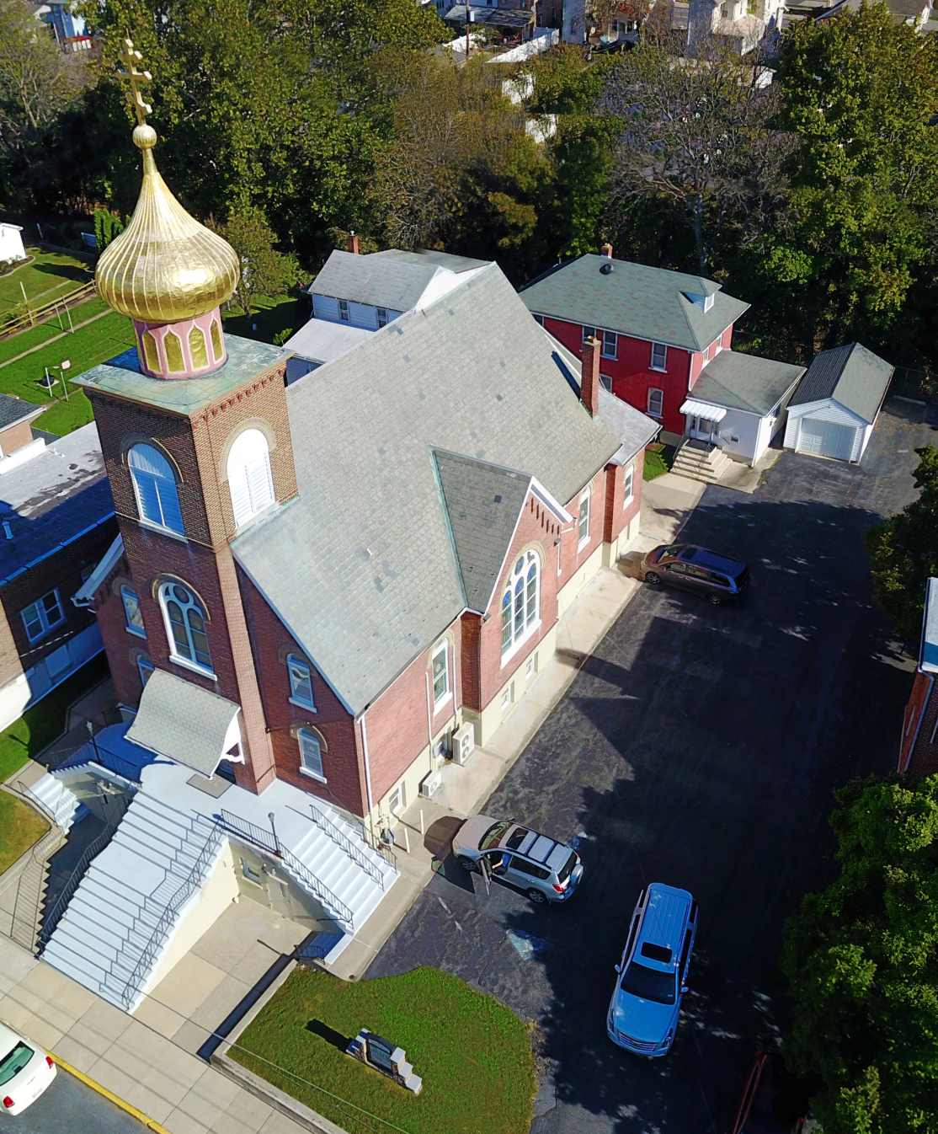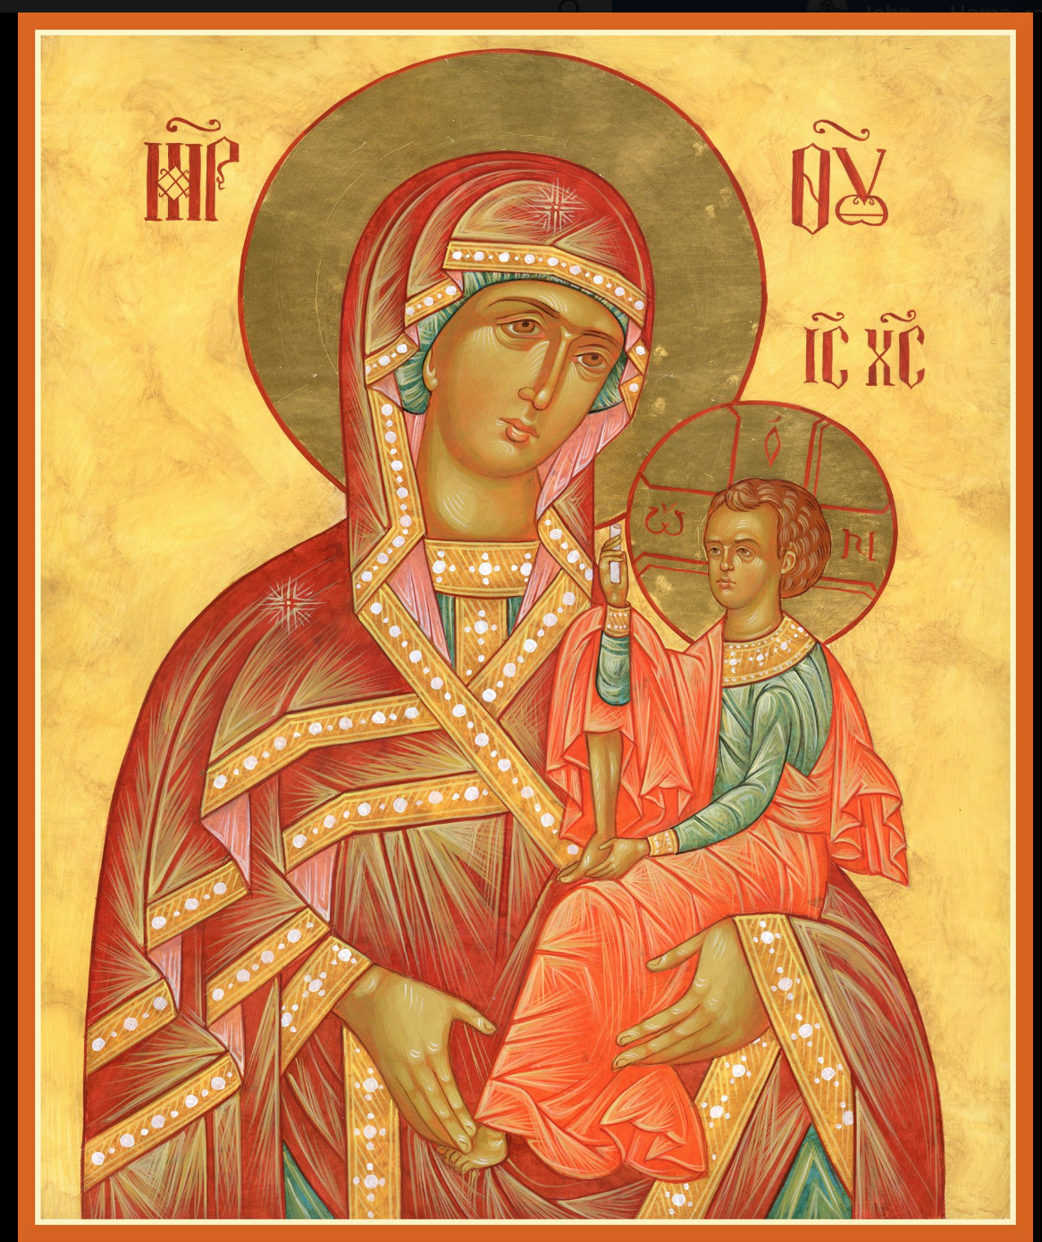

ASSUMPTION OF THE VIRGIN MARY
UKRAINIAN ORTHODOX CHURCH
ECUMENICAL PATRIARCHATE OF CONSTANTINOPLE AND NEW ROME
1301 Newport Avenue
Northampton, Pennsylvania 18067
Rev. Fr. Oleh Kravchenko
Mitered Archpriest Myron Oryhon, Attached
Protodeacon Mychail Sawarynski, Attached

Telephones: Church Office… (610) 262-2882
Church Fax/Kitchen/Hall… (610) 262-0552
Fr. Oleh Kravchenko – (732) 507-2274
Fr. Myron Oryhon – (607) 752-1999
Protodeacon Mychail’s Residence - (610) 262-3876
Websites: holyassumption.org
ukrainianorthodoxchurchusa.org
lvorthodox.wordpress.com
E-mail: Parish… avmuoc@gmail.com
Protodeacon Mychail…pravoslavni@rcn.com
Webmaster, John Hnatow… john.hnatow@gmail.com
==============================================================
1st September (19th August) 2019

Eleventh Sunday after Pentecost. Tone 2. AFTERFEAST OF THE DORMITION. Martyr ANDREW STRATELATES & 2,593 soldiers. Martyrs TIMOTHY, AGAPIUS, & THECLA of Palestine (304).
1 Corinthians 9:2-12 Matthew 18:23-35

PROPERS FOR LITURGY OF ST. JOHN CHRYSOSTOM

Tropar of the Resurrection, Tone 2
When You descended to death, Life Immortal, You slayed Hell with the splendor of Your Divinity. And when from the depths You raised the dead, all the Powers of Heaven cried out: Giver of Life, Christ our God, glory to You.

Tropar of the Dormition, Tone 1
In giving birth, you preserved your virginity. In falling asleep you did not forsake the world, Birth-Giver of God. You were translated to Life, Mother of Life, and through your prayers you deliver our souls from death.

Tropar to Martyr Andrew Stratelates , Tone 5
You renounced the glory of earthly rank and inherited the Kingdom of Heaven; you adorned your incorruptible crown as with beautiful stones. You led an army of martyrs to Christ and with the angles in the never fading light, you found Christ, the never-setting sun. Together with those who suffered with you, holy General Andrew, ever pray to Him that He may save our souls.

Kondak of the Resurrection, Tone 2
Hell became fearful, Almighty Savior, seeing the miracle of Your Resurrection from the tomb. The dead arose and all creation, with Adam, beheld this and rejoiced with You and the world, my Savior, praises You forever.

Glory to the Father and to the Son and to the Holy Spirit.

Kondak to Martyr Andrew, Tone 4
Standing before the Lord in prayer like a star near the sun, you were filled with ineffable joy, beholding your desire: the treasure of the Kingdom. You sing without ceasing to the Immortal King, together with the angels throughout the ages. With them, General Andrew, unceasingly pray for us all.

Now and ever and unto ages of ages. Amen.

Kondak of the Dormition, Tone 2
Neither the tomb nor death had power over the Birth-Giver of God; she is ever watchful in her prayers and in her intercession lies un-failing hope. For as the Mother of Life, she has been translated to life by the One Who dwelt within her ever-virginal womb.

Prokimen of the Resurrection, Tone 2
The Lord is my strength and my song. He has become my salvation.

Verse: The Lord has chastened me sorely, but He has not given me over to death.

Prokimen of the Saint, Tone 4
The Lord has been wondrous in the saints who are on His earth. He has wrought all His desires in them.

Alleluia Verses in Tone 2
May the Lord answer you in the day of trouble. May the Name of the God of Jacob protect you.

Lord, save the king and hear us on the day we call out to You.

The righteous cried and the Lord heard them. He delivered them out of all their tribulations.

Many are the tribulations of the righteous and the Lord shall deliver them out of all.

In place of “It is right in truth…” Beholding the Dormition of the Most Pure One, the angels were amazed, as the Virgin was taken up from earth to heaven.
Irmos, Tone 1: In You, Pure Virgin, the bounds of nature are over-come: Childbirth remains virginal and death is betrothed to life, Birth-Giver of God, Virgin after bearing a child and alive after death, always save Your inheritance.
Communion Hymn:
Praise the Lord from the heavens, praise Him in the Highest.
Rejoice in the Lord, you Righteous; praise befits the upright. Alleluia (3X)

LITURGICAL MENEION & SCRIPTURE READINGS
FOR THE TWELFTH WEEK AFTER PENTECOST

Mon. 02 Sept. Prophet SAMUEL (6th C. BC). Martyrs SEVERUS,
MEMNON and 37 soldiers at Plovdiv, Thrace (304).
2 Corinthians 5:10-15 Mark 1:9-15
10:00 AM BAPTISM & CHRISMATION of infant ELIZABETH
KRAVCHENKO with Archbishop Daniel officiating

Tue. 03 Sept. Apostle THADDEUS of the 70 (44). Martyr BASSA of
Edessa & THEOGONIUS, AGAPIUS & PISTUS.
2 Corinthians 5:15-21 Mark 1:16-22

Wed. 04 Sept. Martyrs AGATHONICUS, ZOTICUS,
FAST DAY THEOPREPIUS, ACINDYNUS, SEVERIAN, ZENO.
2 Corinthians 6:11-16 Mark 1:23-28

Thur. 05 Sept. Martyr LUPUS (306). Hieromartyr IRENAEUS,
Bishop of Lyons (202). EUTYCHIUS (540) &
FLORENTIUS (547) of Nursia.
2 Corinthians 7:1-10 Mark 1:29-35

Fri. 06 Sept. Hieromartyr EUTYCHIUS, disciple of St. John the
FAST DAY; Theologian. Martyr TATION. Virgin martyr CYRA.
OIL 2 Corinthians 7:10-16 Mark 2:18-22

Sat. 07 Sept. Return of the Relics of Apostle BARTHOLOMEW.
Holy Apostle TITUS of the 70. BARSES & EULOGIUS (386), Bishops of Edessa.
1 Corinthians 1:26-29 Matthew 20:29-34

5:00 PM GREAT VESPERS
Sun. 08 Sept. 12th Sunday after Pentecost. Martyrs ADRIAN &
NATALIA & 33 companions of Nicomedia. Tone 3.

8:30 AM THIRD & SIXTH HOURS
9:00 AM DIVINE LITURGY of JOHN CHRYSOSTOM
BLESSING OF CHILDREN & TEACHERS
FOR THE NEW ACADEMIC SCHOOL YEAR

Bene Note: ON HOLY COMMUNION
Please be advised that according to the Canons of the Orthodox Church, the Sacrament of Holy Communion may only be administered to Orthodox Christians (Baptized & Chrismated, making them living members of the Body of Christ). One must be prepared to approach the Holy Chalice by fasting, prayer and confession.

NECROLOGY:
01 Sept…Stephen Nazar ’64, Wasyl Andrus ‘69
Stephen Trimpey ’75, Lyudmila Poshtar ‘93
02 Sept…James Onuschak ‘27
04 Sept…Mary Malast ’49, Tekla Antoniuk ‘67
07 Sept…Anna Hewko ‘11

VICHNAYA PAMYAT! MEMORY ETERNAL

BIRTHDAYS:
02 Sept… Juanita Vitushinsky

ANNIVERSARIES:
01 Sept… Paul & Cheryl Sawarynski
02 Sept… William & Nadine Savitz
05 Sept… David & Meredith Misko
06 Sept… Michael & Barbara Baird

MNOHAYA LITA! MANY YEARS!

SR UOL members annual dues of $20.00 payable by Sept. 30th.

PIEROHI SALES to begin Oct. 3rd. Additional dates: Oct. 17; Nov. 7 & 21; Dec. 5 & 19. Call Helen at 610-261-4575. Price $8.00 per doz.

THANK YOU for your prayers the past 2 years for the child of God, Ekaterina Seremula, who was afflicted with cancer. She is completely free of the disease and requires no further treatments. Once she gets all vaccinations, she will be returning to church. Praise God!

WE PRAY FOR THE HEALTH AND WELL-BEING of the ill afflicted: William Savitz, Catherine Kochenash, Vladimir & Emma Krasnopera, Tessie Kuchinos, Brendan Phillips, Jessie Hnatow, Jessica Meashock, Adam Hewko, Betty Hendrickson, Andrew Thaxton, Michelle Pierzga, Susan Ferretti, Carole Zarayko, William Fischer, Marianna Goshow, Judy Albright, Rob Hewko

OUR CONDOLENCES are extended to the Kowalyshyn Family on the repose of + Dr. Theodore Kowalyshyn, husband and father, on Aug. 14th. Our sympathies to his surviving sisters, Olga Dorosh, Marianne Dworakivsky and Kathryn Fedko. MEMORY ETERNAL

SAVE THE DATE: ANNUAL CHURCH PICNIC will be held at Canal St. Park with a “PIG ROAST”. SATURDAY, SEPTEMBER 28th: 12 noon to 7 PM. Sign-up sheet for your favorite picnic dish in hall. UOL will supply the pig and hot dogs. Outdoor Vespers will be served beginning at 5 PM at the park.

OCMC “AGAPE CANISTER” DONATIONS were $18.00; thank
you for your support of our Missions around the globe.

DONATIONS IN MEMORY OF + WASYL HEWKO
$100 – Bettyann Woyewoda $20 – Ludmila Konovelenko
$100 – Janet Woyewoda

NORTHAMPTON FOODBANK is still in need of foodstuffs, especially tuna, canned potatoes and baby food.

SISTERHOOD MEETING, Sunday, Sept. 22nd following Liturgy.

MARTYR ANDREW STRATELATES IN CILICIA

A military commander in the Roman army during the reign of Emperor Maximian (284-305), General Andrew was beloved because of his bravery, invincibility and fairness. When the Persians invaded Syria the governor Antiochus gave Andrew command of the army. Before the conflict he proclaimed to his troops Jesus Christ. And the small detachment routed the Persians. Jealous men denounced him to Antiochus, saying that he forced his men to convert to Christianity. He was arrested and tortured as were his soldiers, but all refused to renounce Christ. After their release they went to Tarsus where Bishop Peter and Bishop Nonos baptized them. Antiochus wrote a letter to the Governor of Cilicia, Seleucus ordering that they all be killed under the pretext of desertion. Seleucus’ forces came upon them near Mt. Tauros where they were beheaded. A spring of water issued forth from the ground and Bishops Peter and Nonos, who followed them, buried the bodies of 2,593 who suffered with Andrew and healings took place at the spring.

