ASSUMPTION OF THE VIRGIN MARY UKRAINIAN ORTHODOX CHURCH
ECUMENICAL PATRIARCHATE OF CONSTANTINOPLE AND NEW ROME
1301 Newport Avenue, Northampton, Pennsylvania 18067
Rev. Fr. Oleg Kravchenko, Rector
Protodeacon Mikhail Sawarynski, Attached
Websites: holyassumption.org and ukrainianorthodoxchurchusa.org
Facebook: Assumption of the Virgin Mary Ukrainian Orthodox Church
YouTube: AVM UOC Church
Contacts:
Fr. Oleg Kravchenko - (484) 834-7261; olegkravchenko2212@gmail.com
Protodeacon Mikhail – (H) (610) 262-3876); pravoslavni@rcn.com
Office – (610) 262-2882; avmuoc@gmail.com
Webmaster, John Hnatow – john.hnatow@gmail.com

Click HERE for Prayer in Time of Corona Virus
Tune in to our news, announcements, and online Facebook Livestream Liturgies HERE!

LET’S PRAY FOR THE PEACE IN UKRAINE!

DAILY LITURGICAL CALENDAR, SCRIPTURE READINGS AND MENAION

Sun. 21 Aug. TENTH SUNDAY AFTER PENTECOST. TONE 1. AFTERFEAST of the TRANSGURATION. EMILIAN the Confessor, Bishop of Cyzicus (820). MYRON, Bishop of Crete (350). Martyrs ELEUTHRIUS & LEONIDES of Constantinople & the infants. GREGORY, Iconographer of Kyiv Caves (12th C.). Ven. GREGORY of Sinai (Mt. Athos) (1346).
Epistle: 1 Corinthians 4: 9-16 Gospel: Matthew 17: 14-23
Congratulations in occasion of the First Confession of our dear Danica Ost!
Many Blessed Years to you!

Liturgical Meneion & Scripture Readings (THE DORMITION FAST)
Mon. 22 Aug. Apostle Matthias (63). Martyr Anthony of Alexandria. St. Psoes of Egypt.
2 Cor. 2:3-15 Mt. 23:13-22
Tue. 23 Aug. Holy Martyrs Archdeacon Laurence and Pope Sixtus.
2 Cor. 2:14–3:3 Mt. 23:23-28
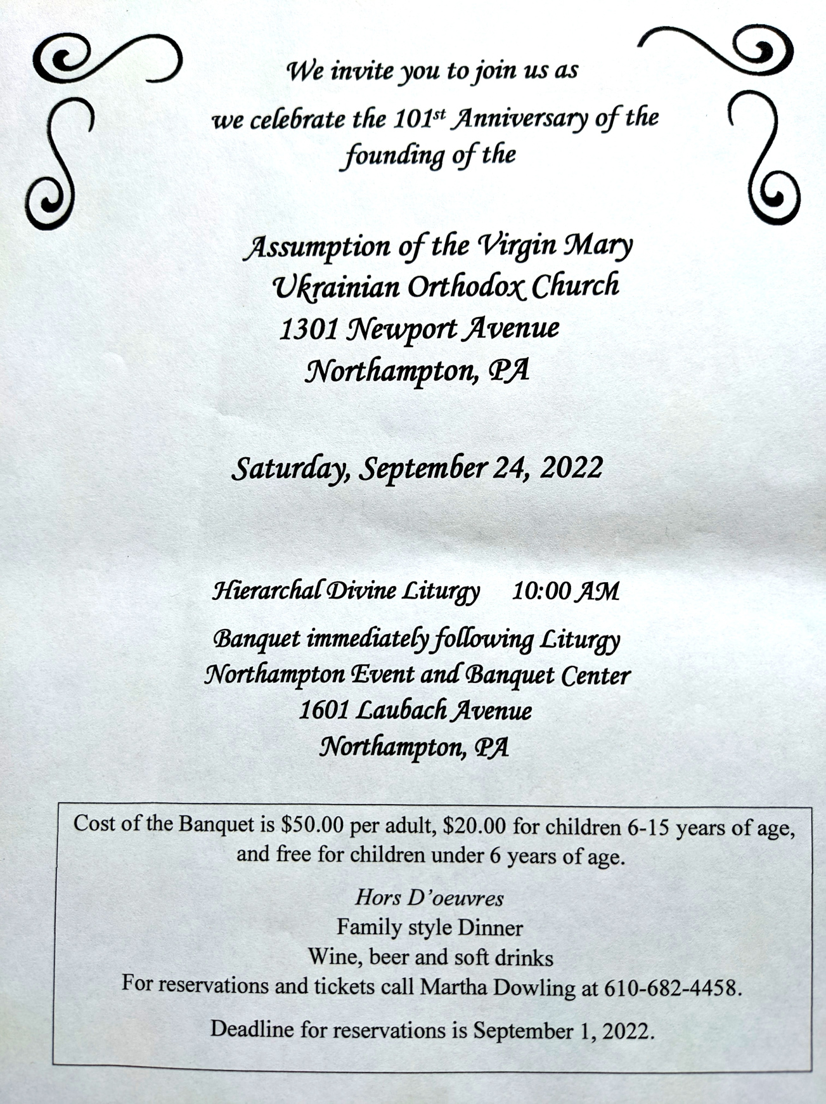
6:30 PM Moleben for Ukraine (Holy Ghost, EASTON).
Wed. 24 Aug. Martyrs Basil and Theodore of the Kyiv Caves (1098).
2 Cor. 3:4-11 Mt. 23:29-39
Thu. 25 Aug Martyrs Anicetus and Photius.
2 Cor. 4:1-6 Mt. 24:13-28
Fri. 26 Aug. St. Maximus the Confessor
2 Cor. 4:13-18 Mt. 24:27-33
Sat. 27 Aug. Prophet Micah (8th c. B.C.).
1 Cor. 1:3-9 Mt. 19:3-12
5:00 PM Great Vespers with the clergy of our deanery.
Sun. 28 Aug. THE DORMITION OF MOTHER OF GOD (Parish’s Feast DAY!)
9:00 AM DIVINE LITURGY
(with our Dean Fr. Robert).
festal brunch after the Liturgy

PROPERS FOR THE LITURGY OF ST. JOHN CHYRSOSTOM
Tropar of the Resurrection, Tone 1. When the stone had been sealed by the Jews, while the soldiers were guarding Your Most Pure Body, You arose on the third day, Savior, granting life to the world. Therefore, the Powers of Heaven cried to You, Giver of Life: Glory to Your Resurrection, Christ. Glory to Your Kingdom. Glory to Your Divine Plan, only Lover of Mankind.
Tropar of the Transfiguration, Tone 7. You were transfigured on the mountain, Christ God, revealing Your Glory to Your disciples as far as they could bear it. Let Your Ever-lasting Light shine on us sinners. Through the prayers of the Birth-Giver of God, Giver of Light, glory to You.
Glory... Kondak of the Resurrection, Tone 1. As God, You arose from the tomb in glory, raising the world with Yourself. Human nature praises You as God for death has vanished. Adam exults, Master. Eve, freed from bondage, rejoices and cries out: “You, Christ, are the Giver of Resurrection to all.”
Now and ever. Kondak Transfiguration. When You were transfigured on the mountain, Christ God, You disciples saw as much of Your Glory as they could bear. So that when they looked upon You being crucified, they would understand that You suffered freely and proclaim to the world that You are indeed the radiance of the Father’s glory.
Prokimen Tone 7. Let Your mercy, Lord, be upon us as we have put our hope in You.
Verse: Rejoice in the Lord, you Righteous. Praise befits the upright.
Prokimen of the Transfiguration, Tone 4. Lord, how many are Your works. In wisdom You have made them all.
Epistle: 1 Corinthians 4:9-16
Alleluia Verses Tone 1. God gives me retribution and has subdued peoples under me.
He magnifies the salvation of the king and deals mercifully for His anointed, for David and his seed forever.
The Heavens are Yours, the earth also is Yours.
Gospel: Matthew 17:14-23
Instead of “It is right in Truth”. Magnify, my soul, the Lord Who transfigured on Tabor. Irmos, Tone 4: Your birth-giving was undefiled. God came from your womb and He appeared on earth in the flesh, making His dwelling among mortals. Therefore, Birth-Giver of God, we all magnify you.
Communion: Lord, the light of Your Countenance has been revealed to us. Lord, we will walk in the light of Your countenance and exult in Your Name forever. Alleluia (3X).
PRAYER FOR THE HEALTH & SALVATION OF THE AFFLICTED: Ukrainian soldiers and civilians wounded during the Russian aggression, Metropolitan Antony, Helen Crayosky, Raisa Melnychuk, Vira Muzychka, Ivan, William Leszczuk, child Charlie, Angela Knoblach, James Osmun, priest Vasyl Dovgan, Rosemarie Pypiuk, Kirk Swauger, Stephanie Donnelly, Nicholas Alexander, Danny Berro, child Alexandria, Elizabeth Pastushenko, Philippe Chasseuil, Joan Molnar, Brandon and Stacy Snyder, Aaliyah Osmun, Ihor Broda, William Savitz, Vladimir Krasnopera, Brendan Phillips, Jessie Hnatow, Jessica Meashock, Adam Hewko, Andrew Thaxton, Susan Ferretti, Judy Albright, Rob Hewko, Daniel Kochenash, Christopher Mack, Norman Betrous, Tom Petro Jr., Robert Zarayko Jr.
Quotes of Maximus the Confessor:
- “Theology without practice is the theology of demons”
- Food is not evil, but gluttony is. Childbearing is not evil, but fornication is. Money is not evil, but avarice is. Glory is not evil, but vainglory is. Indeed, there is no evil in existing things, but only in their misuse.
- “He who busies himself with the sins of others, or judges his brother on suspicion, has not yet even begun to repent or to examine himself so as to discover his own sins...”
Micah was one of the Twelve Minor Prophets of the Bible and was a contemporary of the prophets Isaiah, Amos and Hosea. Micah's messages were directed chiefly toward Jerusalem. He prophesied the future destruction of Jerusalem and Samaria, the destruction and then future restoration of the Judean state, and he rebuked the people of Judah for dishonesty and idolatry. He prophesied that Bethlehem, a small village just south of Jerusalem, would be the birthplace of the Messiah.
- Data change of Parish outing to the Sight and Sound Theater in Lancaster to October 5 (3 pm). Youth are free.
- Melanie Unger is seeking names of parishioners to be sponsors on our Parish's "booster" page for the 101st Anniversary yearbook. Please submit $10.00 per name for this page to show your love and support for our beloved Church on her 101st birthday. Happy birthday to Assumption of the Virgin Mary Ukrainian Orthodox Church. Mnohaya lita!
- Ukrainian language course starts in September. Please Sign up at the hall.
- Join Ukraine's Independence Day, flag-raising ceremony and short program in commemoration. 24 August at 11:00 a.m. at Bethlehem City Plaza (Payrow Plaza).
- Divine Liturgy and Door Opening of our Chrysostom Academy with His Eminence Met. Savas of Pittsburgh GOA. September 1st, 9:30 AM. 395 Bridle Path Rd, Bethlehem, PA 18017.
- Welcome to opening of new Academic Year at St. Sophia Seminary. 10 September, 10am.
- CHOIR REHEARSAL for the 101st parish anniversary Divine Liturgy will be in the church hall, Thursday, September 22nd at 7PM. All choir members are asked to attend. Also, if they is anyone that currently doesn’t sing in the choir but wants to do so for the anniversary, please come join us for rehearsal.
-Day at the Ballpark - Sunday; September 25, 1:35 PM - join our sister Parish St. Mary’s UOC in Allentown for an afternoon and root for the Iron Pigs as they take on the Scranton\Wilkes-Barre RailRiders. Tickets are $28. Youth are free. Picnic Patio area. For tickets ask Fr. Oleg.
- There is a possibility to have a professional icon workshop in our church with an experienced iconographer. You would be able to paint your own icon of the style of our temple’s iconography! Interested?-ask Fr. Oleg.
- Welcome to contribute articles or pictures to the bulletin. Let's make bulletins together!
- Pan-Orthodox Virtual Bible Study via Zoom. Wednesdays at 12 PM. Meeting ID: 576 301 6482. Passcode: 238492. To make it on a big screen at hall ask Fr. Oleg.
- Donations for Ukraine: medical supplies, diapers, baby food, new shoes and clothing.
- For food bank: baby foods, canned potatoes and meats, tuna, pasta, sauces, mac. & cheese.

BIRTHDAYS:
21 Aug…Andriy Semenovych
22 Aug…Helen Crayosky
23 Aug…Jasmine Pavlinsky
25 Aug…Andrew Sawarynski
27 Aug…Tom Petro(Anniversary), Joseph Seremula
MANY YEARS! МНОГАЯ ЛІТА!

NECROLOGY: All Ukrainian civilians and soldiers killed in the Russian invasion. 14 Aug…Oksana (Fr. Oleg’s relative)
21 Aug...Philip Kowalchuk ’54, Wasyl Sheska ‘54
22 Aug…John Ziatyk ‘79
23 Aug…Palahia Maslanyk ’74, Helen Schur ‘01
25 Aug…Stephen Nazar ‘26
26 Aug…John Marakovits ’57
27 Aug…Michael Budnick ’44, Anna Piatok ’87, Evhen Proch ‘14
MEMORY ETERNAL! ВІЧНАЯ ПАМ’ЯТЬ!
Today’s Gospel: Kneeling and saying, Lord, have mercy on my son. The farther of the epileptic expresses his desperate need and his unworthiness before Christ. Sickness, especially epilepsy, is often connected to demonic activity in Scripture. Yet the disciples could not banish Satan. Jesus rebukes His disciples' powerlessness and their participation with the faithless and perverse. Nothing can withstand Jesus' power, for He is the Lord of all. To everyone in need He says, bring him here to Me!
Exorcisms require sincere faith combined with prayer and fasting. Faith is a gift of God, either an ascent to the truth, which profits the soul or a special gift bestowed by Christ which affects things beyond man's power. But it is always both a belief and a trust.
Jesus predicts His death and Resurrection a second time. The Son of Man is not led by compulsion, but He is going to the Passion willingly, so that “He, by the grace of God, might taste death for everyone”.

