ASSUMPTION OF THE VIRGIN MARY UKRAINIAN ORTHODOX CHURCH
ECUMENICAL PATRIARCHATE OF CONSTANTINOPLE AND NEW ROME
1301 Newport Avenue, Northampton, Pennsylvania 18067
Rev. Fr. Oleg Kravchenko, Rector
Protodeacon Mikhail Sawarynski, Attached
Websites: holyassumption.org and ukrainianorthodoxchurchusa.org
Facebook: Assumption of the Virgin Mary Ukrainian Orthodox Church
YouTube: AVM UOC Church
Contacts:
Fr. Oleg Kravchenko - (484) 834-7261; olegkravchenko2212@gmail.com
Protodeacon Mikhail – (H) (610) 262-3876); pravoslavni@rcn.com
Office – (610) 262-2882; avmuoc@gmail.com
Webmaster, John Hnatow – john.hnatow@gmail.com

Click HERE for Prayer in Time of Corona Virus
Tune in to our news, announcements, and online Facebook Livestream Liturgies HERE!

LET’S PRAY FOR THE PEACE IN UKRAINE!

DAILY LITURGICAL CALENDAR, SCRIPTURE READINGS AND MENAION

Sun. 14 Aug. NINTH SUNDAY AFTER PENTECOST. TONE 8. PROCESSION of the PRECIOUS WOOD of the LIFE-GIVING CROSS (1164). THE HOLY SEVEN MACCABEES, their MOTHER SOLOMONIA & TEACHER ELEAZAR (166 B.C.). CELEBRATION OF THE BAPTISM of KYIVAN-RUS (988).
Epistles: 1 Corinthians 3:9-17 & 1 Corinthians 1:18-24
Gospels: Matthew 14:22-34 & John 19:6-11, 13-20, 25-28, 30-35

Liturgical Meneion & Scripture Readings (THE DORMITION FAST)
Mon. 15 Aug. Translation of the relics (428) of the Protomartyr and Archdeacon Stephen.
1 Cor. 15:12-19 Mt. 21:18-22
Tue. 16 Aug. Venn. Isaac, Dalmatus, and Faustus (5th c.). Ven. Anthony the Roman.
1 Cor. 15:29-38 Mt. 21:23-27
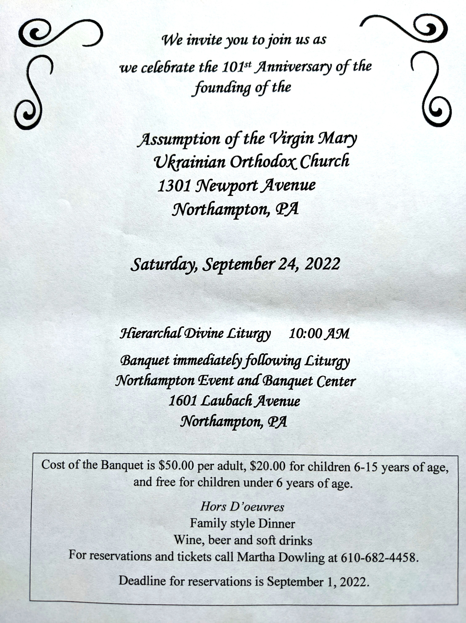
6:30 PM Moleben for Ukraine (Holy Ghost, EASTON).
Wed. 17 Aug. Holy Seven Youths of Ephesus. Martyr Eudocia (362). Martyr Eleutherius.
1 Cor. 16:4-12 Mt. 21:28-32
Thu. 18 Aug Martyr Eusignius of Antioch (362). Hieromartyrs Fabian.
2 Cor. 1:1-7 Mt. 21:43-46
Fri. 19 Aug. TRANSFIGURATION OF OUR GOD AND SAVIOR JESUS CHRIST.
2 Pet. 1:10-19 Mt. 17:1-9
9:00 AM DIVINE LITURGY. Blessing of fruits.
Sat. 20 Aug. Ven. Poemen (Pimen) of the Kyiv Caves.
Rom.15:30-33 Mt.17:24-18:4
5:00 PM Great Vespers.
Sun. 21 Aug. 9:00 AM DIVINE LITURGY
Communion is provided to Orthodox Christians who receive It ONLY in Orthodox Churches.

For the pastoral visitation at home or hospital please contact Fr. Oleg.

PROPERS FOR THE LITURGY OF ST. JOHN CHYRSOSTOM
Tropar of the Resurrection, Tone 8. You descended from on High, Merciful One. You accepted the three-day burial to free us from our passions. Lord, our Life and Resurrection, Glory to You.
Tropar of the Holy Cross, Tone 1. Lord, save Your people and bless Your inheritance. Grant victory to Orthodox Christians over their enemies and by Your Cross, preserve Your community.
Tropar of the Maccabee Tone 7. Let us praise the seven Maccabees, with their Mother Salome and their teacher Eleazar. They were splendid in lawful contest as guardians of the Law. Now, as Christ’s holy martyrs they ceaselessly intercede for the world.
Kondak of the Resurrection, Tone 8. By rising from the tomb, You raised up the dead. Adam is risen and Eve exults in Your Resurrection. The entire world celebrates Your rising from the dead. Greatly Merciful One.
Glory…Kondak of the Maccabee Martyrs, Tone 2. Most wise Maccabees, pillars numbering seven of the Wisdom of God, seven branched candlestick of Divine Light. Great Martyrs before the Martyrs of Christ who later joined you: Ask the God of all to save those who praise you.
Now and ever… Kondak of the Holy Cross, Tone 4. Christ God, as You were voluntarily raised on the Cross for our sake, be compassionate to those who are called by Your Name. Make all Your devout faithful glad through Your Power, granting them victories over their enemies, by bestowing on them the invincible trophy, Your Weapon of Peace.
Prokimen of the Holy Cross, Tone 6. Lord, save Your people and bless Your inheritance.
Verse: To You, Lord, will I call. My God be not silent to me.
Prokimen to the Maccabees, Tone 4. All my delight is in the Saints of His earth.
Epistles: 1 Corinthians 3:9-17 & 1 Corinthians 1:18-24
Alleluia, Tone 1. Remember Your congregation which You have gathered from of old.
God is our King of old. He has fashioned salvation in the midst of the earth.
The Righteous cried, the Lord listened to them and delivered them from all afflictions.
Gospels: Matthew 14:22-34 & John 19:6-11, 12-20, 25-28, 30-35
Communion Hymn: Lord, the light of Your Countenance has been revealed to us. Rejoice in the Lord, you Righteous, praise befits the upright. Alleluia (3X).

PRAYER FOR THE HEALTH & SALVATION OF THE AFFLICTED: Ukrainian soldiers and civilians wounded during the Russian aggression, Metropolitan Antony, Helen Crayosky, Raisa Melnychuk, Vira Muzychka, Ivan, William Leszczuk, child Charlie, Angela Knoblach, James Osmun, priest Vasyl Dovgan, Rosemarie Pypiuk, Kirk Swauger, Stephanie Donnelly, Nicholas Alexander, Danny Berro, child Alexandria, Elizabeth Pastushenko, Philippe Chasseuil, Joan Molnar, Brandon and Stacy Snyder, Aaliyah Osmun, Ihor Broda, William Savitz, Vladimir Krasnopera, Brendan Phillips, Jessie Hnatow, Jessica Meashock, Adam Hewko, Andrew Thaxton, Susan Ferretti, Judy Albright, Rob Hewko, Daniel Kochenash, Christopher Mack, Norman Betrous, Tom Petro Jr., Robert Zarayko Jr.
The fast before the feast of the Assumption of the Blessed Virgin Mary. According to tradition, our heavenly Mother in preparation for her death prayed and fasted. In imitation of her and for proper spiritual preparation for the glorious feast of the Assumption, the Church prescribes for her faithful a fasting period of two weeks. It begins on the feast of the martyred Maccabees. It is also called "Spasivka" (Savior's Fast).
Solitude and Prayer. The moment you wake up each morning, all your wishes and hopes for the day rush at you like wild animals. And the first job each morning consists in
shoving it all back; in listening to that other voice, taking that other point of view, letting that other, larger, stronger, quieter life come flowing in. (C.S. Lewis)
Belief in Prayer – Humor. A tale is told about a small town that had historically been "dry," but then a local businessman decided to build a tavern. A group of Christians from a local church were concerned and planned an all-night prayer meeting to ask God to intervene. It just so happened that shortly thereafter lightning struck the bar and it burned to the ground. The owner of the bar sued the church, claiming that the prayers of the congregation were responsible, but the church hired a lawyer to argue in court that they were not responsible. The presiding judge, after his initial review of the case, stated that "no matter how this case comes out, one thing is clear. The tavern owner believes in prayer and the Christians do not." (J.K. Johnston, Why Christians Sin)
Trust in the Father in the midst of the Storm. One night a house caught fire and a young boy was forced to flee to the roof. The father stood on the ground below with outstretched arms, calling to his son, "Jump! I'll catch you." He knew the boy had to jump to save his life. All the boy could see, however, was flame, smoke, and blackness. As can be imagined, he was afraid to leave the roof. His father kept yelling: "Jump! I will catch you." But the boy protested, "Daddy, I can't see you." The father replied, "But I can see you and that's all that matters."

- Ukrainian language course starts in September. Please Sign up at the hall.
- Parish outing to the Sight and Sound Theater in Lancaster on August 18 to see the 3pm show of David. Please contact Mary Ost at maryost@rcn.com if you would like to attend. Tickets are $66 for adults. Youth are free.
-Let’s take a bike ride for health and fitness! August 20. Start on 8:00 AM. Meet at the D& L access point on the Cementon side of the Northampton-Cementon bridge. Please wear a helmet.
- Join Ukraine's Independence Day, flag-raising ceremony and short program in commemoration. 24 August at 11:00 a.m. at Bethlehem City Plaza (Payrow Plaza).
- Divine Liturgy and Door Opening of our Chrysostom Academy with His Eminence Met. Savas of Pittsburgh GOA. September 1st, 9:30 AM. 395 Bridle Path Rd, Bethlehem, PA 18017.
- Welcome to opening of new Academic Year at St. Sophia Seminary. 10 September, 10am.
-CHOIR REHEARSAL for the 101st parish anniversary Divine Liturgy will be in the church hall, Thursday, September 22nd at 7PM. All choir members are asked to attend. Also, if they is anyone that currently doesn’t sing in the choir but wants to do so for the anniversary, please come join us for rehearsal.
-Day at the Ballpark - Sunday; September 25, 1:35 PM - join our sister Parish St. Mary’s UOC in Allentown for an afternoon and root for the Iron Pigs as they take on the Scranton\Wilkes-Barre RailRiders. Tickets are $28. Youth are free. Picnic Patio area. For tickets ask Fr. Oleg.
- There is a possibility to have a professional icon workshop in our church with an experienced iconographer. You would be able to paint your own icon of the style of our temple’s iconography! Interested?-ask Fr. Oleg.
- Welcome to contribute articles or pictures to the bulletin. Let's make bulletins together!
- Pan-Orthodox Virtual Bible Study via Zoom. Wednesdays at 12 PM. Meeting ID: 576 301 6482. Passcode: 238492. To make it on a big screen at hall ask Fr. Oleg.
- Donations for Ukraine: medical supplies, diapers, baby food, new shoes and clothing.
- For food bank: baby foods, canned potatoes and meats, tuna, pasta, sauces, mac. & cheese.
BIRTHDAYS:
15 Aug…Sandra Meashock
16 Aug…Gregory Misko
19 Aug…Jeremy Madea
20 Aug… Michael Baird, Mary Ann Jaeger, Stanley Scioscia,
MANY YEARS! MNOHAYA LITA!
NECROLOGY: All Ukrainian civilians and soldiers killed in the Russian invasion.
14 Aug...Mary Mazur ‘82
15 Aug…Wasyl Lubianecki ‘23
16 Aug…Evdokia Sivenky ’68, Maria Papaylo ’14, Olga Yurechko ’10
17 Aug…Havryil Antoniuk ’31 19 Aug…Mykyta Zalizko ’36, Parania Bilyk ‘71
20 Aug…Wallace Vasilowsky ‘85
VICHNAYA PAMYAT! MEMORY ETERNAL!

