AUGUST 11, 2019

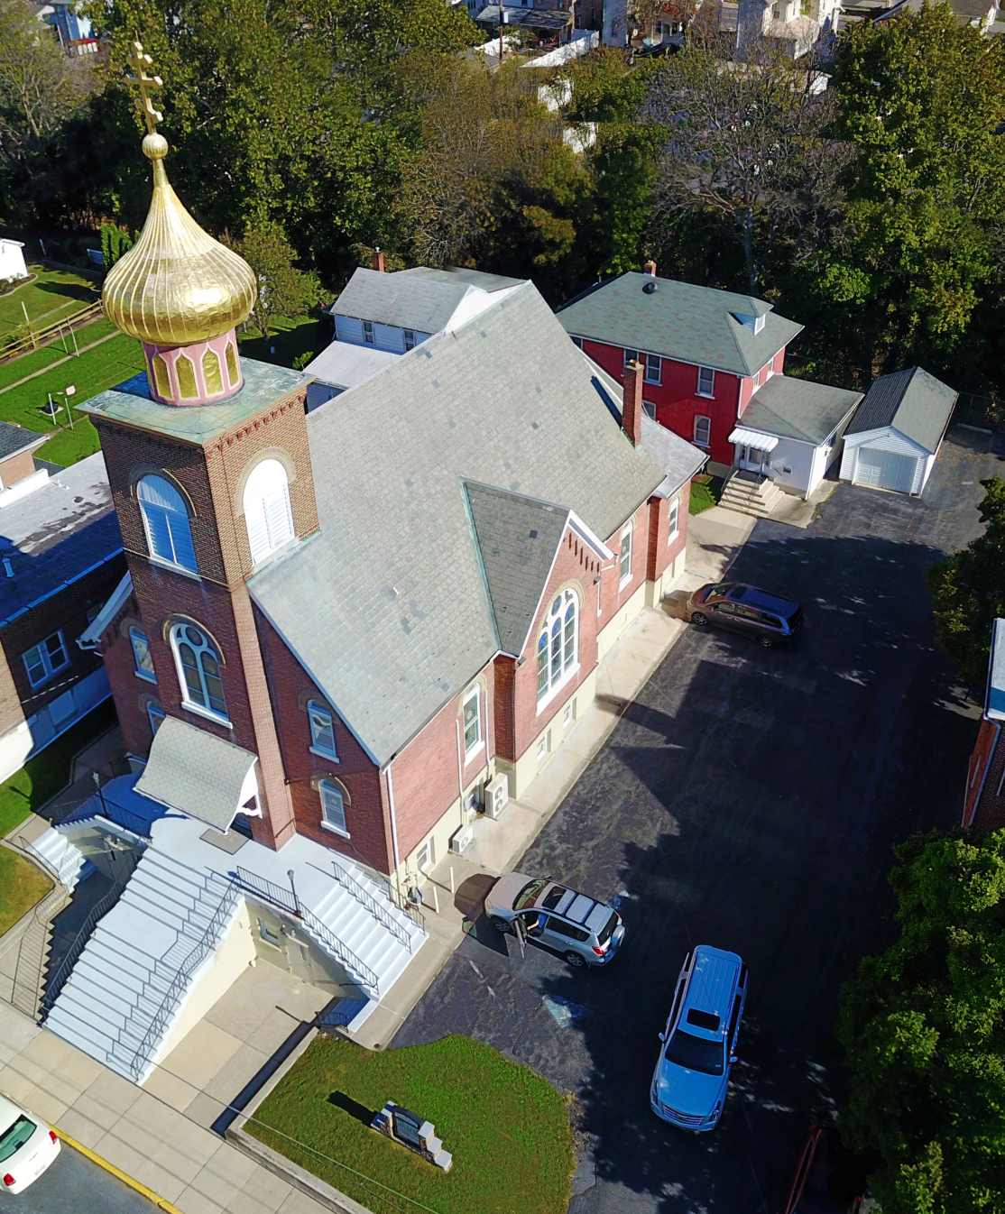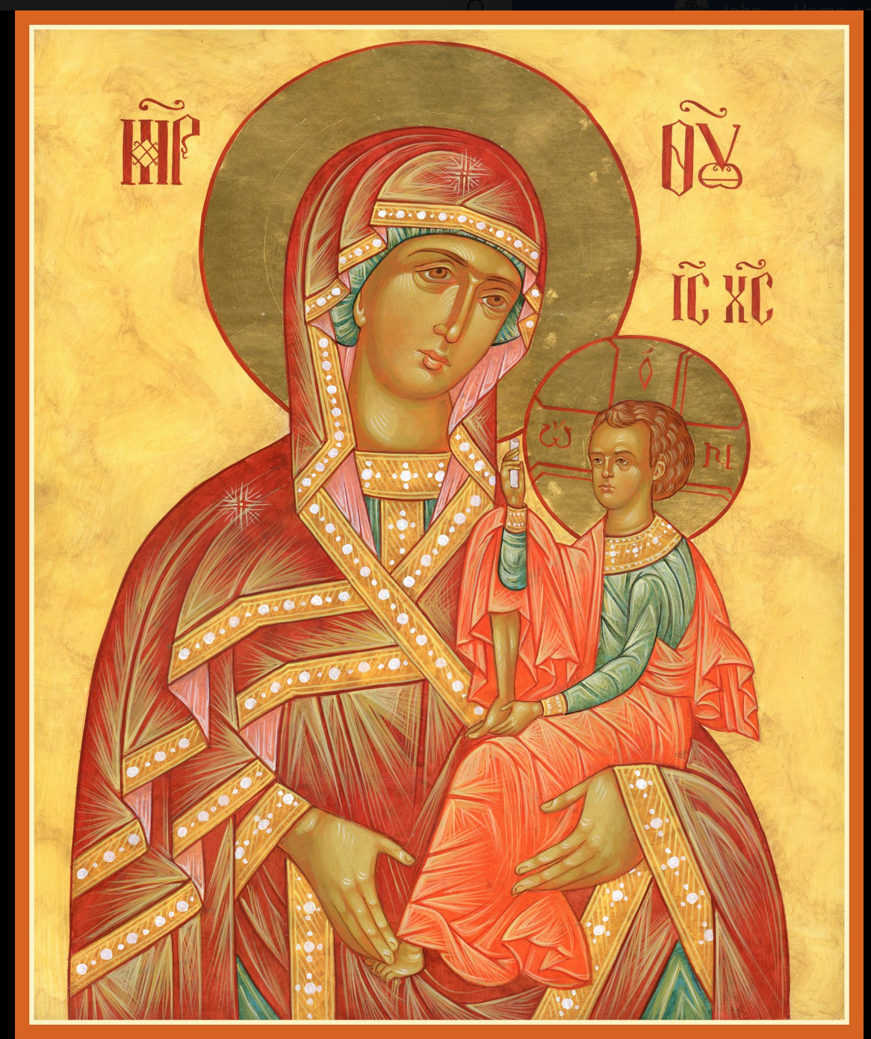

ASSUMPTION OF THE VIRGIN MARY
UKRAINIAN ORTHODOX CHURCH
ECUMENICAL PATRIARCHATE OF CONSTANTINOPLE AND NEW ROME
1301 Newport Avenue
Northampton, Pennsylvania 18067
Mitered Archpriest Myron Oryhon
Rev. Fr. Oleh Kravchenko, Attached
Protodeacon Mychail Sawarynski, Attached

Telephones: Church Office… (610) 262-2882
Church Fax/Kitchen/Hall… (610) 262-0552
Fr. Myron Oryhon – (607) 752-1999
Fr. Oleh Kravchenko (732) 507-2274
Protodeacon Mychail’s Residence… (610) 262-3876
Websites: holyassumption.org
ukrainianorthodoxchurchusa.org
lvorthodox.wordpress.com
E-mail: Parish… avmuoc@gmail.com
Protodeacon Mychail…pravoslavni@rcn.com
Webmaster, John Hnatow… john.hnatow@gmail.com
==============================================================
11th August (29th July) 2019

Eighth Sunday after Pentecost. Tone 7. Martyr CALLINICUS of Gangra (250). Virgin-martyr SERAPHIMA of Antioch (2nd C.)

1 Corinthians 1:10-18 Matthew 14:14-22

PROPERS FOR LITURGY OF ST. JOHN CHRYSOSTOM

Tropar of the Resurrection, Tone 7
By Your Cross, You destroyed Death. To the Thief, You opened Paradise. For the Myrrh-bearers, You changed weeping into joy. Christ God, You commanded Your disciples to proclaim that You are risen, granting the world great mercy.

Tropar of the Dormition, Tone 1
In giving birth, you preserved your virginity. In falling asleep you did not forsake the world, Birth-Giver of God. You were translated to Life, Mother of Life, and through your prayers you deliver our souls from death.

Tropar to Martyr Callinicus, Tone 4
Your holy martyr Callinicus, O Lord, through his suffering has received an incorruptible crown from You our God. For having Your strength, he laid low his adversaries and shattered the powerless boldness of demons. Through his intercessions save our souls.

Kondak of the Resurrection, Tone 7
The dominion of death can no longer hold humanity captive, for Christ, descended shattering and destroying its power. Hell is bound while the prophets rejoice with one voice. The Savior has come to those in faith, saying: “Enter, you faithful, into the Resurrection.”

Glory to the Father and to the Son and to the Holy Spirit.

Kondak to Martyr Callinicus, Tone 2
You worthily inherited joy on high, Callinicus, for aflame with love for Christ you bravely endured the fire. As you stand before Him, never cease to intercede for us all.

Now and ever and unto ages of ages. Amen.

Kondak of the Dormition, Tone 2
Neither the tomb nor death had power over the Birth-Giver of God; she is ever watchful in her prayers and in her intercession lies un-failing hope. For as the Mother of Life, she has been translated to life by the One Who dwelt within her ever-virginal womb.

Prokimen of the Resurrection, Tone 7
The Lord shall give strength to His people. The Lord shall bless His people with peace.

Verse: Bring to the Lord, you sons of God, bring young rams to the Lord.

Alleluia Verses in Tone 7
It is good to give thanks to the Lord, to sing praises to Your Name, O Most High.

To declare Your mercy in the morning and Your truth by night.

Communion Hymn:
Praise the Lord from the heavens, praise Him in the Highest.
Alleluia (3X)

LITURGICAL MENEION & SCRIPTURE READINGS
FOR THE NINTH WEEK AFTER PENTECOST

Mon. 12 Aug. Apostles SILAS & SILVANUS of the 70. Hiero- -
martyr POLYCHRONIUS, Bishop of Babylon (251)
1 Corinthians 11:31-12:6 Matthew 18:1-11

Tue. 13 Aug. Righteous EUDOCIMUS of Cappadocia (9th C.)
Martyr JULITTA at Caesarea (304)
1 Corinthians 12:12-26 Matthew 18:18-19:15

Wed. 14 Aug. BEGINNING OF THE DORMITION FAST.
FAST DAY PROCESSION OF THE LIFE-GIVING CROSS.
SEVEN MACCABEES & their mother SOLOMONIA. BAPTISM OF KYIVAN-RUS.
1 Corinthians 1:18-24 John 19:6-35

Thur. 15 Aug. Translation of the relics of Protomartyr STEPHEN
FAST DAY (428). Translation of the relics of Righteous
NICODEMUS, GAMALIEL, & ABIBUS (415).
1 Corinthians 14:6-19 Matthew 20:17-28

Fri. 16 Aug. Ven. ISAAC & DALMATUS(5th C.) Ven.
FAST DAY ANTHONY the Roman (1147). Ven. COSMAS
the Eunuch & Hermit of Palestine (6th C.)
1 Corinthians 14:26-40 Matthew 21:12-14, 17-20

Sat. 17 Aug. Holy Seven YOUTHS of EPHEUS (250). Martyr
FAST DAY: EUDOCIA (362). Martyr ELEUTHERIUS (4th C.)
OIL Romans 14:6-9 Matthew 15:32-39

5:00 PM GREAT VESPERS

Sun. 18 Aug. 9th Sunday after Pentecost. FOREFEAST OF
FAST DAY: THE TRANSFIGURATION. Tone 8.
OIL
8:30 AM THIRD & SIXTH HOURS
9:00 AM DIVINE LITURGY of JOHN CHRYSOSTOM
5:00 PM FESTAL VESPERS ON EVE OF THE FEAST

Bene Note: ON HOLY COMMUNION
Please be advised that according to the Canons of the Orthodox Church, the Sacrament of Holy Communion can only be administered to Orthodox Christians (Baptized & Chrismated, making them living members of the Body of Christ), One must be prepared to approach the Holy Chalice by fasting, prayer and confession.
NECROLOGY:
11 August… Alexander Mycio ’95, Dennis Kulchycki ‘86
12 August… Joseph Chorney ‘90
13 August… Katherine Panchyshyn ’26, Paul Novak ’27.
Michael Korutz ’64, Ignatij Philips ’68,
Antoinette Meashock ‘70
14 August… Mary Mazur ‘82
15 August… Wasyl Lubianecki ‘23
16 August… Evdokia Sivenky ’68, Maria Papaylo ’14,
Olga Yurechko ‘10
17 August… Havriyil Antoniuk ‘31

VICHNAYA PAMYAT! MEMORY ETERNAL

BIRTHDAYS:
12 August… Matthew Sawarynski, Danica Ost
15 August… Sandra Meashock
16 August… Gregory Misko

ANNIVERSARIES:
13 August… Oleksandr & Lesya Semanovych

MNOHAYA LITA! MANY YEARS!

WE PRAY FOR THE HEALTH AND WELL-BEING of the ill afflicted: William Savitz, Catherine Kochenash, Fr. Vasyl Dovgan, Vladimir & Emma Krasnopera, Tessie Kuchinos, Brendan Phillips, Jessie Hnatow, Jessica Meashock, Adam Hewko, Betty Hendrickson, Andrew Thaxton, Michelle Pierzga, Susan Ferretti, Carole Zarayko, William Fischer, Ekaterina Seremula, Marianna Goshow, Judy Albright, Jerome Yankowy.

SAVE THE DATE: ANNUAL CHURCH PICNIC will be held at Canal St. Park with a “PIG ROAST” catered by Fr. James Cairns on SATURDAY, SEPTEMBER 28th from 12 noon to 7 PM. Outdoor Vespers will be served beginning at 5 PM at the park.

OCMC “AGAPE CANISTER” DONATIONS were $17.00; thank
you for your generous support of our Missions around the globe.

NORTHAMPTON FOODBANK is still in need of foodstuffs, especially tuna, canned potatoes and baby food.

VOLUNTEERS for SUMMER COFFEE HOUR are needed Sign-up sheet in Hall. Coffee will be prepared. You supply the baked goods.

Please continue to save Redner’s tapes; use your Reward’s Card.”

Holy Martyr Callinicus, a native of Cilicia was raised as a child in the Christian faith in the 3rd C. He went throughout the area proclaiming Jesus Christ to the pagans. In Ancyra he was arrested and brought to trial by a fierce persecutor of Christians. He endured the cruelty of torture with patience and calm. On the way to his martyrdom, the soldiers became weak from thirst. Taking pity on them, Callinicus prayed to God and a miraculous spring gushed forth from the stones. Fear of execution compelled them to bring the martyr to Gangra where the saint offered thanks to the Lord and went into the flames giving up his soul. His body, unharmed, was buried by believers.

Over the past couple of weeks, OCMC again partnered with “PROJECT MEXICO”, the building a Home for Missions. The project was a special week of work, witness and fellowship. Volunteers shared the Orthodox faith and the responsibility of building up the Church in a cross-cultural setting. Not only were homes built, but young adults were introduced to the vocation of missions. OCMC is able to help the home-building teams and train some of their staff and summer interns and is making a significant impact in the world. Thank you for your continued and dedicated support to the OCMC.

