ASSUMPTION OF THE VIRGIN MARY UKRAINIAN ORTHODOX CHURCH
ECUMENICAL PATRIARCHATE OF CONSTANTINOPLE AND NEW ROME
1301 Newport Avenue, Northampton, Pennsylvania 18067
Rev. Fr. Oleg Kravchenko, Rector
Protodeacon Mikhail Sawarynski, Attached
Websites: holyassumption.org and ukrainianorthodoxchurchusa.org
Facebook: Assumption of the Virgin Mary Ukrainian Orthodox Church
YouTube: AVM UOC Church
Contacts:
Fr. Oleg Kravchenko - (484) 834-7261; olegkravchenko2212@gmail.com
Protodeacon Mikhail – (H) (610) 262-3876); pravoslavni@rcn.com
Office – (610) 262-2882; avmuoc@gmail.com
Webmaster, John Hnatow – john.hnatow@gmail.com

Click HERE for Prayer in Time of Corona Virus
Tune in to our news, announcements, and online Facebook Livestream Liturgies HERE!

LET’S PRAY FOR THE PEACE IN UKRAINE!

DAILY LITURGICAL CALENDAR, SCRIPTURE READINGS AND MENAION

Sun. 07 Aug. EIGHTH SUNDAY AFTER PENTECOST. TONE 7. DORMITION of RIGHTEOUS ANNA, Mother of the Virgin Mary. OLYMPIAS, the Deaconess (409). Virgin EUPRAXIA of Tabenna (413).
1 Corinthians 1:10-18 Galatians 4:22-31 Matthew 14:14-22 Luke 8:16-21

Bulletin sponsored in memory of Antoinette Meashock
by grandson Darryl Meashock.

Mon. 08 Aug. Ven. Moses the Hungarian, of the Kyiv Caves (1043).
1 Cor. 11:31–12:6 Mt. 18:1-11
Tue. 09 Aug. Holy Great-martyr and Healer Panteleimon (305).
1 Cor. 12:12-26 Mt. 18:18-22 – 19:1-2, 13-15
6:30 PM Moleben for Ukraine (Holly Protection, Allentown).
Wed. 10 Aug. Holy Apostles of the Seventy, Deacons: Prochorus, Nicanor, Timon.
1 Cor. 13:4 – 14:5 Mt. 20:1-16
Thu. 11 Aug Virgin-martyr Seraphima (Serapia) of Antioch (2nd c.).
1 Cor. 14:6-19 Mt. 20:17-28
Fri. 12 Aug. Hieromartyr Valentine, bishop of Interamna (Terni) in Italy (273).
1 Cor. 14:26-40 Mt. 21:12-14, 17-20
Sat. 13 Aug. Righteous Eudocimus of Cappadocia (9th c.). Martyr Julitta at Caesarea.
Rom. 14:6-9 Mt. 15:32-39
5:00 PM Great Vespers.
Sun. 14 Aug. 9:00 AM DIVINE LITURGY

Communion is provided to Orthodox Christians who receive It ONLY in Orthodox Churches.

For the pastoral visitation at home or hospital please contact Fr. Oleg.

PROPERS FOR THE LITURGY OF ST. JOHN CHYRSOSTOM
Tropar of the Resurrection, Tone 7. By Your Cross, You destroyed Death. To the Thief, You opened Paradise. For the Myrrh-Bearers, You changed weeping into joy. Christ God, You commanded Your disciples to proclaim that You are risen, granting the world great mercy.
Tropar to the Righteous Anna, Tone 4. Divinely-wise Anna, you carried in your womb the pure Mother of God, who gave life to our Life. Therefore, you are now carried joyfully to the inheritance of heaven, to the abode of those who rejoice in glory, where you seek forgiveness of sins for those who faithfully honor you, ever blessed
Kondak of the Resurrection, Tone 7. The dominion of death can no longer hold men captive, for Christ descended shattering and destroying its power. Hell is bound for the prophets rejoice with one voice. The Savior has come to those in faith, saying to those in faith, “Enter you faithful into the Resurrection.”
Glory... Kondak to the Righteous Anna, Tone 2. We celebrate the memory of the progenitors of Christ and with faith ask for their help, that deliverance from every affliction be granted to those who cry out: “Be with us, O God, Who in Your good pleasure glorified them.”
Now and ever… Kondak of the Dormition, Tone 2. Neither the tomb nor death had power over the Birth-Giver of God, she is ever watchful in her prayers, and in her intercession lies unfail-ing hope, for as the Mother of Life, she has been translated to Life, by the One Who dwelt within her ever virginal womb.
Prokimen of the Resurrection, Tone 7. The Lord shall give strength to His people. The Lord shall bless His people with peace.
Verse: Bring to the Lord, you sons of God, bring young rams to the Lord.
Prokimen to St. Anna, Tone 4. God is wondrous in His saints, the God of Israel.
Epistles: 1 Corinthians 1: 10-18 & Galatians 4: 22-31
Alleluia Verses, Tone 7. It is good to give thanks to the Lord, to sing praises in Your Name, O Most High.
To declare Your mercy in the morning and Your truth by night.
The salvation of the Righteous is from the Lord. He is their refuge in the time of trouble.
Gospels: Matthew 14: 14-22 & Luke 8: 16-21
Communion Hymn: Praise the Lord from the heavens, praise Him in the Highest. Rejoice in the Lord, you Righteous, praise befits the upright. Alleluia (3X).
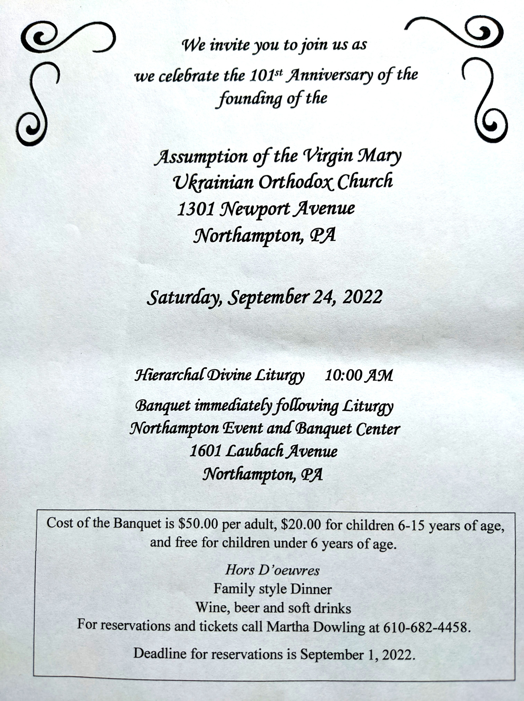
- Parish outing to the Sight and Sound Theater in Lancaster on August 18 to see the 3pm show of David. Please contact Mary Ost at maryost@rcn.com if you would like to attend. Tickets are $66 for adults. Youth are free.
-UOL meeting will be held Sunday August 14 following liturgy. One item on the agenda would be to report on the convention experience.
- There is a possibility to have a professional icon workshop in our church with an experienced iconographer. You would be able to paint your own icon of the style of our temple’s iconography! Interested?-ask Fr. Oleg.
- Welcome to contribute articles or pictures to the bulletin. Let's make bulletins together!
- Pan-Orthodox Virtual Bible Study via Zoom. Wednesdays at 12 PM. Meeting ID: 576 301 6482. Passcode: 238492. To gather in the church hall and make it on the big screen ask Fr. Oleg.
- Donations for Ukraine: medical supplies, diapers, baby food, new or gently used shoes and clothing.
- Donations for the food bank: baby foods; cans of potatoes, tuna fish, canned meats, pasta, spaghetti sauce, mac & cheese.
- SAVE THE DATE! Join us as we celebrate the 101st Anniversary of the founding of our Holy Temple. Saturday, September 24, 2022. Hierarchal Divine Liturgy (10:00 AM) and Banquet in Northampton Event and Banquet Center.
BIRTHDAYS:
09 Aug…Alexandra Ost
12 Aug… Danica Ost, Matthew Sawarynski
ANNIVERSARIES:
12 Aug…Father Oleg & Pani Ol’ha Kravchenko
13 Aug…Oleksandr & Lesya Semanovych
MANY YEARS! MNOHAYA LITA!
NECROLOGY: All Ukrainian civilians and soldiers killed in the Russian invasion.
07 Aug...Dennis Saruba ’89, Eva Pypiuk ’00, Stephania Teply ‘12
09 Aug…John Mislicky ‘62
10 Aug…Paul Smallen ‘63
11 Aug…Alexander Mycio ’45, Dennis Kulchycki ‘86
12 Aug…Joseph Chorney ’90
13 Aug…Katherine Panchyshyn ’26, Paul Novak ’27, Michael Korutz ’64 Ignatij Philips ’68, Antoinette Meashock ‘70
VICHNAYA PAMYAT! MEMORY ETERNAL!
PRAYER FOR THE HEALTH & SALVATION OF THE AFFLICTED: Ukrainian soldiers and civilians wounded during the Russian aggression, Metropolitan Antony, Helen Crayosky, Raisa Melnychuk, Vira Muzychka, Ivan, William Leszczuk, child Charlie, Angela Knoblach, James Osmun, priest Vasyl Dovgan, Rosemarie Pypiuk, Kirk Swauger, Stephanie Donnelly, Nicholas Alexander, Danny Berro, child Alexandria, Elizabeth Pastushenko, Philippe Chasseuil, Joan Molnar, Brandon and Stacy Snyder, Aaliyah Osmun, Ihor Broda, William Savitz, Vladimir Krasnopera, Brendan Phillips, Jessie Hnatow, Jessica Meashock, Adam Hewko, Andrew Thaxton, Susan Ferretti, Judy Albright, Rob Hewko, Daniel Kochenash, Christopher Mack, Norman Betrous, Tom Petro Jr., Robert Zarayko Jr., Viktoriya Yanchuk.

