ASSUMPTION OF THE VIRGIN MARY UKRAINIAN ORTHODOX CHURCH
ECUMENICAL PATRIARCHATE OF CONSTANTINOPLE AND NEW ROME
1301 Newport Avenue, Northampton, Pennsylvania 18067
Rev. Fr. Oleg Kravchenko, Rector
Protodeacon Mikhail Sawarynski, Attached
Websites: holyassumption.org and ukrainianorthodoxchurchusa.org
Facebook: Assumption of the Virgin Mary Ukrainian Orthodox Church
YouTube: AVM UOC Church
Contacts:
Fr. Oleg Kravchenko – (732) 507-2274; olegkravchenko2212@gmail.com
Protodeacon Mikhail – (H) (610) 262-3876); pravoslavni@rcn.com
Office – (610) 262-2882; avmuoc@gmail.com
Webmaster, John Hnatow – john.hnatow@gmail.com

Click HERE for Prayer in Time of Corona Virus
As of this date, the following changes will be in effect:
- We no longer have to preregister for Liturgy attendance.
- ATTENTION - ATTENTION! Today, July 30, 2021, our hierarchs Metropolitan Antony and Archbishop Daniel posted a message titled: "Metrics Associated With the Covid-19 Pandemic and the Necessity of Responsible and Measured Means to Combat Them" The most important takeaway is in this text - “THE MOST OBVIOUS RESPONSE THAT WE ARE NOW CALLING YOU ALL TO IS TO RETURN, AS PER THE INSTRUCTIONS FROM THE CENTER FOR DISEASE CONTROL, TO THE WEARING OF MASKS DURING ANY LITURGICAL SERVICES OR IN ANY PARISH COMMUNITY ACTIVITIES.” (The post in entirety can be found by searching for Daniel Zelinsky on Facebook.)
Tune in to our news, announcements, and online Facebook Livestream Liturgies HERE!

Sun. 01 Aug. SIXTH SUNDAY AFTER PENTECOST. Tone 5. FATHERS OF THE FIRST SIX ECUMENICAL COUNCILS. Ven. MACRINA, sister of Basil the Great (380). Ven. DIUS, Abbot of Antioch. Ven. PAISIUS of the Kyiv Caves (14th C.)
Epistles: Romans 12: 6-14 & Hebrews 13: 7-16
Gospels: Matthew 9: 1-8 & John 17: 1-13
5:00 PM Great Vespers.

Mon. 02 Aug. Holy Glorious Prophet Elias (Elijah) (9th c. B.C.).
Jas. 5:10-20 Lk. 4:22-30
Tue. 03 Aug. Prophet Ezekiel (6th c. B.C.). St. Symeon of Emesa, fool-for-Christ.
1 Cor. 6:20 – 7:12 Mt. 14:1-13
Wed. 04 Aug. Holy Myrrh-bearer and Equal-to-the-Apostles Mary Magdalen (1st c.).
1 Cor. 7:12-24 Mt. 14:35 – 15:11
Thu. 05 Aug. “Pochaiv” (1675) Icon of the Mother of God.
1 Cor. 7:24-35 Mt. 15:12-21
Fri. 06 Aug. Holy Martyrs and Passion-bearers Borys and Hlib (1015).
1 Cor. 7:35–8:7 Mt. 15:29-31
Sat. 07 Aug. The Dormition of the Righteous Anna, mother of the Most Holy Theotokos.
Rom. 12:1-3 Mt. 10:37–11:1
5:00 PM Great Vespers. EXAMINATION OF CONSCIENCE & GENERAL CONFESSION
Sun. 08 Aug. 9:00 AM Divine Liturgy.
If anyone would ask you what you get when you squeeze an orange, more likely than not your answer should be, “Orange juice”. Scientists, however, are a bit more objective, and such an individual would give a more specific answer, “Whatever is inside is what comes out”.
The same type of question can also be applied to ourselves, that is, what comes out when we are squeezed or pressed? Whatever is inside us at the time is what comes out. If it’s anger, if it’s bitterness, if it’s hatred, it will spill out under pressure.
When Jesus was pressed on the Cross by His enemies, what was inside of Him came out: forgiveness. “Father,” He said, “forgive them for they do not know what they are doing.”
It is the same with us. When life squeezes us, what is inside emerges. Most of us can be quite pleasant when things are going well; it is when we are squeezed that the test comes.
If Jesus lives inside you, His love will spill out when someone jostles you. If the Holy Spirit abides in you, the fruits of that Spirit will spill out when left becomes oppressive: “love, joy, peace, patience, kindness, goodness, faithfulness, gentleness and self-control” (Gal. 5:22-23).

Jesus And Forgiveness
Jesus not only taught frequently about forgiveness, he also demonstrated his willingness to forgive. Here are several examples to remind us that he wants to forgive us also.
Jesus forgave... Reference
the paralytic lowered on a mat through the roof Matthew 9:2-8
the woman caught in adultery John 8:3-11
the woman who anointed his feet with oil Luke 7:47-50
Peter, for denying he knew Jesus John 18:15-18, 25-27; 21:15-19
the criminal on the cross Luke 23:39-43
the people who crucified him Luke 23:34

List of the Seven Ecumenical Councils
Today we commemorate Fathers of the first Six Ecumenical Councils.
- First Council of Nicea, (325); repudiated Arianism, adopted the Nicene Creed.
- First Council of Constantinople, (381); revised the Nicene Creed into the present form used in the Eastern and Oriental Orthodox churches.
- Council of Ephesus, (431); repudiated Nestorianism, proclaimed the Virgin Mary as the Mother of God.
- Council of Chalcedon, (451); repudiated the Eutychian doctrine of Monophysitism, described and delineated the two natures of Christ, human and divine; adopted the Chalcedonian Creed.
- Second Council of Constantinople, (553); reaffirmed decisions and doctrines explicated by previous Councils, condemned new Arian, Nestorian, and Monophysite writings.
- Third Council of Constantinople, (680-681); repudiated Monothelitism, affirmed that Christ had both human and Divine wills. Quinisext/Penthekte Council (= Fifth and Sixth) or Council in Trullo, (692); mostly an administrative council that raised some local canons to ecumenical status and established principles of clerical discipline. It is not considered to be a full-fledged council in its own right because it did not determine matters of doctrine. This council is accepted by the Orthodox Church as a part of the Sixth Ecumenical Council.
Second Council of Nicea, (787); restoration of the veneration of icons and end of the first iconoclasm.

PROPERS FOR THE LITURGY ST. JOHN CHRYSOSTOM
Tropar of the Resurrection, Tone 5
Let us, the faithful, praise and worship the Word, co-eternal with the Father and the Spirit, born for our salvation of the Virgin. In His Good Will He was lifted up on the Cross in the flesh to suffer death and to raise the dead, by His glorious Resurrection.
Tropar of the Dormition, Tone 1
In giving birth, you preserved your virginity. In falling asleep, you did not forsake the world, Birth-Giver of God. You were translated to Life, Mother of Life and through your prayers you deliver our souls from death.
Tropar to the Holy Fathers, Tone 8
You are most glorious, Christ our God. You have established the Holy Fathers as lights on the earth. Through them You have guided us to the True Faith. O greatly Compassionate One, glory to You.
Kondak of the Resurrection, Tone 5
You descended into Hell, my Savior, destroying the gates as the Almighty, resurrecting the dead as Creator and destroying the sting of death. You have delivered Adam from the curse, Lover of all Mankind. Therefore, we all cry out to You: Lord, save us.
Glory to the Father and to the Son and to the Holy Spirit.
Kondak to the Holy Fathers, Tone 8
The preaching of the Apostles and doctrines of the Fathers have confirmed one faith for the Church, adorned with the Robe of Truth, woven from heavenly theology. Great is the mystery of piety, which it defines and glorifies.

Now and ever and to the ages of ages. Amen.
Kondak of the Dormition of the Mother of God, Tone 2
Neither the tomb nor death had power over the Birth-Giver of God; she is ever watchful in her prayers and in her intercession lies unfailing hope. For as the Mother of Life, she has been translated to life by the One Who dwelt within her ever-virginal womb.
Prokimen of the Resurrection, Tone 5
You, O Lord, shall protect us and preserve us from this generation forever.
Verse: O Lord, save me for there is no longer any righteous man.
Prokimen for the Holy Fathers, Tone 4
Blessed are You, Lord God of our Fathers, praised and glorified is Your Name to the ages.
Epistles: Romans 12: 6-14 & Hebrews 13: 7-16
Alleluia Verses, Tone 5
Of Your mercies, O Lord, I will sing forever; unto generation and generation I will proclaim Your truth with my mouth.
You have said: Mercy will be established forever and My truth will be prepared in the heavens.
The Lord, the God of gods, has spoken and summoned the earth from east to west.
Gospels: Matthew 9: 1-8 & John 17: 1-13
Communion Hymn: Praise the Lord from the heavens, praise Him in the highest. Rejoice in the Lord, you Righteous, praise befits the upright. Alleluia (3X).

Donations in Memory of Catherine Kochenash: Deacon Mikhail & Pani Martha Sawarynski - $50.00, Howard & Linda Winters - $100.00. Thank you!
Our neighbors Queenship of Mary RCC has its festival Sunday, August 8, from 11:30 to 7:00 PM.
If you would like to volunteer the preparation of coffee hours, please put your name to the list. It will be great service to our parish family!
SR UOL will be holding a picnic on Saturday, Sept. 25th at Canal Street Park to kick off the parish’s 100th anniversary celebration. Mark your calendars.
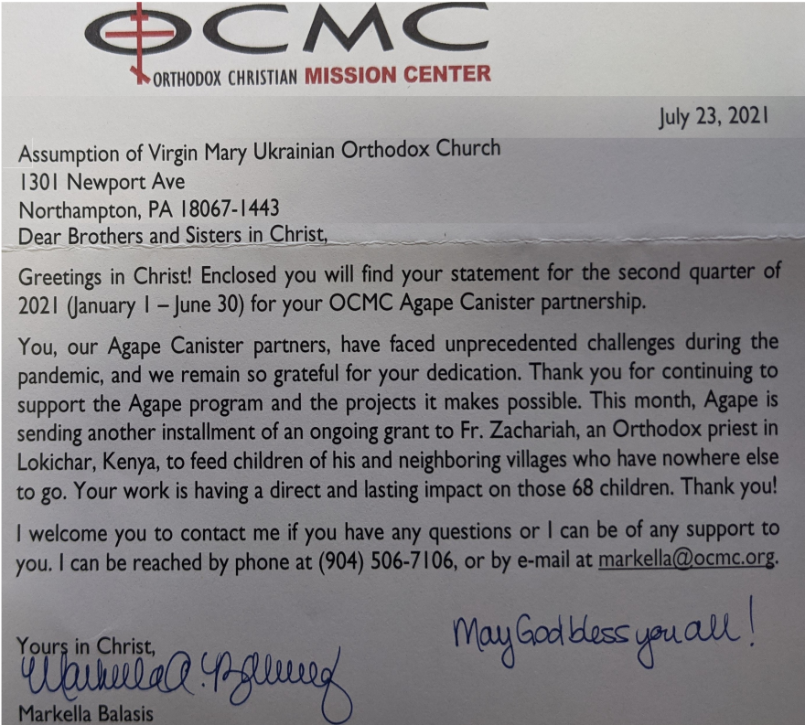
For the food banks: We were assigned baby foods, but they also need cans of potatoes, tuna fish, canned meats, pasta, spaghetti sauce, mac & cheese.
BIRTHDAYS:
02 Aug…Margaret Leindecker
06 Aug…Zachary Phillips
MNOHAYA LITA!
MANY YEARS!
NECROLOGY:
01 Aug…Metro Bodnyk ‘98
02 Aug…Fanny Pritko ‘45
03 Aug…Peter Pokotello ’03
05 Aug…Theodore Stashitsky
’46, Cathryn Fedorishen ’11
07 Aug…Dennis Saruba ’89,
Eva Pypiuk ’00, Stephania Teply ‘12
VICHNAYA PAMYAT! MEMORY ETERNAL!
PRAYER FOR THE HEALTH & SALVATION OF THE AFFLICTED: Stephanie, Rosemary, Steve Sivulich, child Oleksandra, child Alexandria, Elizabeth, Daria, Catherine Kochenash, Joan Molnar, Bill Ketterer, Paul, Evan, Brandon and Stacy Snyder, Aaliyah Osmun, Michael Mack, Ihor Broda, James Osmun, Matthew, Tom, William Savitz, Vladimir & Emma Krasnopera, Brendan Phillips, Jessie Hnatow, Jessica Meashock, Adam Hewko, Andrew Thaxton, Susan Ferretti, Judy Albright, Rob Hewko, Daniel Kochenash, Christopher Mack, Norman Betrous, Luba Walker.
On July 28, the Day of Remembrance of Saint Volodymyr of Kyiv, Ukraine celebrated the 1033rd anniversary of the Baptism of Kyivan Rus’, the stage at which Grand Prince Volodymyr declared Orthodox Christianity the official religion of the land.
Nestor the Chronicler’s The Tale of Bygone Years provides the only confirmation of St. Volodymyr’s baptism and grounds the most broadly accepted account of the event. According to this account, Prince Volodymyr experienced a moral crisis over his continuation of paganism, pushing him to conduct an evaluation of sorts to determine which of the different faiths of the time he and his people should profess. He dispatched envoys to hubs of the major religions—different branches of Christianity, Islam, Judaism—and studied the workings of each one. After examining the religions, capturing the territory of present-day Sevastopol, and deciding to marry Anna of Orthodox Byzantium, Prince Volodymyr and his warriors converted and were baptized.
Prophet Elias of great fame was from Thisbe or Thesbe, a town of Galaad (Gilead), beyond the Jordan. He was of priestly lineage, a man of a solitary and ascetical character, clothed in a mantle of sheep skin, and girded about his loins with a leathern belt. His name is interpreted as "Yah is my God." His zeal for the glory of God was compared to fire, and his speech for teaching and rebuke was likened unto a burning lamp. From this too he received the name Zealot. Therefore, set aflame with such zeal, he sternly reproved the impiety and lawlessness of Ahab and his wife Jezebel. He shut up heaven by means of prayer, and it did not rain for three years and six months. Ravens brought him food for his need when, at God's command, he was hiding by the torrent of Horrath. He multiplied the little flour and oil of the poor widow of Sarephtha of Sidon, who had given him hospitality in her home, and when her son died, he raised him up. He brought down fire from Heaven upon Mount Carmel, and it burned up the sacrifice offered to God before all the people of Israel, that they might know the truth. At the torrent of Kisson, he slew 450 false prophets and priests who worshipped idols and led the people astray. He received food wondrously at the hand of an Angel, and being strengthened by this food he walked for forty days and forty nights. He beheld God on Mount Horeb, as far as this is possible for human nature. He foretold the destruction of the house of Ahab, and the death of his son Ohozias; and as for the two captains of fifty that were sent by the king, he burned them for their punishment, bringing fire down from Heaven. He divided the flow of the Jordan, and he and his disciple Elisseus passed through as it were on dry land; and finally, while speaking with him, Elias was suddenly snatched away by a fiery chariot in the year 895 B.C., and he ascended as though into heaven, whither God most certainly translated him alive, as He did Enoch (Gen. 5:24; IV Kings 2: 11). But from thence also, after seven years, by means of an epistle he reproached Joram, the son of Josaphat, as it is written: "And there came a message in writing to him from Elias the Prophet, saying, Thus saith the Lord God of David thy father, Because thou hast not walked in the way," and so forth (II Chron. 21:12). According to the opinion of the majority of the interpreters, this came to pass either through his disciple Elisseus, or through another Prophet when Elias appeared to them, even as he appeared on Mount Tabor to the disciples of Christ.

