JULY 28, 2019

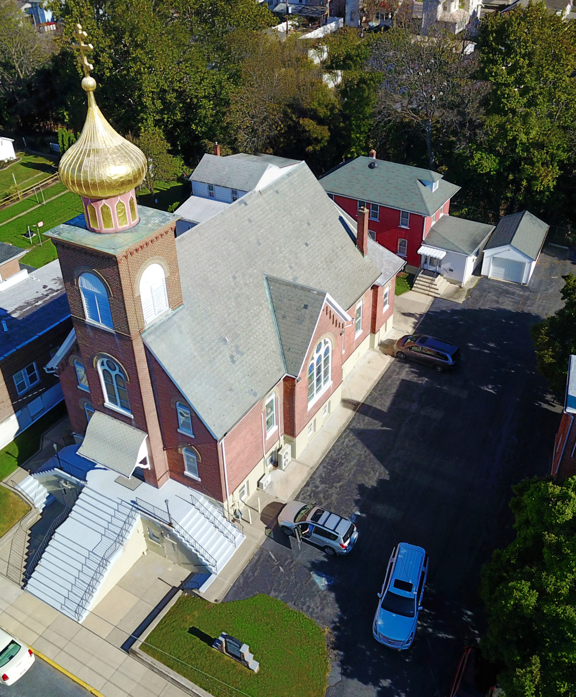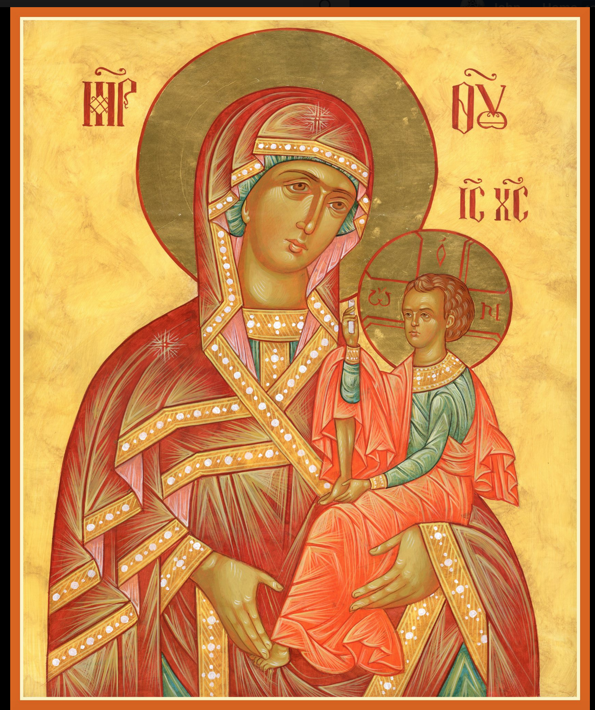

ASSUMPTION OF THE VIRGIN MARY
UKRAINIAN ORTHODOX CHURCH
ECUMENICAL PATRIARCHATE OF CONSTANTINOPLE AND NEW ROME
1301 Newport Avenue
Northampton, Pennsylvania 18067
Mitered Archpriest Myron Oryhon
Rev. Fr. Oleh Kravchenko, Attached
Protodeacon Mychail Sawarynski, Attached

Telephones: Church Office… (610) 262-2882
Church Fax/Kitchen/Hall… (610) 262-0552
Fr. Myron Oryhon – (607) 752-1999
Protodeacon Mychail’s Residence… (610) 262-3876
Websites: holyassumption.org
ukrainianorthodoxchurchusa.org
lvorthodox.wordpress.com
E-mail: Parish… avmuoc@gmail.com
Protodeacon Mychail…pravoslavni@rcn.com
Webmaster, John Hnatow… john.hnatow@gmail.com
==============================================================
28th July (15th July) 2019

Sixth Sunday after Pentecost. Tone 5. HOLY FATHERS of the FIRST SIX COUNCILS. Equal to the Apostles, VOLODYMYR,
Great Prince of Kyiv and Enlightener of Ukraine (1015).
Romans 12: 6-14 Matthew 9: 1-8
Galatians 1:11-19 John 10:1-9

PROPERS FOR LITURGY OF ST. JOHN CHRYSOSTOM

Tropar of the Resurrection, Tone 5
Let us the faithful, praise and worship the Word, co-eternal with the Father and the Spirit, born for our salvation of the Virgin. In His Good Will He was lifted up on the Cross in the flesh to suffer death and to raise the dead by His glorious Resurrection.

Tropar of the Dormition, Tone 1
In giving birth, you preserved your virginity. In falling asleep you did not forsake the world, Birth-Giver of God. You were translated to Life, Mother of Life, and through your prayers you deliver our souls from death.

Tropar to the Holy Fathers of the Six Councils, Tone 8
You are most glorious, O Christ our God. You have established the Holy Fathers as lights on the earth. Through them You have guided us to the True Faith. O greatly Compassionate One, glory to You.

Tropar to St. Volodymyr, Tone 4
O glorious Prince Volodymyr, seated on the throne of God protected Kyiv, you searched for the truth and discovered in Constantinople the Orthodox Faith and the priceless pearl, Christ our God, Who chose you as the second Paul, whose example you have followed by being baptized and enlightened both spiritually and physically. Wherefore, we celebrate your festival and entreat you to pray for the salvation of the Ukrainian people.

Kondak of the Resurrection, Tone 5
You descended into Hell, my Savior, destroying its gates as the Al-mighty, resurrecting the dead as Creator and destroying the sting of death. You have delivered Adam from the curse, Lover of all Man-kind. Therefore, we all cry out You: “Lord save us.”

Kondak to the Holy Fathers, Tone 8
The preaching of the Apostles and the doctrines of the Fathers have confirmed one faith for the Church, adorned with the Robe of Truth woven from heavenly theology. Great is the mystery of piety which it defines and glorifies.

Glory to the Father and to the Son and to the Holy Spirit.

Kondak to St. Volodymyr, Tone 8
Emulating the great Apostle Paul in your maturity, most glorious Volodymyr and putting aside all your zeal for idols as childish thoughts, you have adorned yourself with the royal purple robe of divine baptism. And standing now in gladness before Christ the Savior, pray that your land, Ukraine, be saved and that peace and great mercy be granted to the Orthodox people.

Now and ever and unto ages of ages. Amen.

Kondak of the Dormition, Tone 2
Neither the tomb nor death had power over the Birth-Giver of God; she is ever watchful in her prayers and in her intercession lies un-failing hope. For as the Mother of Life, she has been translated to life by the One Who dwelt within her ever-virginal womb.

Prokimen of the Holy Fathers, Tone 4
Blessed are You, Lord God of our Fathers; praised and glorified is Your Name to the ages.

Prokimen to St. Volodymyr, Tone 3
Sing praises to our God, sing praises. Sing praises to our King, sing praises.

Verse: Clap your hands all you peoples, shout to God with a joyful voice.

Alleluia Verses in Tone 1
The Lord, the God of gods, has spoken and summoned the earth from east to west.

I have raised up one chosen out of my people.

For my hand is an ally to him and My strength fortifies him.

Communion Hymn:
Praise the Lord from the heavens, praise Him in the Highest.

The Righteous shall be in everlasting remembrance. They shall not be afraid of any evil report. Alleluia (3X)

LITURGICAL MENEION & SCRIPTURE READINGS
FOR THE SEVENTH WEEK AFTER PENTECOST

Mon. 29 July Hieromartyr ATHENOGENES, Bishop of Hercleo-
polis and his disciples. Martyrs PAUL & his sisters
CHIONIA & ALEVTINA. Virgin-martyr JULIA.
1 Corinthians 5:9-6:11 Matthew 13:54-58

Tue. 30 July Great Martyr MARGARET of Antioch (4th C.)
1 Corinthians 6:20-7:12 Matthew 14:1-13

Wed. 31 July Martyr EMILIAN in Bulgaria (363) Martyr
FAST DAY HYACINTH of Amastris. Ven. PAMBO of Egypt.
1 Corinthians 7:12-24 Matthew 14:35-15:11

Thur. 01 Aug. Ven. MACRINA (380). Ven. DIUS, Abbot of
Antioch. Ven. PAISIUS of the Kyiv Caves (14th C.)
1 Corinthians 7:24-35 Matthew 15:12-21

Fri. 02 Aug. Glorious Prophet ELIJAH (9th C. BC) Uncovering
FAST DAY the relics of ATHANASIUS, Abbot of Brest (1649)
OIL 1 Corinthians 7;35-8:7 Matthew 15:29-31

Sat. 03 Aug. Prophet EZEKIEL (6th C. BC). SYMEON of Emesa
Fool for Christ (590) & fellow faster JOHN.
Romans 12:1-3 Matthew 10:37-11:1

5:00 PM GREAT VESPERS

Sun. 04 Aug. 7th Sunday after Pentecost. Myrrh-bearer and Equal to the Apostles MARY MAGDALENE. Tone 4.

8:30 AM THIRD & SIXTH HOURS
9:00 AM DIVINE LITURGY of JOHN CHRYSOSTOM

NECROLOGY:
28 July… Volodymyr Zherebecky ’27, Stephen Yaremchuk ‘96
29 July… John Zadubera ’48, Volodymyr Karpenko ‘01
30 July… Ilia Kubalo ’31, Agrippina Radchuk ‘68
31 July… Alex Kereb ’87, Kathryn Sawka ’04,
Andrij Haschenko ‘96
01 Aug… Metro Bodnyk ‘98
02 Aug… Fanny Pritko ‘45
03 Aug… Peter Pokotello ‘03

VICHNAYA PAMYAT! MEMORY ETERNAL

BIRTHDAYS:
30 July… Rosemarie Pypiuk
02 Aug… Margaret Leindecker

ANNIVERSARIES:
30 July… Michael & Martha Misko

MNOHAYA LITA! MANY YEARS!

WE PRAY FOR THE HEALTH AND WELL-BEING of the ill afflicted: Pani Ol’ha Kravchenko and the child she is bearing, William Savitz, Catherine Kochenash, Fr. Vasyl Dovgan, Vladimir & Emma Krasnopera, Tessie Kuchinos, Brendan Phillips, Jessie Hnatow, Jessica Meashock, Wasyl Hewko, Adam Hewko, Betty Hendrickson, Andrew Thaxton, Michelle Pierzga, Susan Ferretti, Carole Zarayko, William Fischer, Ekaterina Seremula, Marianna Goshow, Judy Albright, Jerome Yankowy.

SAVE THE DATE: ANNUAL CHURCH PICNIC will held at Canal St. Park with a “PIG ROAST” catered by Fr. James Cairns on SATURDAY, SEPTEMBER 28th from 12 noon to 7 PM. Outdoor Vespers will be served beginning at 5 PM at the park.

OCMC “AGAPE CANISTER” DONATIONS were $.00; thank
you for your support of our Missions around the globe.

NORTHAMPTON FOODBANK is still in need of foodstuffs, especially tuna, canned potatoes and baby food.

VOLUNTEERS for SUMMER COFFEE HOUR are needed Sign-up sheet in Hall. Coffee will be prepared. You supply the baked goods.

Please continue to save Redner’s tapes; use your Reward’s Card.”

HOLY EQUAL TO THE APOSTLES VOLODYMYR

Today we honor Great Prince Saint Volodymyr, Equal to the Apostles and Enlightener of the Ukrainian Nation. He became sole ruler of Kyivan-Rus in 955, Even though his grandmother, Ol’ha had been baptized into the Orthodox Faith. Searching for the
True Faith his emissaries from Constantinople reported that, “we did not know whether we were in heaven or an earth.” Following his baptism, he ordered his subjects to the Dnipro River and on August 1, 988, they were baptized by Orthodox bishops and priests. His entire life and morals were changed. Churches. He died in 1015.

