ASSUMPTION OF THE VIRGIN MARY UKRAINIAN ORTHODOX CHURCH
ECUMENICAL PATRIARCHATE OF CONSTANTINOPLE AND NEW ROME
1301 Newport Avenue, Northampton, Pennsylvania 18067
Rev. Fr. Oleg Kravchenko, Rector
Protodeacon Mikhail Sawarynski, Attached
Websites: holyassumption.org and ukrainianorthodoxchurchusa.org
Facebook: Assumption of the Virgin Mary Ukrainian Orthodox Church
YouTube: AVM UOC Church
Contacts:
Fr. Oleg Kravchenko - (484) 834-7261; olegkravchenko2212@gmail.com
Protodeacon Mikhail – (H) (610) 262-3876); pravoslavni@rcn.com
Office – (610) 262-2882; avmuoc@gmail.com
Webmaster, John Hnatow – john.hnatow@gmail.com

Click HERE for Prayer in Time of Corona Virus
Tune in to our news, announcements, and online Facebook Livestream Liturgies HERE!

LET’S PRAY FOR THE PEACE IN UKRAINE!

Sun. 17 July 5th Sunday after Pentecost. Tone 4. St. Andrew, archbishop of Crete (712-726). Ven. Martha, mother of St. Symeon Stylites the Younger (551). Martyrs Theodotus and Theodota (108). Hieromartyr Theodore, bishop of Cyrene (310).
Rom. 10:1-10 Mt. 8:28 – 9:1
- We are grateful to Father Vasyl for coming and serving today!
- Today’s bulletin is sponsored by the Ost Family in loving memory of Mary Lee Leszczuk

Christ is among us! He is and always shall be!
Христос посеред нас! Є і Буде!

Liturgical Meneion & Scripture Readings
Mon. 18 July Ven. Athanasius of Mt. Athos (1000). Martyr Anna at Rome (304).
Rom. 16:17-24 Mt. 13:10-23
Tue. 19 July Ven. Sisoes the Great. Martyrs Marinus & Martha & children.
1 Cor. 1:1–9 Mt. 13:24-30
6:30 PM Moleben for Ukraine (St. John the Baptist UCC, Northampton).
Wed. 20 July Ven. Thomas of Mt. Maleon (10th c.). Ven. Acacius of Sinai (6th c.).
1 Cor. 2:9–3:8 Mt. 13:31-36
Thu. 21 July Holy Great-martyr Procopius of Caesarea in Palestine (303).
1 Cor. 3:18-23 Mt. 13:36-43
Fri. 22 July Hieromartyr Pancratius of Sicily. Hieromartyr Cyril of Gortyna.
1 Cor. 4:5-8 Mt. 13:44-54
Sat. 23 July 5 Martyrs of Nicopois, Armenia. Martyr Apollonius of Sardis.
Rom. 9:1-5 Mt. 9:18-26
5:00 PM Great Vespers.
Sun. 24 July 6th Sunday after Pentecost. Tone 5. Princess Ol’ha of Kyiv.
9:00 AM Divine Liturgy

- We are grateful to Father Vasyl for coming and serving today!

Communion is provided to Orthodox Christians who receive It ONLY in Orthodox Churches.

For the pastoral visitation at home or hospital please contact Fr. Oleg.

PROPERS FOR THE LITURGY OF ST. JOHN CHYRSOSTOM
Tropar of the Resurrection, Tone 4. When the women disciples of the Lord learned from the angel the joyous message of Your Resurrection, they cast away the ancestral curse and with gladness told the Apostles: death is overthrown, Christ God is risen, granting the world great mercy.

Tropar of the Dormition of the Mother of God, Tone 1. In giving birth, you preserved your virginity. In falling asleep you did not forsake the world, Birth-Giver of God. You were translated to Life, Mother of Life, and through your prayers you deliver our souls from death.

Tropar to Andrew of Crete, Tone 5. Emulating David, you sang a new song in the assembly of the righteous. As an initiate of the Holy Spirit, you guided us with hymns of grace and the word of righteousness for our salvation, O Andrew, glory of the Fathers.

Kondak of the Resurrection, Tone 4. My Savior and Redeemer, as God arose from the tomb, and delivered the earthborn from bondage. He has shattered the gates of Hell and as Master, He has risen on the third day.

Glory… Kondak to Andrew of Crete, Tone 2. Trumpeting forth divine melodies, you were shone as a far-shining luminary for the world. You shone forth with radiant light of the Trinity, O Venerable Andrew. Therefore, we all cry to you: “Do not cease to intercede fpr us all.”

Now and ever… Kondak of the Dormition, Tone 2. Neither the tomb nor death had power over the Birth-Giver of God, she is ever watchful in her prayers, and in her intercession lies unfailing hope, for as the Mother of Life, she has been translated to Life, by the One Who dwelt within her ever virginal womb.

Prokimen of the Resurrection, Tone 4. How marvelous are Your works, O Lord. In wisdom, You have made them all..

Verse: Bless the Lord, my soul. O Lord my God, You ware very great..

Alleluia, Tone 4. Bend Your bow and proceed prosperously, and reign because of truth, meekness and righteousness..

Verse: You have loved righteousness and hated iniquity.

Communion Hymn: Praise the Lord from the heavens, praise Him in the Highest. Alleluia (3X).

- Fr. Oleg will be away with his family in Europe. In case of a pastoral emergency please call Fr. Richard (St. Mary Protection, Allentown) on his mobile phone 201-240-5888.
- Next Saturday Great Vespers – July 23.
- Please sign up for the Coffee Hours. Thank you.
- Our Senior Chapter of the UOL will be sponsoring a YARD/GARAGE SALE in August! Start searching for items that you are willing to donate. All proceeds will benefit our UOL Chapter. Any unsold items will be returned to the donor. Our UOL Chapter assists our Parish by sponsoring activities and events as well as contributing financial assistance. Stay tuned for further details!
- Pan-Orthodox Virtual Bible Study via Zoom. Wednesdays at 12 PM. Meeting ID: 576 301 6482. Passcode: 238492. For questions, text: johnharbilas@gmail.com. It’s possible to gather in church hall and make it on the big screen. If interested-tell Fr. Oleg.

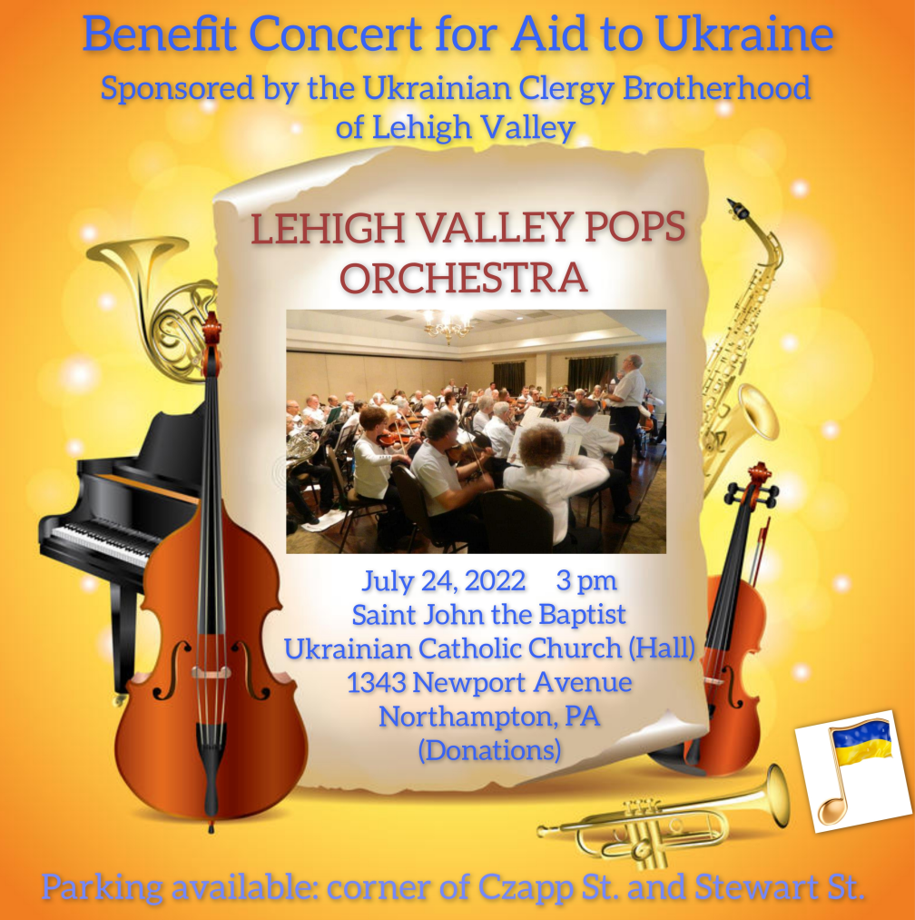
- Lehigh Valley POPS Orchestra – Benefit Concert for Aid to Ukraine sponsored by the Ukrainian Clergy Brotherhood of Lehigh Valley. July 24, 3 PM. Saint John the Baptist Ukrainian Catholic Church Hall, Northampton. Entrance free (donations).- Donations for Ukraine: medical supplies, diapers, baby food, new or gently used shoes and clothing.
- Donations for the food bank: baby foods; cans of potatoes, tuna fish, canned meats, pasta, spaghetti sauce, mac & cheese.
- SAVE THE DATE! Join us as we celebrate the 101st Anniversary of the founding of our Holy Temple. Saturday, September 24, 2022. Hierarchal Divine Liturgy (10:00 AM) and Banquet in Northampton Event and Banquet Center.

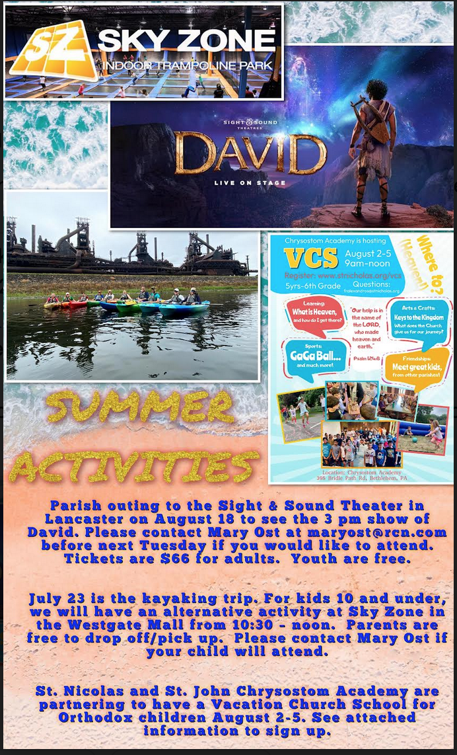

- St. Nicholas and St. John Chrysostom Academy are partnering to have a Vacation Church School for Orthodox children August 2-5. See flyer for sign up information.

-There will be a Parish outing to the Sight & Sound Theater in Lancaster on August 18 to see the 3 pm show of David. Please contact Mary Ost at maryost@rcn.com before next Tuesday if you would like to attend. Tickets are $66 for adults. Youth are free.
- Reminder that July 23 is the kayaking trip. For kids 10 and under, we will have an alternative activity at Sky Zone in the Westgate Mall from 10:30 –noon. Parents are free to drop off/pick up. Please contact Mary Ost if your child will attend.

PRAYER FOR THE HEALTH & SALVATION OF THE AFFLICTED: Ukrainian soldiers and civilians wounded during the Russian aggression, , Helen Crayosky, , Ivan, William Leszczuk, Angela Knoblach, James Osmun, priest Vasyl Dovgan, Kirk Swauger, Stephanie Donnelly, Danny Berro, child Alexandria, Elizabeth Pastushenko, Philippe Chasseuil, Joan Molnar, Brandon and Stacy Snyder, Aaliyah Osmun, Ihor Broda, William Savitz, Vladimir Krasnopera, Jessie Hnatow, Jessica Meashock, Adam Hewko, Andrew Thaxton, Susan Ferretti, Judy Albright, Rob Hewko, Daniel Kochenash, Christopher Mack, Norman Betrous, Tom Petro Jr., Linda Schantz, Michael Lado, Robert Zarayko Jr., Viktoriya Yanchuk.

BIRTHDAYS:
17 July…Mary Ann Dworakivsky
18 July…Brendan Phillips
19 July…Elizabeth Kravchenko
20 July…William Hantz, Anthony Sawarynski

ANNIVERSARIES:
18 July…Matthew & Andrea Sawarynski
MANY YEARS! MNOHAYA LITA!
NECROLOGY: All Ukrainian civilians and soldiers killed in the Russian invasion.
17 July…Justine Czepelak ‘50
18 July…Rosalia Chudyk ’47, Mykola Martyniuk ‘92
19 July…Mary Nieves ’94
20 July…Michael Karypenko ’57, Mary Huryn ’72, Ann Haas ’14
21 July…Bohdan Kowalyshyn (infant) ’38
22 July…Michael Smallen Sr. ’95
23 July…Stephen Hewko ’84, Katherine Bodnyk ’95
VICHNAYA PAMYAT! MEMORY ETERNAL!

