JULY 07, 2019

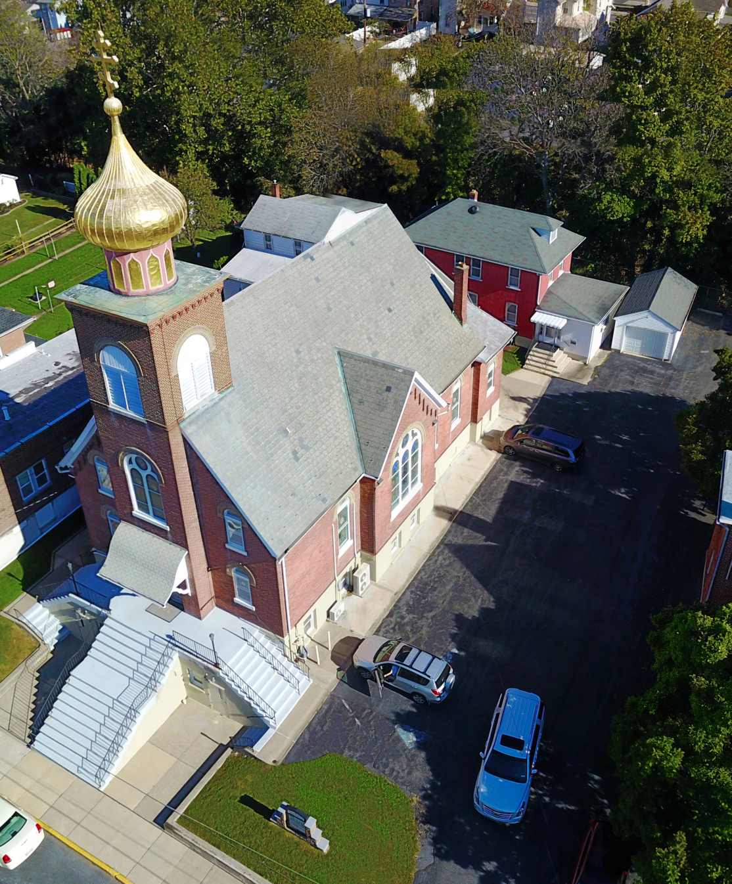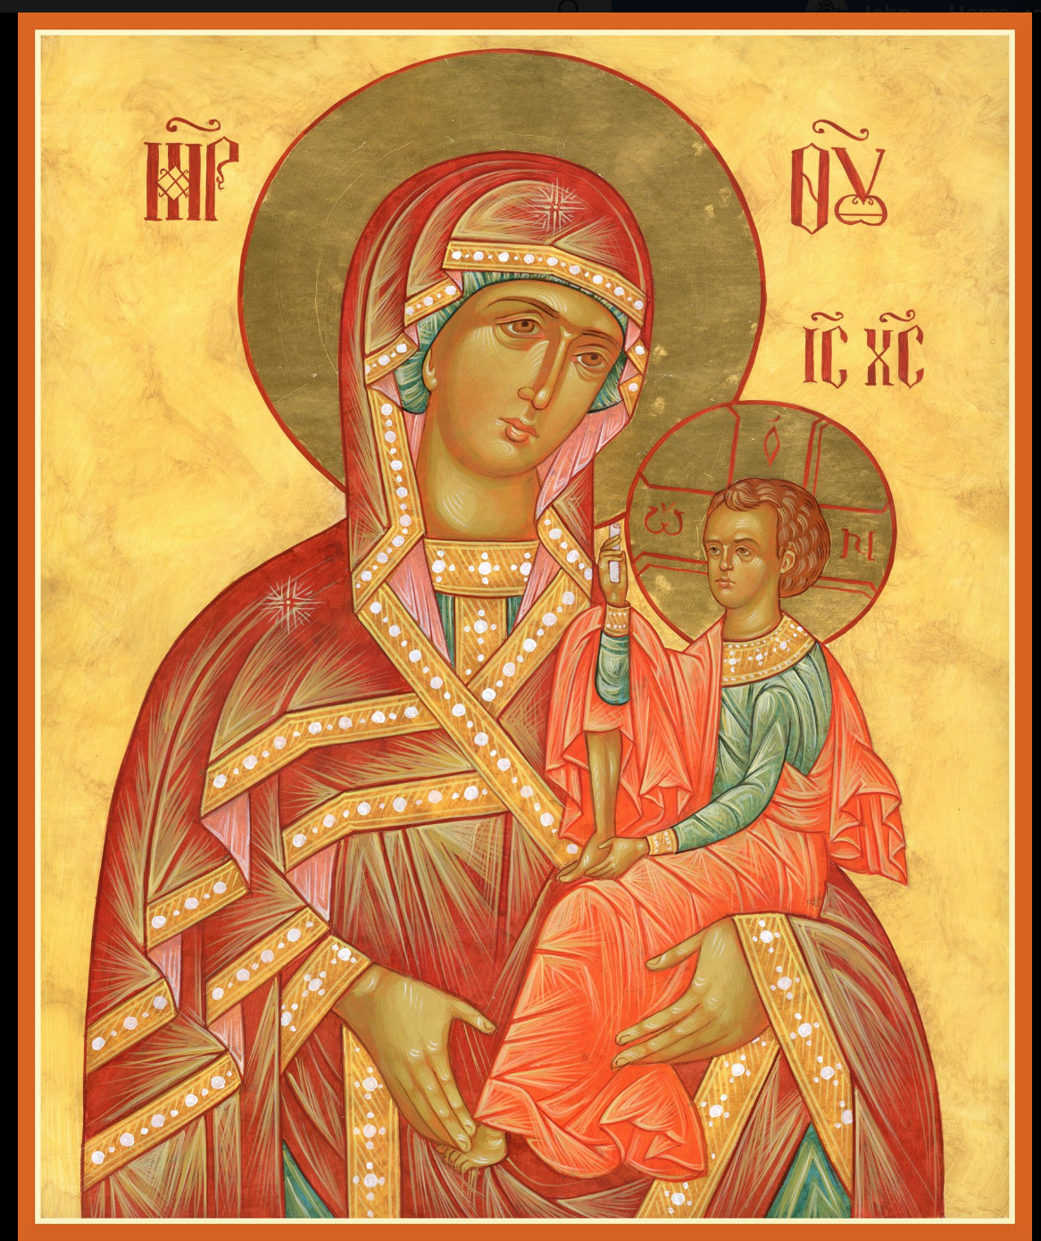

ASSUMPTION OF THE VIRGIN MARY
UKRAINIAN ORTHODOX CHURCH
ECUMENICAL PATRIARCHATE OF CONSTANTINOPLE AND NEW ROME
1301 Newport Avenue
Northampton, Pennsylvania 18067
Mitered Archpriest Myron Oryhon
Rev. Fr. Oleh Kravchenko, Attached
Protodeacon Mychail Sawarynski, Attached

Telephones: Church Office… (610) 262-2882
Church Fax/Kitchen/Hall… (610) 262-0552
Fr. Myron Oryhon – (607) 752-1999
Protodeacon Mychail’s Residence… (610) 262-3876
Websites: holyassumption.org
ukrainianorthodoxchurchusa.org
lvorthodox.wordpress.com
E-mail: Parish… avmuoc@gmail.com
Protodeacon Mychail…pravoslavni@rcn.com
Webmaster, John Hnatow… john.hnatow@gmail.com
==============================================================
07th July (24th June) 2019

Third Sunday after Pentecost. Tone 2. SYNAXIS OF THE SAINTS of HALYCHYNA. NATIVITY OF ST. JOHN THE BAPTIST.
Romans 5: 1-10 Matthew 6:22-33
Romans 13: 12-14:4 Luke 1:1-25, 57-68, 76, 80

PROPERS FOR LITURGY OF ST. JOHN CHRYSOSTOM

Tropar of the Resurrection, Tone 2
When You descended to death, Life Immortal, You slayed Hell with the splendor of Your Divinity. And when from the depths, You raised the dead, all the Powers of Heaven cried out: Giver of Life, Christ our God, glory to You.

Tropar of the Dormition, Tone 1
In giving birth, you preserved your virginity. In falling asleep you did not forsake the world, Birth-Giver of God. You were translated to Life, Mother of Life, and through your prayers you deliver our souls from death.

Tropar of the Nativity of John the Baptist, Tone 4
Prophet and Forerunner of the coming of Christ, we who honor you with love can find no manner of praising you worthily. For the barrenness of one who bore you and the silence of your father have been ended by your being born of divine grace and you have proclaimed to the world the Incarnation of the Son of God.

Kondak of the Resurrection, Tone 2
Hell became fearful, Almighty Savior, seeing the miracle of Your Resurrection from the tomb. The dead arose and all creation, with Adam, beheld this and rejoiced with Your and the world, my Savior, praises You forever.

Glory to the Father and to the Son and to the Holy Spirit.

Kondak of the Nativity of John the Baptist, Tone 3
She who was previously barren now bears the Forerunner of Christ Who is the fulfillment of every prophecy. For the prophets pro-claimed beforehand that having laid hands on Him in the Jordan, he would be manifest as Prophet, Preacher and Forerunner of the Word of God.

Now and ever and unto ages of ages. Amen.
Kondak of the Dormition, Tone 2
Neither the tomb nor death had power over the Birth-Giver of God; she is ever watchful in her prayers and in her intercession lies un-failing hope. For as the Mother of Life, she has been translated to life by the One Who dwelt within her ever-virginal womb.

Prokimen of the Resurrection, Tone 2
The Lord is my strength and my song. He has become my salvation.

Verse: The Lord has chastened me sorely, but He has not given me over to death.

Prokimen for John the Baptist, Tone 7
The Righteous shall rejoice in the Lord and hope in Him.

Verse: God, hear my prayers when I make my petition to You.

Alleluia Verses in Tone 2
May the Lord answer you in the day of trouble. May the Name of the God of Jacob protect you.

Lord, save the king and hear us on the day we call out to You.

Blessed be the Lord God of Israel, for He has visited and redeemed His people.

And You, child, shall be called the Prophet of the Most High.

Communion Hymn:
Praise the Lord from the heavens, praise Him in the Highest.

The Righteous shall be in everlasting remembrance. They shall not be afraid of any evil report. Alleluia (3X)

LITURGICAL MENEION & SCRIPTURE READINGS
FOR THE FOURTH WEEK AFTER PENTECOST

THE APOSTOLIC FAST CONTINUES

Mon. 08 July Virgin Martyr FEBRONIA of Nisibis (304)
FAST DAY: Romans 9: 18-33 Matthew 11: 2-15
FISH

Tue. 09 July DAVID of Thessalonica (540). JOHN, Bishop
FAST DAY: of the Goths in Crimea (787).
FISH Romans 10: 11-11:2 Matthew 11:16-20

Wed. 10 July Ven. SAMPSON the Hospitable (530). JOANNA
FAST DAY the Myrrh-bearer. SEVERUS, presbyter in Italy.
Romans 11:2-12 Matthew 11:20-26
Thur. 11 July Translation of the Relics of CYRUS & JOHN (311)
FAST DAY: XENOPHON of Rebeika. PAUL the Physician.
FISH Romans 11:13-24 Matthew 11:27-30

Fri. 12 July HOLY GLORIOUS ALL PRAISED LEADERS of
FAST DAY: the APOSTLES PETER & PAUL (67).
FISH 1 Corinthians 4:9-16 Matthew 16:13-19

9:00 AM Divine Liturgy of St. John Chrysostom

END OF THE APOSTOLIC FAST

Sat. 13 July SYNAXIS OF THE GLORIOUS AND ALL-
PRAISED TWELVE APOSTLES.
Romans 6:11-17 Matthew 8:14-23
5:00 PM GREAT VESPERS

Sun. 14 July 4th Sunday after Pentecost. Unmercenaries COSMAS & DAMIAN, martyrs at Rome. Tone 3.
8:30 AM THIRD & SIXTH HOURS
9:00 AM DIVINE LITURGY of JOHN CHRYSOSTOM

NECROLOGY:
07 July… Stephania Ripka ’25, Mary Kereb ‘12
09 July… Mary Bohyn ‘60
12 July… Vladimir Schur ’59, Michael Metchoe ‘09
13 July… Mary Miga ‘01
14 July… Katherine Smallen ‘88

VICHNAYA PAMYAT! MEMORY ETERNAL
BIRTHDAYS:
09 July… Paul Kochenash
10 July… Kathleen Crayosky, Julia Kroboth
12 July… Nicholas Alexander
13 July… Dennis Schmall

MNOHAYA LITA! MANY YEARS!

WE PRAY FOR THE HEALTH AND WELL-BEING of the ill afflicted: Pani Ol’ha Kravchenko and the child she is bearing, William Savitz, Catherine Kochenash, Fr. Vasyl Dovgan, Vladimir & Emma Krasnopera, Tessie Kuchinos, Brendan Phillips, Jessie Hnatow, Jessica Meashock, Wasyl Hewko, Adam Hewko, Betty Hendrickson, Andrew Thaxton, Michelle Pierzga, Susan Ferretti, Carole Zarayko, William Fischer, Ekaterina Seremula, Marianna Goshow, Judy Albright, Jerry Yankovy.

SAVE THE DATE: ANNUAL CHURCH PICNIC will held at Canal St. Park with a “PIG ROAST” catered by Fr. James Cairns on SATURDAY, SEPTEMBER 28th from 12 noon to 7 PM. Outdoor Vespers will be served beginning at 5 PM at the park.

OCMC “AGAPE CANISTER” DONATIONS were $17.00; thank
you for your support of our Missions around the globe.

NORTHAMPTON FOODBANK is still in need of foodstuffs, especially tuna, canned potatoes and baby food.

VOLUNTEERS for SUMMER COFFEE HOUR are needed Sign-up sheet in Hall. Coffee will be prepared. You supply the baked goods.

Please continue to save Redner’s tapes; use your Reward’s Card.”

PARISH COUNCIL MEETING, WEDNESDAY JULY 10TH at 7 PM

MANY THANKS to Stephen & Edwina Vlossak for their $100 donation to the Church’s Perpetual Care Fund in Memory of
+ MICHAEL SMALLEN JR. VICHNAYA PAMYAT!

NEWS FROM THE ORTHODOX WORLD
Hierarchs from throughout the Orthodox World gathered in Kyiv on June 25th to celebrate the Feast of St. Onuphriy the Great, the name’s day of His Beatitude Metropolitan Onuphriy on the occasion of his 75th birthday with an open-air Divine Liturgy outside the walls of the Pecherska Lavra attended by thousands.

On the last day of his visit to Tanzania, Patriarch Theodoros II of Alexandria consecrated the site for the third Mission Center in Tanzania named in honor of Archimandrite Nicodemus, the first missionary who catechized and baptized the first people 80 yrs. ago.

Metropolitan Nicolae laid the cornerstone for a new church at the Protection of the women’s Monastery of the Protection in Allegan, Michigan, dedicated to St. John Jacob of Neamt.

On June 27th the Patriarchate of Jerusalem celebrated the commemoration of Holy Prophet Elisha, son of Saphat and disciple of Prophet Elizjah, in Jericho by the sycamore tree of Zachaeus.

With the blessing of Metropolitan Bartholomew of Rivne, thousands of Ukrainian Orthodox began a 6 day, 120 km Cross Procession with the wonder-working Icon of the Mother of God, “The Only Hope of the Desperate,” to St. Anna’s Skete in the village of Onyshkiv.

