JUNE 30, 2019

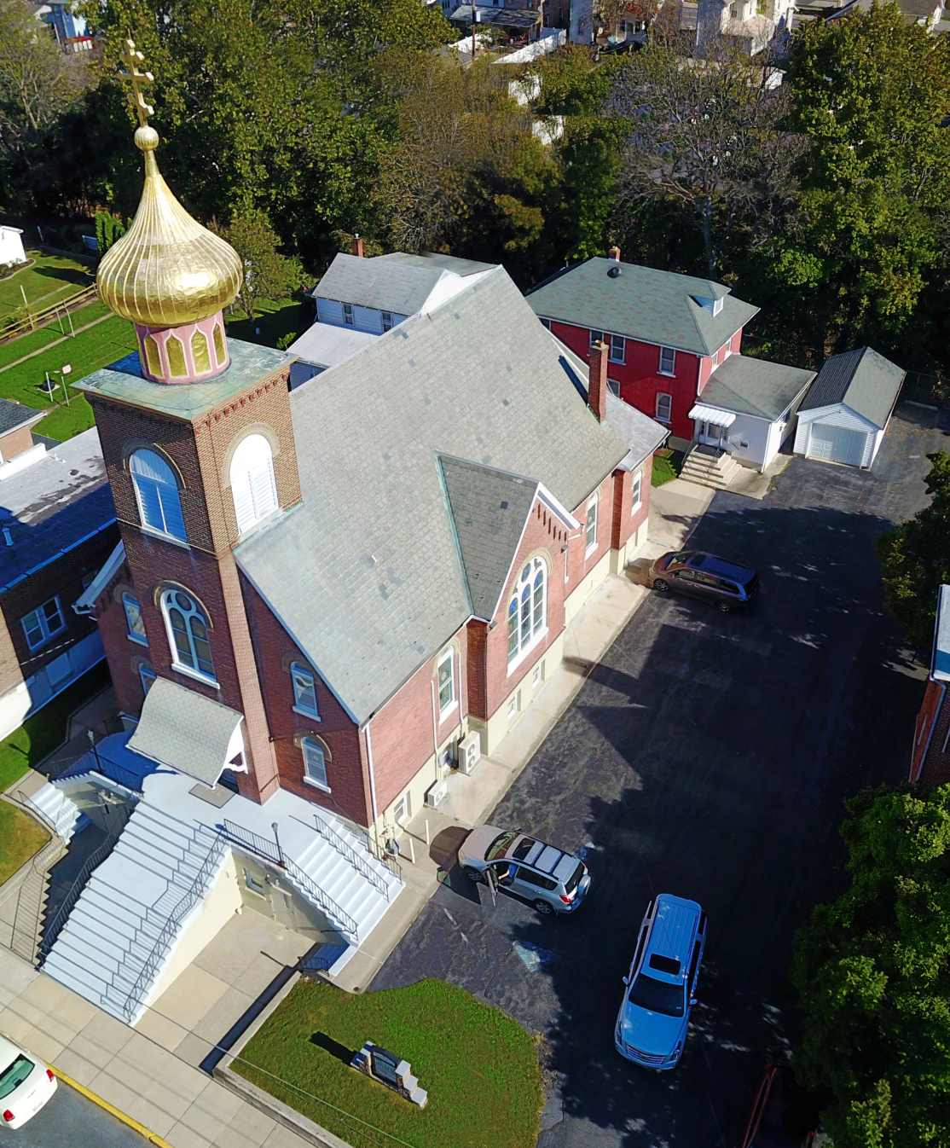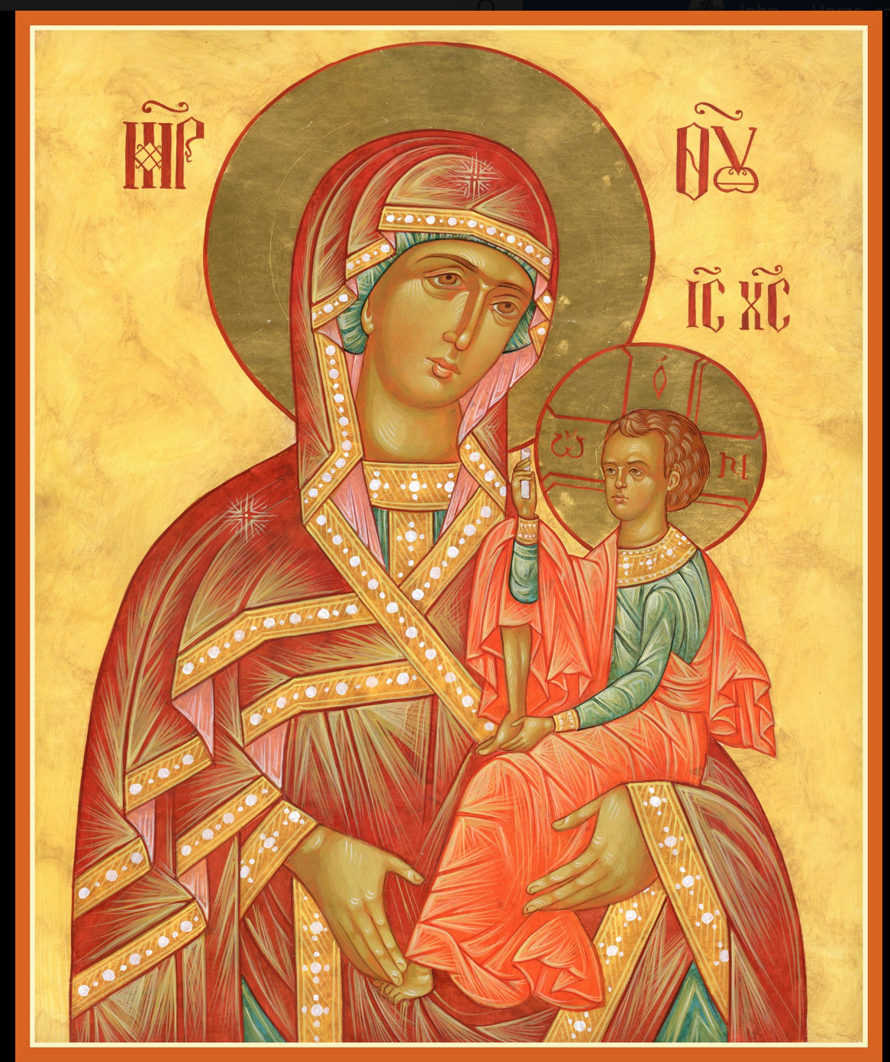

ASSUMPTION OF THE VIRGIN MARY
UKRAINIAN ORTHODOX CHURCH
ECUMENICAL PATRIARCHATE OF CONSTANTINOPLE AND NEW ROME
1301 Newport Avenue
Northampton, Pennsylvania 18067
Mitered Archpriest Myron Oryhon
Rev. Fr. Oleh Kravchenko, Attached
Protodeacon Mychail Sawarynski, Attached

Telephones: Church Office… (610) 262-2882
Church Fax/Kitchen/Hall… (610) 262-0552
Fr. Myron Oryhon – (607) 752-1999
Protodeacon Mychail’s Residence… (610) 262-3876
Websites: holyassumption.org
ukrainianorthodoxchurchusa.org
lvorthodox.wordpress.com
E-mail: Parish… avmuoc@gmail.com
Protodeacon Mychail…pravoslavni@rcn.com
Webmaster, John Hnatow… john.hnatow@gmail.com
==============================================================
30th June (17th June) 2019

2nd Sunday after Pentecost. Tone 1. ALL SAINTS of UKRAINE.
ALL SAINTS OF THE HOLY MOUNTAIN. Martyrs MANUEL, SABEL & ISHMAEL of Persia (362).
Romans 2:10-16 Matthew4:18-23 Hebrews 11:33-12:2 Matthew 4:25-5:12

PROPERS FOR LITURGY OF ST. JOHN CHRYSOSTOM

Tropar of the Resurrection, Tone 1
When the stone had been sealed by the Jews, while the soldiers were guarding Your Most Pure Body, You arose on the third day, Savior, granting life to the world. Therefore, the Powers of Heaven cried to You Giver of Life: Glory to Your Resurrection, Christ. Glory to Your Kingdom. Glory to Your Divine Plan only Lover of Mankind.

Tropar of the Dormition, Tone 1
In giving birth, you preserved your virginity. In falling asleep you did not forsake the world, Birth-Giver of God. You were translated to life, Mother of Life, and through your prayers you deliver our souls from death.

Tropar for All Saints of Ukraine, Tone 8
As beautiful fruit of salvation you have sown, Lord, the land of Ukraine offers You the Saints, who have shone in her land. By their intercession and through the Birth-Giver of God, preserve the Church and our land in profound peace, Greatly Merciful One.

Kondak of the Resurrection, Tone 1
As God, You arose from the tomb in glory, raising the world with Yourself. Human nature praises You as God for death has vanished. Adam exults, Master. Eve, freed from bondage, rejoices and cries out: “You, Christ, are the Giver of Resurrection to all.”

Glory to the Father and to the Son and to the Holy Spirit.

Kondak for All Saints of Ukraine, Tone 3
Today, the choir of God-pleasing Saints from the land of Ukraine stands invisibly with us in church praying to God on our behalf; with them the angels render glory and all the Saints of Christ’s Church celebrate; for together they pray to the Eternal God for us.

Now and ever and unto ages of ages. Amen.

Kondak of the Dormition, Tone 2
Neither the tomb nor death had power over the Birth-Giver of God; she is ever watchful in her prayers and in her intercession lies unfailing hope. For as the Mother of Life, she has been translated to life by the One Who dwelt within her ever virginal womb.

Prokimen of the Resurrection, Tone 1
Let Your mercy, Lord be upon us for we have placed our hope in You.
Prokimen for the Saints, Tone 7
Precious in the sight of the Lord is the death of His Saints.

Verse: Clap your hands, all you nations, shout to God with joyous voices.

Alleluia Verses in Tone 3
I place my hope in You, Lord, grant that I do not mourn forever.

Be to me a God of protection, a firm refuge, that You may save me.

Blessed is the man who fears the Lord and abides in his commandments.

Communion Hymn:
Praise the Lord from the heavens, praise Him in the Highest.

Rejoice in the Lord, you righteous, praise befits the upright.
Alleluia (3X)

OUR MOST SINCERE PRAYERS are offered today for the newly ordained PRIEST, FATHER OLEG KRAVCHENKO, who was ordained to the Holy Priesthood yesterday by Archbishop Daniel at Ss. Peter and Paul Church in Wilmington, DE. We wish him and his PANI OL’HA many blessed years of service in Christ’s vineyard. MNOHAYA I BLAHAYA LITA!
LITURGICAL MENEION & SCRIPTURE READINGS
FOR THE THIRD WEEK AFTER PENTECOST

THE APOSTOLIC FAST CONTINUES

Mon. 01 July Martyrs LEONTIUS, HYPATIUS & THEODULUS
FAST DAY of Tripoli, Syria (73). LEONTIUS of the Kyiv Caves.
Romans 7:1-13 Matthew 9:36-10-8

Tue. 02 July Holy Apostle JUDE, Brother of the Lord (80). Mar-
FAST DAY: ZOSIMAS the Soldier at Antioch.
FISH Romans 7:14-8:2 Matthew 10:9-15

Wed. 03 July Hieromartyr METHODIUS of Patara (312).
FAST DAY Martyrs INNA, PINNA & RIMMA in Scythia. Romans 8:2-13 Matthew 10:16-22

Thur. 04 July Martyr JULIAN of Tarsus (305) Hieromartyr
FAST DAY: TERENCE, Bishop of Iconium. JULIUS of Novara.
OIL Romans 8:22-27 Matthew 10:23-31

Fri. 05 July Hieromartyr EUSEBIUS of Samosata (380).
FAST DAY Martyrs ZENO & his servant ZENAS (304).
Romans 9:6-19 Matthew 10:32-36, 11:1

Sat. 06 July Martyr AGRIPPINA of Rome (260). Martyrs
FAST DAY: EUSTOCHIUS, GAIUS, PROBUS, LOLLIUS &
FISH URBAN of Ancyra (4th C.)
Romans 3:28-4:3 Matthew 7:24-8:4
5:00 PM FESTAL VESPERS of ST. JOHN THE BAPTIST
5:30 PM Examination of Conscience; General Confession.

Sun. 07 July 3rd Sunday after Pentecost. ALL SAINTS OF HALYCHYNA. NATIVITY OF ST. JOHN THE BAPTIST. Tone 2
8:30 AM THIRD & SIXTH HOURS
9:00 AM DIVINE LITURGY of JOHN CHRYSOSTOM
NECROLOGY:
30 June John Stupcryski ‘31
02 July… Tekla Pontician ’63, Anna Kereb ’81,
Milton Kochenash ‘00
03 July… Semen Vitushinsky ’65, Albert Tripolone ‘87
04 July… Alexander Fedko ‘90
06 July… Sophia Greene ‘09

VICHNAYA PAMYAT! MEMORY ETERNAL

BIRTHDAYS:
01 July… Joel Hnatow
02 July… Vira Harnaho
04 July… Gregory Pypiuk

ANNIVERSARIES:
03 July… John & Jessie Hnatow
06 July… James & Karen Osmun

MNOHAYA LITA! MANY YEARS!

WE PRAY FOR THE HEALTH AND WELL-BEING of the ill afflicted: Pani Ol’ha Kravchenko and the child she is bearing, William Savitz, Catherine Kochenash, Fr. Vasyl Dovgan, Vladimir & Emma Krasnopera, Tessie Kuchinos, Brendan Phillips, Jessie Hnatow, Jessica Meashock, Wasyl Hewko, Adam Hewko, Betty Hendrickson, Andrew Thaxton, Michelle Pierzga, Susan Ferretti, Carole Zarayko, William Fischer, Ekaterina Seremula, Marianna Goshow, Judy Albright, Jerry Yankovy.

SAVE THE DATE: ANNUAL CHURCH PICNIC will held at Canal St. Park with a “PIG ROAST” catered by Fr. James Cairns on SATURDAY, SEPTEMBER 28th from 12 noon to 7 PM. Outdoor Vespers will be served beginning at 5 PM at the park.

OCMC “AGAPE CANISTER” DONATIONS were $19.00.
Thank you for your support of our Missions around the globe.

NORTHAMPTON FOODBANK is still in need of foodstuffs, especially tuna, canned potatoes and baby food.

VOLUNTEERS for SUMMER COFFEE HOUR are needed Sign-up sheet in Hall. Coffee will be prepared. You supply the baked goods.

Please continue to save Redner’s tapes; use your Reward’s Card.”

PARISH COUNCIL MEETING, WEDNESDAY JULY 10TH at 7 PM

2 Palm plants are available. Anyone interested, see Martha Misko

THOUSANDS OF UKRAINIAN ORTHODOX
Gathered at the women’s Monastery of the Holy Trinity on June 20th to commemorate the miraculous Icon of the Mother of God, “Assurance of Sinners” (1622) in Korets, Rivne oblast. Divine Liturgy was celebrated by Metropolitan Antoniy of Borispil & 9 other hierarchs.

WORLD REFUGEE DAY
The United Nations declared June 20th as World Refugee Day. The main charity of the Orthodox Church since 1992 has been the Inter-national Orthodox Christian Charities (IOCC) which has provided over $692 million in relief and developmental programs to families in the former Yugoslavia, Georgia, Ethiopia, Syria, Jordan, and the U.S. Thanks to your ongoing support the IOCC has offered emergency assistance and long term aid as well as hope and opportunity to millions of refugees fleeing violence and uncertainty. PLEASE CONTINUE YOUR FINANCIAL SUPPORT TO THE IOCC.

ARCHBISHOP ELPIDOPOROS was enthroned Saturday, June 22nd at Holy Trinity Cathedral in NYC. He was appointed by the Holy Synod of Constantinople to lead the Greek Orthodox Arch-diocese of the Americas.

