r JUNE 09, 2019

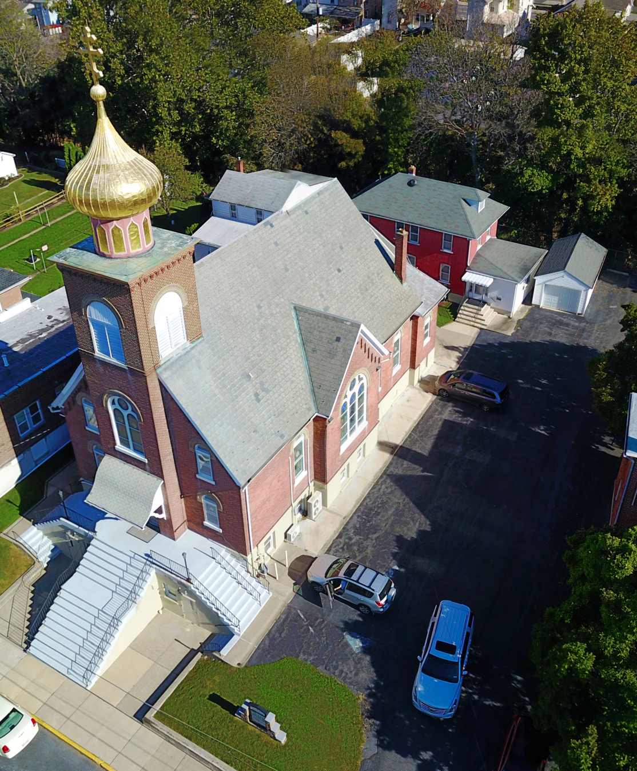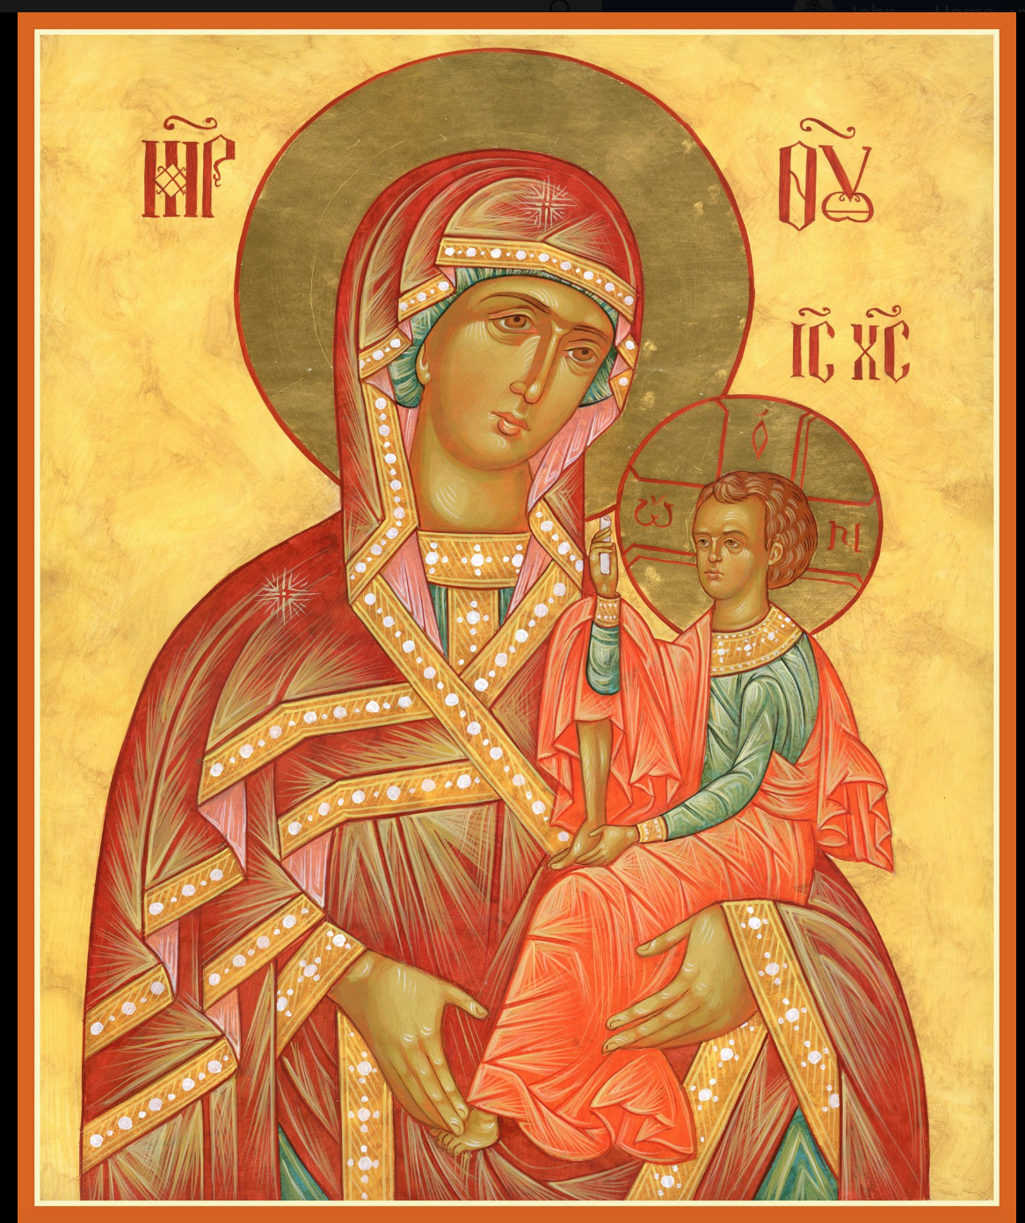

ASSUMPTION OF THE VIRGIN MARY
UKRAINIAN ORTHODOX CHURCH
ECUMENICAL PATRIARCHATE OF CONSTANTINOPLE AND NEW ROME
1301 Newport Avenue
Northampton, Pennsylvania 18067
Mitered Archpriest Myron Oryhon
Protodeacon Mychail Sawarynski, Attached
Deacon Oleh Kravchenko, Attached
Telephones: Church Office… (610) 262-2882
Church Fax/Kitchen/Hall… (610) 262-0552
Fr. Myron Oryhon – (607) 752-1999
Protodeacon Mychail’s Residence… (610) 262-3876
Websites: holyassumption.org
ukrainianorthodoxchurchusa.org
lvorthodox.wordpress.com
E-mail: Parish… avmuoc@gmail.com
Protodeacon Mychail…pravoslavni@rcn.com
Webmaster, John Hnatow… john.hnatow@gmail.com
==============================================================
09th June (27th May) 2019

8th SUNDAY OF PASCHA; FATHERS of the FIRST ECUMEN-ICAL COUNCIL. AFTERFEAST OF ASCENSION. Tone 6. Hieromartyr THERAPON, Bishop of Sardis (259). Virgin-martyr THEODORA & Martyr DIDYMUS the Soldier of Alexandria (304),
Acts 20: 16-18, 28-36 John 17: 1-13

CHRIST IS ASCENDED! TRULY, HE IS ASCENDED!
PROPERS FOR LITURGY OF ST. JOHN CHRYSOSTOM

Tropar, Tone 6
The angelic powers were at Your tomb. The guards became as dead men. Mary stood by Your grave seeking Your Most Pure Body. You captured Hell not being tempted by it. You came to the Virgin granting Life. Lord, Who arose from the dead: Glory to You.

Tropar of the Ascension, Tone 4
You have ascended in Glory, Christ our God, having made Your disciples joyful by the promise of the Holy Spirit. Through this blessing they were assured that You are the Son of God, the Redeemer of the world.

Tropar of the Holy Fathers, Tone 8
You are most glorious, Christ our God. You have established the Holy Fathers as lights on the earth. Through them You have guided us to the True Faith. Greatly Compassionate One, Glory to You.

Glory to the Father and to the Son and to the Holy Spirit.

Kondak of the Holy Fathers, Tone 8
The preaching of the Apostles and doctrines of the Fathers have established One Faith for the Church. Adorned with the robe of Truth, woven from heavenly theology, great is the mystery of piety that it defines and glorifies.

Now and ever and unto ages of ages. Amen.

Kondak of the Ascension, Tone 6
When You had accomplished Your Divine Plan for us and had united earthly and heavenly things, You ascended in Glory, Christ our God. Yet in manner did You depart from us. Rather You abide with us forever. And You cry out to those who love You: “I am with you and none shall prevail against you.”

Prokimen of the Holy Fathers, Tone 4
Blessed are You, Lord God of our Fathers, praised and glorified is Your Name to the ages.

Verse: For You are righteous in all that You have done for us.

Alleluia Verses, Tone 1
The Lord, the God of gods, has spoken and summoned the earth from the rising of the sun to its setting.

Gather around Him, you His venerable ones, who made covenant with Him through sacrifices.

In place of “It is right in truth…”
Magnify, my soul, the Life-Giver, Who has ascended from earth to heaven.
Irmos, Tone 5: Above understanding and speech, you became the Mother of God and ineffably brought forth the One Who is beyond time. We, the faithful, with one accord, magnify you

Communion Hymn:
Receive the Body of Christ, taste the Fountain of Immortality.

Praise the Lord from the heavens, praise Him in the highest.

Rejoice in the Lord, you righteous. Praise befits the upright.
(Alleluia 3X)

In place of “We have seen the true light…”
You have ascended in Glory, Christ our God, having made Your disciples joyful by the promise of the Holy Spirit. Through the blessing they were assured that You are the Son of God, the Redeemer of the world. (slowly 1X)

LITURGICAL MENEION & SCRIPTURE READINGS
FOR THE AFTERFEAST OF ASCENSION

Mon. 10 June Ven. NICETAS, Bishop of Chalcedon. EUTYCHIUS
Bishop of Melitene. IGNATIUS, Bishop of Rostov.
Acts 21:8-14 John 14:27-15:7

Tue. 11 June Virgin-martyr THEODOSIA of Tyre (308).
Acts 21:26-32 John 16:2-13

Wed. 12 June Ven. ISAAC, Founder of Dalmatian Monastery (383)
Fast Day: Acts 23:1-11 John 16:15-23
Fish

Thur. 13 June Apostle HERMES of the 70. Martyr HERMIAS at
Comana. Martyr PHILOSOPHUS at Alexandria.
Acts 25:13-19 John 16:23-33

Fri. 14 June LEAVE-TAKING OF THE ASCENSION. Martyr
Fast Day: JUSTIN the Philosopher at Rome and those with
Fish him JUSTIN, CHARITON & his wife CHARITA,
EUELPISTUS, HIERAX, PEON, VALERIAN, &
JUSTUS (106). Martyr VICTORIA of Rome.
Acts 27:1-44 John 17:18-26

Sat. 15 June MEMORIAL SATURDAY. NICEPHORUS the
Confessor, Patriarch of Constantinople (828).
Acts 28:1-31 John 21:15-25

5:00 PM FESTAL VESPERS OF TRINITY SUNDAY

Sun. 16 June TRINITY SUNDAY. PENTECOST.
FAST FREE WEEK
8:30 AM THIRD & SIXTH HOURS
9:00 AM TYPIKA (READER’S SERVICE) in our church
LITURGY of JOHN CHRYSOSTOM at ST. MARY’S in ALLENTOWN with Holy Communion
NECROLOGY:
09 June… Prokip Sandovy ’30, Havryil Antoniuk ’61,
Andrew Chepelak ‘68
10 June… Alexander Malanitch ‘90
11 June… Patriarch Mstyslav (Skrypnyk) ‘93
13 June… Karol Matko ’22, Gregory Zaharuyko ’66, Mary
Huzela ’75, Metro Lelo ’96, William Nieves ‘99
14 June… Paul Kochenash ’27, Mary Nazar ‘88
15 June… Uliana Kudrick (infant) ‘26

VICHNAYA PAMYAT! MEMORY ETERNAL

BIRTHDAYS:
13 June… Natalia Seremula
14 June… Emma Krasnopera, Luke Vitushinsky
15 June… Patricia Mauser

MNOHAYA LITA! MANY YEARS!

WE PRAY FOR THE HEALTH AND WELL-BEING of the ill afflicted: Pani Olha Kravchenko and the child she bears, William Savitz, Catherine Kochenash, Fr. Vasyl Dovgan, Vladimir & Emma Krasnopera, Tessie Kuchinos, Brendan Phillips, Jessie Hnatow, Jessica Meashock, Wasyl Hewko, Adam Hewko, Betty Hendrickson, Andrew Thaxton, Michelle Pierzga, Susan Ferretti, Carole Zarayko, William Fischer, Ekaterina Seremula, Marianna Goshow, Judy Albright, Priest Victor Wronskyj, Priest Gerald Ozlanski.

The bus trip to Hard Rock Casino, Atlantic City, on July 11 to see “THE JERSEY BOYS,” had to be canceled for lack of interest.

UOL SUPER COFFEE HOUR TODAY following the Liturgy. Price is $5.00. Fathers and clergy admitted free. Proceeds will go to the Metropolitan John Scholarship Fund.

CONGRATULATIONS to ANTHONY SAWARYNSKI, son of Matthew & Andrea Sawarynski, and senior Altar Server for 10 years. who graduated from Northampton High School, June 1st
and will attend Penn State in the Fall. Many blessed years!

Vladimir Krasnopera extends thanks and glory to God and heartfelt thanks and appreciation to Father Myron and Deacon Michael, and to all who offered prayers, phone calls, conveyed caring thoughts and sent cards during his recent injury. He deeply appreciates your kindness and your care.

OCMC “AGAPE CANISTER” DONATIONS were $32.00.
Thank you for your support of our Missions around the globe.

The Parish is deeply indebted to all the PYROHONA workers who selflessly give their time and labor for the well-being of the Church. Many thanks to the Sisterhood for organizing this ministry, to all who contributed to this project which made over 5,000 dozen of varrenyki this past year. To the sales staff and to those who purchased them God grant you MANY, BLESSED YEARS! The Proto-deacon apologizes if he has in any way slighted people inadvertently who are part of this project for there are so many to be grateful for.

RELIGIOUS INSTRUCTION CLASS FOR PARISH CHILDREN ends today for the Summer vacation.

NORTHAMPTON FOODBANK is still in need of foodstuffs, especially tuna, canned potatoes and baby food.

VOLUNTEERS for SUMMER COFFEE HOUR are needed Sign-up sheet in Hall. Coffee will be prepared. You supply the baked goods.

Please continue to save Redner’s tapes; use your Reward’s Card.”

The Church acknowledges the receipt of $500 from the JR. UOL.
God grant all of its members MANY, BLESSED YEARS!

