MAY 26, 2019

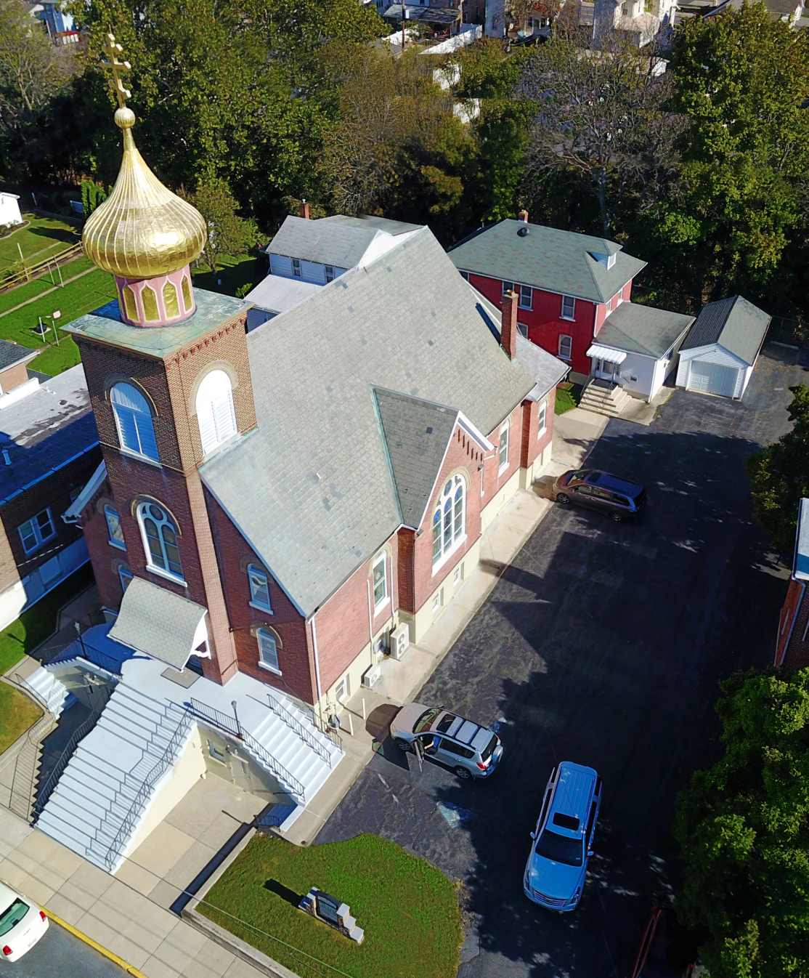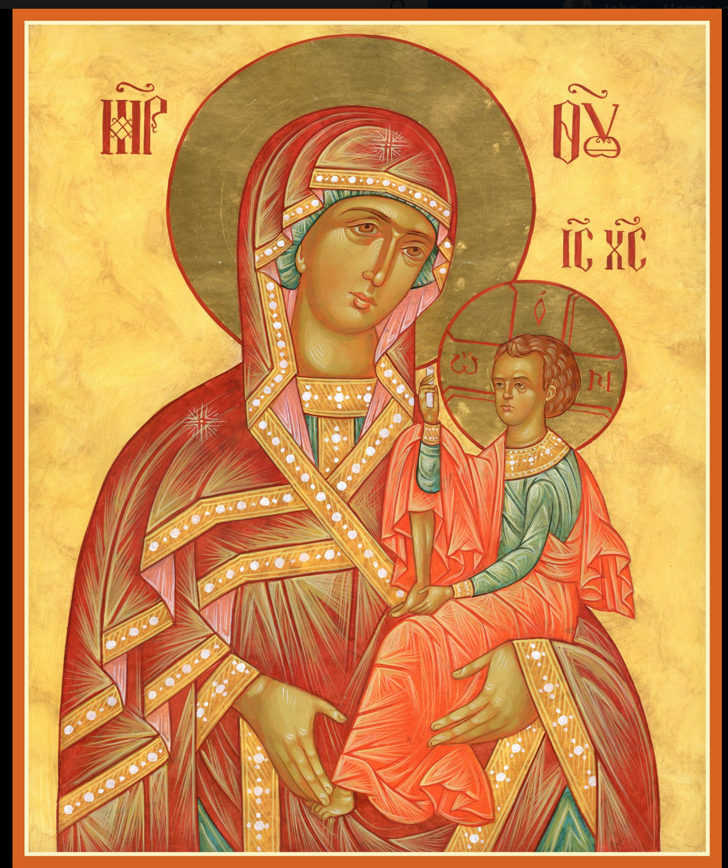

ASSUMPTION OF THE VIRGIN MARY
UKRAINIAN ORTHODOX CHURCH
ECUMENICAL PATRIARCHATE OF CONSTANTINOPLE AND NEW ROME
1301 Newport Avenue
Northampton, Pennsylvania 18067
Mitered Archpriest Myron Oryhon
Protodeacon Mychail Sawarynski, Attached
Telephones: Church Office… (610) 262-2882
Church Fax/Kitchen/Hall… (610) 262-0552
Fr. Myron Oryhon – (607) 752-1999
Protodeacon Mychail’s Residence… (610) 262-3876
Websites: holyassumption.org
ukrainianorthodoxchurchusa.org
lvorthodox.wordpress.com
E-mail: Parish… avmuoc@gmail.com
Protodeacon Mychail…pravoslavni@rcn.com
Webmaster, John Hnatow… john.hnatow@gmail.com
==============================================================
26th May (13th May) 2019

5th SUNDAY OF PASCHA of the SAMARITAN WOMAN. Virgin-martyr GLYCERIA of Heraclea (177). Martyrs LAODICIUS. Martyr ALEXANDER Confessor of Constantinople his wife & children (842). Translation of the Relics of Wonderworker MAKARIY Archimandrite of Pinsk and Kaniv (1688). Tone 4.
Acts 11:19-26; 29-30 John 4: 5-42
Today’s Bulletin is sponsored in memory of all + MEN & WOMEN of the armed forces who gave their lives in defense of this nation. PROPERS FOR LITURGY OF ST. JOHN CHRYSOSTOM

Tropar, Tone 4
When the women disciples of the Lord learned from the angel the joyous news of the Resurrection, they cast away the ancestral curse and with gladness told the Apostles: Death is overthrown. Christ God is risen, granting the world great mercy.

Tropar of Mid-Pentecost, Tone 8,
Savior, in the middle of the feast, fill my thirsting soul with the waters of piety, as You cried to all: “If anyone thirsts, come to Me and drink.” Christ God, fountain of our Life, glory to You.

Glory to the Father and to the Son and to the Holy Spirit.

Kondak of the Samaritan Woman, Tone 8
The Samaritan woman came to the well in faith. She saw You, the Water of Wisdom and drank abundantly. She inherited the Kingdom on High and is ever glorified.

Now and ever and unto ages of ages. Amen.

Kondak of Mid-Pentecost, Tone 4
Christ the God, the Creator and Master of All, cried in the middle of the Feast of the Law: “Come and draw the Water of Immortality.” We bow before You and faithfully cry out: “Grant us Your compassion, for You are the Wellspring of our Lives.”

Prokimen in Tone 3,
Sing praises to our God, sing praises. Sing praises to our King, sing praises.

Verse: Clap your hands, all you peoples. Shout to God with loud songs of joy.

Alleluia Verses, Tone 4, Go forth and prosper and reign, because of truth, meekness and righteousness.

You love righteousness and hate iniquity.

In place of “It is right in truth…”
The angel cried to the Lady, Full of Grace; Rejoice, Pure Virgin. Again I say: Rejoice, Your Son is risen from His three days in the tomb. With Himself He has raised up all the dead: Rejoice, all peoples.
Irmos: Shine, Shine, O New Jerusalem, for the Glory of the Lord has shone on you. Exult now and be glad, O Zion, and rejoice: Pure Birth-Giver of God in the Resurrection of Your Son.

Communion Hymn:
Receive the Body of Christ, taste the Fountain of Immortality.

Praise the Lord from the heavens, praise Him in the highest. (Alleluia 3X)

In place of “We have seen the true light…”
Christ is risen from the dead, trampling down death by death, and upon those in the tombs bestowing life. (slowly 1X)

At the end of Liturgy the priest intones “Glory to You, O Christ…”
Paschal Tropar: Christ is risen… (3X) and Paschal Dismissal.

LITURGICAL MENEION & SCRIPTURE READINGS
FOR THE FIFTH WEEK OF PASCHA

Mon. 27 May Martyr ISIDORE of Chios (251). Martyr
MAXIMUS (250). SERAPION of Egypt.
Acts 12:12-17 John 8:42-51

Tue. 28 May PACHOMIUS the Great (346). ACHILLIES,
Bishop of Larissa ((330). ISAIAH, Bishop & Wonder-worker of Rostov (1090)
Acts 12:25-13:12 John 8:51-59

Wed. 29 May THEODORE the Sanctified (368). ALEXANDER,
Fast Day: Archbishop of Jerusalem. VISTUS, MODESTUS &
Fish CRESCENTIA (303). Blessed Child MUSA (5th C.)
Acts 13:13-24 John 6:5-14

Thur. 30 May Apostle ANDRONICUS of the 70 and JUNIA.
Martyrs SOLOCHON, PAMPHAMER &
PAMPHALON at Chalcedon (298).
Acts 14:20-27 John 9:39-10:9

Fri. 31 May Martyr THEODOTUS of Ancyra & 7 Virgin-
Fast Day: martyrs. Martyrs PETER, DIONYSIUS, ANDREW
Fish PAUL & CHRISTINA (250).
Acts 15:5-34 John 10:17-28

Sat. 01 June Hieromartyr PATRICK, Bishop of Prusa & his
Companions (100). Martyr ACOLUTHUS (305)
JOHN, Bishop of the Goths in Crimea (787)
Acts 15:35-41 John 10:27-38

5:00 PM GREAT VESPERS OF THE BLIND MAN

Sun. 02 June 6th SUNDAY OF PASCHA; BLIND MAN
8:30 AM THIRD & SIXTH HOURS
9:00 AM LITURGY OF ST. JOHN CHRYSOSTOM

NECROLOGY:
27 May… Mary Doncsecz ‘13
28 May… Alex Hewko ‘09
29 May… Fannie Micio ‘70
30 May… Richard Dowling ’92, Ludmila Klynowski ‘18
01 June…Kataryna Porochniak ‘93

VICHNAYA PAMYAT! MEMORY ETERNAL

BIRTHDAYS:
26 May… Volodimir Harnaho
27 May… Jessie Hnatow
28 May… Reader Evhen Seremula, Lienna Rippey
30 May… Irene Alexander, Paul Carlantone

MNOHAYA LITA! MANY YEARS!

WE PRAY FOR THE HEALTH AND WELL-BEING of the ill afflicted: William Savitz, Catherine Kochenash, Fr. Vasyl Dovgan, Vladimir & Emma Krasnopera, Tessie Kuchinos, Brendan Phillips, Jessie Hnatow, Jessica Meashock, Wasyl Hewko, Adam Hewko, Betty Hendrickson, Andrew Thaxton, Michelle Pierzga, Susan Ferretti, Carole Zarayko, William Fischer, Ekaterina Seremula, Marianna Goshow, Judy Albright,

Melanie Unger will be accepting donations for the patron page of the UOL Convention Book. Patrons are $3.00. Please see Melanie.

There will be a Sisterhood Meeting Sunday, June 2 following coffee hour.

OCMC “AGAPE CANISTER” DONATIONS were $.00.
Thank you for your support of our Missions around the globe.

RELIGIOUS INSTRUCTION CLASS FOR PARISH CHILDREN:
Mrs. Mary Ost – Sundays 9:00-9:30
Mrs. Linda Winters- May 26- no class; June 2-11 AM; June 9-9 AM
Ms. Bettyann Woyewoda – Sundays at 8:40-9:15; May 26; June 2, 9

NORTHAMPTON FOODBANK is still in need of foodstuffs especially tuna, canned potatoes and baby food.

VOLUNTEERS for SUMMER COFFEE HOUR are needed Sign-up sheet in Hall. Coffee will be prepared. You supply baked goods.

SISTERHOOD MEETING, SUNDAY, June 2nd after LITURGY.

Please continue collecting Redner’s receipts using “Rewards Card.”

