MAY 19, 2019

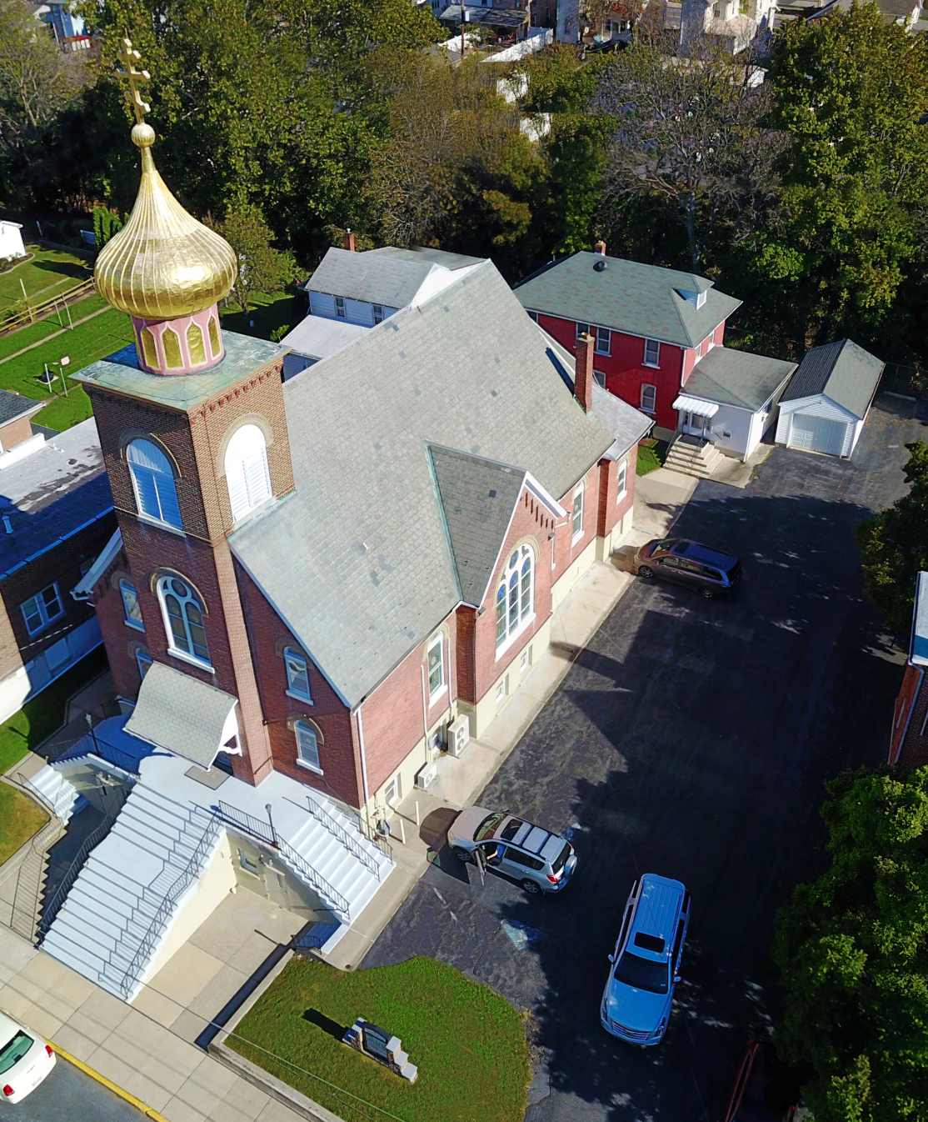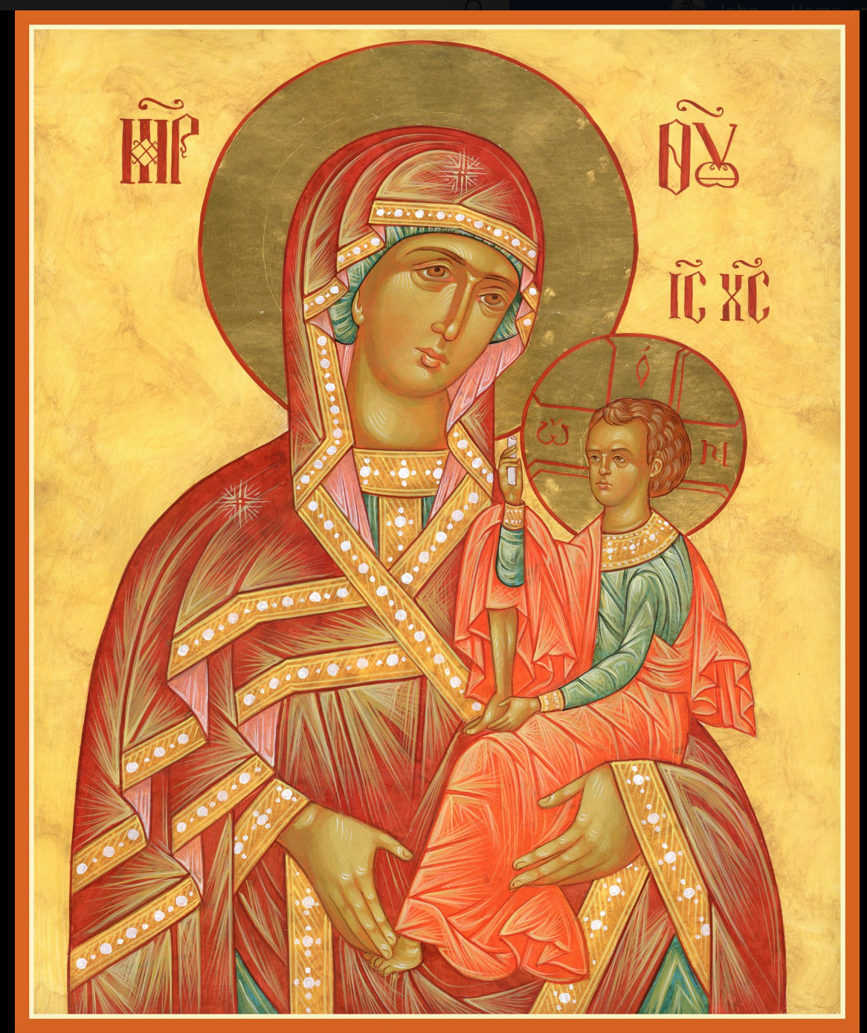

ASSUMPTION OF THE VIRGIN MARY
UKRAINIAN ORTHODOX CHURCH
ECUMENICAL PATRIARCHATE OF CONSTANTINOPLE AND NEW ROME
1301 Newport Avenue
Northampton, Pennsylvania 18067
Mitered Archpriest Myron Oryhon
Protodeacon Mychail Sawarynski, Attached

Telephones: Church Office… (610) 262-2882
Church Fax/Kitchen/Hall… (610) 262-0552
Fr. Myron Oryhon – (607) 752-1999
Protodeacon Mychail’s Residence… (610) 262-3876
Websites: holyassumption.org
ukrainianorthodoxchurchusa.org
lvorthodox.wordpress.com
E-mail: Parish… avmuoc@gmail.com
Protodeacon Mychail…pravoslavni@rcn.com
Webmaster, John Hnatow… john.hnatow@gmail.com
==============================================================
19th May (06th May) 2019

4th SUNDAY OF PASCHA of the Paralytic. Righteous TABITHA
(1st C). Ven. JOB, Abbot and Wonderworker of Pochaiyev (1651). Translation of the Relics of ABRAMIUS of Bulgaria (1230, Rigtheous JOB the Long suffering. Martyrs BARBARUS the soldier.
Acts 9: 32-42 John 5: 1-15
IN MEMORY OF + ARCHPRIEST BAZYL ZAWIERUCHA
(1956-2018)
PROPERS FOR LITURGY OF ST. JOHN CHRYSOSTOM

Tropar, Tone 3,
Let the heavens rejoice, let the earth be glad. For the Lord has shone strength with His Arm. He has trampled down Death by death. He has become the First born of the Dead, He has delivered us from the
depths of Hell and has granted the world great mercy.

Kondak, Tone 3,
Lord, as You once raised the paralytic, now through Your divine mercy raise my soul, paralyzed by sins and thoughtless actions. So
that being saved, I may chant to You: Glory to Your Might, Merciful Christ.

Glory to the Father and to the Son and to the Holy Spirit, now and ever, and unto ages of ages. Amen.

Paschal Kondak, Tone 8
You descended into the tomb, Immortal One and destroyed the power of Death. In victory You rose, Christ God, proclaiming, “Rejoice!” to the Myrrh-bearing women. You granted peace to Your Apostles and bestowed resurrection on the fallen.

Prokimen in Tone 1,
Let Your mercy, Lord, be upon us as we have set our hope in You.

Verse: Rejoice in the Lord, you Righteous. Praise befits the upright.

Alleluia Verses, Tone 5,
Lord, I will chant of Your mercies forever; with my mouth I will proclaim Your truth from generation to generation.

For You have said: “My mercy is established to the ages; in heaven, You have confirmed Your faithfulness.”

In place of “It is right in truth…”
The angel cried to the Lady, Full of Grace; Rejoice, Pure Virgin. Again I say: Rejoice, Your Son is risen from His three days in the tomb. With Himself He has raised up all the dead: Rejoice, all peoples.
Irmos: Shine, Shine, O New Jerusalem, for the Glory of the Lord has shone on you. Exult now and be glad, O Zion, and rejoice: Pure Birth Giver of God in the Resurrection of Your Son.

Communion Hymn:
Receive the Body of Christ, taste the Fountain of Immortality.

Praise the Lord from the heavens, praise Him in the highest. (Alleluia 3X)

In place of “We have seen the true light…”
Christ is risen from the dead, trampling down death by death, and upon those in the tombs bestowing life. (slowly 1X)

At the end of Liturgy the priest intones “Glory to You, O Christ…”
Paschal Tropar: Christ is risen… (3X) and Paschal Dismissal.

LITURGICAL MENEION & SCRIPTURE READINGS
FOR THE FOURTH WEEK OF PASCHA

Sun. 19 May Litya in memory of Fr. Bazyl following Liturgy &
Blessing of Graves at the Parish Cemetery

Mon. 20 May Commemoration of the Sign of the Precious Cross
Over Jerusalem (351) Martyr ARCACIUS (303)
Acts 10: 1-16 John 6: 56-69

Tue. 21 May Holy Apostle and Evangelist JOHN the Theologian
(117) Ven. ARSENIUS the Great of Scetis (448)
Acts 10:21-33 John 7:1-13

Wed. 22 May MID PENTECOST. Prophet ISAIAH (8th C. BC)
Fast Day: Translation of the Relics of St. NICHOLAS.
Fish Acts: 14:6-18 John 7:14-30

Thur. 23 May Apostle SIMON the Zealot. Martyrs PHILADELPPHUS, CYPRIAN, ALPHAEUS, ONESIUMUS, ERASMUS & 14 others in Sicily (251)
Acts 10:34-43 John 8: 12-20

Fri. 24 May Holy Equal to the Apostles & teachers of the Slavs
Fast Day: CYRIL & MOTHDOIUS. Ven. SOPHRONIUS of
Fish the Kyiv Caves (13th C.)
Acts 10: 44-11:10 John 8:21-30

Sat. 25 May EPIPHANIUS, Bishop of Cyprus (403) GERMANUS, Patriarch of Constantinople (740)
Acts 12:1-11 John 8: 31-42

5:00 PM GREAT VESPERS OF SAMARITAN WOMAN

Sun. 26 May 5th SUNDAY OF PASCHA; SAMARITAN WOMAN. Virgin martyr GLYCERIA at
Heraclea (177) & with her Martyr LAODICIUS.
8:30 AM THIRD & SIXTH HOURS
9:00 AM LITURGY OF ST. JOHN CHRYSOSTOM

NECROLOGY:
19 May… Tekla Zaparyliuk ‘48
21 May… Wasyl Prus ’30, John Lelo ’46, Fenka Sawarynski ’90,
Metropolitan Constantine ‘12
24 May… Elias Ohotski ’57, John Schuryn ‘62

VICHNAYA PAMYAT! MEMORY ETERNAL

BIRTHDAYS:
25 May… Danielle Vitushinsky, Oleksandr Semenonvych

ANNIVERSARY:
21 May… Jerome & Anne Marie Kroboth

MNOHAYA LITA! MANY YEARS!

WE PRAY FOR THE HEALTH AND WELL-BEING of the ill afflicted: William Savitz, Catherine Kochenash, Fr. Vasyl Dovgan, Vladimir & Emma Krasnopera, Tessie Kuchinos, Brendan Phillips, Jessie Hnatow, Jessica Meashock, Wasyl Hewko, Adam Hewko, Betty Hendrickson, Andrew Thaxton, Michelle Pierzga, Susan Ferretti, Carole Zarayko, William Fischer, Ekaterina Seremula, Marianna Goshow, Judy Albright,

THANK YOU for your donations to the Charity “HEIFER INTERNATIONAL” sponsored by the School Children. It netted $300.

Melanie Unger will be accepting donations for the patron page of the UOL Convention Book. Patrons are $3.00. Please see Melanie.

OCMC “AGAPE CANISTER” DONATIONS were $15.00.
Thank you for your support of our Missions around the globe.

RELIGIOUS INSTRUCTION CLASS FOR PARISH CHILDREN:
Mrs. Mary Ost – Sundays 9:00-9:30
Mrs. Linda Winters- May 19 & 26 – no class; June 2 – 11 AM; June 9 – 9 AM
Ms. Bettyann Woyewoda – Sundays at 8:40-9:15; May 19. 26

LAST DATE FOR PIEROHI SALES WILL BE MAY 23rd. Order by May 19th. Call Helen 610-261-4575 or 484-239-5731.

NORTHAMPTON FOODBANK is still in need of foodstuffs, especially tuna, canned potatoes and baby food.

VOLUNTEERS for SUMMER COFFEE HOUR needed Sign-up sheet in Hall. Coffee will be prepared. You supply baked goods.

