MAY 12, 2019

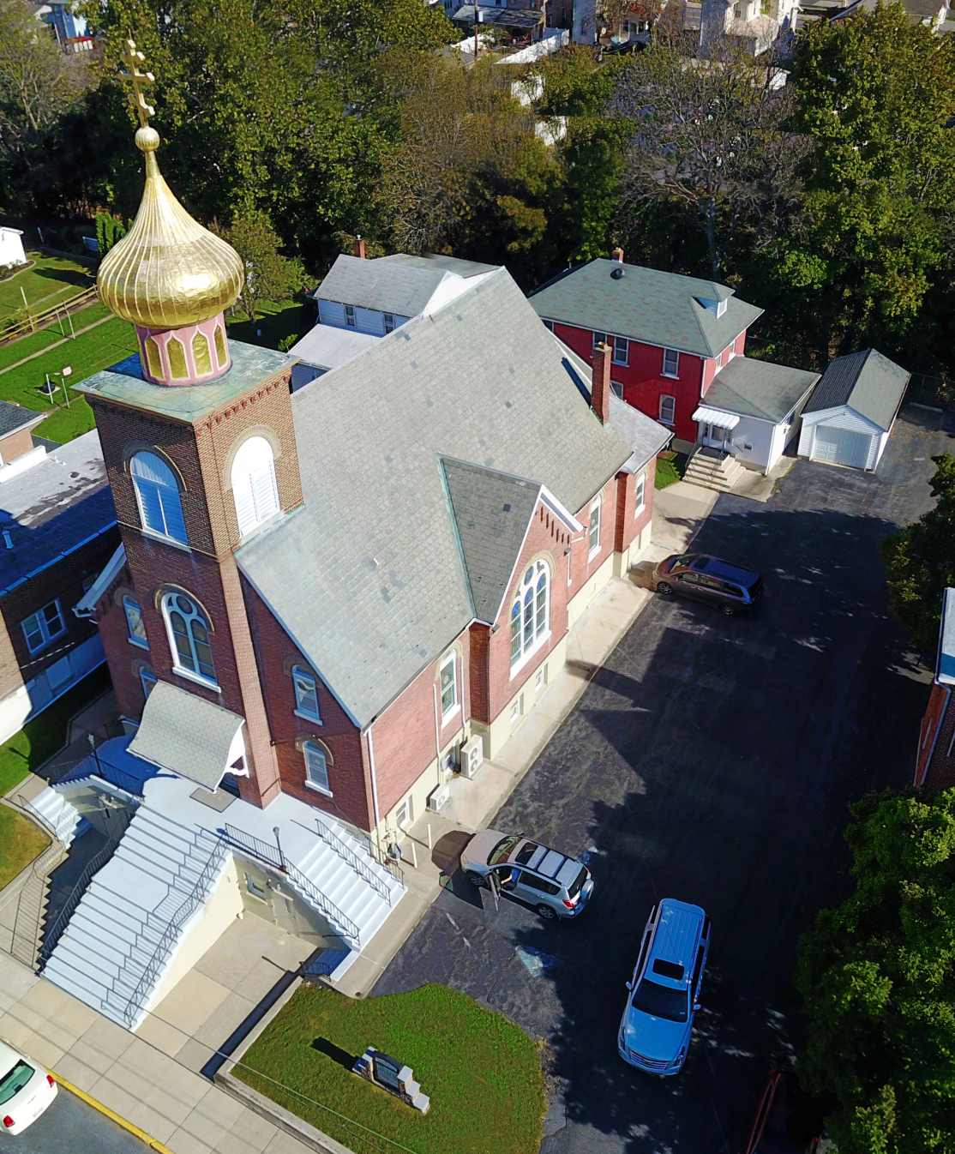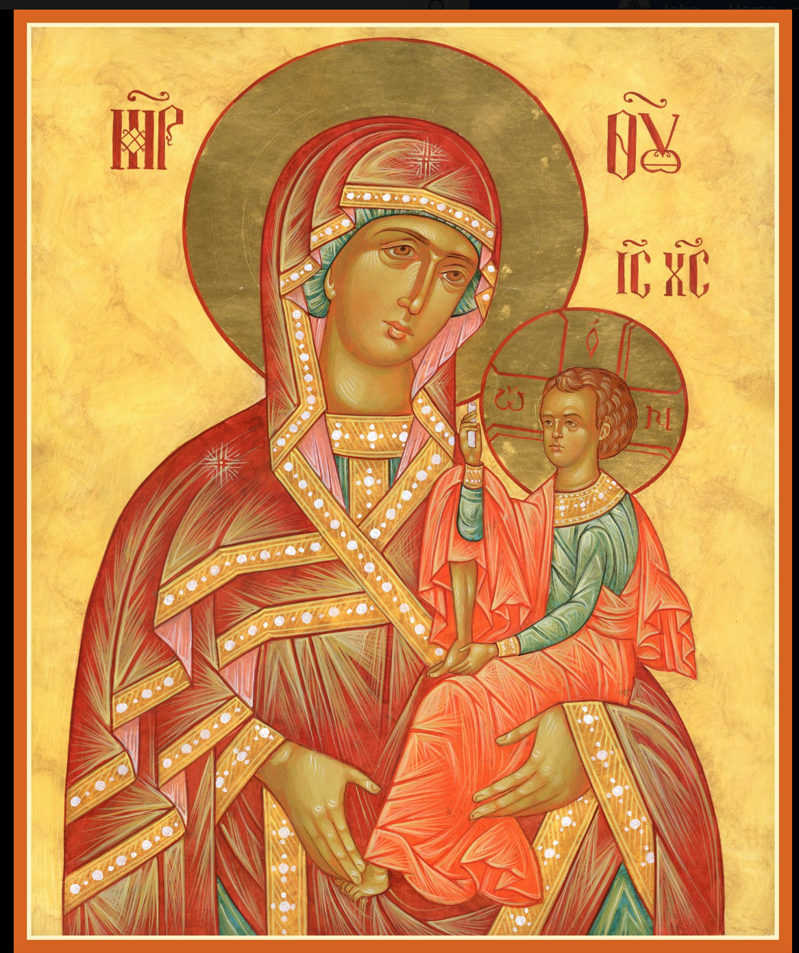

ASSUMPTION OF THE VIRGIN MARY
UKRAINIAN ORTHODOX CHURCH
ECUMENICAL PATRIARCHATE OF CONSTANTINOPLE AND NEW ROME
1301 Newport Avenue
Northampton, Pennsylvania 18067
Mitered Archpriest Myron Oryhon
Protodeacon Mychail Sawarynski, Attached

Telephones: Church Office… (610) 262-2882
Church Fax/Kitchen/Hall… (610) 262-0552
Fr. Myron Oryhon – (607) 752-1999
Protodeacon Mychail’s Residence… (610) 262-3876
Websites: holyassumption.org
ukrainianorthodoxchurchusa.org
lvorthodox.wordpress.com
E-mail: Parish… avmuoc@gmail.com
Protodeacon Mychail…pravoslavni@rcn.com
Webmaster, John Hnatow… john.hnatow@gmail.com
==============================================================
12th May (29th April) 2019
3rd SUNDAY OF PASCHA of the MYRRH-BEARING WOMEN, RIGHTEOUS JOSEPH of ARIMATHEA & NICODEMUS. Nine Martyrs of Cyzicus. MEMNON, Wonderworker of Corfu (2nd C.)
Acts 6: 1-7 Mark 15:43-16:8
Today’s Bulletin, sponsored in loving memory of grandfather, +MICHAEL MEASHOCK, is offered by Reader Maximos Meashock.
HAPPY MOTHER’S DAY to all the Mothers of the Parish!

PROPERS FOR LITURGY OF ST. JOHN CHRYSOSTOM

Tropar, Tone 2,
When You descended into death, Life Immortal, You slayed Hell with the splendor of Your Divinity. And when from the depths You raised the dead, all the Powers of Heaven cried out: Giver of Life, Christ our God, glory to You.

Tropar, Tone 2,
The noble Joseph took Your Most Pure Body down from the Tree, Wrapping It in fine linen and anointing It with spices, He placed It in a new tomb. Our Third Day Resurrection, Lord, granted the world great mercy.

Tropar, Tone 2,
The angel came to the Myrrh-bearing women at the tomb and said: “Myrrh is appropriate for the dead, but Christ has revealed Himself to be a stranger to corruption. So proclaim: The Lord is risen, granting the world great mercy.

Glory to the Father and to the Son and to the Holy Spirit,

Kondak, Tone 2
Christ, You commanded the Myrrh-bearers to rejoice. By Your Resurrection, God, You stopped the lamentation of Eve. You commanded your Apostles to preach: The Savior is risen.

Now and ever, and unto ages of ages. Amen.

Paschal Kondak, Tone 8
You descended into the tomb, Immortal One and destroyed the power of Death. In victory You rose, Christ God, proclaiming, “Rejoice!” to the Myrrh-bearing women. You granted peace to Your Apostles and bestowed resurrection on the fallen.

Prokimen in Tone 6,
Lord, save Your people and bless your inheritance.

Verse: To You Lord will I call. My God, be not silent to me.

Alleluia Verses, Tone 8,
Lord, You have favored Your Land; You have restored the well-being of Jacob.

Kindness and Truth shall meet; Justice and Peace shall kiss.

In place of “It is right in truth…”
The angel cried to the Lady, Full of Grace; Rejoice, Pure Virgin. Again I say: Rejoice, Your Son is risen from His three days in the tomb. With Himself He has raised up all the dead: Rejoice, all peoples.
Irmos: Shine, Shine, O New Jerusalem, for the Glory of the Lord has shone on you. Exult now and be glad, O Zion, and rejoice: Pure Birth-Giver of God in the Resurrection of Your Son.

Communion Hymn:
Receive the Body of Christ, taste the Fountain of Immortality.

Praise the Lord from the heavens, praise Him in the highest. (Alleluia 3X)

In place of “We have seen the true light…”
Christ is risen from the dead, trampling down death by death, and upon those in the tombs bestowing life. (slowly 1X)

At the end of Liturgy the priest intones “Glory to You, O Christ…”
Paschal Tropar: Christ is risen… (3X) and Paschal Dismissal.

LITURGICAL MENEION & SCRIPTURE READINGS
FOR THE THIRD WEEK OF PASCHA

Mon. 13 May Holy Apostle JAMES, brother of St. John the Theologian (44) DONATUS, Bishop of Euroea (387).
Acts 6:8-7:5; 7:47-60 John 4:46-54

Tue. 14 May Prophet JEREMIAH (650 BC) Martyr BATAS of
Nisibis (395) Hieromartyr MAKARY of Kyiv (1497).
Acts 8:5-17 John 6:27-33
Wed. 15 May ATHANASIUS the Great, Archbishop of Alexandria
Fast Day: (373) Martyrs HESPERUS, ZOE and their sons
Fish CYRIACUS & THEODULUS at Attalia (2nd C.)
Acts 8:18-25 John 6:35-39

Thur. 16 May Martyrs TIMOTHY & MAURA (286) PETER the
Wonderworker. THEODOSIY, Abbot of Kyiv Caves.
Hebrews 13:7-16 Matthew 11:27-30

Fri. 17 May Virgin Martyr PELAGIA of Tarsus (287) Hiero-
Fast Day: martyr ERASMUS of Formia. Hieromartyr
Fish ALBIAN, Bishop of Anaea. Hieromartyr SILVANUS
Acts 8:40-9:19 John 6:48-54

Sat. 18 May Martyr IRENE of Thessalonica (1st C.)
Acts 9:20-31 John 15:17-16:2

5:00 PM GREAT VESPERS OF THE PARALYZED MAN

Sun. 19 May 4th SUNDAY OF PASCHA; PARALYZED MAN.

8:30 AM THIRD & SIXTH HOURS
9:00 AM LITURGY OF ST. JOHN CHRYSOSTOM
LITYA ON THE 1st Anniversary of the repose of
FATHER BAZYL following Liturgy
11:30 AM PARASTAS at Cemetery and Blessing of Graves
NECROLOGY:
12 May… Anastasia Dworakivsky ‘94
14 May… Margaret Zarayko ‘99
16 May… Anthony Pontician ’38, Priest Andrew Dworakivsky ‘76
Very Rev. Bazyl Zawierucha ‘18
17 May… Semen Lubianecki ’39, Margaret Lelo ’51,
Andrew Micio ‘67
18 May… Mary Ohotski ‘70

VICHNAYA PAMYAT! MEMORY ETERNAL

BIRTHDAYS:
19 May… Judy Ketterer, Lilly Vitushinsky

ANNIVERSARY:
17 May… Anthony & Patricia Mauser

MNOHAYA LITA! MANY YEARS!

WE PRAY FOR THE HEALTH AND WELL-BEING of the ill afflicted: William Savitz, Catherine Kochenash, Fr. Vasyl Dovgan, Vladimir & Emma Krasnopera, Tessie Kuchinos, Brendan Phillips, Jessie Hnatow, Jessica Meashock, Wasyl Hewko, Adam Hewko, Betty Hendrickson, Andrew Thaxton, Michelle Pierzga, Susan Ferretti, Carole Zarayko, William Fischer, Ekaterina Seremula, Marianna Goshow, Judy Albright,

St. John of Damascus in Poway, CA is right next to the Chabad Synagogue which was attacked by a gun-man on April 27 while Holy Saturday services were going on in the Church as they finished the Reading of the Prophecies. As a result, Mid-night services had to been canceled and the Paschal Liturgy was then celebrated on Sunday morning.
VOLUNTEERS NEEDED: Fri. May 17th at 9 AM and Sat. May 18th at 10 AM to clean out and recycle items from the 2 parish garages. Contact Martha Misko if you are willing to help.

Many thanks to the SR. UOL for their $1.000 Paschal donation to the parish.

OCMC “AGAPE CANISTER” DONATIONS were $.00.
Thank you for your support of our Missions around the globe.

RELIGIOUS INSTRUCTION CLASS FOR PARISH CHILDREN:
Mrs. Mary Ost – Sundays 9:00-9:30
Mrs. Linda Winters- May 12 – 9 AM; May 19 – no class; May 26 – no class; June 2 – 11 AM; June 9 – 9 AM
Ms. Bettyann Woyewoda – Sundays at 8:40-9:15; May 12, 19. 26

NEXT PIEROHI SALE WILL BE MAY 16th . Order by May 12th.
Call Helen 610-261-4575 or 484-239-5731. Final date is May 23rd.

NORTHAMPTON FOODBANK is still in need of foodstuffs.

Continue to collect receipts from “REDNER’S SAVE A TAPE PROGRAM”. This quarter brought in a total of $158.84. Thanks for supporting this project and to Helen Crayosky for chairing it.

We continue to greet fellow Christians for the next 25 days with the Paschal Greeting “CHRIST IS RISEN!”, “CHRISTOS VOSKRES!”; “KRISTOS ANESTI!”; “EL MESSIEH KAHM!”; Ascension Day.

Today the Church commemorates the Holy Myrrh-bearing women: MARY MAGDALENE; MARY the wife of Clopas; JOANNA; SALOME mother of the sons of Zebedee; MARTHA & MARY, sisters of Lazarus. Also we remember JOSEPH of Arimathea & NICODEMUS.

