ASSUMPTION OF THE VIRGIN MARY UKRAINIAN ORTHODOX CHURCH
ECUMENICAL PATRIARCHATE OF CONSTANTINOPLE AND NEW ROME
1301 Newport Avenue, Northampton, Pennsylvania 18067
Rev. Fr. Oleg Kravchenko, Rector
Protodeacon Mikhail Sawarynski, Attached
Websites: holyassumption.org and ukrainianorthodoxchurchusa.org
Facebook: Assumption of the Virgin Mary Ukrainian Orthodox Church
YouTube: AVM UOC Church
Contacts: Fr. Oleg Kravchenko – (732) 507-2274; olegkravchenko2212@gmail.com
Protodeacon Mikhail – (H) (610) 262-3876); pravoslavni@rcn.com
Office – (610) 262-2882; avmuoc@gmail.com
Webmaster, John Hnatow – john.hnatow@gmail.com

Sun. 02 May. (April 19th) THE BRIGHT RESURRECTION OF CHRIST. HOLY PASCHA OF THE LORD. St. JOHN of the Caves in Palestine (8th C.). Martyrs CHRISTOPHER, THEONAS & ANTONINUS in Nicomedia (303). Hiero-martyr PAPHNUTIUS of Jerusalem. GEORGE the Confessor, Bishop of Antioch. Patriarch TRYPHON of Constantinople. NICEPHORUS, Abbot of Katabad.
Acts 1:1-8 John 1:1-17
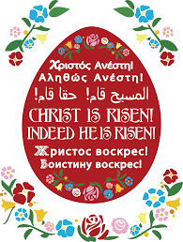

Liturgical Meneion & Scripture Readings
(No kneeling for 50 days. Fast free week)
Mon. 03 May BRIGHT MONDAY. St. Theodore Trichinas (“the Hair-shirt Wearer”).
Acts 1:12-17, 21-26 Jn. 1:18-28
9:00 AM Divine Liturgy (restriction of 50 people; also available Online)

Tue. 04 May BRIGHT TUESDAY. Hieromartyr Januarius, and his companions.
Acts 2:14-21 Lk. 24:12-35
Wed. 05 May BRIGHT WEDNESDAY. St. Theodore the Sykeote.
Acts 2:22-36 Jn. 1:35-51
Thu. 06 May BRIGHT THURSDAY. Holy Glorious Great-martyr George (303).
Acts 2:38-43 Jn. 3:1-15
Fri. 07 May BRIGHT FRIDAY. Martyr Sabbas Stratelates (“the General”) of Rome.
Acts 3:1-8 Jn. 2:12-22
Sat. 08 May BRIGHT SATURDAY. Holy Apostle and Evangelist Mark (63).
Acts 3:11-16 Jn. 3:22-33
Sun. 09 May Antipascha. 2nd Sunday of Pascha, of St. Thomas.
9:00 AM Divine Liturgy (restriction of 50 people; also available Online)

PASCHA! (By Saint Gregory Palamas, 1296 - 1359 A.D.)
"THE SON OF GOD, Who in His compassion became man, died so far as His body was concerned, when His soul was separated from His body; but this body was not separated from His Divinity, and so He raised up His body once more and took it with Him to heaven in glory. Similarly, when those who have lived here in a godly manner are separated from their bodies, they are not separated from God, and in the resurrection they will take their bodies with them to God, and in their bodies they will enter with inexpressible joy there where Jesus has preceded us (cf. Heb. 6:20) and in their bodies they will enjoy the glory that will be revealed in Christ (cf 1 Peter 5:1). Indeed, they will share not only in the resurrection, but also in the Lord's ascension and in all Divine life. But this does not apply to those who live this present life in an unregenerate manner and who at death have no communion with God. For though all will be resurrected, yet the resurrection of each individual will be in accordance with his own inner state (cf 1 Cor. 15:23)."

PASCHA.
(By St. John Damascene)
The day of resurrection?
Earth, tell it out abroad;
The Passover of gladness,
The Passover of God.
From death to life eternal,
From this world to the sky,
Our Christ hath brought us over
With hymns of victory.
Now let the heavens be joyful,
Let earth her song begin;
Let the round world keep triumph,
And all that is therein;
Let all things seen and unseen Their notes in gladness blend,
For Christ the Lord hath risen, Our Joy that hath no end.
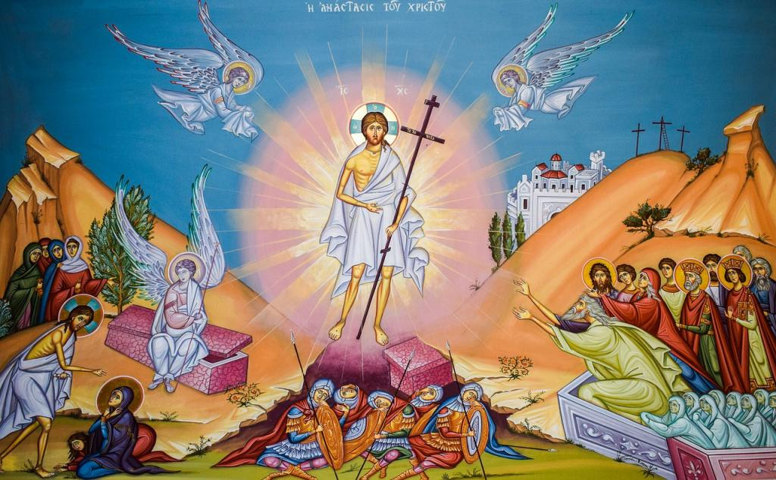

(by Darrel Adams)
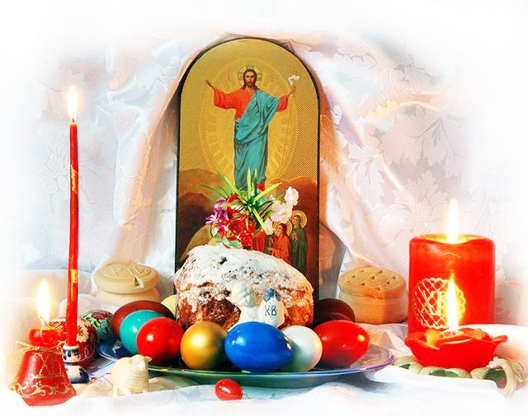
It once was an age of sin and death,
And the hissing snake of pride
Was wrapped around the world so tight,
It seemed all good had died.
And when they strung up Jesus,
The venom killed Him dead.
But come next Sunday morning,
He crushed the serpent's head.

PROPERS of the LITURGY of JOHN CHRYSOSTOM

After “Blessed is the Kingdom” The Paschal Tropar.
Christ is risen from the dead, trampling down death by death and upon those in the tombs bestowing Life. (3X)

Paschal Verses followed by the Paschal Tropar.
Let God arise, let His enemies be scattered; let those who hate Him flee from before His Face. Refrain: Christ is Risen....
As smoke vanishes, so let them vanish; as wax melts before the fire. Refrain.
So the sinners will perish before the Face of God; but let the righteous be glad. Refrain.
This is the day which the Lord has made. Let us rejoice and be glad in it. Refrain.
Glory to the Father and to the Son and to the Holy Spirit. Refrain.
Now and ever and to the ages of ages. Amen. Refrain.
Christ is risen from the dead, trampling down death by death.
And upon those in the tombs bestowing Life.

Antiphon One, Tone 2
Verse: Make a joyful noise to God, all the earth. Sing of His Name, give glory to His Praise.
Refrain: Through the prayers of the Birth-Giver of God, Savior, save us.
Verse: Say to God: How awesome are Your deeds. So great is Your Power that Your enemies cringe before You. Refrain.
Verse: Let all the earth worship You and praise You. Let it praise Your Name, O Most High. Refrain.
Glory to the Father and to the Son and to the Holy Spirit, now and ever and to the ages of ages. Amen.
Refrain: Through the prayers…

Antiphon Two, Tone 2
Verse: May God be gracious to us and bless us and may he make His countenance shine upon us and have mercy on us.
Refrain: Son of God, Who rose from the dead, save us who sing to You: Alleluia.
Verse: That we may know Your way upon the earth and Your salvation among all nations. Refrain.
Verse: Let the people give thanks to You, O God. Let all people give thanks to You. Refrain.
Verse: Let God bless us and let all the ends of the earth fear Him. Refrain.
Glory to the Father and to the Son and to the Holy Spirit, now and ever and to the ages of ages. Amen.
Only Begotten Son and Word of God…

Antiphon 3, Tone 5
Verse: Let God arise, let His enemies be scattered; let those who hate Him flee from before His Face.
Tropar, Christ is risen from the dead…
Verse: As smoke vanishes, so let them vanish; as was melts before the fire. Tropar.
Verse: So the sinners will perish before the face of God; but let the righteous be glad. Tropar.

Entrance Hymn: Bless God in the Churches, You, Lord, Who are of Israel’s offspring.

Tropar: Christ is risen from the dead.…
Ipakoe, Tone 4: Before the dawn, Mary and women came and found the stone rolled away from the tomb. They heard the angelic voice: “Why do you seek among the dead as a mortal, the One Who is Everlasting Light? Behold the burial clothes in the tomb. Go and proclaim to the world: The Lord is risen. He has slain death, for He is the Son of God, saving the human race.”
Glory to the Father and to the Son and to the Holy Spirit, now and ever and to the ages of ages. Amen.
Konkak, Tone 8: You descended into the tomb, Immortal One and destroyed the power of Death. In victory You arose, Christ God, proclaiming, “Rejoice!” to the Myrrh-bearing women. You granted peace to Your Apostles and bestowed Resurrection upon the fallen.

Instead of the Thrice-Holy Hymn: As many as have been baptized into Christ have put on Christ. Alleluia! (3X)

Prokimen, Tone 8: This is the day that the Lord has made. Let us rejoice and be glad in it.
Verse: Give thanks to the Lord, for He is Good, for His mercy endures forever.

Epistle: Acts 1:1-8

Alleluia Verses, Tone 4
Lord, You shall rise up and have mercy on Zion.
The Lord from Heaven has looked upon the earth.

Gospel: John 1: 1-17

In Place of “It is right in truth”…
The angel cried to the Lady, Full of Grace: Rejoice, Pure Virgin. Again I say: Rejoice. Your Son is risen from His three days in the tomb. With Himself He has raised up all the dead. Rejoice, all peoples.
Irmos. Shine, Shine, O New Jerusalem, for the Glory of the Lord has shone on You. Exult now and be glad, O Zion and rejoice, Pure Birth-Giver of God, in the Resurrection of your Son.

Communion Hymn: Receive the Body of Christ, taste of the fountain of immortality. Alleluia (3X).

Instead of “Blessed is He Who comes in the Name of the Lord,” “We have seen the True Light,” and “Let our mouths be filled” we sing the Paschal Tropar once: Christ is risen from the dead, trampling down Death by death and upon those in the tombs, bestowing Life.

At the Dismissal the priest intones the Paschal Tropar.
After the tropar the final Hymn, Tone 8: And unto us He has given eternal Life. Let us worship His Resurrection on the third day.
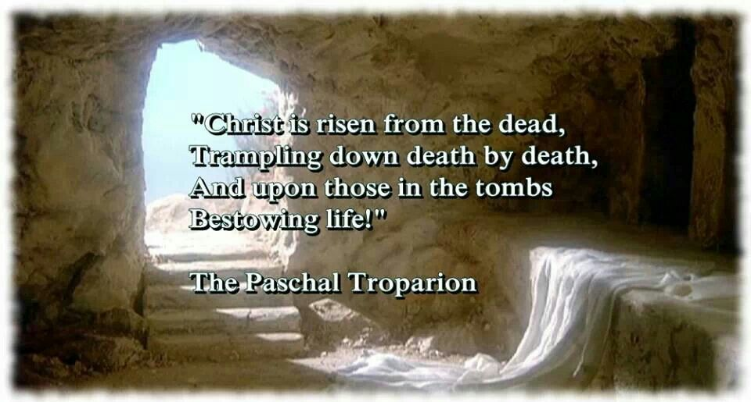
Blessing of the baskets following Liturgy on Pascha in the Parish Hall.
Thank you to Sisterhood of Faith, Hope and Love for the Paschal Donation of $10,000 to the parish. We thank also for donation of flowers.
Donation in Memory of Olga Dorosh – Michael & Martha Misko - $50. .
2021 Spring pierogi schedule: May 6, 13, 20. For orders or volunteers please call Helen: 610-261-4575.
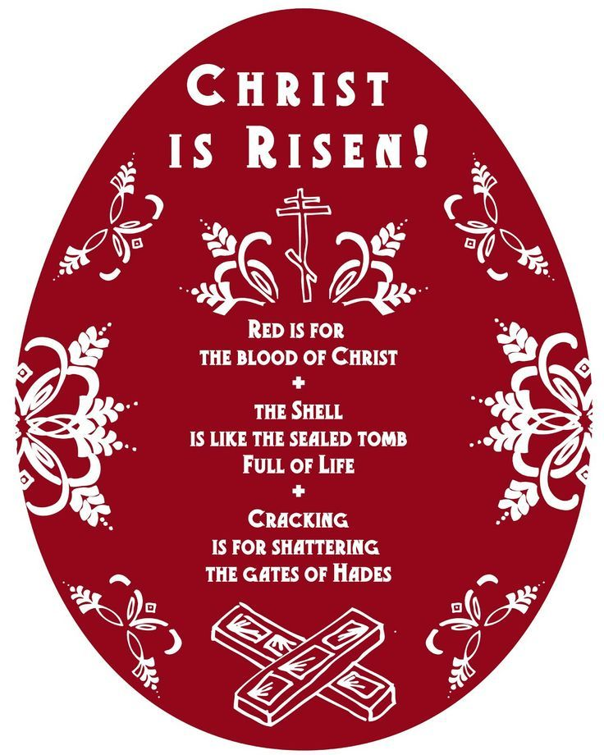
For the food banks: We were assigned baby foods, but they also need cans of potatoes, tuna fish, canned meats, pasta, spaghetti sauce, mac & cheese.
BIRTHDAYS:
06 May…Stephen Unger

ANNIVERSARIES:
02 May…John & Linda Vitushinsky
MNOHAYA LITA! MANY YEARS!
NECROLOGY:
02 May…Metropolitan Ioan (Teodorovich) ’71,
Nicholas Kymniankevych ’29, Caroline Kuliansky ’72
03 May…Agnes Chuyko ‘66
04 May…Semen Chychota ’30, Russell Gontar ’85, Helen MacKenzie ‘99
05 May…Theodore Micio ’57, Xenia Klodnycky’83, Leroy Drobick ’86, Stella Antolick ‘15
06 May…Taras Yaremchuk (infant) ‘43
08 May…Anastasia Schur ‘68
VICHNAYA PAMYAT! MEMORY ETERNAL!
WE PRAY FOR THE HEALTH AND WELL-BEING of the ill-afflicted: Raisa, child Oleksandra, child Alexandria, Elizabeth, Daria, Catherine Kochenash, Joan Molnar, Bill Ketterer, Paul, Richard Stetch, Evan, Brandon and Stacy Snyder, Aaliyah Osmun, Michael Mack, Ihor Broda, James Osmun, Matthew, Tom, William Savitz, Vladimir & Emma Krasnopera, Brendan Phillips, Jessie Hnatow, Jessica Meashock, Adam Hewko, Andrew Thaxton, Susan Ferretti, Judy Albright, Rob Hewko, Daniel Kochenash, Christopher Mack, Norman Betrous, Luba Walker.

PASCHA (By Saint Hippolytus of Rome)
Christ is risen: The world below lies desolate.
Christ is risen: The spirits of evil are fallen.
Christ is risen: The angels of God are rejoicing.
Christ is risen: The tombs of the dead are empty.
Christ is risen indeed from the dead, The first of the sleepers.
Glory and power are his forever and ever!
Symbolism of Paschal meal. The meat products: ham, roasted lamb, kolbasa. All meat products represent the animals used in sacrifice in the Old Testament, and remind us of the sacrifice of our Savior Jesus Christ, who became for us “a Lamb of God, taking away the sins of the world.” Meats also remind us of the story of the fattened calf prepared by the father for the Prodigal Son; the analogy is the Lord giving His Son to mankind who sinned. Ham symbolizes freedom from the Old Law, which did not allow some kinds of meat; the New Law began with the Resurrection. Roasted lamb is symbolic of Jesus, the Paschal Lamb by whose blood we are saved. Kolbasa represents the links of chains of death, which were broken when Christ rose from the dead.
The dairy products: butter & cheese. Butter in shape of a lamb can also remind us of Jesus, the Paschal Lamb. All dairy products are related to the prophecies that told of the prosperity and peace of the Messianic times and are symbolic of the special gifts, which God gives us.
The Easter bread: pascha. Bread is symbolic of Jesus Christ, the “Living Bread” who “came down from heaven to give life eternal to the world”. The richness of this bread both in ingredients and in decoration is a reflection of the special meaning it holds. Bread reminds us of Jesus who in the Eucharist is the true bread of everlasting life and who nourishes our souls as bread nourishes our bodies.
The horseradish and the salt. Horseradish was part of the original Passover meal as a reminder to Jews of the bitterness and harshness of life in Egypt. To Christians, the horseradish represents the bitterness of sin and the hardships we must go through in life because of the original sin. The horseradish sweetened with red beets reminds us of the bitterness of the Passion of Christ which He overcame in glory through His Sacrifice and Resurrection. Salt is a reflection of Christ’s words: “You are the salt of the earth” which we Christians must follow. Salt is also a symbol of fast and self-denial.
The basket. The basket used for the blessing of the Easter food was special and never used for any other purpose. Careful attention is paid to the preparation of the food to go in the basket. The embroidered covers for the baskets are symbolic of the great beauty of the “New Life” given all believers through Christ’s suffering and Resurrection. Each basket also contains a lighted candle, which is a symbol of the radiance of the resurrected Christ.

