ASSUMPTION OF THE VIRGIN MARY UKRAINIAN ORTHODOX CHURCH
ECUMENICAL PATRIARCHATE OF CONSTANTINOPLE AND NEW ROME
1301 Newport Avenue, Northampton, Pennsylvania 18067
Rev. Fr. Oleg Kravchenko, Rector
Protodeacon Mikhail Sawarynski, Attached
Websites: holyassumption.org and ukrainianorthodoxchurchusa.org
Facebook: Assumption of the Virgin Mary Ukrainian Orthodox Church
YouTube: AVM UOC Church
Contacts:
Fr. Oleg Kravchenko - (484) 834-7261; olegkravchenko2212@gmail.com
Protodeacon Mikhail – (H) (610) 262-3876); pravoslavni@rcn.com
Office – (610) 262-2882; avmuoc@gmail.com
Webmaster, John Hnatow – john.hnatow@gmail.com

Click HERE for Prayer in Time of Corona Virus
Tune in to our news, announcements, and online Facebook Livestream Liturgies HERE!

Sun. 24 Apr. THE BRIGHT RESURRECTION OF CHRIST. HOLY PASCHA. Hieromartyr ANTIPAS, Bishop of Pergamus (68). Martyr PROCESSUS & MARTINIAN of Rome (67), Ven. PHARMUTHIUS, the anchorite of Egypt. Ven. JOHN, disciple of Gregory of Decapolis (820).
Acts of the Apostles 1: 1-8 John 1: 1-17
6:00 AM THE MIDNIGHT OFFICE. THE MATINS OF PASCHA. LITURGY. BLESSING OF PASCHAL FOOD (IN THE CHURCH HALL).
COMMON “SVIACHENE” MEAL OF THE BLESSED FOOD.

Christ is Risen! Truly He is Risen! Christos Anesti! Alethos Anesti!
Христос Воскрес! Воістину Воскрес!
Liturgical Meneion & Scripture Readings (no kneeling until pentecost Sunday)
Mon. 25 Apr. BRIGHT MONDAY. Acts 1:12-17, 21-26 Jn. 1:18-28
9:00 AM DIVINE LITURGY
Tue. 26 Apr. BRIGHT TUESDAY. Acts 2:14-21 Lk. 24:12-35
Wed. 27 Apr. GREAT BRIGHT WEDNESDAY. Acts 2:22-36 Jn. 1:35-51
Thu. 28 Apr. BRIGHT THURSDAY. Acts 2:38-43 Jn. 3:1-15
Fri. 29 Apr. BRIGHT FRIDAY. Acts 3:1-8 Jn. 2:12-22
Sat. 30 Apr. BRIGHT SATURDAY. Acts 3:11-16 Jn. 3:22-33
Sun. 01 May Antipascha. 2nd Sunday of Pascha, of St. Thomas.
9:00 AM DIVINE LITURGY

For the pastoral visitation at home or hospital please contact Fr. Oleg.

In Place of “It is right in truth”…
The angel cried to the Lady, Full of Grace: Rejoice, Pure Virgin. Again I say: Rejoice. Your Son is risen from His three days in the tomb. With Himself He has raised up all the dead. Rejoice, all peoples.
Irmos. Shine, Shine, O New Jerusalem, for the Glory of the Lord has shone on You. Exult now and be glad, O Zion and rejoice, Pure Birth-Giver of God, in the Resurrection of your Son.

Communion Hymn: Receive the Body of Christ, taste of the fountain of immortality. Alleluia (3X).

Instead of “Blessed is He Who comes in the Name of the Lord,” “We have seen the True Light,” and “Let our mouths be filled” we sing the Paschal Tropar once: Christ is risen from the dead...

At the Dismissal the priest intones the Paschal Tropar.
After the Tropar the final Hymn, Tone 8: And unto us He has given eternal Life. Let us worship His Resurrection on the third day.
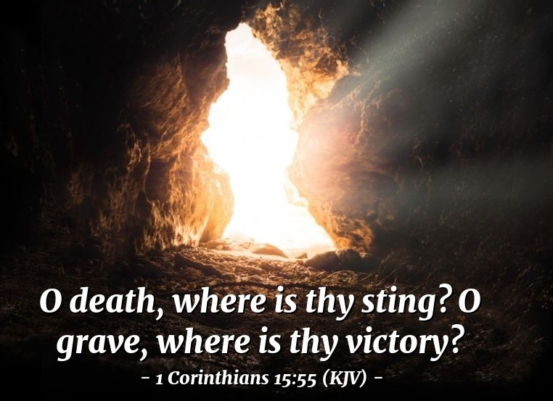
PASCHAL PROPERS of the LITURGY of JOHN CHRYSOSTOM

After “Blessed is the Kingdom” The Paschal Tropar.
Christ is risen from the dead, trampling down death by death and upon those in the tombs bestowing Life. (3X)

Paschal Verses followed by the Paschal Tropar.
Let God arise, let His enemies be scattered; let those who hate Him flee from before His Face. Refrain: Christ is Risen…
As smoke vanishes, so let them vanish; as wax melts before the fire. Refrain.
So the sinners will perish before the Face of God; but let the righteous be glad. Refrain.
This is the day which the Lord has made. Let us rejoice and be glad in it. Refrain.
Glory to the Father and to the Son and to the Holy Spirit. Refrain.
Now and ever and to the ages of ages. Amen. Refrain.
Christ is risen from the dead, trampling down death by death.
And upon those in the tombs bestowing Life.

Antiphon One, Tone 2
Verse: Make a joyful noise to God, all the earth. Sing of His Name, give glory to His Praise.
Refrain: Through the prayers of the Birth-Giver of God, Savior, save us.
Verse: Say to God: How awesome are Your deeds. So great is Your Power that Your enemies cringe before You. Refrain.
Verse: Let all the earth worship You and praise You. Let it praise Your Name, O Most High. Refrain.
Glory to the Father and to the Son and to the Holy Spirit, now and ever and to the ages of ages. Amen. Refrain.

Antiphon Two, Tone 2
Verse: May God be gracious to us and bless us and may he make His countenance shine upon us and have mercy on us.
Refrain: Son of God, Who rose from the dead, save us who sing to You: Alleluia.
Verse: That we may know Your way upon the earth and Your salvation among all nations. Refrain.
Verse: Let the people give thanks to You, O God. Let all people give thanks to You. Refrain.
Verse: Let God bless us and let all the ends of the earth fear Him. Refrain.
Glory to the Father and to the Son and to the Holy Spirit, now and ever and to the ages of ages. Amen.
Only Begotten Son and Word of God…

Antiphon Three, Tone 5
Verse: Let God arise, let His enemies be scattered; let those who hate Him flee from before His Face.
Paschal Tropar: Christ is risen from the dead…
Verse: As smoke vanishes, so let them vanish; as was melts before the fire. Paschal Tropar.
Verse: So the sinners will perish before the face of God; but let the righteous be glad. Paschal Tropar.
Entrance Hymn: Bless God in the Churches, You, Lord, Who are of Israel’s offspring.

Tropar: Christ is risen from the dead.…
Ipakoe, Tone 4: Before the dawn, Mary and women came and found the stone rolled away from the tomb. They heard the angelic voice: “Why do you seek among the dead as a mortal, the One Who is Everlasting Light? Behold the burial clothes in the tomb. Go and proclaim to the world: The Lord is risen. He has slain death, for He is the Son of God, saving the human race.”
Glory to the Father and to the Son and to the Holy Spirit, now and ever and to the ages of ages. Amen.
Kondak, Tone 8: You descended into the tomb, Immortal One and destroyed the power of Death. In victory You arose, Christ God, proclaiming, “Rejoice!” to the Myrrh-bearing women. You granted peace to Your Apostles and bestowed Resurrection upon the fallen.

Instead of the Thrice-Holy Hymn: As many as have been baptized into Christ have put on Christ. Alleluia! (3X)

Prokimen, Tone 8: This is the day that the Lord has made. Let us rejoice and be glad in it.
Verse: Give thanks to the Lord, for He is Good, for His mercy endures forever.

Reading from the Acts of the Apostles: 1:1-8

Alleluia Verses, Tone 4
Verse: Lord, You shall rise up and have mercy on Zion.
Verse: The Lord from Heaven has looked upon the earth.
Gospel: John 1: 1-17

- Fundraiser for Ukrainian Relief Fund BBQ Raffle $10.00 Total prize value approx. $800. Drawing to be held May 1, 2022 Winner will be notified by phone. Call Margaret for tickets 494-934-8094 (Leave message). Thank you Margaret Leindecker for organizing that!
- The Senior UOL is having an Easter Pysanky Raffle. Congratulation of the winner - Bonnie Wagner! The Raffle collected $357.00. Thank you the organizers - Janet and Bettyann Woyewoda!
-Thank you to Jessie Hnatow and Christina Deutsch for conducting a Pysanky workshop and donating all proceeds to Ukrainian aid ($320).

- Thank you to Sisterhood of Faith, Hope and Love for the Paschal Donation of $5,000 to the parish. We thank also for donation of flowers.
- Thank you Walter Seremula for providing us with pussy willows.
- Stone Drink Coasters $16.00 SET OF TWO (www.etsy.com/shop/kelliespetproject) or order in the CHURCH HALL, Sundays. Thank you Kellie Pypiuk for the project.
- VARENYKY SCHEDULE: APRIL 28. INCOME TO THE UKRAINIAN RELIEF FUND. We strongly need your help as a volunteer. Please call Helen (610-261-4575) or Martha Dowling (610-682-4458).
- SUNDAY SCHOOL SCHEDULE: Mrs. Mary Ost (Preschool/ Elementary) Sundays 8:55-9:20 AM. Mrs. Karen Osmun (Secondary) Sundays at 8:45-9:15 AM.
- FOR THE FOOD BANK: baby foods; cans of potatoes, tuna fish, canned meats, pasta, spaghetti sauce, mac & cheese.
BIRTHDAYS:
25 Apr…Andrea Sawarynski
MANY YEARS! MNOHAYA LITA!
NECROLOGY: All Ukrainian soldiers and civilians killed in this war.
24 Apr…Ivan Lutyi ’79
25 Apr…Mary Gulka ‘55
27 Apr…Helen Vasilavsky ‘88
28 Apr…Tekla Fedorovych ‘26
29 Apr…Philip Kereb ’25, Nelcy Azar ‘15
30 Apr…Julian Didenko ’39, Mary Kulp ’91, Natalia Lutyi ‘18
VICHNAYA PAMYAT! MEMORY ETERNAL!
PRAYER FOR THE HEALTH & SALVATION OF THE AFFLICTED: Ukrainian soldiers and civilians wounded during the Russian aggression, William Leszczuk, Steve Sivulich, child Charlie, Helen Crayosky, Linda Vitushinsky, Angela Knoblach, James Osmun, priest Vasyl Dovgan, Rosemarie Pypiuk, Kirk Swauger, Stephanie Donnelly, Nicholas Alexander, Danny Berro, Paulette Mecherly, child Alexandria, Elizabeth Pastushenko, Philippe Chasseuil, Joan Molnar, Brandon and Stacy Snyder, Aaliyah Osmun, Ihor Broda, William Savitz, Vladimir Krasnopera, Brendan Phillips, Jessie Hnatow, Jessica Meashock, Adam Hewko, Andrew Thaxton, Susan Ferretti, Judy Albright, Rob Hewko, Daniel Kochenash, Christopher Mack, Norman Betrous, Tom Petro Jr., Linda Schantz, Michael Lado.
