APRIL 21, 2019

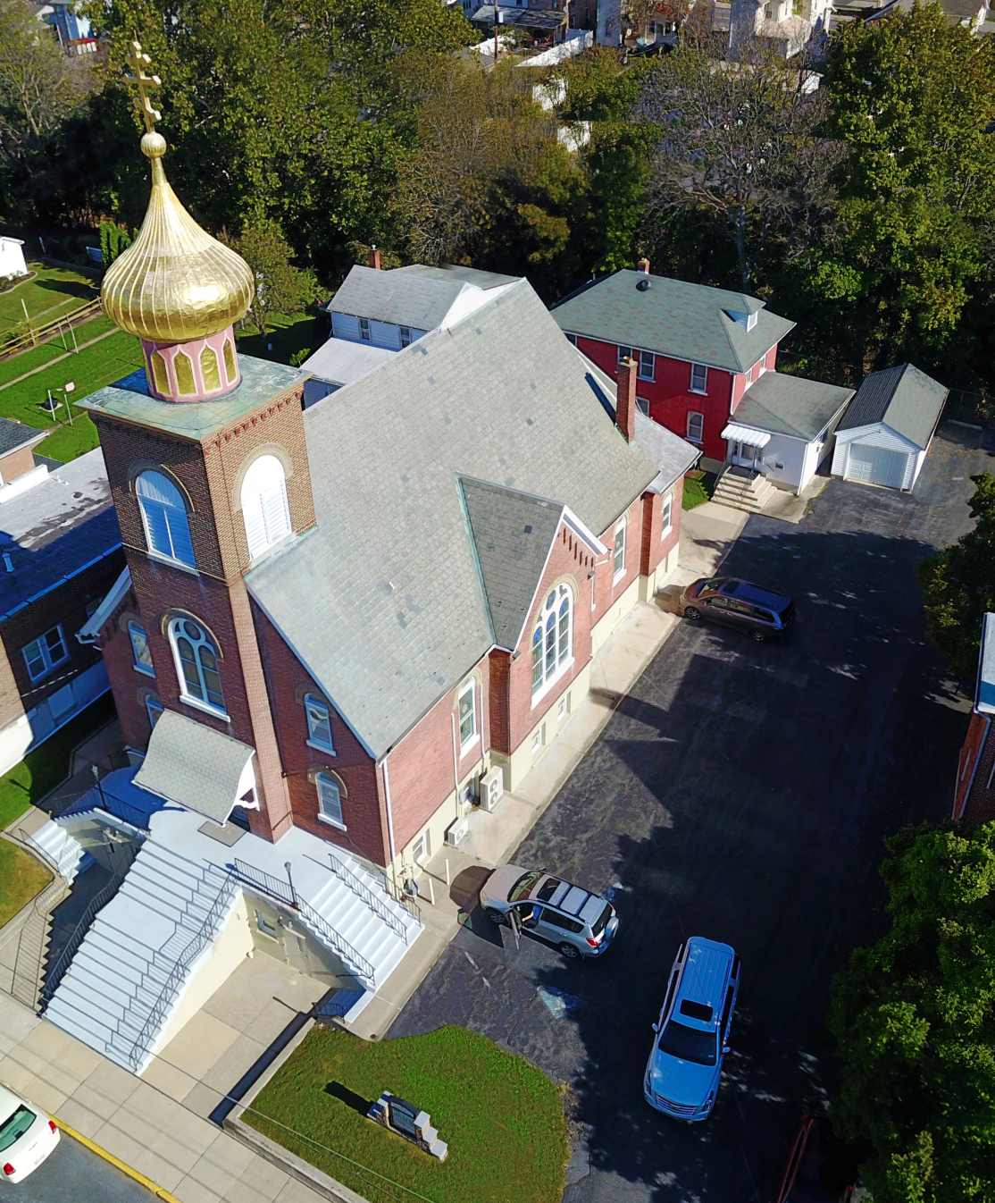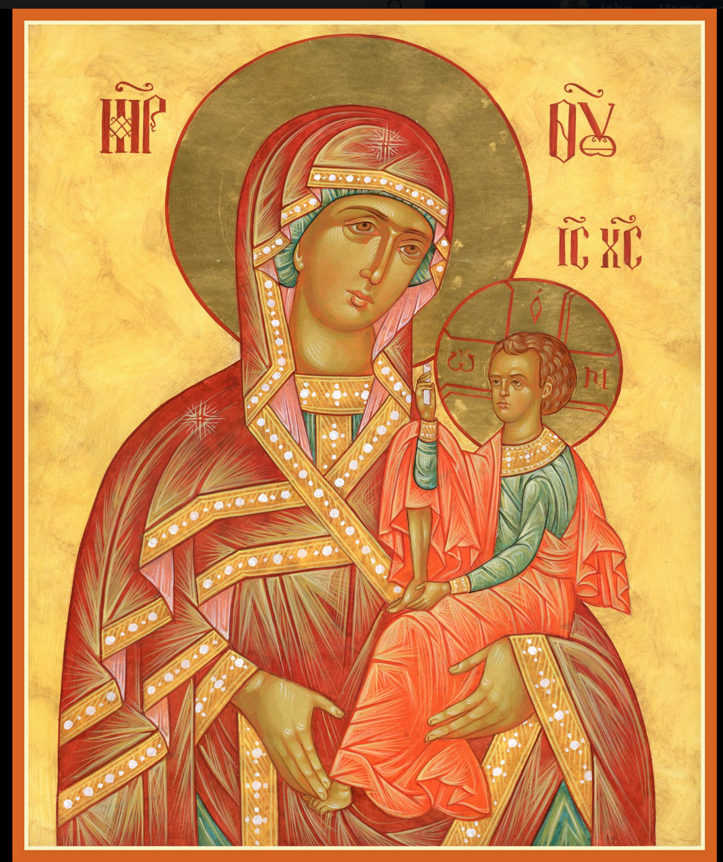

ASSUMPTION OF THE VIRGIN MARY
UKRAINIAN ORTHODOX CHURCH
ECUMENICAL PATRIARCHATE OF CONSTANTINOPLE AND NEW ROME
1301 Newport Avenue
Northampton, Pennsylvania 18067
Mitered Archpriest Myron Oryhon
Protodeacon Mychail Sawarynski, Attached

Telephones: Church Office… (610) 262-2882
Church Fax/Kitchen/Hall… (610) 262-0552
Fr. Myron Oryhon – (607) 752-1999
Protodeacon Mychail’s Residence… (610) 262-3876
Websites: holyassumption.org
ukrainianorthodoxchurchusa.org
lvorthodox.wordpress.com
E-mail: Parish… avmuoc@gmail.com
Protodeacon Mychail…pravoslavni@rcn.com
Webmaster, John Hnatow… john.hnatow@gmail.com
==============================================================
21st April (08th April) 2019
THE ENTRY OF OUR LORD INTO JERUSALEM. PALM SUNDAY. Holy Apostles of the 70; HERODION, AGABUS, ASYNCRITUS, RUFUS, PHLEGON, HERMES (1st C.).
Philippians 4:4-9 John 12: 1-18
Today’s Bulletin, sponsored in loving memory of father, +MARTIN SHESKA, is offered by Michael & Martha Misko
PROPERS FOR LITURGY OF ST. JOHN CHRYSOSTOM
Antiphon One, Tone 1
Verse: I am filled with love, for the Lord will hear the voice of my supplication. Refrain: Through the prayers of the Birth-Giver of God, Savior, save us.
Verse 2: The anguish of death encompassed me, the perils of Hell beset me. Refrain: Through the prayers…
Verse 3: I found tribulation and anguish and I called upon the Name of the Lord. Refrain: Through the prayers…
Verse 4: I will walk before the Lord in the land of the living. Refrain: Through the prayers…
Glory to the Father and to the Son and to the Holy Spirit, now and ever and to the ages of ages. Amen. Refrain: Through the prayers…
Antiphon Two, Tone 2
Verse 1: I believed and therefore I have spoken, but I was sore troubled. Refrain: Son of God, Who was carried on the colt of a donkey, save us who sing to You: Alleluia.
Verse 2: What shall I give to the Lord, for all that He has given to me? Refrain: Son of God…
Verse 3: I will take the cup of salvation and I will call upon the Name of the Lord. Refrain: Son of God…
Verse 4: I will fulfill my vows to the Lord in the presence of all His people. Refrain: Son of God…
Glory to the Father and to the Son and to the Holy Spirit, now and ever and to the ages of ages. Amen. Only Begotten Son…
Antiphon Three, Tone 1
Verse 1: Give thanks to the Lord, for He is Good; for His mercy endures forever.

Tropar, Tone 1: By raising Lazarus from the dead before Your passion, You confirmed the universal resurrection, O Christ God. Like the children with the palms of victory, we cry out to You, O Vanquisher of Death: “Hosanna in the highest! Blessed is He Who
comes in the Name of the Lord.”

Verse 2: Let the House of Israel now confess that He is Good, for His mercy endures forever. Tropar: By raising…

Verse 3: Let the House of Aaron now confess that He is Good; For His mercy endures forever. Tropar: By raising…

Verse 4: Let all who fear the Lord now confess that He is Good; For His mercy endures forever. Tropar: By raising…

Entrance Hymn, Tone 1: Blessed is He Who come in the Name of the Lord. We bless You from the House of the Lord. God is the Lord, and has revealed Himself to us. Tropar: By raising…

Tropar, Tone 2: Christ our God, we have been buried with You through Baptism. Therefore, we have become worthy of immortal Life through Your Resurrection. We cry out to You chanting a hymn of praise: Hosanna in the Highest. Blessed is He Who comes in the Name of the Lord.

Glory to the Father and to the Son and to the Holy Spirit, now and ever and to the ages of ages. Amen.

Kondak, Tone 6: Seated in heaven upon Your throne and on earth upon a colt, Christ our God, You have accepted the praise of the angels and the songs of the children who cried out to You: Blessed is the One Who comes to restore Adam.

Prokimen in Tone 4
Blessed is He Who comes in the Name of the Lord: the Lord is God, and He has appeared to us.

Verse: Give thanks to the Lord, for He is Good, for His mercy endures forever.

Alleluia Verses, Tone 1
Sing to the Lord a new song, for He has done marvelous things.

All the ends of the earth have seen the salvation of our God.

In place of “It is right in truth…”
Magnify, my soul, the Lord Who sat upon a colt.

Irmos, Tone 4: The Lord has appeared to us, let us keep the feast together. Come with great rejoicing, let us magnify Christ with palms and branches. Let us cry aloud: Blessed is He Who comes in the Name of the Lord, Our Savior.

Communion Hymn:
Blessed is He Who comes in the Name of the Lord. God is the Lord and has revealed Himself to us.

LITURGICAL MENEION & SCRIPTURE READINGS
FOR HOLY WEEK
Mon. 22 Apr. GREAT MONDAY. Martyr EUPSYCHIUS (362)
Strict Fast Martyrs DESAN, bishop, MARIABUS, presbyter,
ABDIESUS and 270 other martyrs in Persia (362).
Matthew 21:18-43 Matthew 24:36-26:2
4:00 PM Pre-Sanctified Liturgy; St. Mary’s, Allentown
7:00 PM Bridegroom Matins; St. Mary’s, Allentown

Tue. 23 Apr. GREAT TUESDAY. Martyrs TERENCE, POM-
Strict Fast PEIUS, AFRICANUS, MAXIMUS, ZENO, ALEX-
ANDER, THEODORE & 33 beheaded at Carthage.
Matthew 22:15-23:39 Matthew 24:36-26:2
4:00 PM Pre-Sanctified Liturgy; St. Mary’s, Allentown
7:00 PM Bridegroom Matins; St. Mary’s, Allentown

Wed. 24 Apr. GREAT WEDNESDAY. Martyrs ANTIPAS, Bishop
Strict Fast of Pergamus (68). Martyrs PROCESSUS & MAR-
TINIAN of Rome (67). Ven. PHARMTHIUS (4th C.)
John 12:17-50 Matthew 26:6-16
4:00 PM Pre-Sanctified Liturgy; St. Mary’s, Allentown
5:00 PM EXAMINATION OF CONSCIENCE. GENERAL
CONFESSION AND ABSOLUTION
6:00 PM SACRAMENT OF HOLY UNCTION

Thur. 25 Apr. THE MYSTICAL SUPPER. Ven. BASIL of Parium
Strict Fast: (760). Hieromartyr ZENO, Bishop of Verona (260).
Wine & Oil Ven. ISAAC the Syrian, Abbot of Spoleto (550).
1 Corinthians 11:23-32 Matthew 26:1-40
9:00 AM VESPERAL LITURGY OF BASIL THE GREAT
6:00 PM MATINS & READING OF 12 PASSION GOSPELS

Fri. 26 Apr. GREAT FRIDAY; CRUCIFIXION OF OUR
Strict Fast: LORD AND SAVIOR JESUS CHRIST
Total Abstinence Galatians 6:14-18 Matthew 27;1-56
9:00 AM ROYAL HOURS (1ST, 3RD, 6TH & 9TH )
6:00 PM VESPERS & PLACING THE HOLY SHROUD
IN THE TOMB. ALL NIGHT VIGIL AT GRAVE.

Sat. 27 Apr. HOLY SATURDAY; BLESSED SABBATH;
Fast Day: DESCENT OF THE LORD INTO HADES
Wine & Oil Romans 6:3-11 Matthew 28:1-20
2:30 PM CONFESSIONS
3:00 PM VESPERAL LITURGY OF ST. BASIL THE
GREAT & BLESSING OF PASCHAL FOODS

Sun. 28 Apr. THE BRIGHT RESURRECTION OF CHRIST;
No Fast THE PASCHA OF THE LORD.

5:30 AM MIDNIGHT OFFICE
6:00 AM PROCESSION & PASCHAL MATINS
7:30 AM LITURGY OF ST. JOHN CHRYSOSTOM
& BLESSING OF PASCHAL FOODS

NECROLOGY:
21 April… Antin Masur ’44, Jameleh Azar ‘85
22 April… Alexander Potycha ’62, Michael Lubenesky ‘01
24 April… Ivan Lutyi ‘79
25 April… Mary Gulka ‘55
27 April… Helen Vasilawsky ‘88

VICHNAYA PAMYAT! MEMORY ETERNAL

BIRTHDAYS:
25 April… Andrea Sawarynski

MNOHAYA LITA! MANY YEARS!

WE PRAY FOR THE HEALTH AND WELL-BEING of the ill afflicted: William Savitz, Catherine Kochenash, Fr. Vasyl Dovgan, Vladimir & Emma Krasnopera, Tessie Kuchinos, Brendan Phillips, Jessie Hnatow, Jessica Meashock, Wasyl Hewko, Adam Hewko, Betty Hendrickson, Andrew Thaxton, Michelle Pierzga, Susan Ferretti, Carole Zarayko, William Fischer, Ekaterina Seremula, Marianna Goshow, child born to Ariel Weiller, Judy Albright,

OCMC “AGAPE CANISTER” DONATIONS were $52.00 Thank you for your support of our Missions around the globe.

RELIGIOUS INSTRUCTION CLASS FOR PARISH CHILDREN:
Mrs. Mary Ost – Sundays 9:00-9:30
Mrs. Linda Winters- Apr. 21 – 11 AM; May 5 – 11 AM
Ms. Bettyann Woyewoda – Sundays at 8:40-9:15; April 21; May 5, 12, 19. 26

NEXT PIEROHI SALE WILL BE MAY 9th . Order by May 5th.
Call Helen 610-261-4575 or 484-239-5731. Additional dates are:
May 16 & 23.

SR UOL MEETING MAY 5th following the Coffee Hour.

