APRIL 14, 2019

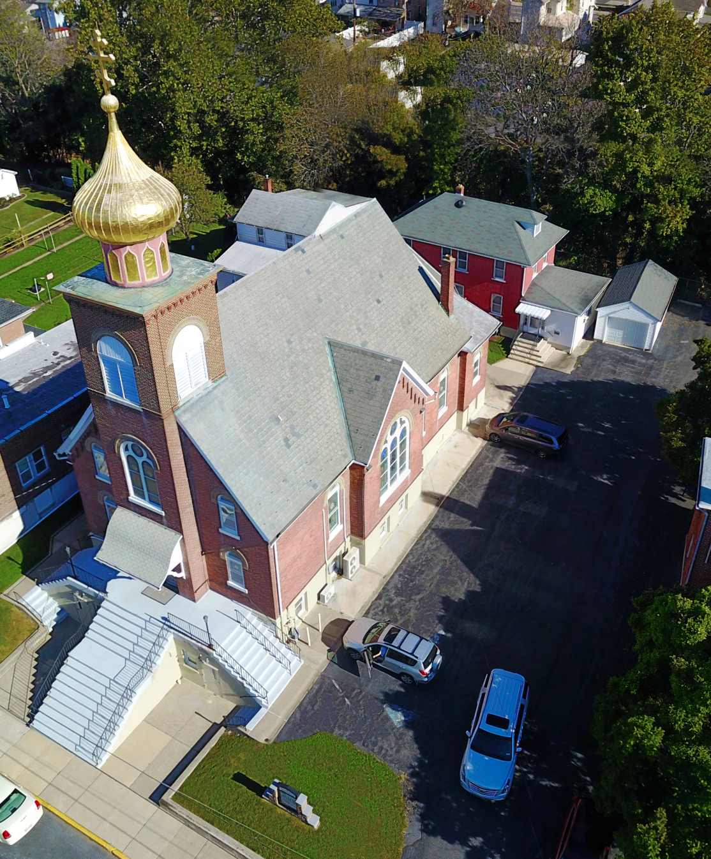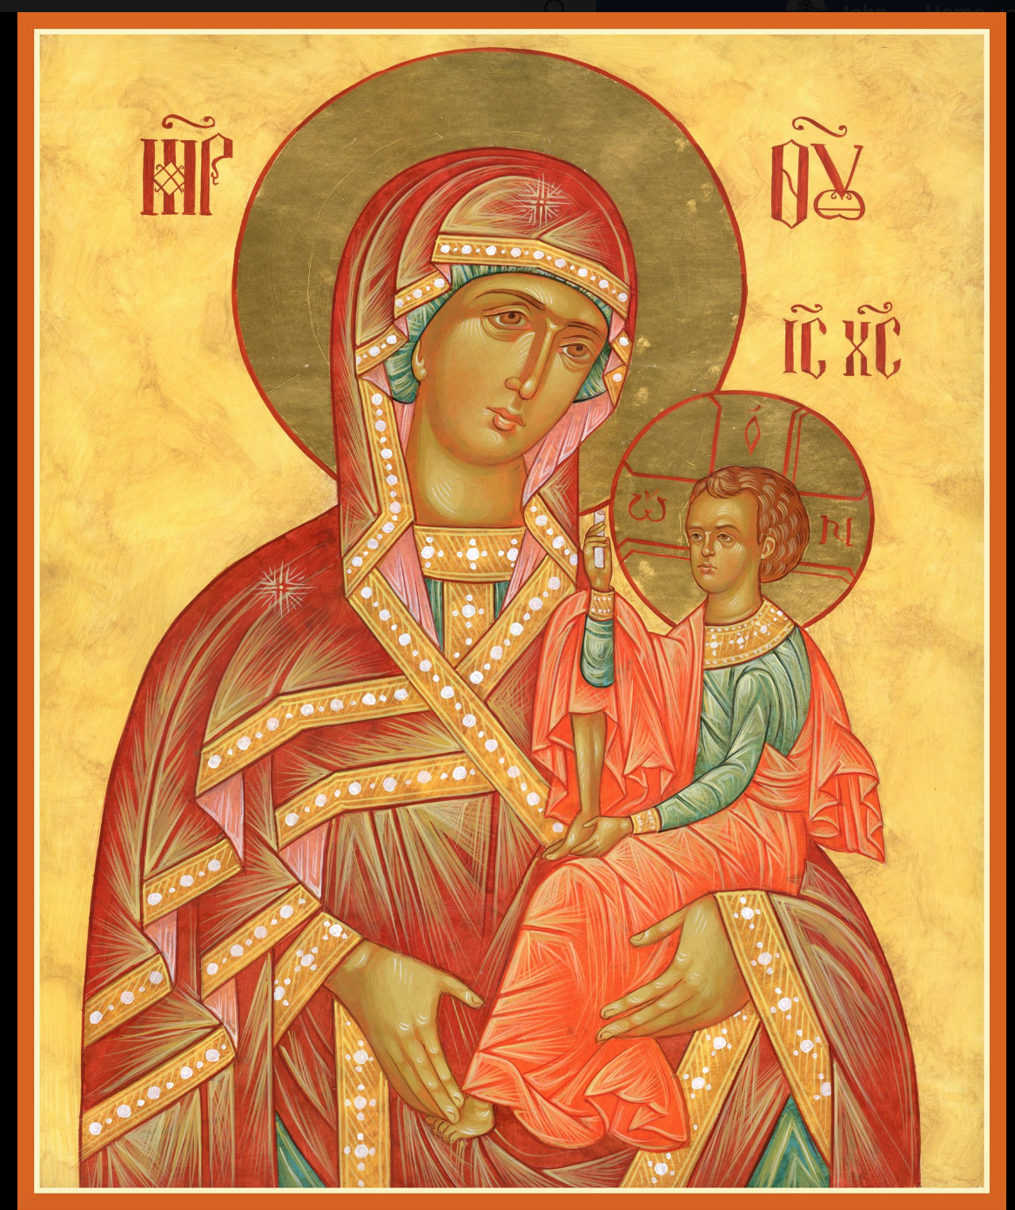

ASSUMPTION OF THE VIRGIN MARY
UKRAINIAN ORTHODOX CHURCH
ECUMENICAL PATRIARCHATE OF CONSTANTINOPLE AND NEW ROME
1301 Newport Avenue
Northampton, Pennsylvania 18067
Mitered Archpriest Myron Oryhon
Protodeacon Mychail Sawarynski, Attached

Telephones: Church Office… (610) 262-2882
Church Fax/Kitchen/Hall… (610) 262-0552
Fr. Myron Oryhon – (607) 752-1999
Protodeacon Mychail’s Residence… (610) 262-3876
Websites: holyassumption.org
ukrainianorthodoxchurchusa.org
lvorthodox.wordpress.com
E-mail: Parish… avmuoc@gmail.com
Protodeacon Mychail…pravoslavni@rcn.com
Webmaster, John Hnatow… john.hnatow@gmail.com
==============================================================
14th April (01st April) 2019
FIFTH SUNDAY OF GREAT LENT. Venerable MARY of Egypt (522). Martyrs GERONCIUS & BASILIDES. Righteous ACHAZ. Ven. MACARIUS, Abbot of Pelecete (840). Tone 5.
Hebrews 9:11-14 Mark 10:32-45 Galatians 3:23-29 Luke 7:36-50

PROPERS FOR LITURGY OF ST. BASIL THE GREAT
Tropar of the Resurrection, Tone 5
Let us, the faithful, praise and worship the Word, co-eternal with the Father and the Spirit, born for our salvation of the Virgin. In His Good Will He was lifted up on the Cross in the flesh to suffer death and to raise the dead, by His glorious Resurrection.
Tropar of the Dormition of the Virgin Mary , Tone 1
In giving birth, you preserved your virginity. In falling asleep you did not forsake the world, Birth-Giver of God. You were translated to life, Mother of Life, and through your prayers you deliver our souls from death.
Tropar to Venerable Mary of Egypt, Tone 8
The image of God was truly preserved in you, O Mother, for you took up the cross and followed Christ. By so doing, you taught us to disregard the flesh, for it passes away, but to care instead for the soul, since it is immortal. Therefore, Holy Mother Mary, your spirit rejoices with the angels.
Kondak of the Resurrection, Tone 5
You descended into Hell, my Savior, destroying its gates as the Almighty, resurrecting the dead as Creator and destroying the sting of death. You have delivered Adam from the curse, Lover of all Mankind. Therefore, we all cry out to You: Lord, save us.
Glory to the Father and to the Son and to the Holy Spirit.
Kondak of the Triodion, Tone 4

Having suffered the temptations of spiritual winter, let us bring renewed souls and the fruit of good deeds, uplifted in spirit. Behold the Bridegroom Christ is drawing near and giving the crowns of sainthood. Let us be attentive that He might find us worthy to accept the eternal crowns.
Now and ever and unto ages of ages. Amen.

Kondak of the Dormition, Tone 2

Neither the tomb nor death had power over the Birth-Giver of God; she is ever watchful in her prayers and in her intercession lies un-failing hope. For as the Mother of Life, she has been translated to life by the One Who dwelt within her ever virginal womb.

Prokimen in Tone 5
You, O Lord, shall protect us and preserve us from this generation forever.

Verse: O Lord, save me for there is no longer any righteous man.

Prokimen for Venerable Mary in Tone 4
God is wondrous in His saints, the God of Israel.

Alleluia Verses, Tone 5
Of Your mercies, O Lord, I will sing forever; unto generation and generation I will proclaim your truth with my mouth.

You have said: Mercy will be established forever and My truth will be prepared in the heavens.

With patience have I waited for the Lord, and He was attentive to me and listened to my supplication.

In place of “It is right in truth…”
All of creation rejoices in you, Lady, Full of Grace, the assembly of angels and the human race, Sanctified Temple and Spiritual Paradise, the Glory of Virgins, from whom God was incarnate and be-came a Child – our God before the ages. He made your body into a throne and your womb more spacious than the heavens. All of creation rejoices in you, Lady Full of Grace, Glory to you!

Communion Hymn:
Praise the Lord from the heavens, praise Him in the highest.
The righteous shall be in everlasting remembrance. He shall not be afraid of any evil report. Alleluia (3X)

LITURGICAL MENEION & SCRIPTURE READINGS
SIXTH WEEK OF GREAT LENT

Sun. 14 April. Fifth Sunday of the Great Fast.
4:00 PM VESPERS at St. Nicholas Cathedral, Bethlehem

Mon. 15 Apr. Ven. TITUS the Wonderworker. Martyrs
Strict Fast AMPHIANUS & EDESIUS of Lycia (306)
Genesis 27:1-41 Proverbs 19:16-25

Tue. 16 Apr. Ven. NICETAS the Confessor, Abbot of Medikion
Strict Fast (824). Virgin-martyr THEODOSIA of Tyre &
Martyr IRENE (306). Ven. ILLYRICUS.
Genesis 31:2-16 Proverbs 21:3-21

Wed. 17 Apr. JOSEPH the Hymnographer of Sicily (883).
Strict Fast GEORGE the monk of Mt. Maleon.
Genesis 43:26-31; 44:1-16 Proverbs 21:23-22:4
4:00 PM PRESANCTIFIED LITURGY St. Mary’s Allentown

Thur. 18 Apr. Martyrs THEODULUS & AGATHOPODES (303).
Strict Fast Monk PUBLIUS of Egypt. PLATO, Abbot of the
Studion (814). THEODORA, nun of Thessalonica.
Genesis:46:1-7 Proverbs 23:15--24:5

Fri. 19 Apr. EUTYCHIUS, Patriarch of Constantinople.
Strict Fast METHODIUS, Enlightener of the Slavs (885).
Genesis 49:33-50:26 Proverbs 31:8-32

6:00 PM VESPERS OF LAZARUS SATURDAY
6:30 PM EXAMINATION OF CONSCIENCE: GENERAL
CONFESSION AND ABSOLUTION
Sat. 20 Apr. RESURRECTION OF RIGHTEOUS LAZARUS.
Fast Day:
Caviar Hebrews 12:28-13:8 John 11:1-45
8:30 AM THIRD & SIXTH HOUR
9:00 AM LITURGY OF ST. JOHN CHRYSOSTOM

5:00 PM FESTAL VESPERS & BLESSING OF PALMS

Sun. 21 Apr. 6th SUNDAY OF GREAT LENT. ENTRY OF THE LORD INTO JERUSALEM; PALM SUNDAY.
Fast Day: Fish
8:30 AM THIRD & SIXTH HOUR

9:00 AM LITURGY OF ST. JOHN CHRYSOSTOM
& BLESSING OF WILLOW BRANCHES

NECROLOGY:
14 April… John Shushinskie ’52, Nicholas Gill ’67, Harry
Kowalchuk ’83, George Kowalchuk ’95. Paul
Kochenash ’99. Volodymyr Pypiuk ‘72
15 April… Anne Yaaremchuk ‘01
17 April… Joakim Krawchuk ’30, Russell Kowalyshyn ’88,
Anna Yost ’03, Jaroslawa Zawierucha ‘12
19 April… Gregory Gal ’30, Olga Sokalsky ‘92
20 April… Martin Sheska ‘12

VICHNAYA PAMYAT! MEMORY ETERNAL

BIRTHDAYS:
17 April… Pani Martha Sawarynski

MNOHAYA LITA! MANY YEARS!

WE PRAY FOR THE HEALTH AND WELL-BEING of the ill afflicted: William Savitz, Catherine Kochenash, Fr. Vasyl Dovgan, Vladimir & Emma Krasnopera, Tessie Kuchinos, Brendan Phillips, Jessie Hnatow, Jessica Meashock, Wasyl Hewko, Adam Hewko, Betty Hendrickson, Andrew Thaxton, Michelle Pierzga, Susan Ferretti, Carole Zarayko, William Fischer, Ekaterina Seremula, Marianna Goshow, child born to Ariel Weiller, Judy Albright,

NORTHAMPTON FOODBANK is still in need of foodstuffs, especially tuna, canned potatoes and baby food.

OCMC “AGAPE CANISTER” DONATIONS were $64.00 Thank you for your support of our Missions around the globe.

RELIGIOUS INSTRUCTION CLASS FOR PARISH CHILDREN:
Mrs. Mary Ost – Sundays 9:00-9:30
Mrs. Linda Winters-Apr. 14- 9 AM; Apr. 21 – 11 AM.
Ms. Bettyann Woyewoda – Sundays at 8:40-9:15; April 14, 21; May 5, 12, 19. 26

NEXT PIEROHI SALE WILL BE APRIL 18th. Order by Apr. 14th. Call Helen 610-261-4575 or 484-239-5731. Additional dates are:
May 9, 16, 23.

JR UOL PASKA SALE: Pick-up on TODAY, Sunday, April 14th.

Continue to collect receipts from “Redner’s Save a Tape Program.

Sunday School students are collecting funds for “HEIFER INTER-NATIONAL”, a global nonprofit charity working to end poverty and hunger through sustainable, community development. It distributes animals and agricultural based training to families in need around the world as a means of providing self-sufficiency. Collection jar is located in the hall on the Coffee Hour table.

SR UOL MEETING MAY 5th following the Coffee Hour.

