April 4, 2021
ASSUMPTION OF THE VIRGIN MARY UKRAINIAN ORTHODOX CHURCH
ECUMENICAL PATRIARCHATE OF CONSTANTINOPLE AND NEW ROME
1301 Newport Avenue, Northampton, Pennsylvania 18067
Rev. Fr. Oleg Kravchenko, Rector
Protodeacon Mikhail Sawarynski, Attached
Websites: holyassumption.org and ukrainianorthodoxchurchusa.org
Facebook: Assumption of the Virgin Mary Ukrainian Orthodox Church
YouTube: AVM UOC Church
Contacts: Fr. Oleg Kravchenko – (732) 507-2274; olegkravchenko2212@gmail.com
Protodeacon Mikhail – (H) (610) 262-3876); pravoslavni@rcn.com
Office – (610) 262-2882; avmuoc@gmail.com
Webmaster, John Hnatow; john.hnatow@gmail.com

Attendance at any Liturgy: If you wish to attend a liturgy, you must sign up by 7:00 PM the evening before the liturgy. Currently, registration is limited to 40 participants. NOTE: If you have signed up but cannot attend the service, please edit your sign up so the slot will be open for someone else.
Sign up here to be on a list of people who will be allowed in our church to attend a liturgy on the specified date
Tune in to our news, announcements, and online Facebook Livestream Liturgies HERE!
Great Vespers: If you wish to attend a Vespers service you must sign up by 7:00 PM Friday. Currently, registration is limited to 40 participants.
Sign up here to be on a list of people who will be allowed in our church to attend a Vespers service on the specified date
Holy Confession: Our Heirarchs have indicated that all parishioners must receive the sacrament of Holy Confession prior to receiving Holy Communion. Father Oleg has scheduled general confessions immediately after Vespers on the first Saturday of each month. Father will also hear confession by appointment on Saturdays.
Sign up here for a Saturday appointment for Holy Confession

Sun. 04 Apr. (Mar. 22) THIRD SUNDAY of the GREAT FAST; ADORATION OF THE HOLY CROSS. TONE 2. Hieromartyr BASIL of Ancyra (362). Martyr DROSIDA of Antioch & the 5 virgins (104). Ven. ISAAC, founder of the Dalmatian Monastery at Constantinople (383).
Hebrews 4:14:-5:6 Mark 8:34-9:1
5:00 PM Passia or the Divine Suffering of Christ (our church)

The Bulletin is sponsored by John and Linda Vitushinsky on their 51st Wedding Anniversary

Liturgical Meneion & Scripture Readings

Mon. 05 Apr. Monk-martyr Nicon and 199 disciples, in Sicily (251).
Is. 14:24-32 Gen. 8:21–9:7 Prov. 11:19–12:6
Tue. 06 Apr. Ven. Zacharias the Recluse of Egypt (4th c.).
Is. 25:1-9 Gen. 9:8-17 Prov. 12:8-22
Wed. 07 Apr. THE ANNUNCIATION OF THE THEOTOKOS.
9:00 AM Divine Liturgy of St. John Chrysostom
Heb. 2:11-18 Lk. 1:24-38
Thu. 08 Apr. Synaxis of the Archangel Gabriel.
Is. 28:14-22 Gen. 10:32–11:9 Prov. 13:20–14:6
Fri. 09 Apr. St. Matrona of Thessalonica (4th c.).
Is. 29:13-23 Gen. 12:1-7 Prov. 14:15-26
Sat. 10 Apr. Memorial Saturday
Heb. 6:9-12 Mk. 7:31-37 1 Thess. 4:13-17 Jn. 5:24-30
9:00 AM Divine Liturgy of St. John Chrysostom
5:00 PM Great Vespers
Sun. 11 Apr. 4th Sunday of the Great Lent. Venerable John Listvychnyk
9:00 AM Divine Liturgy of St. Basil the Great. (40 people; available Online)
5:00 PM Passia or the Divine Suffering of Christ (Allentown)

March 21, 2020 – Assumption of the Virgin Mary Ukrainian Orthodox Church
PROPERS FOR THE LITURGY of BASIL the GREAT
Tropar of the Resurrection, Tone 2
When You descended to death, Life Immortal, You slayed Hell with the splendor of Your Divinity. And when from the depths You raised the dead, all the Powers of Heaven cried out: Giver of Life, Christ our God, glory to You.
Tropar of the Holy Cross, Tone 1
Lord, save Your people and bless Your inheritance. Grant victory to Orthodox Christians over their adversaries. And by Your Cross, preserve Your community.
Glory to the Father and to the Son and to the Holy Spirit. now and ever and to the ages of ages. Amen.
Kondak of the Triodion, Tone 7
The flaming sword no longer guards the gates of Paradise. It has been mysteriously extinguished by the Wood of the Cross. The sting of death and the victory of Hell have been vanquished. For You, O my Savior, came and cried to those in Hell: enter again into Paradise.
Instead of “Holy God, Holy Mighty…”
Before Your Cross, we bow down, O Master, and Your Holy Resurrection, we glorify. (3X)
Prokimen of the Cross, Tone 6
Save Your people, O Lord, and bless Your inheritance.
Verse: O Lord, to You will I call. O my God, be not silent to me.
Reading: Hebrews 4: 14-5:6
Alleluia Verses, Tone 1
Remember Your congregation which You have acquired from old.
God is our King of old.
Verse: He has wrought salvation in the midst of the earth.
Gospel: Mark 8:34-9:1
In place of “It is right in truth…”
All of creation rejoices in you, Lady, Full of Grace, the assembly of angels and the human race, Sanctified Temple and Spiritual Paradise, the Glory of Virgins, from whom God was incarnate and became a Child; our God before the ages. He made your body into aa throne, and your womb more spacious than the heavens. All of creation rejoices n you, Lady Full of Grace, Glory to you!
Communion Hymn
Praise the Lord from the heavens, praise Him in the highest. The light of Your Countenance, O Lord, has been signed upon us. Alleluia (3X)

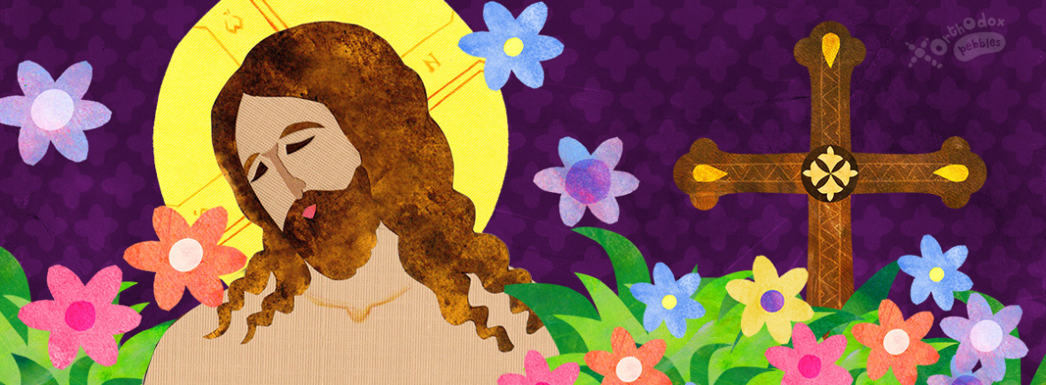

Donations in Memory of Olga Dorosh – Michael & Barbara Baird $50.
SR UOL Cheesecake Sale for PASCHA. Order by 04/18 for delivery on Sunday, 04/25.Cost is $20. Please place orders with Linda Winters
2021 Spring pierogi schedule: April 15; May 6, 13, 20. For orders or volunteers please call Helen: 610-261-4575.
RELIGIOUS EDUCATION: Every Wednesday evening, the Office of Youth Ministry holds 30-minute sessions via Zoom, with a different theme for each week! For details, go to https://www.uocyouth.org/faithhopeandlovehomeedition.
For the food banks: We were assigned baby foods, but they also need cans of potatoes, tuna fish, canned meats, pasta, spaghetti sauce, mac & cheese.

BIRTHDAYS:
06 Apr…David Dworakivsky
07 Apr…Karen Osmun, Walter Dworakivsky
08 Apr…Patricia Kuchinos, Michael Kuchinos, Jared Kroboth
10 Apr…Lara Smallen, Jerome Kroboth
MNOHAYA LITA! MANY YEARS!

NECROLOGY: Allan Bach
04 Apr…Anna Wagel ‘72
05 Apr…Michael Mizhak ’22, Katherine Korutz ’45, Mary Antoniuk ’90,
Mary Grunderom ‘99
06 Apr…Anna Fanok ’69, Olga Tripolone ‘08
07 Apr…Gregory Zaoba ’32, Katherine Wentz ‘78
09 Apr…Volodymyr Burskyj (infant) ’35, Karolina Yarmechuk ’85,
Nicholas Chuyko ’88, Michael Kuchinos ‘03
VICHNAYA PAMYAT! MEMORY ETERNAL!

WE PRAY FOR THE HEALTH AND WELL-BEING of the ill-afflicted: Michael, Raisa, child Oleksandra, child Alexandria, Catherine Kochenash, Joan Molnar, Bill Ketterer, Paul, Richard Stetch, Evan, Brandon and Stacy Snyder, Aaliyah Osmun, Michael Mack, Ihor Broda, James Osmun, Matthew, Tom, William Savitz, Vladimir & Emma Krasnopera, Brendan Phillips, Jessie Hnatow, Jessica Meashock, Adam Hewko, Betty Hendrickson, Andrew Thaxton, Susan Ferretti, Judy Albright, Rob Hewko, Daniel Kochenash, Christopher Mack, Norman Betrous, Luba Walker.

The cross of Jesus Christ is triumphant.
The victory of the cross of Jesus Christ is seen in many places throughout the Bible.
The cross of Jesus Christ triumphs over the law (Col. 2:14).
The cross of Jesus Christ triumphs over sin (Heb. 9:26).
The cross of Jesus Christ triumphs over death (Heb. 2:14-15).
The cross of Jesus Christ triumphs over the devil (John 3:8; Rev. 12:10-11).
The cross of Jesus Christ triumphs overall (Col. 2:15).
Has Jesus Christ triumphed in your life?
The cross of Jesus Christ is primary.
The cross of Jesus Christ was primary in his life (Luke 9:51).
The cross of Jesus Christ is primary in becoming a believer (John 3:16; Matt. 16:24).
The cross of Jesus Christ is primary in glorying God (Gal. 6: 14).

Poem by John Newton
In evil long I took delight,
Unawed by shame or fear,
Till a new object struck my sight,
And stopp'd my wild career:
I saw One hanging on a Tree
In agonies and blood,
Who fix'd His languid eyes on me.
As near His Cross I stood.
Sure never till my latest breath,
Can I forget that look:
It seem'd to charge me with His death,
Though not a word He spoke:
My conscience felt and own'd the guilt,
And plunged me in despair:
I saw my sins His Blood had spilt,
And help'd to nail Him there.
Alas! I knew not what I did!
But now my tears are vain:
Where shall my trembling soul be hid?
For I the Lord have slain!
A second look He gave, which said,
"I freely all forgive;
This blood is for thy ransom paid;
I die that thou may'st live."
Thus, while His death my sin displays
In all its blackest hue,
Such is the mystery of grace,
It seals my pardon too.
With pleasing grief, and mournful joy,
My spirit now if fill'd,
That I should such a life destroy,
Yet live by Him I kill'd!

