MARCH 31, 2019

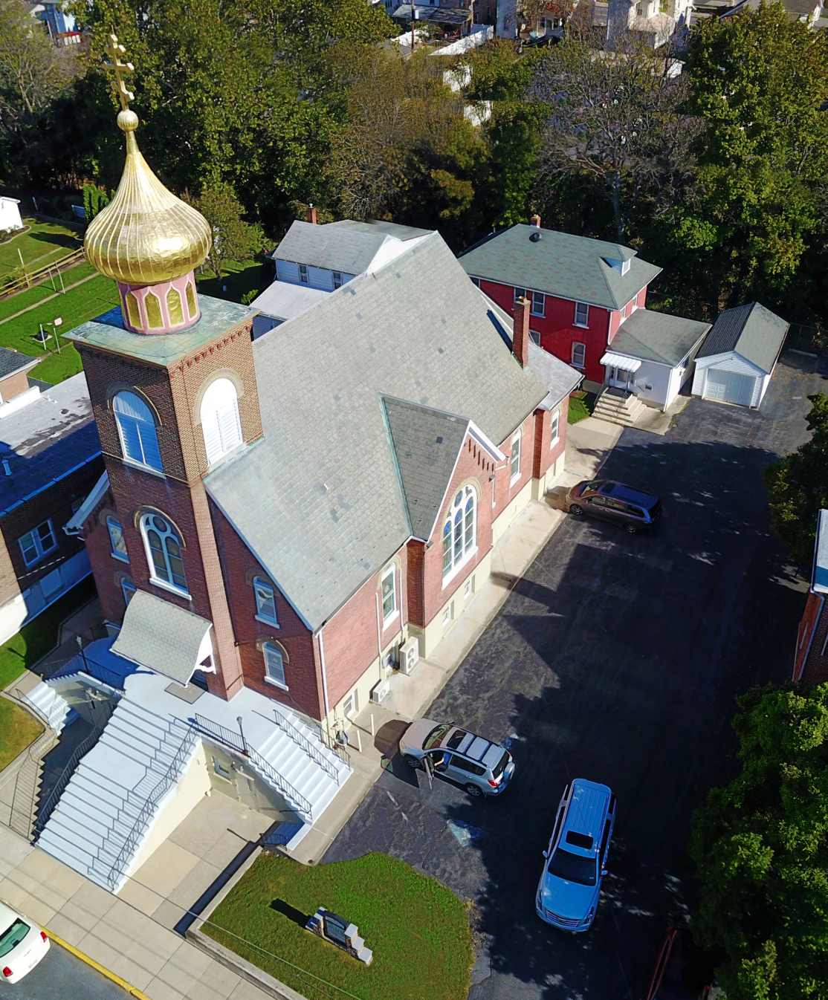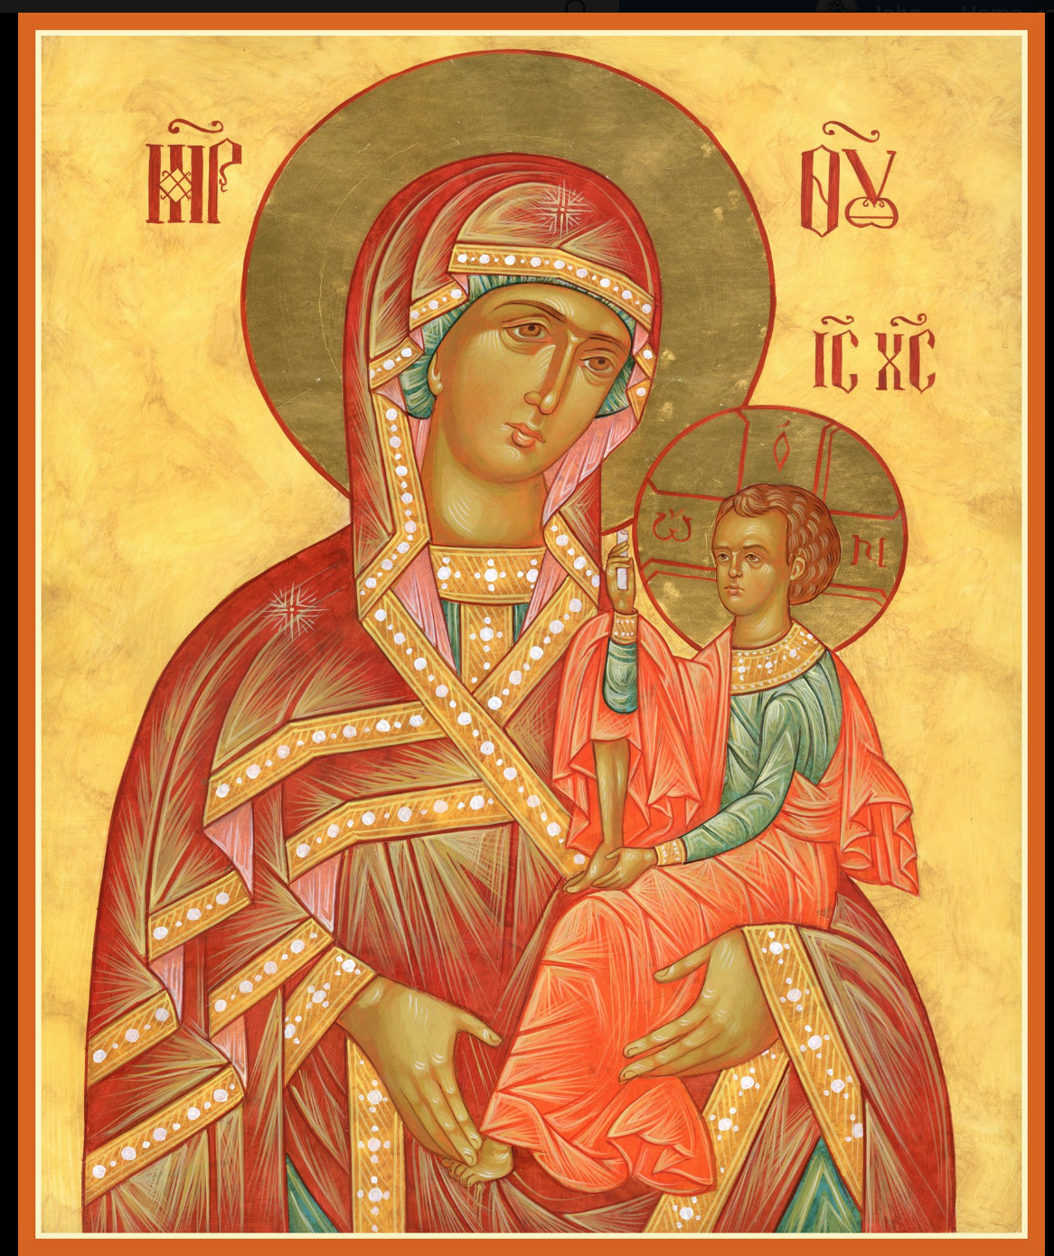

ASSUMPTION OF THE VIRGIN MARY
UKRAINIAN ORTHODOX CHURCH
ECUMENICAL PATRIARCHATE OF CONSTANTINOPLE AND NEW ROME
1301 Newport Avenue
Northampton, Pennsylvania 18067
Mitered Archpriest Myron Oryhon
Protodeacon Mychail Sawarynski, Attached

Telephones: Church Office… (610) 262-2882
Church Fax/Kitchen/Hall… (610) 262-0552
Fr. Myron Oryhon – (607) 752-1999
Protodeacon Mychail’s Residence… (610) 262-3876
Websites: holyassumption.org
ukrainianorthodoxchurchusa.org
lvorthodox.wordpress.com
E-mail: Parish… avmuoc@gmail.com
Protodeacon Mychail…pravoslavni@rcn.com
Webmaster, John Hnatow… john.hnatow@gmail.com
==============================================================
31st March, (18th Mar.) 2019
THIRD SUNDAY OF GREAT LENT. ADORATION of the HOLY PRECIOUS CROSS. Tone 3. CYRIL, Archbishop of Jerusalem (386). Martyrs TROPHIMUS & EUCARPUS of Nicomedia (300).
Hebrews 4:14-5:6 Mark 8:34-9:1

PROPERS FOR LITURGY OF ST. BASIL THE GREAT
Tropar of the Resurrection, Tone 3
Let the heavens rejoice. Let the earth be glad. For the Lord has shown strength with His Arm. He has trampled down death by death. He has become the Firstborn of the Dead. He has delivered us from the depths of Hell and has granted the world great mercy.
Tropar of the Holy Cross, Tone 1
Lord, save Your people and bless Your inheritance. Grant victory to Orthodox Christians over their adversaries. By Your Cross preserve Your people.
Glory to the Father and to the Son and to the Holy Spirit now and ever and unto ages of ages. Amen.
Kondak of the Triodion, Tone 7

The flaming sword no longer guards the gates of Paradise. It has been mysteriously extinguished by the Wood of the Cross. The sting of death and the victory of Hell have been vanquished. For You, O my Savior came and cried to those in Hell: enter again into Paradise

“In place of the Thrice Holy Hymn”
Before Your Cross we bow down, O Master, and Your Holy
Resurrection, we glorify. (3X)

Prokimen in Tone 6
Save Your people, O Lord, and bless Your inheritance.

Verse: O Lord, to You will I call. O my God, be not silent unto me.

Alleluia Verses, Tone 1
Remember Your congregation which You have acquired from old.

God is our King of old. He has wrought salvation in the midst of the earth.
In place of “It is right in truth…”
All of creation rejoices in you, Lady, Full of Grace, the assembly of angels and the human race. Sanctified Temple and Spiritual Paradise, the Glory of Virgins, from whom God was incarnate and became a Child – our God before the ages. He made your body into a throne, and your womb more spacious than the heavens. All of creation rejoices in you, Lady Full of Grace. Glory to you!

Communion Hymn:
Praise the Lord from the heavens, praise Him in the highest.
The light of Your Countenance, O Lord, has been signed upon us. Alleluia(3X)

LITURGICAL MENEION & SCRIPTURE READINGS
FOURTH WEEK OF GREAT LENT

Sun. 31 Mar. Third Sunday of the Great Fast.
4:00 PM VESPERS at St. Paul’s Church, Emmaus.

Mon. 01 Apr. Martyrs CHRYSANTHUS & DARIA and those
Strict Fast with them at Rome. Martyr PANCHARIUS.
Genesis 8:21-9:7 Proverbs 11:19:12:6

Tue. 02 Apr. HOLY MARTYRS slain at St. Sabbas Monastery
Strict Fast (796). PHOTINA & her children (66).
Genesis 9:8-17 Proverbs 12:8-22

Wed. 03 Apr. JAMES the Confessor, Bishop of Studium (8TH C.)
Strict Fast CYRIL, Bishop of Catania (2nd C.) THOMAS, Patriarch of Constantinople (610).
Genesis 9:18-10:1 Proverbs 12:23-13:9
4:00 PM PRESANCTIFIED LITURGY St. Mary’s Allentown

Thur. 04 Apr. Hieromartyr BASIL, Presbyter of Ancyra (362).
Strict Fast Martyr DROSIDA of Antioch & the five virgins.
Genesis 10:32-11:9 Proverbs 13:20-14:6
Fri. 05 Apr. Monk-martyr NICON & 199 disciples (251).
Strict Fast Martyrs PHILETAS, his wife LYDIA & sons.
Genesis 12:1-7 Proverbs 14:15-26
5:30 PM CONFESSIONS; 9th HOUR & TYPICA
6:00 PM LITURGY OF THE PRESANCTIFIED GIFTS
(Fasting from 12:00 Noon, if able)
Soup and Bread will follow in church hall.

Sat. 06 Apr. FOREFEAST OF THE ANNUNCIATION.
Fast Day: Hebrews 6:9-12 Mark 7:31-37
Wine & Oil
9:00- Visitation of the sick and homebound with Holy
12:00 AM Communion (call Father for a time)
2:00 PM LENTEN RETREAT at our parish
5:00 PM FESTAL VESPERS followed by CONFESSIONS

SUN. 07 Apr. 4th SUNDAY OF GREAT LENT. TONE 4
Fast Day: Fish ANNUNCIATION OF THE VIRGIN MARY.
8:30 AM THIRD & SIXTH HOUR; Mystery of Penance
9:00 AM DIVINE LITURGY OF BASIL the GREAT
4:00 PM LENTEN VESPERS at St. Mary’s, Allentown

NECROLOGY:
01 April… Serhiy Kutas ’70, Frank Haas ’04, Gnat Rud ‘80
03 April… Florence Andrus ‘52
04 April… Anna Wagyl ‘72
05 April… Michael Mizhak ’22, Katherine Korutz ’45,
Mary Antoniuk ’90, Mary Grundstrom ‘99
06 April… Anna Fanok ’69, Olga Tripolone ‘08

VICHNAYA PAMYAT! MEMORY ETERNAL

BIRTHDAYS:
03 April… Walter Seremula
06 April… David Dworakivsky

MNOHAYA LITA! MANY YEARS!

WE PRAY FOR THE HEALTH AND WELLBEING of the ill afflicted: William Savitz, Catherine Kochenash, Fr. Vasyl Dovgan, Vladimir & Emma Krasnopera, Tessie Kuchinos, Brendan Phillips, Jessie Hnatow, Jessica Meashock, Wasyl Hewko, Adam Hewko, Betty Hendrickson, Andrew Thaxton, Michelle Pierzga, Susan Ferretti, Carole Zarayko, William Fischer, Ekaterina Seremula, Reader Evhen (Roger) Seremula, Marianna Goshow, child born to Ariel Weiller, Judy Albright, Nancy Stellato

SR UOL cheesecake and nutroll sale. Pick them up at church hall on Saturday, April 13th between 9 and 12 AM.

NORTHAMPTON FOODBANK is still in need of foodstuffs, especially tuna and canned potatoes.

RELIGIOUS INSTRUCTION CLASS FOR PARISH CHILDREN:
Mrs. Mary Ost – Sundays 9:00-9:30
Mrs. Linda Winters- Mar. 31- 9 AM; Apr. 7- 11 AM; Apr. 14- 9 AM
Ms. Bettyann Woyewoda – Sundays at 8:40-9:15; April 7, 14, 21; May 5, 12, 19. 26

OCMC “AGAPE CANISTER” DONATIONS were $29.00. Thank you for your support of our Missions around the globe.

NEXT PIEROHI SALE WILL BE APRIL 4th. Order by MAR. 31st Call Helen 610-261-4575 or 484-239-5731. Additional dates are: April 18, May 9, 16, 23.

JR UOL PASKA SALE: Last Sunday for orders is today. Price is $7.00. Pick them up on Sunday, April 14th. Order sheet is in the hall.

Continue to collect receipts from “Redner’s Save a Tape Program”

Sunday School students are collecting funds for “HEIFER INTERNATIONAL”, a global nonprofit charity working to end poverty and hunger through sustainable, values-based holistic community development. It distributes animals and agricultural and values-based training to families in need around the world as a means of providing self-sufficiency. Collection jar is located in the hall on the Coffee Hour table. Please be generous during this Great Lent.

ADULT EDUCATION CLASS conducted by Fr. Myron will be held today, following the Coffee Hour.

ALL SUNDAY LENTEN VESPERS AT 4 P.M.
Apr. 7 - St. Mary’s Church, Allentown,
Apr. 14 – St. Nicholas Greek Orthodox Cathedral, Bethlehem

LENTEN RETREAT on APRIL 13th at St. Francis Center for Renewal in Bethlehem. The theme will be “SPIRITUAL JOURNEY”.
Guest speakers are Metropolitan Gregory and Fr. Anthony Perkins.
Fee: $45 for adults. Contact Natalie (nsufler@aol.com) reservations.

SR UOL sponsored LENTEN RETREAT in our parish on Saturday,
April 6th beginning at 2 P.M. Fr. Anthony Perkins and members of St. Mary’s of Allentown will join us. If you are interested in any Lenten topics to be discussed, please contact Fr. Myron. Beverages will be provided. Festal Vespers will be celebrated at 5 PM.

FLOWERS FOR THE GRAVE AND PASCHA can be ordered from Bettyann Woyewoda. Order forms are in the Vestibule.

SR UOL MEETING MAY 5th following the Coffee Hour.

Our most sincere gratitude to the SISTERHOOD OF FAITH, HOPE AND LOVE for their donation of the flowers adorning the HOLY, PRECIOUS and LIFE-GIVING CROSS today.

“ORTHODOX AFRICA”
St. Barnabas Orthodox Orphanage and School has 180 children that it cares for; feeding them two meals a day, taking care of their medical needs, educating them and teaching them the Orthodox Faith.
Fr. Methodius Kariuki, rector, plans to build a dormitory to house the children at a cost of $45,000. If you would like to become a “FOUNDER” of the dormitory by sponsoring a child for $250 or if you can give any amount to become a “DONOR”, you and your family (living and dead) will be commemorated at every Liturgy in Kinangop, Kenya in perpetuity. Checks can be made out and sent to St. Nicholas Orthodox Church, P.O. Box 37, McKinney, TX 75070.
Designate “St. Barnabas Orphanage.” If you would prefer to make a cash donation, see Deacon Mikhail and he will send the funds. May this be a part of your joyous Lenten journey.

