MARCH 24, 2019

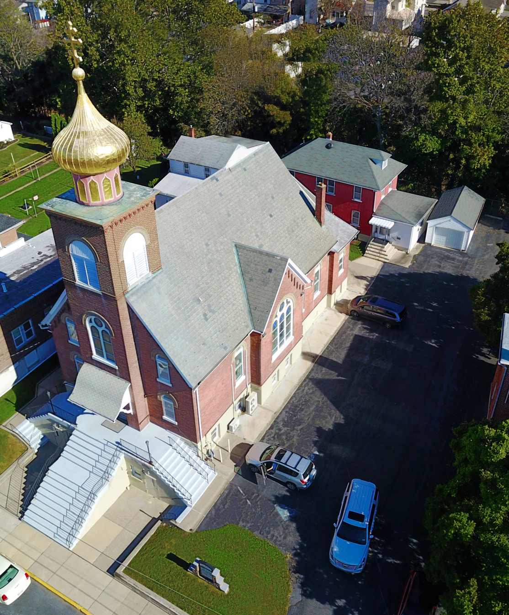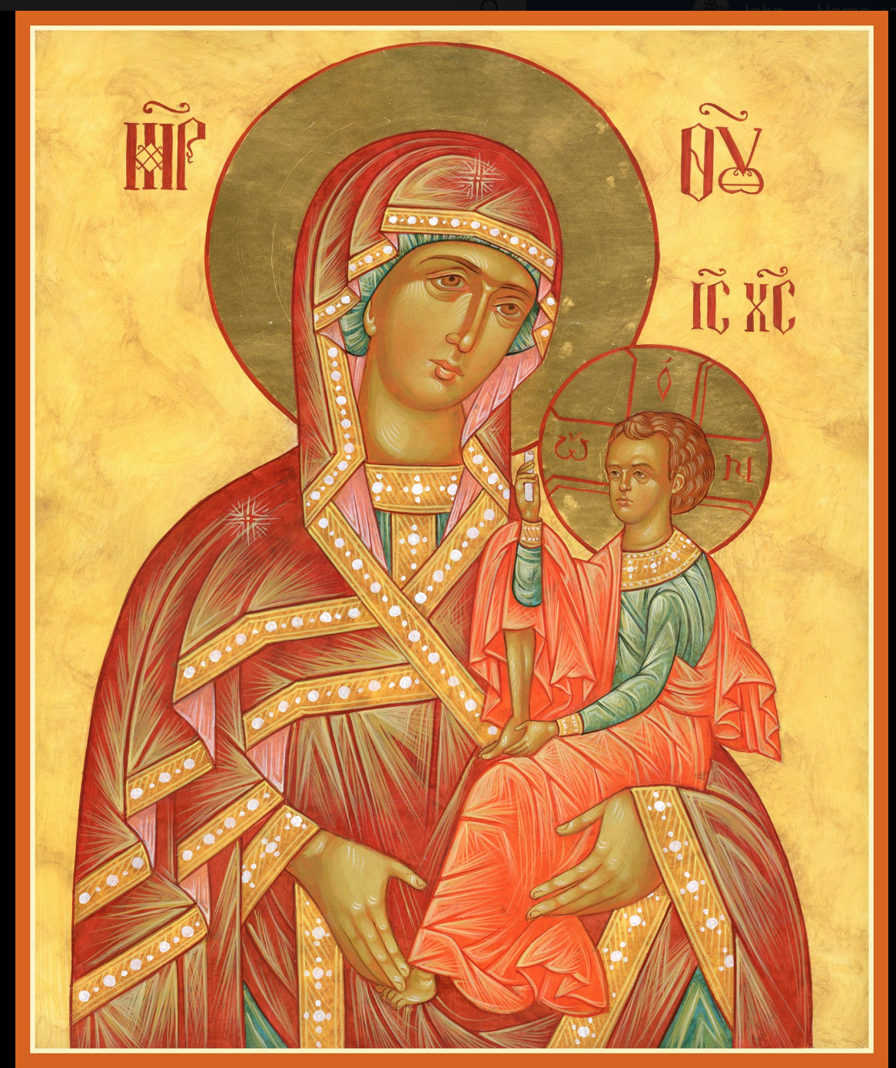

ASSUMPTION OF THE VIRGIN MARY
UKRAINIAN ORTHODOX CHURCH
ECUMENICAL PATRIARCHATE OF CONSTANTINOPLE AND NEW ROME
1301 Newport Avenue
Northampton, Pennsylvania 18067
Mitered Archpriest Myron Oryhon
Protodeacon Mychail Sawarynski, Attached

Telephones: Church Office… (610) 262-2882
Church Fax/Kitchen/Hall… (610) 262-0552
Fr. Myron Oryhon – (607) 752-1999
Protodeacon Mychail’s Residence… (610) 262-3876
Websites: holyassumption.org
ukrainianorthodoxchurchusa.org
lvorthodox.wordpress.com
E-mail: Parish… avmuoc@gmail.com
Protodeacon Mychail…pravoslavni@rcn.com
Webmaster, John Hnatow… john.hnatow@gmail.com
==============================================================
24th March, (11th Mar.) 2019
SECOND SUNDAY OF GREAT LENT. GREGORY PALAMAS Tone 2. Synaxis of the Venerable Fathers of the Kyiv Caves. St. SOPHRONIUS, Patriarch of Jerusalem (638).
Heb. 1:10-2:3 & Heb. 7:26-8:2 Mark 2:1-12 & John 10:9-16
Today’s Bulletin, sponsored in loving memory of +Xenia Sheska is offered by Michael & Martha Misko. Vichnaya Pamyat!
PROPERS FOR LITURGY OF ST. BASIL THE GREAT
Tropar of the Resurrection, Tone 2
When You descended to death, Life Immortal, You slayed Hell with the splendor of Your Divinity. And when from the depths You raised the dead, all the Powers of Heaven cried out: Giver of Life, Christ our God, glory to You.
Tropar of the Dormition of the Virgin Mary, Tone 1
In giving birth, you preserved your virginity. In falling asleep you did not forsake the world, Birth-Giver of God. You were translated to life, Mother of Life, and through your prayers you deliver our souls from death.
Tropar to St. Gregory Palamas, Tone 8
Light of Orthodoxy, support and teacher of the Church, glory of monks and invincible champion of theologians, O Gregory the Wonderworker, pride of Thessalonica and preacher of grace; pray without ceasing for the salvation of our souls.
Kondak of the Triodion, Tone 4
The season of good action has now been revealed and judgment is at the doors. Let us rise, keeping the fast, offering tears of compunction with almsgiving crying out: we have sinned more than the sands of the sea. Forgive us Creator of All, so that we may receive incorruptible crowns.
Glory to the Father and to the Son and to the Holy Spirit…
Kondak to St. Gregory Palamas, Tone 8

Holy and divine organ of wisdom and joyful trumpet of theology, we chant your praises in harmony, divinely inspired Gregory. But as a mind standing before the Primordial Mind guide our mind to Him O Father, that we may cry: Rejoice, preacher of grace.

Now and ever and unto ages of ages. Amen.
Kondak of the Dormition, Tone 2

Neither the tomb nor death had power over the Birth-Giver of God; she is ever watchful in her prayers and in her intercession lies unfailing hope. For as the Mother of Life, she has been translated to life by the One Who dwelt in her ever virginal womb.

Prokimen in Tone 5
You, O Lord, shall protect us and preserve us from this generation forever.

Verse: O Lord, save me for there is no longer any righteous man.

Prokimen of the Triodion, Tone 1
My mouth shall speak of wisdom and the meditation of my heart shall bring forth understanding.

Alleluia Verses, Tone 2
May the Lord answer you in the day of trouble. May the Name of the God of Jacob protect you.

Lord, save the king and hear us on the day we call out to You.

Lord, I will chant of Your mercies forever. With my mouth I will proclaim Your truth from generation to generation.

You have said: Mercy will be built up forever. Your Truth will be established in the heaven.

In place of “It is right in truth…”
All of creation rejoices in you, Lady, Full of Grace, the assembly of angels and the human race. Sanctified Temple and Spiritual Paradise, the Glory of Virgins, from whom God was incarnate and became a Child – our God before the ages. He made your body into a throne, and your womb more spacious than the heavens. All of creation rejoices in you, Lady Full of Grace. Glory to you!

Communion Hymn:
Praise the Lord from the heavens, praise Him in the highest.
The righteous man shall be in everlasting remembrance. He shall not be afraid of any evil report. Alleluia(3X)

LITURGICAL MENEION & SCRIPTURE READINGS
THIRD WEEK OF GREAT LENT

Sun. 24 Mar. Second Sunday of the Great Fast.
4:00 PM VESPERS at St. Nicholas Church, Bethlehem.

Mon. 25 Mar. THEOPANES the Confessor of Sigriane (818).
Strict Fast Righteous PHINEAS, grandson of Aaron. GREGORY DIALOGIST, Pope of Rome (604). SYMEON the New Theologian (1021).
Genesis 6:9-22 Proverbs 8:1-21

Tue. 26 Mar. Translation of the relics of NICEPHORUS the
Strict Fast Confessor. Martyr SABINUS of Egypt (303).
Genesis 7:1-5 Proverbs 8:32-9:11

Wed. 27 Mar. BENEDICT of Nursia, abbot (543). ROSTISLAV,
Strict Fast Prince of Kyiv (1167), THEOGNOSTUS, Metro-
politan of Kyiv and All Rus (1353).
Genesis 7:6-9 Proverbs 9:12-18

Thur. 28 Mar. Martyrs AGAPIUS, PUBLIUS, TIMOLAUS,
Strict Fast ROMULUS, 2 named DIONYSISU & 2 named
ALEXANDER at Caesarea in Palestine (303).
Genesis 7:11-8:3 Proverbs 10:1-22

Fri. 29 Mar. Martyr SABINAS of Hermopolis (303). Martyr
Strict Fast PAPAS of Lycaonia. Apostle ARISTOBULUS of the
70, Bishop of Britain. Hiermartyr ALEXANDER,
Pope of Rome (119). Martyr JULIAN of Anazarbus.
Genesis 8:4-21 Proverbs 10:31-11:12
5:30 PM CONFESSIONS; 9th HOUR & TYPICA
6:00 PM LITURGY OF THE PRESANCTIFIED GIFTS
(Fasting from 12:00 Noon, if able)
Soup and Bread will follow in church hall.

Sat. 30 Mar. MEMORIAL SATURDAY (ALL SOULS)
Fast Day:Oil St. ALEXIS the Man of God in Rome (411)
Hebrews 10:32-38 Mark 2:14-17
9:00 AM GENERAL PARASTAS (Reading of diptychs)

5:00 PM GREAT VESPERS followed by CONFESSIONS

SUN. 31 Mar. 3rd SUNDAY OF GREAT LENT. TONE 3
Fast Day:Oil ADORATION OF THE HOLY CROSS.

8:30 AM THIRD & SIXTH HOUR; Mystery of Penance
9:00 AM DIVINE LITURGY OF BASIL the GREAT
4:00 PM LENTEN VESPERS at St. Nicholas Church,
Bridle Path Rd., Bethlehem

NECROLOGY:
25 March… Helen Kokolus ‘96
26 March… Suzette Kropf ’93, Xenia Sheska ‘12
27 March… Stephen Myc ’30, Constantine Wulchak ’60,
John Gulka ‘89
29 March… Oksana Poshtar ‘07
30 March… Maxim Zuravel ’37, Paul Poticha ‘92

VICHNAYA PAMYAT! MEMORY ETERNAL!

BIRTHDAYS:
24 March… Barbara Baird
25 March… Joseph Keslosky Jr.
26 March… Stephanie Burk
29 March… Martha Misko

MNOHAYA LITA! MANY YEARS!

WE PRAY FOR THE HEALTH AND WELLBEING of the ill afflicted: Rosemarie Pypiuk, William Savitz, Catherine Kochenash, Fr. Vasyl Dovgan, Vladimir & Emma Krasnopera, Tessie Kuchinos, Brendan Phillips, Jessie Hnatow, Jessica Meashock Wasyl Hewko, Adam Hewko, Betty Hendrickson, Andrew Thaxton, Michelle Pierzga, Susan Ferretti, Carole Zarayko, William Fischer, Ekaterina Seremula, Reader Evhen (Roger) Seremula, Marianna Goshow,
child born to Ariel Weiller, Deacon Nicholas Zachary, Judy Albright.

SR UOL is sponsoring a cheesecake and nutroll dale. Nut rolls are $16 and include; apricot, lekvar, raspberry, poppyseed, & coconut. Cheesecakes are $20. Pickup at the church hall on Saturday, April 13th between 9-12 AM. Place orders with Linda (610-837-3076) or Marty (610-682-4458) no later than March 27th.

NORTHAMPTON FOODBANK is still in need of foodstuffs, especially tuna and canned potatoes.

RELIGIOUS INSTRUCTION CLASS FOR PARISH CHILDREN:
Mrs. Mary Ost – Sundays 9:00-9:30
Mrs. Linda Winters – Mar. 24 – 11 AM ; Mar. 31 – 9 AM; April 7 – 11 AM; April 14 – 9 AM
Ms. Bettyann Woyewoda – Sundays at 8:40-9:15; March 24, 31; April 7, 14, 21; May 5, 12, 19. 26

OCMC “AGAPE CANISTER” DONATIONS were $42.00. Thank you for your support of our Missions around the globe.

NEXT PIEROHI SALE WILL BE APRIL 4th. Order by MAR. 31st Call Helen 610-261-4575 or 484-239-5731. Additional dates are: April 18, May 9, 16, 23.

JR UOL PASKA SALE: Last Sunday for orders, Mar. 31st. Price is $7.00. Pickup on Sunday, April 14th. Order sheet is in the Church Hall at the Coffee Hour Table.

To my extended parish family and Father Myron:
I would like to express my gratitude to all of you for all the prayers, cards and wishes for a speedy recovery. Also, to the people who have given me rides back and forth to church since I can no longer drive. You have been very kind to me during this time.
Thanks again, Reader Yevhen Seremula

Continue to collect receipts from “Redner’s Save a Tape Program”

SUNDAY LENTEN VESPERS on March 24th will be at ST. NICHOLAS CHURCH, BETHLEHM beginning at 4 PM.
will be the guest homilist.

ALL SUNDAY LENTEN VESPERS AT 4 P.M.
Mar. 31 – St. Paul’s Church, Emmaus
Apr. 7 - St. Mary’s Church, Allentown,
Apr. 14 – St. Nicholas Greek Orthodox Cathedral, Bethlehem

LENTEN RETREAT on APRIL 13th at St. Francis Center for Renewal in Bethlehem. The theme will be “SPIRITUAL JOURNEY”.
Guest speakers are Metropolitan Gregory and Fr. Anthony Perkins.
Fee: $45 for adults. Contact Natalie (nsufler@aol.com) reservations.

Our most sincere and heartfelt gratitude to the SISTERHOOD of FAITH, HOPE and LOVE for their loving and generous PASCHAL DONATION to the church of $10,000. God bless all of you and many, many years! Mnohay I blahaya lita!

FOCUS NORTH AMERICA
Is observing its 10th anniversary. Last year the 10,542 volunteers of the Fellowship of Orthodox Christians United to Serve, prepared and served 414,273 healthy meals and distributed 69,792 articles of clothing. Would you consider a gift of $10 or more to this ministry? FOCUS North America, PO Box 645039, Pittsburgh, PA 15264-5039.

Hierarchs, priests, deacons, monastics and faithful of the Ukrainian Orthodox Church, the parishioners, the priests who have served this parish, family members and friends of the parish: the members of the Antoniuk family, the Alexander family, the Azar family, the Bochnock family, the Bodnyk family, the Bruchok family, the Busch family, the Chudolyi family, the Chromiak family, the Crayosky family, the Czerkas family, the Dorosh family, the Dowling family, the Drobick family, the Dworakivsky family, the Fanok family, the Fedko family, the Fedorishen family, the Gulka family, the Gretchlevich family, the Hewko family, the Harnaho family, the Hnatow family, the Huzela family, the Isczuk family, the Kereb family, the Kerick family, the Koback family, the Kochenash family, the Kowalchk family, the Korutz family, the Kowalyshyn family, the Krasnopera family, the Kravchuk family, the Kuchinos family, the Kulchycki family, the Kutiansky family, the Lelo family, the Lubenesky family, the Lutyi family, the Martnick family, the Mazur family, the Meashock family, the Metchoe family, the Molnar family, the Micio family, the Nazar family, the Onuschak family, the Parchomenko family, the Pokotello family, the Pontician family, the Porochniak family, the Poticha family, the Pypiuk family, the Sawarynski family, the Sawka family, the Schmall family, the Schur family, the Schuryn family, the Semenovych family, the Seremula family, the Sheska family, the Smallen family, the Teply family, the Tokarzyk family, the Unger family, the Vasilovsky family, the Vitushinsky family, the Voronkevich family, the Werbicky family, the Woyewoda family, the Wulchak family, the Yaremchuk family, the Zadubera family, the Zarayko family, the Zawierucha family, and the Zazworsky family

