MARCH 17, 2019

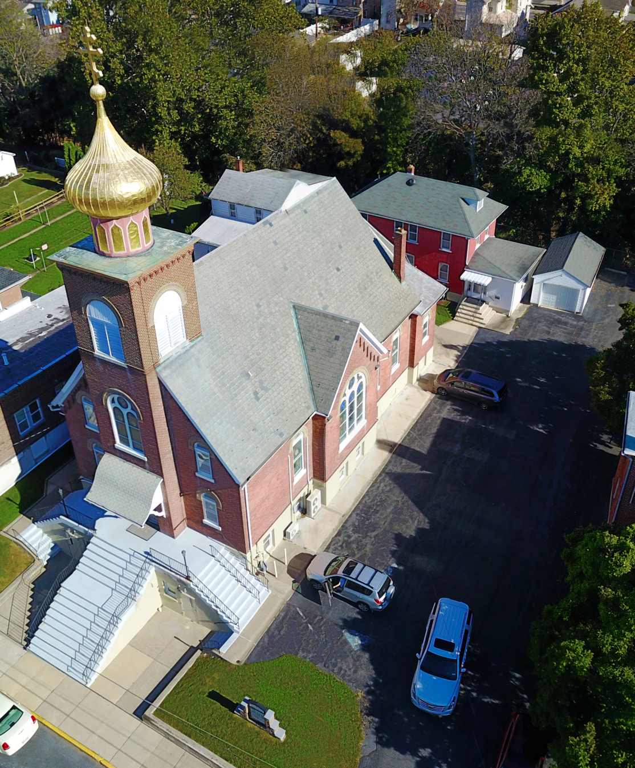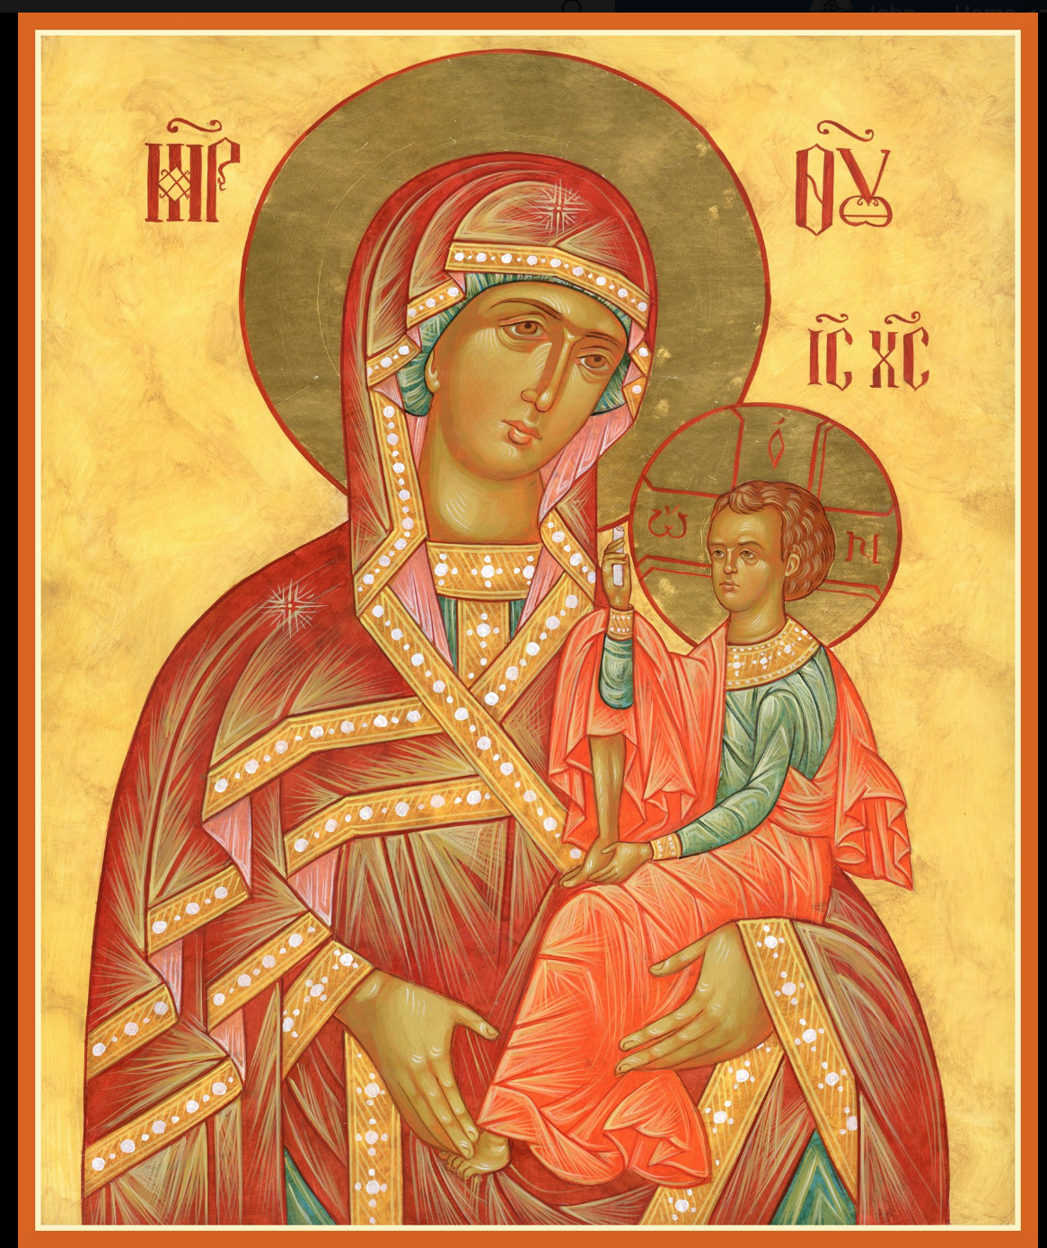

ASSUMPTION OF THE VIRGIN MARY
UKRAINIAN ORTHODOX CHURCH
ECUMENICAL PATRIARCHATE OF CONSTANTINOPLE AND NEW ROME
1301 Newport Avenue
Northampton, Pennsylvania 18067
Mitered Archpriest Myron Oryhon
Protodeacon Mychail Sawarynski, Attached

Telephones: Church Office… (610) 262-2882
Church Fax/Kitchen/Hall… (610) 262-0552
Fr. Myron Oryhon – (607) 752-1999
Protodeacon Mychail’s Residence… (610) 262-3876
Websites: holyassumption.org
ukrainianorthodoxchurchusa.org
lvorthodox.wordpress.com
E-mail: Parish… avmuoc@gmail.com
Protodeacon Mychail…pravoslavni@rcn.com
Webmaster, John Hnatow… john.hnatow@gmail.com
==============================================================
17th March, (04th Mar.) 2019

FIRST SUNDAY OF GREAT LENT. TRIUMPH OF ORTHODOXY Tone 1. GERASIMUS of the Jordan (475). JULIAN, Patriarch of Alexandria (189). JAMES the Faster of Phoenicia. WENCESLAUS, martyr of the Czechs (938). BASILKO, Prince of Rostov (1238)
Hebrews 11:24-26, 32-122:2 John 1:43-51

PROPERS FOR LITURGY OF ST. BASIL THE GREAT
Tropar of the Resurrection, Tone 1
When the stone had been sealed by the Jews, while the soldiers were guarding Your Most Pure Body, You arose on the third day, Savior, granting life to the world. Therefore, the Powers of Heaven cried to You the Giver of Life: Glory to Your Resurrection, Christ. Glory to Your Kingdom. Glory to Your Divine Plan, only Lover of mankind.
Tropar of the Triodion, Tone 2
We venerate Your most pure image, O Good One, asking You to forgive our transgressions, O Christ God. In Your good will it pleased You to ascend the Cross in the flesh and to deliver from enslavement to the enemy those whom You had fashioned. There-fore, we cry out to You in thanksgiving: You have filled all things with joy, O Savior; for You have come to save the world.
Glory to the Father and to the Son and to the Holy Spirit now and ever and to ages of ages. Amen.
Kondak of the Triodion, Tone 8
The uncircumscribed Word of the Father became circumscribed, taking flesh from you, Birth-Giver of God. He has restored the tarnished image to its ancient glory, filling it with divine beauty. We confess this our salvation in word and deed.

Prokimen in Tone 4
Blessed are You, Lord God of our Fathers, praised and glorified is Your Name to the ages.

Verse: For You are righteous in all that You have done for us.

Alleluia Verses, Tone 4
Moses and Aaron are among His Priests and Samuel among those who call upon His Name.

They called upon the Lord and He answered them.

In place of “It is right in truth…”
All of creation rejoices in you, Lady, Full of Grace, the assembly of angels and the human race. Sanctified Temple and Spiritual Paradise, the Glory of Virgins, from whom God was incarnate and be-came a Child – our God before the ages. He made your body into a throne, and your womb more spacious than the heavens. All of creation rejoices in you, Lady Full of Grace. Glory to you!

Communion Hymn:
Praise the Lord from the heavens, praise Him in the highest.
Rejoice in the Lord, you righteous, praise befits the upright. Alleluia(3X)

LITURGICAL MENEION & SCRIPTURE READINGS
SECOND WEEK OF GREAT LENT

Sun. 17 Mar. TRIUMPH OF ORTHODOXY.
4:00 PM VESPERS at St. Philip’s Church, Souderton.

Mon. 18 Mar. Martyrs CONON, ONISIUS of Isauria. Martyr
Strict Fast CONON the Gardener of Pamphylia (251).
Genesis 3:21-4:7 Proverbs 3:34-4:22

Tue. 19 Mar. 42 MARTYRS of Ammoria in Phrygia (845). Un-
Strict Fast covering of the Precious Cross by St. Helen (326).
Genesis 4:8-15 Proverbs 5:1-15

Wed. 20 Mar. Hieromartyrs of Cherson: BASIL, EPHRAIM,
Strict Fast CAPITA, EUGENE, AETHERIUS, ELPIDIUS &
AGATODORUS. PAUL the Simple of Egypt (4th C.)
Genesis 4:16-26 Proverbs 5:15-6:3
Thur. 21 Mar. THEOPHYLACTUS, Bishop of Nicomedia (845)
Strict Fast Apostle HERMAS of the 70. (1st C.)
Genesis 5:1-24 Proverbs 6:3-20

Fri. 22 Mar. FORTY MARTYRS OF SEBASTE (320).
Strict Fast Righteous CAESARIUS. TARASIUS of Liconium.
Genesis 5:32-6:8 Proverbs 6:20-7:1
5:30 PM CONFESSIONS; 9th HOUR & TYPICA
6:00 PM LITURGY OF THE PRESANCTIFIED GIFTS
(Fasting from 12:00 Noon, if able)
Soup and Bread will follow in church hall.

Sat. 23 Mar. MEMORIAL SATURDAY (ALL SOULS)
Fast Day: Oil Hebrews 3:12-16 Mark 1:35-44

9:00 AM GENERAL PARASTAS (Reading of diptychs)

5:00 PM GREAT VESPERS followed by CONFESSIONS

SUN. 24 Mar. 2nd SUNDAY OF GREAT LENT. TONE 2
Fast Day: Oil

8:30 AM THIRD & SIXTH HOUR; Mystery of Penance
9:00 AM DIVINE LITURGY OF BASIL the GREAT
4:00 PM LENTEN VESPERS at St. Nicholas Church,
Bridle Path Rd., Bethlehem

NECROLOGY:
17 March… John Nazar ‘07
18 March… Marianne Proch ‘06
19 March… Michael Pontician ‘52
20 March… Julia Zadubera ‘65
22 March… Gregory Yaremko ‘23

VICHNAYA PAMYAT! MEMORY ETERNAL!

BIRTHDAYS:
18 March… Nadine Savitz
21 March… Brian Ost
24 March… Barbara Baird

MNOHAYA LITA! MANY YEARS!

WE PRAY FOR THE HEALTH AND WELL-BEING of the ill afflicted: Rosemarie Pypiuk, William Savitz, Catherine Kochenash, Fr. Vasyl Dovgan, Vladimir & Emma Krasnopera, Tessie Kuchinos, Brendan Phillips, Jessie Hnatow, Jessica Meashock Wasyl Hewko, Adam Hewko, Betty Hendrickson, Andrew Thaxton, Michelle Pierzga, Susan Ferretti, Carole Zarayko, William Fischer, Ekaterina Seremula, Reader Evhen (Roger) Seremula, Marianna Goshow,
child born to Ariel Weiller, Deacon Nicholas Zachary.

SR UOL is sponsoring a cheesecake and nutroll dale. Nut rolls are $16 and include; apricot, lekvar, raspberry, poppyseed, & coconut. Cheesecakes are $20. Pick-up at the church hall on Saturday, April 13th between 9-12 AM. Place orders with Linda (610-837-3076) or Marty (610-682-4458) no later than March 27th.

NORTHAMPTON FOODBANK is still in need of foodstuffs, especially tuna and canned potatoes.

RELIGIOUS INSTRUCTION CLASS FOR PARISH CHILDREN:
Mrs. Mary Ost – Sundays 9:00-9:30
Mrs. Linda Winters – Mar. 17 – 9 AM; Mar. 24 – 11 AM ; Mar. 31 – 9 AM; April 7 – 11 AM; April 14 – 9 AM
Ms. Bettyann Woyewoda – Sundays at 8:40-9:15; March 17, 24, 31; April 7, 14, 21; May 5, 12, 19. 26

OCMC “AGAPE CANISTER” DONATIONS were $48.00. Thank you for your support of our Missions around the globe.

NEXT PIEROHI SALE WILL BE MARCH 21ST. Order by Mar. 17th. Call Helen 610-261-4575 or 484-239-5731. Additional dates are: April 4 & 18; May 9, 16, 23.

Continue to collect receipts from “Redner’s Save a Tape Program”.

JR UOL PASKA SALE: Last Sunday for orders, Mar. 31st. Price is $7.00. Pick-up on Sunday, April 14th. Order sheet is in the Church Hall at the Coffee Hour Table.

SUNDAY OF ORTHODOXY VESPERS on March 17th will be at ST. PHILIP’S CHURCH, SOUDERTON, PA. beginning at 4 PM.
Fr. John Parker will be the guest homilist.

ALL SUNDAY LENTEN VESPERS AT 4 P.M.
Mar. 24 – St. Nicholas Church, Bridle Path Rd., Bethlehem.
Mar. 31 – St. Paul’s Church, Emmaus
Apr. 7 - St. Mary’s Church, Allentown,
Apr. 14 – St. Nicholas Greek Orthodox Cathedral, Bethlehem

LENTEN RETREAT on APRIL 13th at St. Francis Center for Renewal in Bethlehem. The theme will be “SPIRITUAL JOURNEY”.
Guest speakers are Metropolitan Gregory and Fr. Anthony Perkins.
Fee: $45 for adults. Contact Natalie (nsufler@aol.com) reservations.

Our most sincere and heartfelt gratitude to the SISTERHOOD of FAITH, HOPE and LOVE for their loving and generous PASCHAL DONATION to the church of $10,000. God bless all of you and many, many years! Mnohay I blahaya lita!

FOCUS NORTH AMERICA
Is observing its 10th anniversary. Last year the 10,542 volunteers of the Fellowship of Orthodox Christians United to Serve, prepared and served 414,273 healthy meals and distributed 69,792 articles of clothing. Would you consider a gift of $10 or more to this ministry: FOCUS North America, PO Box 645039, Pittsburgh, PA 15264-5039.

LENTEN RECIPE
BEET SALAD:
1 lg. jar of sauerkraut (drain & rinse) 1 onion sliced
1 can of kidney beans (drain & rinse) 3 boiled potatoes, diced
2 jars of pickled beets, sliced 1 jar of pickles, sliced

Mix all ingredients, add pepper & oil to taste. Serve cold.

Hierarchs, priests, deacons, monastics and faithful of the Ukrainian Orthodox Church, the parishioners, the priests who have served this parish, family members and friends of the parish: the members of the Antoniuk family, the Alexander family, the Azar family, the Bochnock family, the Bodnyk family, the Bruchok family, the Busch family, the Chudolyi family, the Chromiak family, the Crayosky family, the Czerkas family, the Dorosh family, the Dowling family, the Drobick family, the Dworakivsky family, the Fanok family, the Fedko family, the Fedorishen family, the Gulka family, the Gretchlevich family, the Hewko family, the Harnaho family, the Hnatow family, the Huzela family, the Isczuk family, the Kereb family, the Kerick family, the Koback family, the Kochenash family, the Kowalchk family, the Korutz family, the Kowalyshyn family, the Krasnopera family, the Kravchuk family, the Kuchinos family, the Kulchycki family, the Kutiansky family, the Lelo family, the Lubenesky family, the Lutyi family, the Martnick family, the Mazur family, the Meashock family, the Metchoe family, the Molnar family, the Micio family, the Nazar family, the Onuschak family, the Parchomenko family, the Pokotello family, the Pontician family, the Porochniak family, the Poticha family, the Pypiuk family, the Sawarynski family, the Sawka family, the Schmall family, the Schur family, the Schuryn family, the Semenovych family, the Seremula family, the Sheska family, the Smallen family, the Teply family, the Tokarzyk family, the Unger family, the Vasilovsky family, the Vitushinsky family, the Voronkevich family, the Werbicky family, the Woyewoda family, the Wulchak family, the Yaremchuk family, the Zadubera family, the Zarayko family, the Zawierucha family, and the Zazworsky family

