MARCH 10, 2019

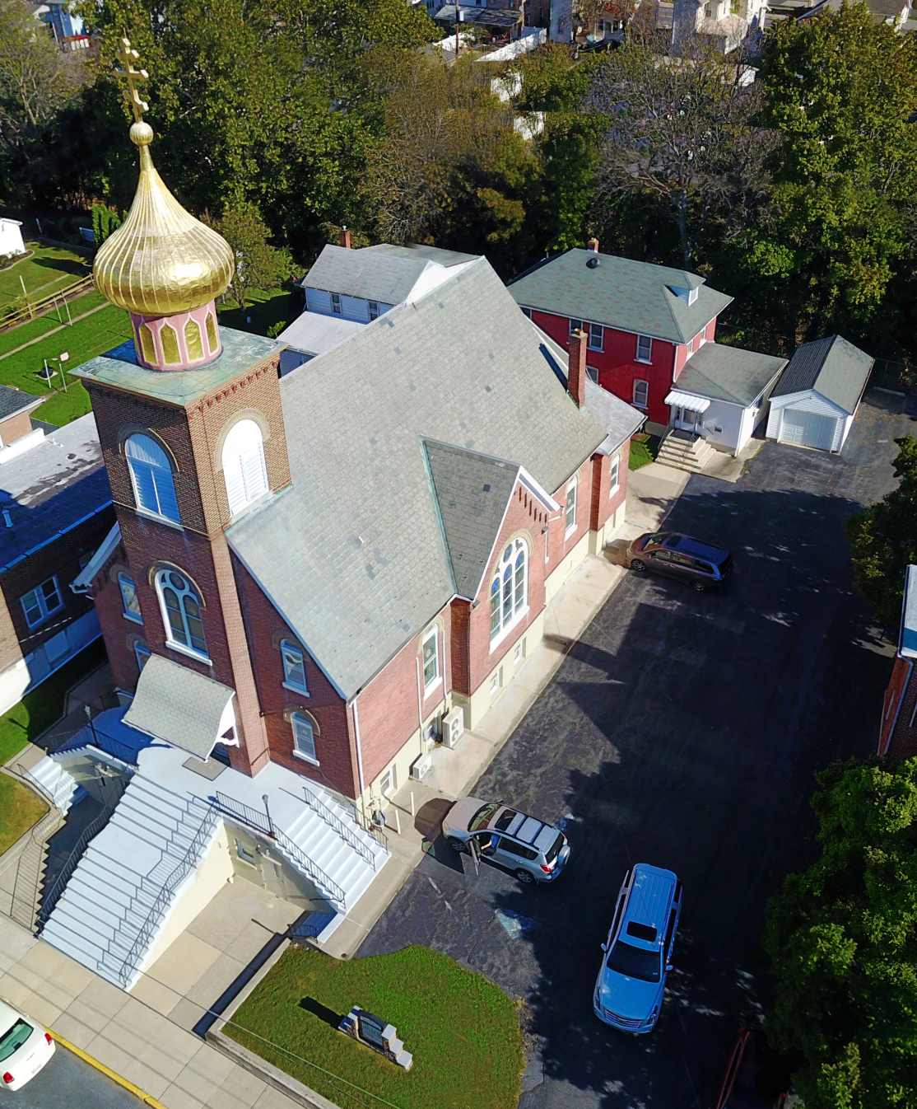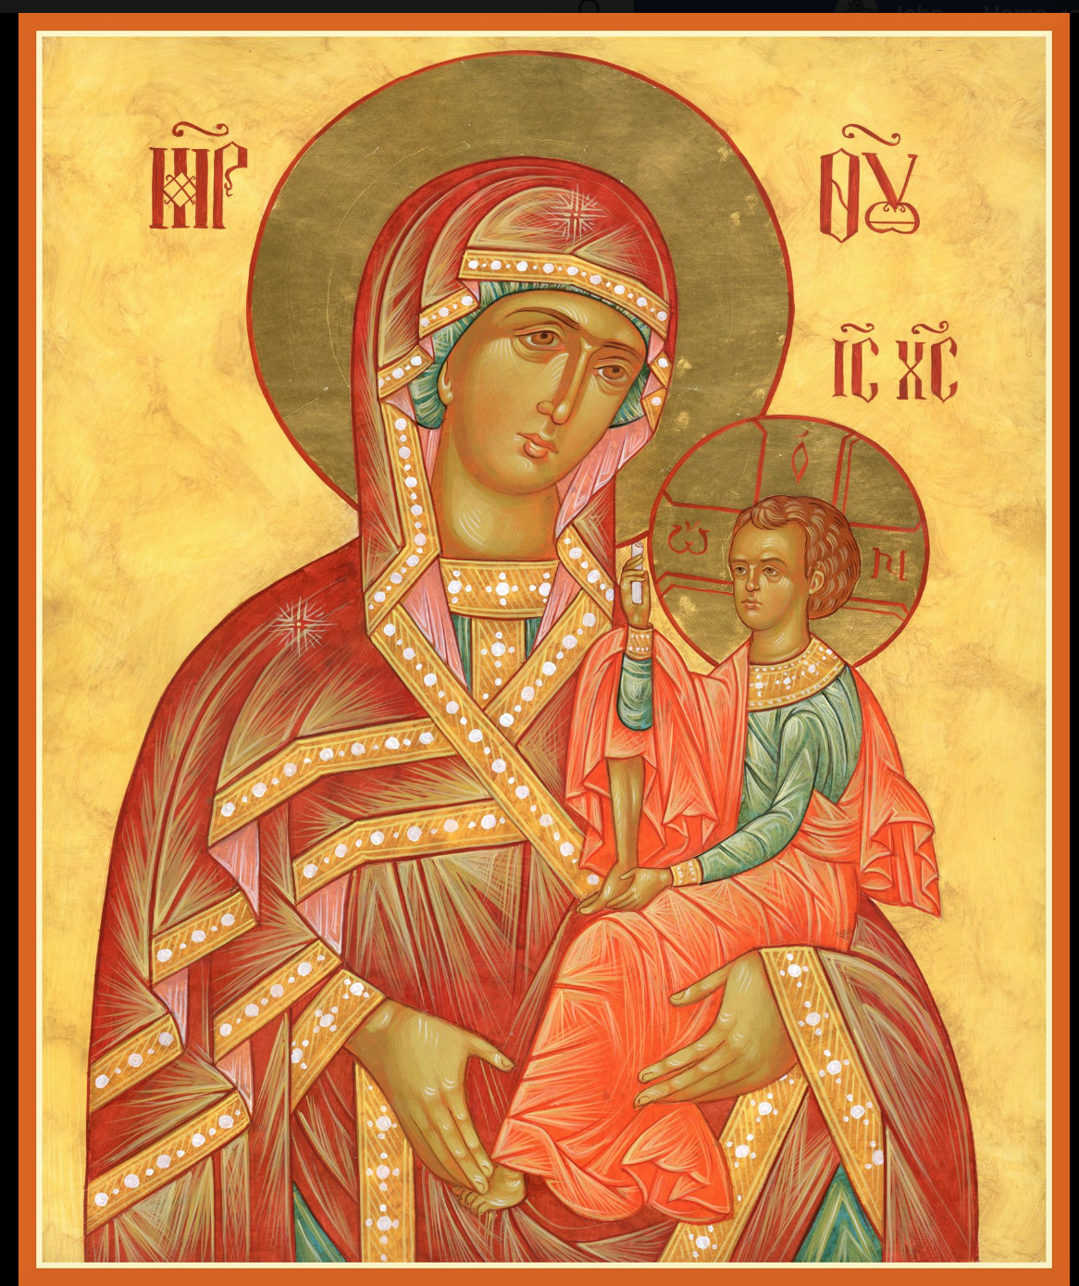

ASSUMPTION OF THE VIRGIN MARY
UKRAINIAN ORTHODOX CHURCH
ECUMENICAL PATRIARCHATE OF CONSTANTINOPLE AND NEW ROME
1301 Newport Avenue
Northampton, Pennsylvania 18067
Mitered Archpriest Myron Oryhon
Protodeacon Mychail Sawarynski, Attached

Telephones: Church Office… (610) 262-2882
Church Fax/Kitchen/Hall… (610) 262-0552
Fr. Myron Oryhon – (607) 752-1999
Protodeacon Mychail’s Residence… (610) 262-3876
Websites: holyassumption.org
ukrainianorthodoxchurchusa.org
lvorthodox.wordpress.com
E-mail: Parish… avmuoc@gmail.com
Protodeacon Mychail…pravoslavni@rcn.com
Webmaster, John Hnatow… john.hnatow@gmail.com
==============================================================
10th March, (25th Feb.) 2019

CHEESEFARE SUNDAY, OF FORGIVENESS. Tone 8.
Expulsion of Adam from Paradise. TARASIUS, Archbishop of Constantinople (806). Last day before the Great Fast.

Romans 13: 11-14:4 Matthew 6: 14-21

Today’s Bulletin, sponsored in loving memory of mother,
+Mary Praetorius is offered by John & Linda Vitushinsky
PROPERS FOR LITURGY OF ST. JOHN CHRYSOSTOM
Tropar of the Resurrection, Tone 8
You descended from on high, Merciful One. You accepted the three day burial to free us from our passions. Lord, our Life and Resurrection, Glory to You.
Tropar of the Dormition of the Birth-Giver of God, Tone 1
In giving birth, you preserved your virginity. In falling asleep you did not forsake the world, Birth-Giver of God. You were translated to life, Mother of Life, and through your prayers you deliver our souls from death.
Glory to the Father and to the Son and to the Holy Spirit…
Kondak of the Triodion, Tone 6
O Master, Guide to wisdom, Giver of prudent counsel, Instructor of the foolish and Champion of the poor; make my heart steadfast by granting it understanding. O Word of the Father, grant me words, for behold, I shall not stop my lips from crying out to You: I am fallen, have mercy on me in Your Compassion.
Now and ever and to the ages of ages. Amen.
Kondak of the Dormition, Tone 2
Neither the tomb nor death had power over the Birth-Giver of God; she is ever watchful in her prayers and in her intercession lies un- failing hope. For as the Mother of Life, she has been translated to life by the One Who dwelt in her ever-virginal womb.

Prokimen in Tone 3
Make your vows and pay them to the Lord our God.

Verse: In Judah God is known; His Name is great in Israel.

Alleluia Verses, Tone 6
It is good to give praise to the Lord, and to sing unto Your Name, O Most High.

To declare Your mercy in the morning and Your Truth by night.

Communion Hymn:
Praise the Lord from the heavens, praise Him in the highest.
Rejoice in the Lord, you righteous, praise befits the upright. Alleluia(3X)

LITURGICAL MENEION & SCRIPTURE READINGS
FIRST WEEK OF GREAT LENT

Sun. 10 Mar. The beginning of the Great Fast at sundown.
4:00 PM FORGIVENESS VESPERS in our church.

Mon. 11 Mar. PORPHYRIUS, Bishop of Gaza (420).
Strict Fast: Martyr SEBASTIAN (66)
Bread, fruit & Genesis 1:1-13 Proverbs 1:1-20
Vegetables CANON OF ST. ANDREW OF CRETE, Part 1
7:00 PM St. Mary’s Church in Allentown

Tue. 12 Mar. PROCOPIUS the Confessor (750). THALELAEUS,
Strict Fast hermit of Syria. TITUS the Soldier of Kyiv Caves.
Genesis 1:14-23 Proverbs 1:20-33
CANON OF ST. ANDREW OF CRETE; Part 2
7:00 PM St. Mary’s Church in Allentown

Wed. 13 Mar. BASIL the Confessor (747). Hieromartyr NESTOR,
Strict Fast Bishop of Magydos. Sts. MARANA & CYANNA.
Genesis 1:24-2:3 Proverbs 2:1-22
CANON OF ST. ANDREW OF CRETE; Part 3
7:00 PM St. Mary’s Church in Allentown

Thur. 14 Mar. Martyr EUDOCIA of Heliopolis (152). Martyrs
Strict Fast NESTOR, TRIBIMUS, MACELLUS & ANTHONY.
Genesis 2:4-19 Proverbs 3:1-18
CANON OF ST. ANDREW OF CRETE; Part 4
7:00 PM St. Mary’s Church in Allentown

Fri. 15 Mar. Hieromartyr THEODOTUS, Bishop of Cyrenia.
Strict Fast Virgin-martyr EUTHALIA. Martyr TROADIUS.
Genesis 2:20-3:20 Proverbs 3:19-34
5:30 PM CONFESSIONS; 9th HOUR & TYPICA
6:00 PM LITURGY OF THE PRESANCTIFIED GIFTS
(Fasting from 12:00 Noon, if able)
Soup and Bread will follow in church hall.

Sat. 16 Mar. Great Martyr THEODORE of Tyre (306).
Fast Day: Oil 2 Timothy 2:1-10 John 15:17-16:2
9:00 AM CANON OF INTERCESSION to Great Martyr
THEODORE OF TYRE & Blessing of Kolyva

5:00 PM GREAT VESPERS followed by CONFESSIONS

SUN. 17 Mar. TRIUMPH OF ORTHODOXY. TONE 1
Fast Day: Oil GERASIMUS of Jordan. JULIAN, Patriarch of
Alexandria. JAMES the Faster of Phoenicia.

8:30 AM THIRD & SIXTH HOUR; Mystery of Penance
9:00 AM DIVINE LITURGY OF BASIL the GREAT
4:00 PM ORTHODOXY VESPERS at St. Philip’s Church
in Souderton. Fr. John Parker, guest homilist.

PARISH COUNCIL MEETING, MARCH 13TH AT 7:00 PM

NECROLOGY:
10 March… Michael Andrushkiw ’31, John Zyrebecky ’76,
Mary Praetorius ‘05
11 March… Anna Metchoe ’97. Anna Turick ‘09
14 March…Michael Czepeliak ’26, Anna Tokarzyk ‘88
16 March…Mary Gill ’48, Anna Onuschak ‘66

VICHNAYA PAMYAT! MEMORY ETERNAL!

BIRTHDAYS:
10 March… Keith Rippey
12 March…Victor Harnaho
13 March…Julie Mauser

MNOHAYA LITA! MANY YEARS!

WE PRAY FOR THE HEALTH AND WELL-BEING of the ill afflicted: Rosemarie Pypiuk, William Savitz, Catherine Kochenash, Fr. Vasyl Dovgan, Vladimir & Emma Krasnopera, Tessie Kuchinos, Brendan Phillips, Jessie Hnatow, Jessica Meashock Wasyl Hewko, Adam Hewko, Betty Hendrickson, Andrew Thaxton, Michelle Pierzga, Susan Ferretti, Carole Zarayko, William Fischer, Ekaterina Seremula, Reader Evhen (Roger) Seremula, Marianna Goshow,
child born to Ariel Weiller

SR UOL is sponsoring a cheesecake and nutroll dale. Nut rolls are $16 and include; apricot, lekvar, raspberry, poppyseed, & coconut. Cheesecakes are $20. Pick-up at the church hall on Saturday, April 13th between 9-12 AM. Place orders with Linda (610-837-3076) or Marty (610-682-4458) no later than March 27th.

NORTHAMPTON FOODBANK is still in need of foodstuffs, especially tuna and canned potatoes.

NEXT PIEROHI SALE WILL BE ON MARCH 21st . Order by Mar. 17th . Call Helen at 610-261-4575 or 484-239-5731. Additional dates: April 4 & 18. May 9, 16, 23.

RELIGIOUS INSTRUCTION CLASS FOR PARISH CHILDREN:
Mrs. Mary Ost – Sundays 9:00-9:30
Mrs. Linda Winters – Mar. 10 – 11 AM; Mar. 17 – 9 AM; Mar. 24 – 11 AM ; Mar. 31 – 9 AM; April 7 – 11 AM; April 14 – 9 AM
Ms. Bettyann Woyewoda – Sundays at 8:40-9:15; March 17, 24, 31; April 7, 14, 21; May 5, 12, 19. 26

OCMC “AGAPE CANISTER” DONATIONS were $33.00. Thank you for your support of our Missions around the globe.

Continue to collect receipts from “Redner’s Save a Tape Program.”

JR UOL PASKA SALE: Last Sunday for orders, Mar. 31st. Price is $7.00. Pick-up on Sunday, April 14th. Order sheet is in the Church Hall at the Coffee Hour Table.

SUNDAY OF ORTHODOXY VESPERS on March 17th will be at ST. PHILIP’S CHURCH, SOUDERTON, PA. beginning at 4 PM.
Fr. John Parker will be the guest homilist.

ALL SUNDAY LENTEN VESPERS AT 4 P.M.
Mar. 24 – St. Nicholas Church, Bridle Path Rd., Bethlehem.
Mar. 31 – St. Paul’s Church, Emmaus
Apr. 7 - St. Mary’s Church, Allentown,
Apr. 14 – St. Nicholas Greek Orthodox Cathedral, Bethlehem

LENTEN RETREAT on APRIL 13th at St. Francis Center for Renewal in Bethlehem. The theme will be “SPIRITUAL JOURNEY”.
Guest speakers are Metropolitan Gregory and Fr. Anthony Perkins.
Fee: $45 for adults. Contact Natalie (nsufler@aol.com) reservations.

Our most sincere and heartfelt gratitude to the SISTERHOOD of FAITH, HOPE and LOVE for their loving and generous PASCHAL DONATION to the church of $10,000. God bless all of you and many, many years! Mnohay I blahaya lita!

Hierarchs, priests, deacons, monastics and faithful of the Ukrainian Orthodox Church, the parishioners, the priests who have served this parish, family members and friends of the parish: the members of the Antoniuk family, the Alexander family, the Azar family, the Bochnock family, the Bodnyk family, the Bruchok family, the Busch family, the Chudolyi family, the Chromiak family, the Crayosky family, the Czerkas family, the Dorosh family, the Dowling family, the Drobick family, the Dworakivsky family, the Fanok family, the Fedko family, the Fedorishen family, the Gulka family, the Gretchlevich family, the Hewko family, the Harnaho family, the Hnatow family, the Huzela family, the Isczuk family, the Kereb family, the Kerick family, the Koback family, the Kochenash family, the Kowalchk family, the Korutz family, the Kowalyshyn family, the Krasnopera family, the Kravchuk family, the Kuchinos family, the Kulchycki family, the Kutiansky family, the Lelo family, the Lubenesky family, the Lutyi family, the Martnick family, the Mazur family, the Meashock family, the Metchoe family, the Molnar family, the Micio family, the Nazar family, the Onuschak family, the Parchomenko family, the Pokotello family, the Pontician family, the Porochniak family, the Poticha family, the Pypiuk family, the Sawarynski family, the Sawka family, the Schmall family, the Schur family, the Schuryn family, the Semenovych family, the Seremula family, the Sheska family, the Smallen family, the Teply family, the Tokarzyk family, the Unger family, the Vasilovsky family, the Vitushinsky family, the Voronkevich family, the Werbicky family, the Woyewoda family, the Wulchak family, the Yaremchuk family, the Zadubera family, the Zarayko family, the Zawierucha family, and the Zazworsky family

