Mar. 07, 2021
ASSUMPTION OF THE VIRGIN MARY UKRAINIAN ORTHODOX CHURCH
ECUMENICAL PATRIARCHATE OF CONSTANTINOPLE AND NEW ROME
1301 Newport Avenue, Northampton, Pennsylvania 18067
Rev. Fr. Oleg Kravchenko, Rector
Protodeacon Mikhail Sawarynski, Attached
Websites: holyassumption.org and ukrainianorthodoxchurchusa.org
Facebook: Assumption of the Virgin Mary Ukrainian Orthodox Church
YouTube: AVM UOC Church
Contacts: Fr. Oleg Kravchenko – (732) 507-2274; olegkravchenko2212@gmail.com
Protodeacon Mikhail – (H) (610) 262-3876); pravoslavni@rcn.com
Office – (610) 262-2882; avmuoc@gmail.com
Webmaster, John Hnatow; john.hnatow@gmail.com

Attendance at any Liturgy: If you wish to attend a liturgy, you must sign up by 7:00 PM the evening before the liturgy. Currently, registration is limited to 40 participants. NOTE: If you have signed up but cannot attend the service, please edit your sign up so the slot will be open for someone else.
Sign up here to be on a list of people who will be allowed in our church to attend a liturgy on the specified date
Tune in to our news, announcements, and online Facebook Livestream Liturgies HERE!
Great Vespers: If you wish to attend a Vespers service you must sign up by 7:00 PM Friday. Currently, registration is limited to 40 participants.
Sign up here to be on a list of people who will be allowed in our church to attend a Vespers service on the specified date
Holy Confession: Our Heirarchs have indicated that all parishioners must receive the sacrament of Holy Confession prior to receiving Holy Communion. Father Oleg has scheduled general confessions immediately after Vespers on the first Saturday of each month. Father will also hear confession by appointment on Saturdays.
Sign up here for a Saturday appointment for Holy Confession

Sun. 07 Mar. (Feb. 22) MEATFARE SUNDAY. THE LAST JUDGMENT. TONE 6. Uncovering the relics of the Holy Martyrs at Eugenius Gate in Constantinople Ss. THALASSIUS. LIMNAEUS & BARADATES, hermits of Syria. ATHANASIUS the Confessor of Constantinople. (826).
1 Corinthians 8: 8-9:2 Matthew 25: 31-46

THE BULLETIN IS SPONSORED IN MEMORY OF ELIZABETH PAUKOVITZ
(1ST ANNIVERSARY OF HER REPOSE).

Liturgical Meneion & Scripture Readings For The Next Week (Cheesefare)

Mon. 08 Mar. Hieromartyr Polycarp, bishop of Smyrna (167).
3 Jn. 1:1-15 Lk. 19:29-40; 22:7-39
Tue. 09 Mar. First and Second Findings of the Precious Head of St. John the Baptist.
Jud. 1:1-10 Lk. 22:39-42, 45–23:1
Wed. 10 Mar. St. Tarasius, archbishop of Constantinople (806).
Joel. 2:12-26 Joel. 4:12-21
Thu. 11 Mar. St. Porphyrius, bishop of Gaza (420). Martyr Sebastian (66).
Jude 1:11-25 Lk. 23:1-34, 44-56
Fri. 12 Mar. St. Procopius the Confessor of Decapolis (ca. 750).
Zech. 8:7-17 Zech. 8:19-23
Sat. 13 Mar. All of the venerable fathers, lit up with great deeds.
Rom. 14:19-26 Mt. 6:1-13
5:00 PM Great Vespers.
Sun. 14 Mar. Cheesefare Sunday, of Forgiveness. The Last day before the Great Lent
Rom. 13:11–14:4 Mt. 6:14-21
9:00 AM Divine Liturgy (restriction of 40 people; Also available Online)
5:00 PM FORGIVENESS VESPERS

PROPERS FOR THE LITURGY of JOHN CHRYSOSTOM
Tropar of the Resurrection, Tone 6
The angelic powers were at Your tomb. The guards became as dead men. Mary stood by Your grave seeking Your Most Pure Body. You captured Hell, not being tempted by it. You came to the Virgin, granting Life. Lord, risen from dead, glory to You.
Tropar of the Dormition of the Virgin Mary, Tone 1
In giving birth, you preserved your virginity. In falling asleep you did not forsake the world, Birth-Giver of God. You were translated to life, Mother of Life and through your prayers you deliver our souls from death.
Glory to the Father and to the Son and to the Holy Spirit.
Kondak of the Triodion, Tone 1
When You come to the earth in Glory, O God, all creation will tremble. The river of fire will flow before Your Judgment Seat. The books will be opened and all secrets disclosed. Deliver me then from the unquenchable fire and count me worthy to stand at Your Right Hand, Most Righteous Judge.
Now and ever and to the ages of ages. Amen.
Kondak of the Dormition, Tone 2
Neither the tomb nor death had power over the Birth-Giver of God. She is ever watchful in her prayers and in her intercession lies unfailing hope. For as the Mother of Life, she has been translated to life, by the One Who dwelt within her ever-virginal womb.
Prokimen Tone 3, Great is our Lord and great is His power. His understanding is beyond measure.
Verse: Praise the Lord, for a psalm is good; let praise be sweet unto our God.
Reading: 1 Corinthians 8:8-9:2
Alleluia Verses: Come let us rejoice in the Lord. Let us shout with joy to God our Savior.
Verse: Let us come before His Countenance with thanksgiving; and with psalms let us shout with joy to Him.
Gospel: Matthew 25: 31-46
Hymn to the Mother of God:
It is right in truth, to glorify you, the Birth-Giver of God, the Ever Blessed wholly immaculate and the Mother of our God. More honorable than the Cherubim and beyond compare more glorious than the Seraphim. You, who without defilement did bare God the Word, true Birth-Giver of God, we magnify you.
Communion Hymn
Praise the Lord from the heavens, praise Him in the highest. Rejoice in the Lord you righteous. Praise befits the upright. Alleluia (3X)
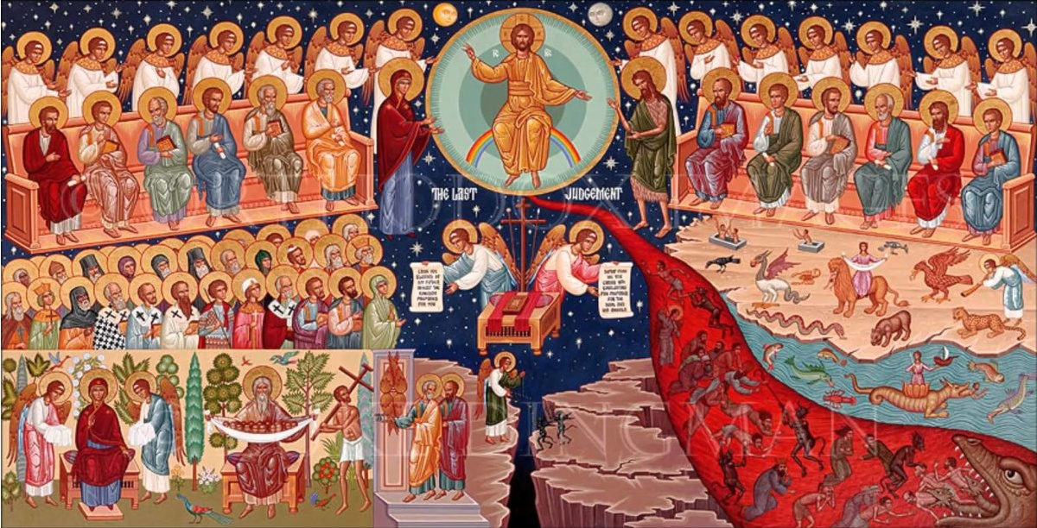

Saturday night, March 14th we change our clocks to one hour ahead.
Council meeting: Wednesday, March 10 at 7:00 PM.
2021 Spring pierogi schedule: March 18; April 1, 15; May 6, 13, 20. For orders or volunteers please call Helen: 610-261-4575.
EASTER NUT ROLL SALE. $16 each! Different fillings - apricot, prune, nut, poppyseed, red raspberry, pumpkin/cheese, coconut cream, apple. Pick-up: Sat., March 27, 9-12. Call for orders: Marty 610-682-4458. Last day for orders – March 15. Please wear masks.
RELIGIOUS EDUCATION: Every Wednesday evening, the Office of Youth Ministry holds 30-minute sessions via Zoom, with a different theme for each week! For details, go to https://www.uocyouth.org/faithhopeandlovehomeedition.
For the food banks: We were assigned baby foods, but they also need cans of potatoes, tuna fish, canned meats, pasta, spaghetti sauce, mac & cheese.
BIRTHDAYS: MNOHAYA LITA! MANY YEARS!
07 Mar…John Hnatow
10 Mar…Keith Rippey
12 Mar…Victor Garnaho
NECROLOGY:
02 Mar…Elizabeth Paukovitz (First Anniversary)
07 Mar…Mary Werbicky
09 Mar…Walter Zarayko ‘94
10 Mar…Michael Andrushkiv ’31, John Zyrebecky ’76, Mary Praaetorius ‘05
11 Mar…Anna Metchoe ’97, Anna Turick ‘09
VICHNAYA PAMYAT! MEMORY ETERNAL!
WE PRAY FOR THE HEALTH AND WELL-BEING of the ill-afflicted: Pani Mary Ann Cherkas, child Oleksandra, Catherine Kochenash, Joan Molnar, Bill Ketterer, Paul, Richard Stetch, Evan, Brandon and Stacy Snyder, Aaliyah Osmun, Olga Dorosh, Michael Mack, Allan Bach, Ihor Broda, James Osmun, Matthew, Tom, William Savitz, Vladimir & Emma Krasnopera, Brendan Phillips, Jessie Hnatow, Jessica Meashock, Adam Hewko, Betty Hendrickson, Andrew Thaxton, Susan Ferretti, Judy Albright, Rob Hewko, Daniel Kochenash, Christopher Mack, Norman Betrous, Luba Walker.
St Theophan the Recluse: All the things we have to do, great or small, should be done as though the eyes of God were looking at us. Every visitor or every person we meet should be welcome as a messenger from God. The first question we should always ask inwardly is this: what does the Lord wish me to do with or for this person? We should receive everyone as though they were the image of God, reverencing them and ready to help them all we can.
“The Least of These”
“Let the nations be roused; let them advance into the Valley of Jehoshaphat, for there I will sit to judge all the nations on every side.” Joel 3:12
Is your life marked by the desire to give or to get?
A Dreadful Judgment:
1. This is a judgment that occurs when Christ returns.
2. The basis of the judgment is charity.
3. For God’s people it still shows the heart that God desires.
Hearts that Give:
1. Jesus was willing to reward those who gave.
2. They were surprised they didn’t see themselves as charitable.
Calloused Hearts:
1. Jesus cast out those who didn’t give.
2. They were surprised they didn’t see themselves as uncharitable.
3. Which type of heart do you have?
“Not so with you. Instead, whoever wants to become great among you must be your servant, and whoever wants to be first must be your slave-just as the Son of Man did not come to be served, but to serve, and to give his life as a ransom for many.” Matthew 20:26-28

• At times He was hungry, as when He was tempted in the wilderness and remained righteous for you.

• At times He was thirsty especially when He suffered on the cross.

• At times He was a stranger. His own hometown rejected Him and sought to kill Him.

• At times He was naked, for the soldiers stripped Him bare before they drove the nails into His hands and feet.

• At times He, too, was sick. For He bore your sickness and infirmity on the cross.

• And while He was never imprisoned, He was put into the brutal custody of Roman guards who scourged Him before His death.

