MARCH 03, 2019

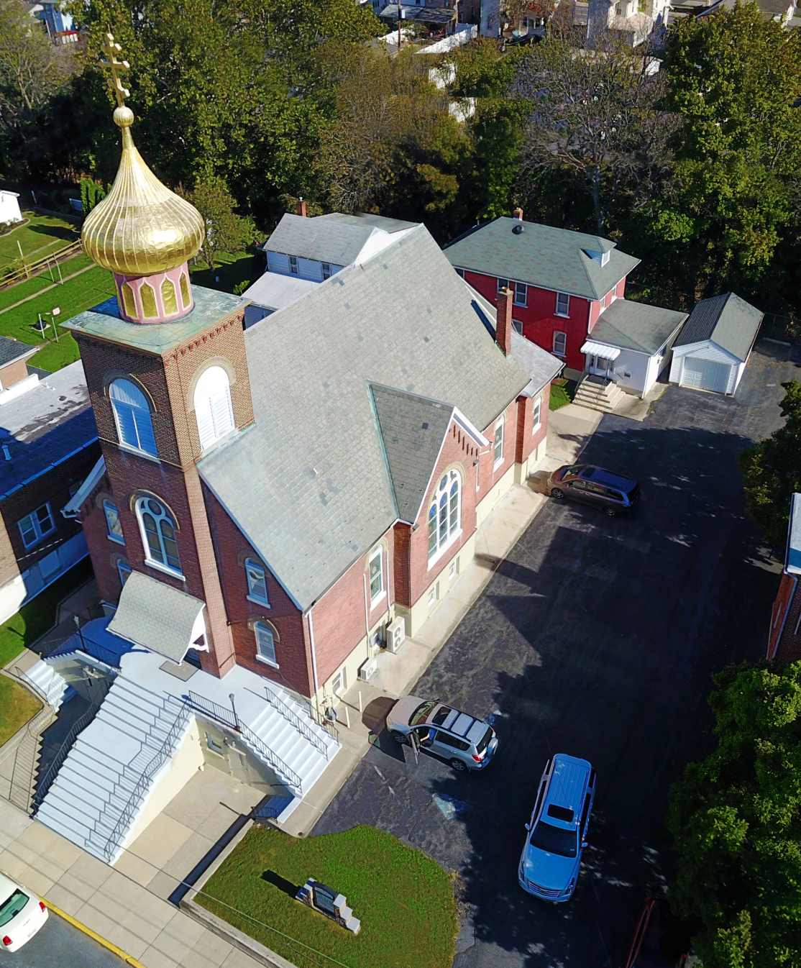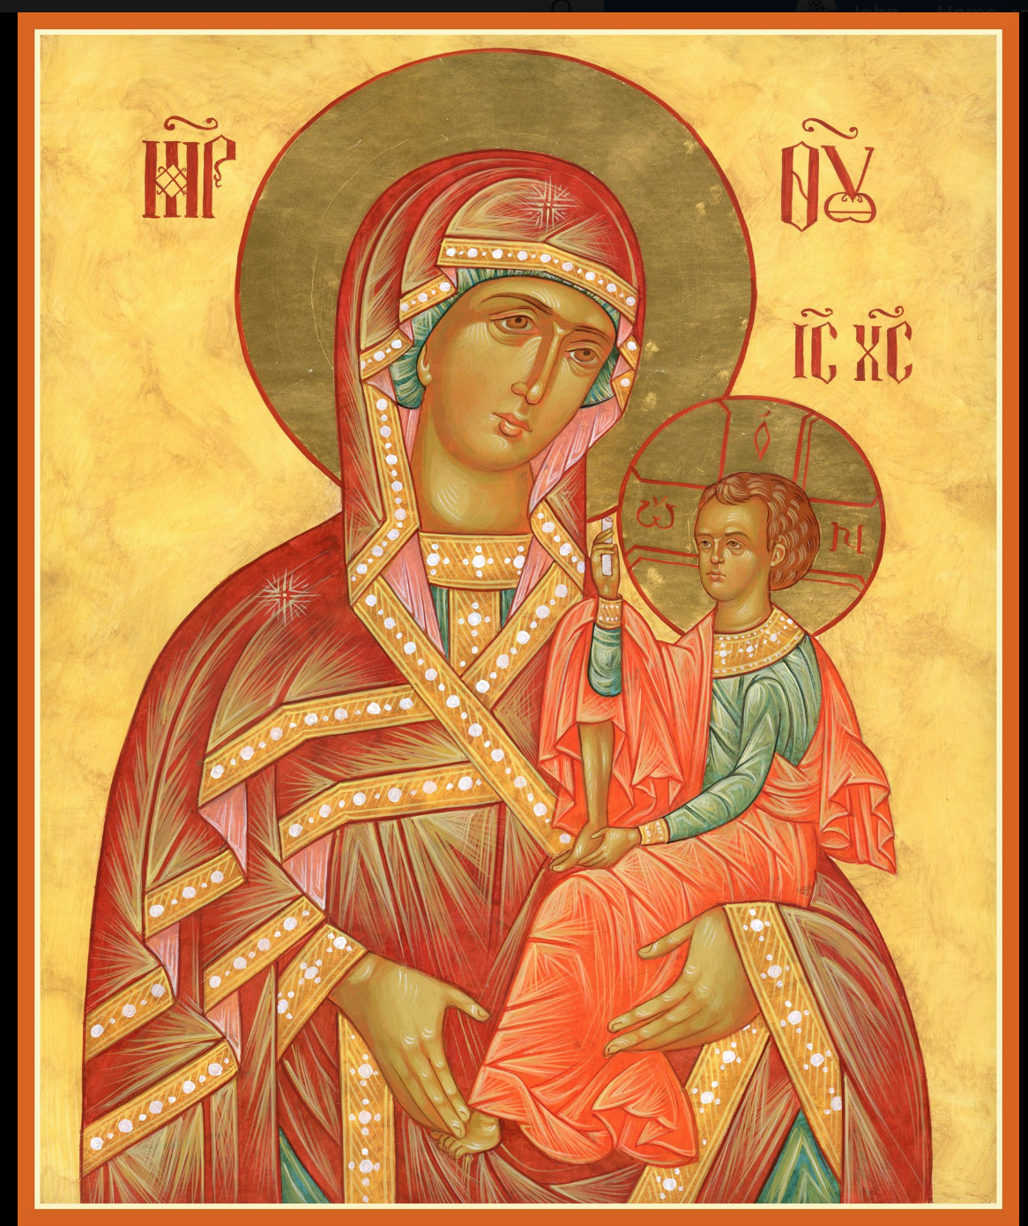

ASSUMPTION OF THE VIRGIN MARY
UKRAINIAN ORTHODOX CHURCH
ECUMENICAL PATRIARCHATE OF CONSTANTINOPLE AND NEW ROME
1301 Newport Avenue
Northampton, Pennsylvania 18067
Mitered Archpriest Myron Oryhon
Protodeacon Mychail Sawarynski, Attached

Telephones: Church Office… (610) 262-2882
Church Fax/Kitchen/Hall… (610) 262-0552
Fr. Myron Oryhon – (607) 752-1999
Protodeacon Mychail’s Residence… (610) 262-3876
Websites: holyassumption.org
ukrainianorthodoxchurchusa.org
lvorthodox.wordpress.com
E-mail: Parish… avmuoc@gmail.com
Protodeacon Mychail…pravoslavni@rcn.com
Webmaster, John Hnatow… john.hnatow@gmail.com
==============================================================
03rd March, (18th Feb.) 2019

MEATFARE SUNDAY OF THE LAST JUDGMENT. Tone 7.
LEO the Great, Pope of Rome (461). AGAPITUS, Bishop of Synnada. COSMAS the monk of Yakhromsk (1492).

1 Corinthians 8:8-9:2 Matthew 25:31-46

Today’s Bulletin, sponsored in loving memory of husband,
+Michael Vitushinsky is offered by Juanita Vitushinsky
PROPERS FOR LITURGY OF ST. JOHN CHRYSOSTOM
Tropar of the Resurrection, Tone 7
By Your Cross, You destroyed Death. To the Thief, You opened Paradise. For the Myrrh-bearers, You changed weeping into joy. Christ God, You commanded Your disciples to proclaim that You are risen, granting the world great mercy.
Tropar of the Dormition of the Birth-Giver of God, Tone 1
In giving birth, you preserved your virginity. In falling asleep you did not forsake the world, Birth-Giver of God. You were translated to life, Mother of Life, and through your prayers you deliver our souls from death.
Glory to the Father and to the Son and to the Holy Spirit…
Kondak of the Dormition, Tone 2
Neither the tomb nor death had power over the Birth-Giver of God; she is ever watchful in her prayers and in her intercession lies un- failing hope. For as the Mother of Life, she has been translated to life by the One Who dwelt in her ever-virginal womb.
Now and ever and to the ages of ages. Amen.
Kondak of the Triodion, Tone 1
When You come to earth in Glory, O God, all creation will tremble. The river of fire will flow before Your Judgment Seat. The books will be opened and all secrets disclosed. Deliver me then from the unquenchable fire and count me worthy to stand at Your Right hand, Most Righteous judge.

Prokimen in Tone 3
Great is our Lord and great is His power. His understanding is beyond measure.

Verse: Praise the Lord, for a psalm is good; let praise be sweet unto our God.

Alleluia Verses, Tone 8
Come let us rejoice in the Lord. Let us shout with joy to God our Savior.

Let us come before His Countenance with thanksgiving; and with psalms let us shout with joy to Him.

Communion Hymn:
Praise the Lord from the heavens, praise Him in the highest.
Rejoice in the Lord, you righteous, praise befits the upright. Alleluia(3X)

LITURGICAL MENEION & SCRIPTURE READINGS
CHEESEFARE WEEK

Mon. 04 Mar. Apostles ARCHIPPUS & PHILEMON of the 70.
Cheesefare Martyrs MAXIMUS, THEODULUS, HESYCHIUS
(Maslynitsa) & ASCLEPIODOTUS of Adrianople (311).
3 John 1:1-15 Luke 19:29-40;22:7-39

Tue. 05 Mar. LEO, Bishop of Catania, Sicily (780). Ven. Prince
Cheesefare YAROSLAV the Wise of Kyiv (1054).
Jude 1:1-10 Luke 22:39-42, 45-23:1

Wed. 06 Mar. TIMOTHY of Symbola. EUSTATHIUS of Antioch.
Cheesefare Joel 2:12-26 Joel 4:12-21 No Liturgy

Thur. 07 Mar. Uncovering of the relics of the Martyrs in Eugenius.
Cheesefare Jude 1:11-25 Luke 23:1-34, 44-56

Fri. 08 Hieromartyr POLYCARP, Bishop of Smyrna (167).
Cheesefare Ascetics of the Syrian Desert.
6th Hour: Zechariah 8:7-17
Vespers: Zechariah 8:19-23 No Liturgy

Sat. 09 Mar. ALL VENERABLE ONES, GLORIFIED IN THE
Cheesefare ASCETIC LIFE
Galatians 5:22-6:2 Matthew 11:27-30

9:00 AM DIVINE LITURGY OF ST. JOHN CHRYSOSTOM

5:00 PM GREAT VESPERS followed by CONFESSIONS

SUN. 10 Mar. FORGIVENESS SUNDAY, CHEESEFARE, Tone 8
The last day before Great Lent

8:30 AM THIRD & SIXTH HOUR; Mystery of Penance
9:00 AM DIVINE LITURGY OF JOHN CHRYSOSTOM
4:00 PM VESPERS OF FORGIVENESS (Start of Lent)

SR UOL PRE-LENTEN BREAKFAST TODAY after Liturgy. Features eggs, sausage, baked goods. $5 adults $3 children.

SISTERHOOD MEETING TODAY after the Breakfast.

PARISH COUNCIL MEETING, MARCH 13TH AT 7:00 PM

NECROLOGY:
03 March… Dionisiy Jankovyi ’30, Anna Pypiuk ‘88
Joseph Petro ‘01
04 March… Mary Martyniuk (infant) ’24, Mary Talalaj
(6 years old) ’27, Alex Lubianecki ‘53
05 March… Michael Magerka ’57, Priest Michael Mostensky ‘70
07 March… Mary Werbicky ‘68
09 March… Walter Zarayko ‘94
10 March… Michael Andrushkiw ’31, John Zyrebecky ’76,
Mary Praetorius ‘05

VICHNAYA PAMYAT! MEMORY ETERNAL!

BIRTHDAYS:
03 March… Kellie Pypiuk
07 March… John Hnatow
10 March… Keith Rippey

MNOHAYA LITA! MANY YEARS!

WE PRAY FOR THE HEALTH AND WELL-BEING of the ill afflicted: Rosemarie Pypiuk, William Savitz, Catherine Kochenash, Fr. Vasyl Dovgan, Vladimir & Emma Krasnopera, Tessie Kuchinos, Brendan Phillips, Jessie Hnatow, Jessica Meashock Wasyl Hewko, Adam Hewko, Betty Hendrickson, Andrew Thaxton, Michelle Pierzga, Susan Ferretti, Carole Zarayko, William Fischer, Ekaterina Seremula, Reader Evhen (Roger) Seremula

SR UOL is sponsoring a cheesecake and nutroll dale. Nut rolls are $16 and include; apricot, lekvar, raspberry, poppyseed, & coconut. Cheesecakes are $20. Pick-up at the church hall on Saturday, April 13th between 9-12 AM. Place orders with Linda (610-837-3076) or Marty (610-682-4458) no later than March 27th.

NORTHAMPTON FOODBANK is still in need of foodstuffs.

NEXT PIEROHI SALE WILL BE ON MARCH 7th. Order by Mar. 3rd. Call Helen at 610-261-4575 or 484-239-5731. Additional dates: March 21, April 4 & 18. May 9, 16, 23.

RELIGIOUS INSTRUCTION CLASS FOR PARISH CHILDREN:
Mrs. Mary Ost – Sundays 9:00-9:30
Mrs. Linda Winters – Mar. 3 – no class; Mar. 10 – 11 AM;
Mar. 17 – 9 AM; Mar. 24 – 11 AM ; Mar. 31 – 9 AM;
April 7 – 11 AM; April 14 – 9 AM
Ms. Bettyann Woyewoda – Sundays at 8:40-9:15; March 3, 17, 24, 31; April 7, 14, 21; May 5, 12, 19. 26

OCMC “AGAPE CANISTER” DONATIONS were $19.00. Thank you for your support of our Missions around the globe.

Continue to collect receipts from “Redner’s Save a Tape Program.”

JR UOL PASKA SALE: Last Sunday for orders, Mar. 31st. Price is $7.00. Pick-up on Sunday, April 14th. Order sheet is in the Church Hall at the Coffee Hour Table.

SUNDAY OF ORTHODOXY VESPERS on March 17th will be at ST. PHILIP’S CHURCH, SOUDERTON, PA. beginning at 4 PM.
Fr. John Parker will be the guest speaker.

ALL SUNDAY LENTEN VESPERS AT 4 P.M.
Mar. 24 – St. Nicholas Church, Bridle Path Rd., Bethlehem.
Mar. 31 – St. Paul’s Church, Emmaus
Apr. 7 - St. Mary’s Church, Allentown,
Apr. 14 – St. Nicholas Greek Orthodox Cathedral, Bethlehem

OCMC
Thanks to your great support, OCMC was able to send 25 mission teams around the world, one of which was its 300th. The first mission team to Jamaica will leave soon, as well as to new countries (Colombia & Ghana) in the coming year. Your support made it possible to sustain 28 long term missionaries, as well as to train new candidates in the mission field. You also helped support to 400 Orthodox clergy in countries where Orthodoxy is growing through the SAMP Pro-gram. So we ask for your continued help in 2019 for these new efforts. Next Sunday, Mar. 10th is MISSION SUNDAY in the U.S. The second collection that day will go to support Mission activities.
In the early Church worship took place in people’s homes. Dr. Bill Black, OCMC missionary established a house church in Kisumu, Kenya in 2018 with 5 people. A priest was ordained and the parish continues to grow with 20 people preparing to be baptized on Holy Saturday.

Hierarchs, priests, deacons, monastics and faithful of the Ukrainian Orthodox Church, the parishioners, the priests who have served this parish, family members and friends of the parish: the members of the Antoniuk family, the Alexander family, the Azar family, the Bochnock family, the Bodnyk family, the Bruchok family, the Busch family, the Chudolyi family, the Chromiak family, the Crayosky family, the Czerkas family, the Dorosh family, the Dowling family, the Drobick family, the Dworakivsky family, the Fanok family, the Fedko family, the Fedorishen family, the Gulka family, the Gretchlevich family, the Hewko family, the Harnaho family, the Hnatow family, the Huzela family, the Isczuk family, the Kereb family, the Kerick family, the Koback family, the Kochenash family, the Kowalchk family, the Korutz family, the Kowalyshyn family, the Krasnopera family, the Kravchuk family, the Kuchinos family, the Kulchycki family, the Kutiansky family, the Lelo family, the Lubenesky family, the Lutyi family, the Martnick family, the Mazur family, the Meashock family, the Metchoe family, the Molnar family, the Micio family, the Nazar family, the Onuschak family, the Parchomenko family, the Pokotello family, the Pontician family, the Porochniak family, the Poticha family, the Pypiuk family, the Sawarynski family, the Sawka family, the Schmall family, the Schur family, the Schuryn family, the Semenovych family, the Seremula family, the Sheska family, the Smallen family, the Teply family, the Tokarzyk family, the Unger family, the Vasilovsky family, the Vitushinsky family, the Voronkevich family, the Werbicky family, the Woyewoda family, the Wulchak family, the Yaremchuk family, the Zadubera family, the Zarayko family, the Zawierucha family, and the Zazworsky family

