FEBRUARY 24, 2019

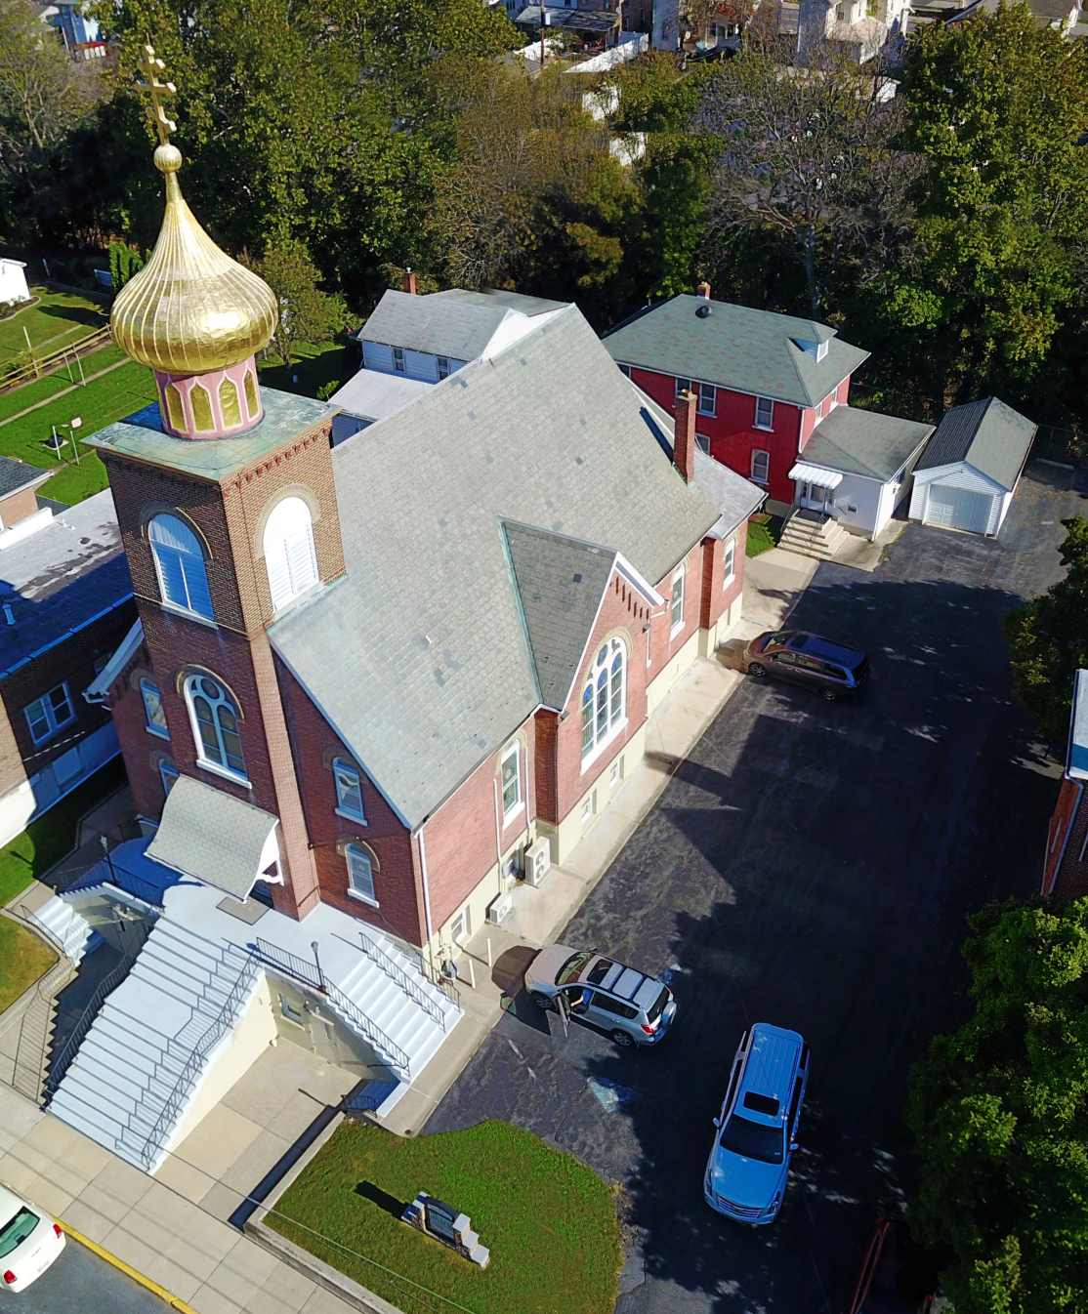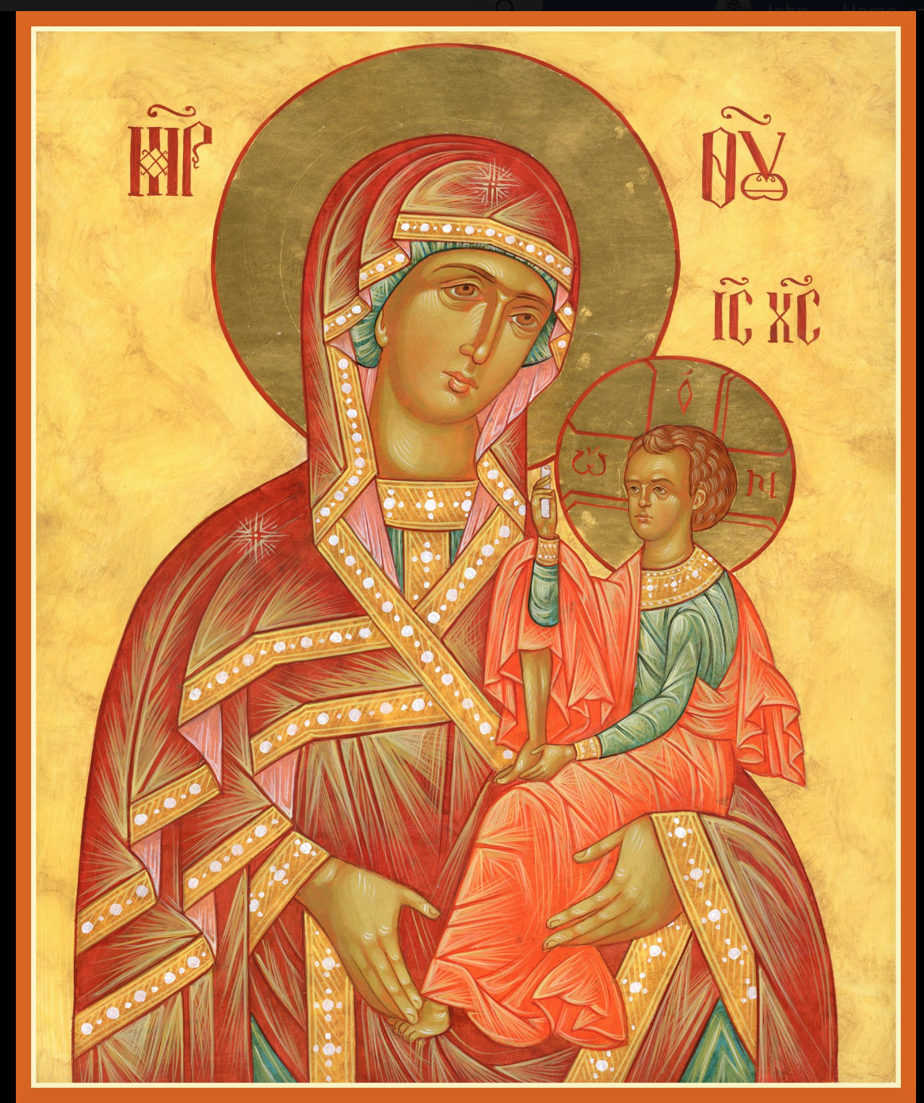

ASSUMPTION OF THE VIRGIN MARY
UKRAINIAN ORTHODOX CHURCH
ECUMENICAL PATRIARCHATE OF CONSTANTINOPLE AND NEW ROME
1301 Newport Avenue
Northampton, Pennsylvania 18067
Mitered Archpriest Myron Oryhon
Protodeacon Mychail Sawarynski, Attached

Telephones: Church Office… (610) 262-2882
Church Fax/Kitchen/Hall… (610) 262-0552
Fr. Myron Oryhon – (607) 752-1999
Protodeacon Mychail’s Residence… (610) 262-3876
Websites: holyassumption.org
ukrainianorthodoxchurchusa.org
lvorthodox.wordpress.com
E-mail: Parish… avmuoc@gmail.com
Protodeacon Mychail…pravoslavni@rcn.com
Webmaster, John Hnatow… john.hnatow@gmail.com
==============================================================
24th February, (11th Feb.) 2019

SUNDAY OF THE PRODIGAL SON. Tone 6. Hieromartyr BLAISE
Bishop of Sebaste (316). St. THEODORA (867)

1 Corinthians 6:12-20 Luke 15:11-32

Panikhída following Liturgy today in memory of +Tyler Pavlinsky on the 3rd Anniversary of his repose offered by his parents Nadda & Bob, his sister Jasmine and brother Sean. Memory Eternal!
PROPERS FOR LITURGY OF ST. JOHN CHRYSOSTOM
Tropar of the Resurrection, Tone 6
The angelic powers were at Your tomb. The guards became as dead men. Mary stood by Your grave, seeking Your Most Pure Body. You captured Hell, not being tempted by it. You came to the Virgin granting Life. Lord, Who arose from the dead: Glory to You.
Tropar of the Dormition of the Birth-Giver of God, Tone 1
In giving birth, you preserved your virginity. In falling asleep you did not forsake the world, Birth-Giver of God. You were translated to life, Mother of Life, and through your prayers you deliver our souls from death.
Glory to the Father and to the Son and to the Holy Spirit…
Kondak of the Dormition, Tone 2
Neither the tomb nor death had power over the Birth-Giver of God; she is ever watchful in her prayers and in her intercession lies un- failing hope. For as the Mother of Life, she has been translated to life by the One Who dwelt in her ever-virginal womb.
Now and ever and to the ages of ages. Amen.
Kondak of the Triodion, Tone 3
Having foolishly abandoned Your paternal glory, I have squandered on vices the wealth that You have given me. Therefore, with the voice of the prodigal, I cry out to You: I have sinned before You, Compassionate Father, accept me in repentance and make me as one of Your hired servants.

Prokimen in Tone 6
Save Your people, O Lord, and bless Your inheritance.

Verse: O Lord, to You will I call. O my God, be not silent unto me.

Alleluia Verses, Tone 6
He that dwells in the aid of the Most High will abide in the shelter of the God of Heaven.

He will say to the Lord: You are my Helper and my Refuge. He is my God and I will hope in Him.

Communion Hymn:
Praise the Lord from the heavens, praise Him in the highest. Alleluia(3X)

LITURGICAL MENEION & SCRIPTURE READINGS
MEATFARE WEEK

Mon. 25 Feb. MELETIUS, Archbishop of Antioch (381). Ven. MARY the nun & her father, EUGENE (6th C.)
1 John 2:18-3:10 Mark 11:1-11

Tue. 26 Feb. St. MARTINIAN (422). Ven. ZOE of Bethlehem &
Virgin PHOTINA. EULOGIUS of Alexandria (608).
1 John 3:10-20 Mark 14:10-42

Wed. 27 Feb. AUXENTIUS, monk of Bithynia (470). MARON,
Fast Day: hermit of Syria (423). ABRAHAM, Bishop of
Fish Charres. CYRIL, Teacher of the Slavs (869).
1 John 3:21-4:6 Mark 14:43-15:1

Thur. 28 Feb. Apostle ONESIMUS of the 70. Ven. PAPHNUTIUS
& his daughter EUPHROSYNE, nun of Alexandria
1 John 4:20-5:21 Mark 15:1-15

Fri. 01 Mar. Martyrs PAMPHILUS, presbyter, VALENS,
Fast Day: deacon, PAUL, SELEUCUS, PORPHYRIUS,
Fish JULIAN, THEODULUS, ELIAS, JEREMIAH,
ISAIAH, SAMUEL, DANIEL in Palestine (309).
2 John 1:1-13 Mark 15:22-41

Sat. 02 Mar. MEMORIAL SATURDAY (MEATFARE). Great
Martyr THEODORE of Tyre (306). MARIAMNE,
Sister of Apostle Philip. Uncovering of the relics of
Martyr MENAS the Melodius of Alexandria (313)
1 Corinthians 10:23-28 Luke 21:8-36

9:00 AM DIVINE LITURGY for the departed of the parish
(Zadushnaya Subbota) reading of the dyptichs.

5:00 PM GREAT VESPERS

SUN. 03 Mar. SUNDAY OF THE LAST JUDGMENT, Tone 7

8:30 AM THIRD & SIXTH HOUR; Mystery of Penance
9:00 AM DIVINE LITURGY OF JOHN CHRYSOSTOM

SR UOL PRE-LENTEN BREAKFAST FOLLOWING LITURGY Mar. 3rd features eggs, sausage, baked goods. $5 adults $3 children.

SISTERHOOD MEETING Next Sunday after the Breakfast.

PARISH COUNCIL MEETING, MARCH 13TH AT 7:00 PM

NECROLOGY:
24 February…Nancy Fogel (infant) ‘39
25 February…Protopresbyter Myron Pacholok ‘91
26 February…Priest Michael Zemlachenko ‘13
27 February…Anna Kowalyshyn ‘91
28 February…Nicholas Panchyshyn (infant) ‘30
29 February…Charles Boyko ‘88
01 March……Wasyl Palnitsa (infant) ’26, Harry Kuchinos ’65,
Michael Vitushinsky ’13, Protodeacon Volodymyr
Polischuk ‘10
02 March……Julia Arbatowsky ’63, Thomas Huryn ’72,
Priest Michael Petlak ‘09

VICHNAYA PAMYAT! MEMORY ETERNAL!
BIRTHDAYS:
24 February… Alexander Grason
28 February… Russell Kerick

MNOHAYA LITA! MANY YEARS!

WE PRAY FOR THE HEALTH AND WELL-BEING of the ill afflicted: Rosemarie Pypiuk, Anne Lelo, William Savitz, Catherine Kochenash, Fr. Vasyl Dovgan, Vladimir & Emma Krasnopera, Tessie Kuchinos, Brendan Phillips, Jessie Hnatow, Jessica Meashock Wasyl Hewko, Adam Hewko, Betty Hendrickson, Andrew Thaxton, Michelle Pierzga, Susan Ferretti, Carole Zarayko, William Fischer, Ekaterina Seremula, Fr. Nicholas Dilendorf, Ariel Weiller and the child born to her, Reader Evhen (Roger) Seremula

SR UOL is sponsoring a cheesecake and nutroll dale. Nut rolls are $16 and include; apricot, lekvar, raspberry, poppyseed, & coconut. Cheesecakes are $20. Pick-up at the church hall on Saturday, April 13th between 9-12 AM. Place orders with Linda (610-837-3076) or Marty (610-682-4458) no later than March 27th.

NORTHAMPTON FOODBANK is still in need of foodstuffs; especially baby food.

NEXT PIEROHI SALE WILL BE ON MARCH 7th. Order by Mar. 3rd. Call Helen at 610-261-4575 or 484-239-5731. Additional dates: March 21, April 4 & 18. May 9, 16, 23.

RELIGIOUS INSTRUCTION CLASS FOR PARISH CHILDREN:
Mrs. Mary Ost – Sundays 9:00-9:30
Mrs. Linda Winters – Feb. 24 – 9AM; Mar. 3 – 11 AM; Mar. 10 – 9; Mar. 17 – 11 AM; Mar. 24 – 9 AM; April 7 – 11 AM; April 14 – 9 AM
Ms. Bettyann Woyewoda – Sundays at 8:40-9:15; February 24; March 3, 17, 24, 31; April 7, 14, 21; May 5, 12, 19. 26

OCMC “AGAPE CANISTER” DONATIONS were $15.00. Thank you for your support of our Missions around the globe.

Continue to collect receipts from “Redner’s Save a Tape Program.”

SUNDAY OF ORTHODOXY VESPERS on March 17th will be at ST. PHILIP’S CHURCH, SOUDERTON, PA. beginning at 4 PM.

BENE NOTE: DEAR PARISHIONERS;
To all of you for the get well wishes and cards. I know that
was very helpful in my recovery. It’s good to be back at church
again. Thank you. In Christ, Anne Lelo

OCMC
Thanks to your great support, OCMC was able to send 25 mission teams around the world, one of which was its 300th. The first mission team will be going to Jamaica soon, as well as to new countries in the coming year. Your support made it possible to sustain 28 long term missionaries, as well as to train new candidates in the mission field. You also helped support 400 Orthodox clergy in countries where Orthodoxy is growing through the SAMP Program. So we ask for your continued help in 2019 for these ongoing efforts. Sunday, March 10th is MISSION SUNDAY in the U.S. The second collection on that day will go to support the Mission Center.

IOCC
Is supporting better health & nutrition, serving hundreds of thou-sands of people each year. People in need are receiving assistance right now in Lebanon, Syria, Jordan, West Bank, Gaza, Jerusalem, Ethiopia and Uganda. Some of the current projects include:
a. weekly hot meals for families; b. immunizations for children;
c. malnutrition screening & referral; d. prevention & treatment of podoconiosis. Please select one of these charities and make it your commitment during the Great Lent.

