FEBRUARY 17, 2019

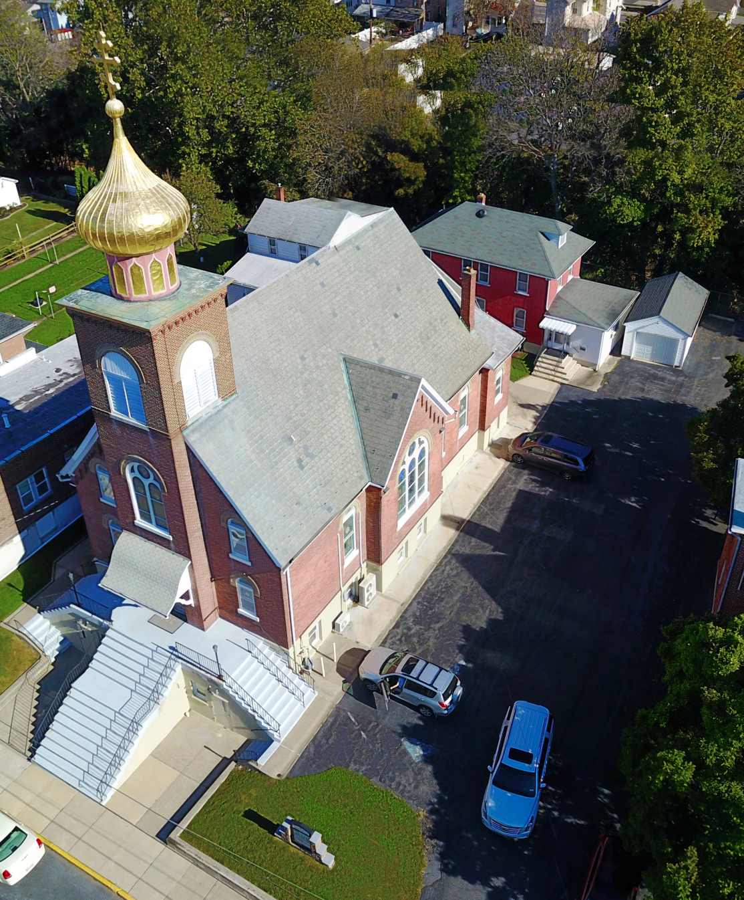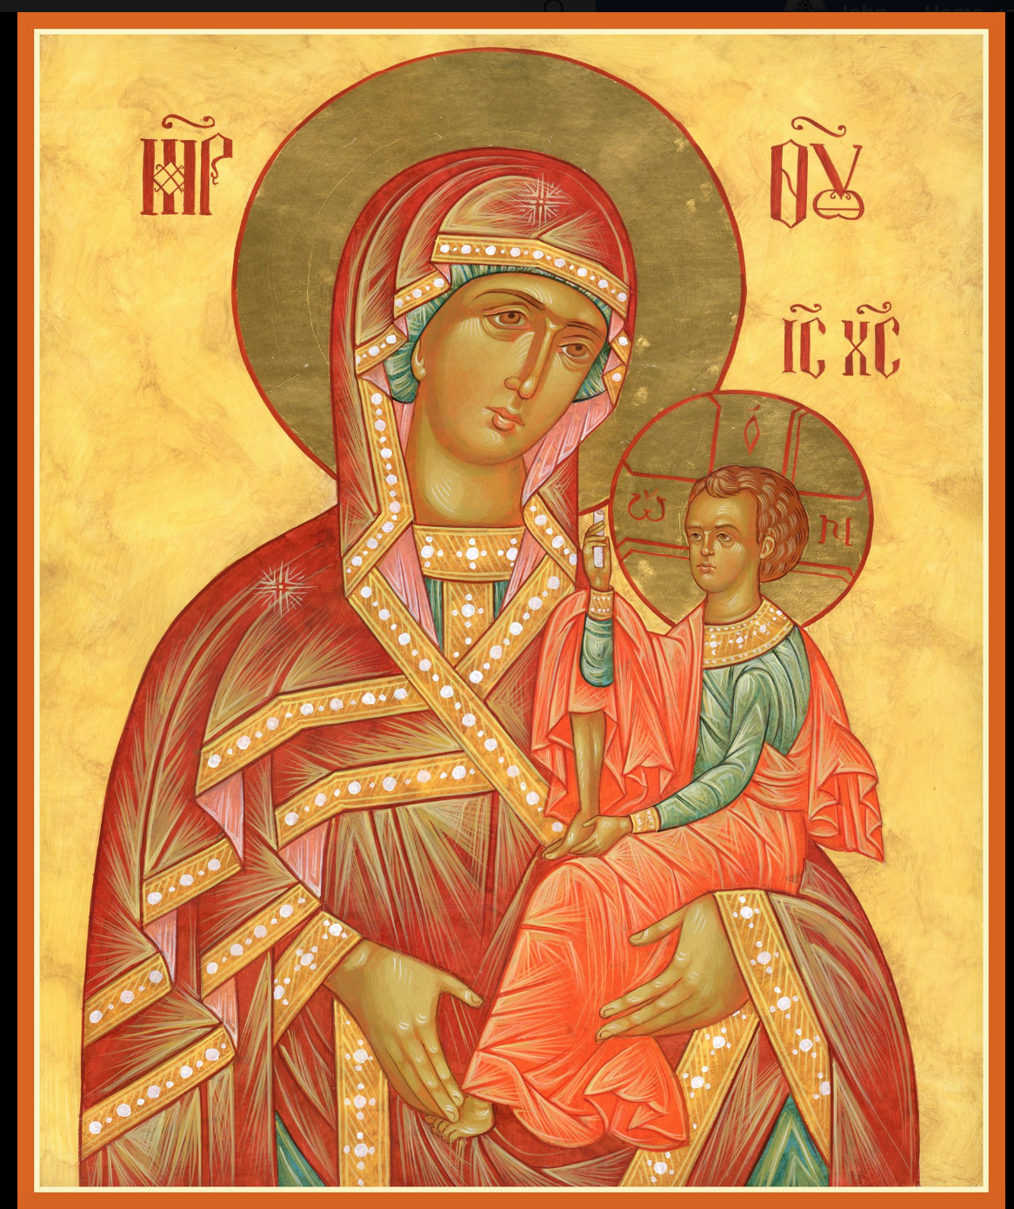

ASSUMPTION OF THE VIRGIN MARY
UKRAINIAN ORTHODOX CHURCH
ECUMENICAL PATRIARCHATE OF CONSTANTINOPLE AND NEW ROME
1301 Newport Avenue
Northampton, Pennsylvania 18067
Mitered Archpriest Myron Oryhon
Protodeacon Mychail Sawarynski, Attached

Telephones: Church Office… (610) 262-2882
Church Fax/Kitchen/Hall… (610) 262-0552
Fr. Myron Oryhon – (607) 752-1999
Protodeacon Mychail’s Residence… (610) 262-3876
Websites: holyassumption.org
ukrainianorthodoxchurchusa.org
lvorthodox.wordpress.com
E-mail: Parish… avmuoc@gmail.com
Protodeacon Mychail…pravoslavni@rcn.com
Webmaster, John Hnatow… john.hnatow@gmail.com
==============================================================
17th February, (4th Feb.) 2019

SUNDAY OF THE PUBLICAN & PHARISEE. Tone 5. Afterfeast of the MEETING OF OUR LORD IN THE TEMPLE. Ven. ISIDORE of Pelusium. Ven. NICHOLAS the Confessor, Abbot of Studion (868)

2 Timothy 3: 10-15 Luke 18: 10-14

TODAY’S BULLETIN is sponsored in loving memory of mother +Stella Vitushinsky and is offered by John & Linda Vitushinsky

PROPERS FOR LITURGY OF ST. JOHN CHRYSOSTOM
Tropar of the Resurrection, Tone 5
Let us, the faithful, praise and worship the Word, co-eternal with the Father and the Spirit, born for our salvation of the Virgin. In His Good Will, He was lifted up on the Cross in the flesh, to suffer death and to raise the dead, by His glorious Resurrection.
Tropar of the Meeting of the Lord, Tone 1
Rejoice, Virgin Birth-Giver of God, full of Grace; from you shone the Sun of Righteousness, Christ our God, enlightening those who sat in darkness. Rejoice and be glad, Righteous Elder Simeon, you accepted in your arms the Redeemer of our souls, Who grants us Resurrection.
Glory to the Father and to the Son and to the Holy Spirit…
Kondak of the Triodion, Tone 4
Let us flee from the proud boasting of the Pharisee and learn the humility of the Publican. With groaning let us cry out to the Savior; Be merciful to us, for You alone are always ready to forgive.
Now and ever and to the ages of ages. Amen.
Kondak of the Meeting, Tone 1

By your Birth, Christ our God, You sanctified the Virgin’s womb and blessed Simeon’s hands and now You have come and saved us. Grant peace in the midst of aggression to Your community and strengthen the people, embraced by You Love, Only Lover of Mankind.

Prokimen of the Resurrection, Tone 5
You, O Lord, shall protect us and preserve us from this generation forever.

Verse: O Lord, save us for there is no longer any righteous man.

Prokimen of the Meeting of the Lord, Tone 3
My soul magnifies the Lord and my spirit rejoices in God my Savior.

Verse: For He has regarded the low estate of His handmaiden. For behold, henceforth all generations will call me blessed.

Alleluia Verses, Tone 5
Of Your mercies O Lord, I will sing forever; unto generation and generation I will proclaim Your truth with my mouth.

You have said: Mercy will be established forever and My truth will be prepared in the heavens.

Master, now let Your servant depart in peace, according to Your word.

A Light for revelation to the Gentiles and for glory to Your people Israel.

In place of “It is right in truth…”
Virgin Birth-Giver of God, Hope of all Christians; Protect, preserve and save all who hope in you.

Irmos, Tone 3
In the shadow and letter of the law, let us, the faithful, discern a figure: Every male child who opens the womb shall be sanctified to God. Therefore, the First-Born Word and Son of the Father without beginning and the First-Born Child of an Unwedded Mother, we magnify.

Communion Hymn:
Praise the Lord from the heavens, praise Him in the highest.
I will take the cup of salvation and call upon the Name of the Lord. Alleluia(3X)

LITURGICAL MENEION & SCRIPTURE READINGS
WEEK OF THE PRODIGAL SON
FAST FREE WEEK
Mon. 18 Feb. Holy Martyr AGATHA (251). THEODOSIUS,
Archbishop of Chernihiv (1696)
2 Peter 1:20-2:9 Mark 13: 9-13

Tue. 19 Feb. Ven. BUCOLUS, Bishop of Smyrna. Virgin-martyr
DOROTHEA, CHRISTINA, CALLISTA, sisters,
THEOPHILUS of Caesarea. PHOTIUS, Patriarch
Of Constantinople (891).
2 Peter 2:9-22 Mark 13: 14-23

Wed. 20 Feb. PARTHENIUS , Bishop of Lampsacus. Ven. LUKE,
No Fast of Mt. Steirion (953). 1,003 martyrs of Nicomedia.
2 Peter 3:1-18 Mark 13:24-31

Thur. 21 Feb. Great Martyr THEODORE STRATELATES (257).
Prophet ZECHARIA. SAVVA, Archbishop of Serbia
1 John 1:8-2:6 Mark 13:31-14:2

Fri. 22 Feb. APODOSIS OF THE MEETING. Martyr NICE-
No Fast PHORUS of Antioch. Hieromartyrs MARCEL-
LUS of Sicily, PHILAGRIUS of Cyprus, & PAN-
CRATIUS of Taomina, disciples of Apostle Peter.
1 John 2:7-17 Mark 14:3-9

Sat. 23 Feb. Hieromartyr CHARALAMPUS, Bishop of Magnesia. Martyrs PORPHYRIUS & BAPTUS (202).
ANNA, wife of Prince Yaroslav (1050).
2 Timothy 3:1-9 Luke 20:45-21:4

5:00 PM GREAT VESPERS

SUN. 24 Feb. SUNDAY OF PRODIGAL SON. Tone 6.
8:30 AM THIRD & SIXTH HOUR; Mystery of Penance
9:00 AM DIVINE LITURGY OF JOHN CHRYSOSTOM
OCMC “AGAPE CANISTER” DONATIONS were $16.00. Thank you
for your support of Missions around the globe.

NECROLOGY:
17 February…Vladimir Bochnok ’95, Protopresbyter
Antoniy Beryk ‘65
18 February…Protopres. Dmytro Sawka ’89, John Hnatow ‘14
19 February…John Volsky ’28, Anna Poticha ’56. Justine
Czerkas ’76, Archbishop Iov (Skakalsky) ‘74
20 February…Ilko Sawka ’47, Ronald Zarayko ’77, Protopresby.
Mykola Cherniawsky ’91, Helen Kulchycky ‘10
22 February…Mary Plaska ’58, Sophie Fedko ’61,
Paul Reznick ’86, Tyler Pavlinsky ‘16
23 February… Alexander Chuhij ’30, Fenny Magerka ’56,
John Fedko ’58, Bishop Joseph (Zhuk) ‘34

VICHNAYA PAMYAT! MEMORY ETERNAL!

BIRTHDAYS:
18 February… Adrianna Truss
19 February… Michael Misko, Alexander Pypiuk

MNOHAYA LITA! MANY YEARS!

WE PRAY FOR THE HEALTH AND WELL-BEING of the ill afflicted: Rosemarie Pypiuk, Anne Lelo, William Savitz, Catherine Kochenash, Fr. Vasyl Dovgan, Vladimir & Emma Krasnopera, Tessie Kuchinos, Brendan Phillips, Jessie Hnatow, Jessica Meashock Wasyl Hewko, Adam Hewko, Betty Hendrickson, Andrew Thaxton, Michelle Pierzga, Susan Ferretti, Carole Zarayko, William Fischer, Ekaterina Seremula, Fr. Nicholas Dilendorf, Ariel Weiller and the child born to her, Reader Evhen (Roger) Seremula

SR UOL PRE-LENTEN BREAKFAST following Liturgy, Mar. 3rd
featuring eggs, sausage, fruits, baked goods. $5 adults, $3 children.

NORTHAMPTON FOODBANK still in need of foodstuffs.
CANDLES BLESSED on the Feast of the Meeting are available.
for purchase. Large are $3, medium are $2 and small are $1.

NEXT PIEROHI SALE WILL BE ON FEBRUARY 21st . Order by Feb. 17th . Call Helen at 610-261-4575 or 484-239-5731. Additional dates: March 7 & 21, April 4 & 18. May 9, 16, 23.

RELIGIOUS INSTRUCTION CLASS FOR PARISH CHILDREN:
Mrs. Mary Ost – Sundays 9:00-9:30
Mrs. Linda Winters – Feb. 17-11 AM; Feb. 24 – 9AM.
Ms. Bettyann Woyewoda – Sundays at 8:40-9:15; February 17, 24; March 3, 17, 24, 31; April 7, 14, 21; May 5, 12.

Rosemarie Pypiuk would like to thank all parishioners and friends for their prayers, cards, visits and calls during her recent illness and hospitalization. We’re so happy to see her back at church.

BENE NOTE: DEAR PARISHIONERS;
We want to thank you all so much for your most generous gift, hope and prayers for our daughter, Katerina. It was so thoughtful, gracious and kind for you all to do.
An update: Katerina is proceeding nicely through her treatment plan and is currently in the third phase of immunotherapy at the Children’s Hospital of Philadelphia. We can describe her as a happy seven-year-old in spirit and mind, eating well and growing full of life and a fighter. She is also keeping up with her 1st grade studies as best she can at home.
There have been a few challenges for her to overcome over the last 15 months, but with the grace of God watching over her and the best doctors, she’s in very good hands and the only hospital to be at in the world. We truly believe her prognosis is positive and she will survive this terrible disease and live a normal life in the future. God bless you all for helping us.
In Christ,
John & Nataliya Seremula & Family

Continue to collect receipts from “Redner’s Save a Tape Program.”

