FEBRUARY 10, 2019
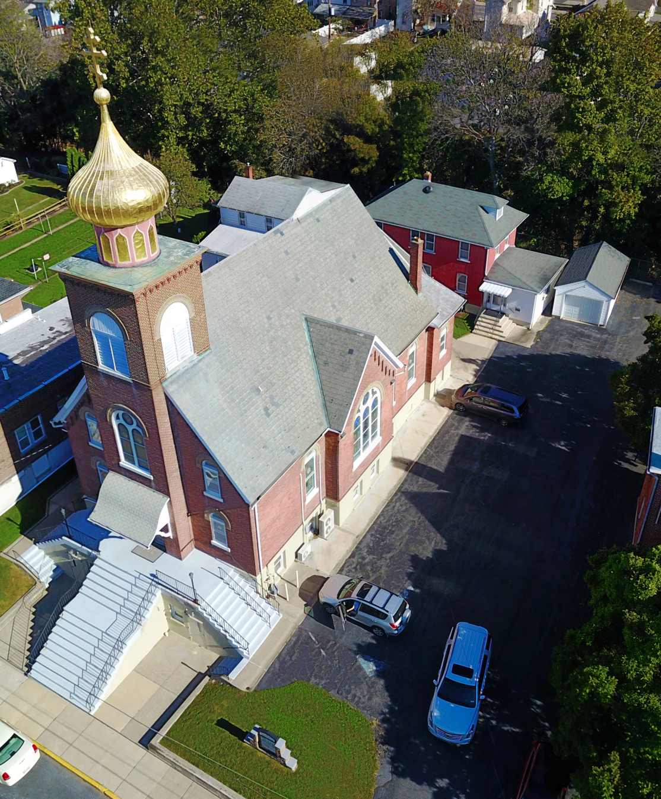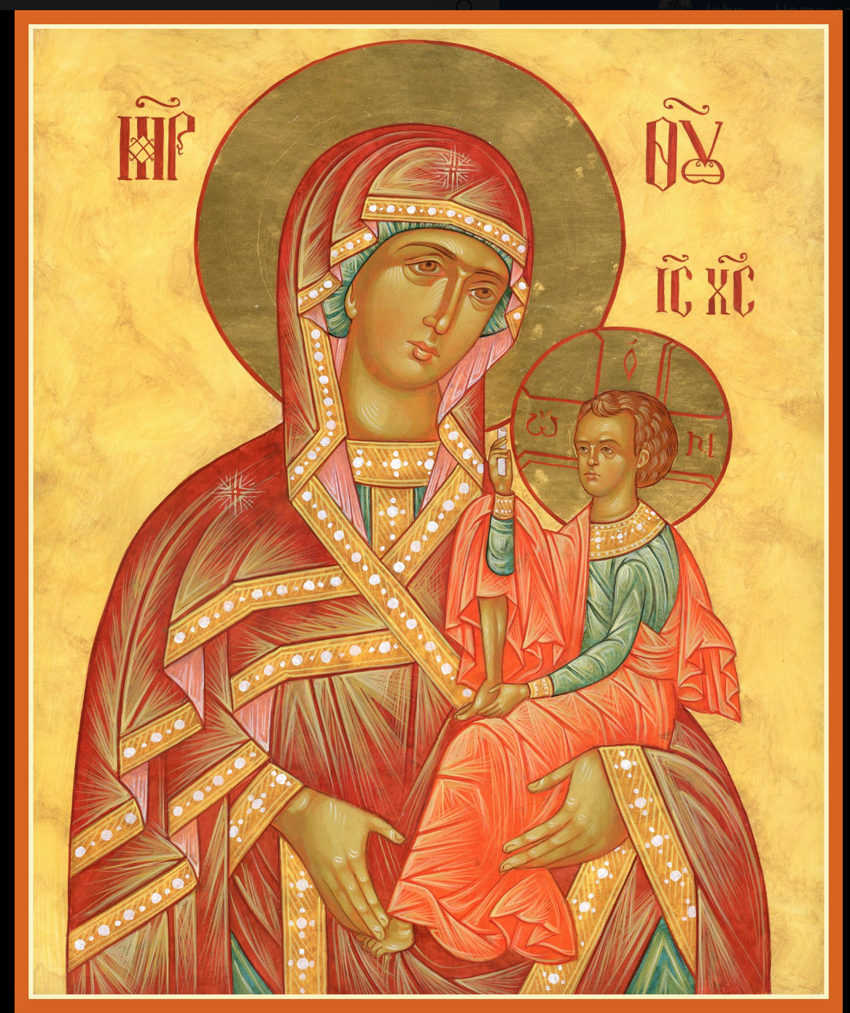

ASSUMPTION OF THE VIRGIN MARY
UKRAINIAN ORTHODOX CHURCH
ECUMENICAL PATRIARCHATE OF CONSTANTINOPLE AND NEW ROME
1301 Newport Avenue
Northampton, Pennsylvania 18067
Mitered Archpriest Myron Oryhon
Protodeacon Mychail Sawarynski, Attached

Telephones: Church Office… (610) 262-2882
Church Fax/Kitchen/Hall… (610) 262-0552
Fr. Myron Oryhon – (607) 752-1999
Protodeacon Mychail’s Residence… (610) 262-3876
Websites: holyassumption.org
ukrainianorthodoxchurchusa.org
lvorthodox.wordpress.com
E-mail: Parish… avmuoc@gmail.com
Protodeacon Mychail…pravoslavni@rcn.com
Webmaster, John Hnatow… john.hnatow@gmail.com
==============================================================
10th February, (28th Jan.) 2019

Thirty-Seventh Sunday after Pentecost. Tone 4. ZACCHAEUS SUNDAY. EPHRAIM the Syrian (373). PALLADIUS the Hermit of Antioch (4th C.). ISAAC the Syrian, Bishop of Nineveh (7th C.)

1 Timothy 4: 9-15 Luke 19: 1-10
Galatians 5: 22-6:2 Matthew 13: 27-30

Today’s Bulletin is sponsored in loving memory of +Anna Hewko & John Woyewoda & is offered by Bettyann & Janet Woyewoda

PROPERS FOR LITURGY OF ST. JOHN CHRYSOSTOM
Tropar of the Resurrection, Tone 4
When the women disciples of the Lord learned from the angel the joyous message of Your Resurrection, they cast away the ancestral curse and with gladness told the apostles: death is overthrown, Christ God is risen, granting the world great mercy.
Tropar of the Dormition of the Virgin Mary, Tone 1
In giving birth, you preserved your virginity. In falling asleep you did not forsake the world, Birth-Giver of God. You were translated to life, Mother of Life, and through your prayers you deliver our souls from death.
Tropar to Venerable Ephraim the Syrian, Tone 8
By a flood of tears you made the desert fertile and your longing for God brought forth fruits of abundance. By the radiance of miracles you illumined the whole universe. Our Father Ephraim, pray to Christ God to save our souls.
Kondak of the Resurrection, Tone 4
My Savior and Redeemer as God, arose from the tomb and delivered the earth-born from bondage. He has shattered the gates of Hell and, as Master, He has risen on the third day.
Glory to the Father and to the Son and to the Holy Spirit…
Kondak of Venerable Ephraim, Tone 2
Ever anticipating the hour of judgment, you lamented bitterly, Venerable Ephraim. Through your deeds you were a teacher by example; therefore, universal Father, you rouse the slothful to repentance.
Now and ever and to the ages of ages. Amen.

Kondak of the Dormition, Tone 2

Neither the tomb nor death had power over the Birth-Giver of God; she is ever watchful in her prayers and in her intercessions lies un-failing hope. For as the Mother of Life, she has been translated to life by the One Who dwelt within her ever virginal womb.

Prokimen of the Resurrection, Tone 4
How marvelous are Your works, O Lord. In wisdom You have made them all.

Verse: Bless the Lord my soul. O Lord my God, You are very great.

Prokimen of Venerable Ephraim, Tone 7
Precious in the sight of the Lord is the death of His saints.

Verse: What shall I render to the Lord for all that He has done for me?

Alleluia Verses, Tone 4
Bend Your bow and proceed prosperously and reign because of truth, meekness and righteousness.

You have loved righteousness and hated iniquity.

Blessed is the man who fears the Lord. In His commandments shall he greatly delight.

His seed shall be mighty upon the earth.

Communion Hymn:
Praise the Lord from the heavens, praise Him in the highest. The Righteous shall be in everlasting remembrance. He shall not fear any evil tidings. Alleluia(3X)

SR UOL MEETING TODAY, FEB. 10TH AFTER COFFEE HOUR.

LITURGICAL MENEION & SCRIPTURE READINGS
38th WEEK AFTER PENTECOST

Mon. 11 Feb. Translation of the relics of Hieromartyr IGNATIUS
the God-bearer (107)
1 Peter 2:21-3:9 Mark 12: 13-17

Tue. 12 Feb. Synaxis of the Three Hierarchs: BASIL the Great,
GREGORY the Theologian, JOHN CHRYSOSTOM
Hebrews 13:7-16 Matthew 5:14-19

Wed. 13 Feb. Holy Wonderworkers & Unmercenaries CYRUS &
Fast Day: JOHN (311) & with them Martyrs ATHANASIA,
Fish THEOCTISTE, THEODOTA, & EUDOXIA (311).
1 Peter 4: 1-11 Mark 12:28-37

Thur. 14 Feb. Martyr TRYPHON of Campsada (250). Martyrs
PERPETUA, SATURUS, REVOCATUS, SATUR-NINUS, SECUNDULUS & FELICITAS (203).
1 Peter 4:12-5:5 Mark 13:1-8

Fri. 15 Feb. MEETING OF THE LORD IN THE TEMPLE.
Fast Day:
Fish Hebrews 7:7-17 Luke 2:22-40

Sat. 16 Feb. AFTERFEAST OF THE MEETING; Holy &
Righteous SYMEON the God-receiver & ANNA
The Prophetess (1st C.). Prophet AZARIAS (10th C)
Hebrews 9:11-14 Luke 2:25-38

5:00 PM GREAT VESPERS followed by Blessing of Candles

SUN. 17 Feb. 37th Sunday after Pentecost. Sunday of Publican and Pharisee Tone 5. Ven. ISIDORE of Pelusium.

8:30 AM THIRD & SIXTH HOUR; Mystery of Penance
9:00 AM DIVINE LITURGY OF JOHN CHRYSOSTOM

MANY BLESSED YEARS TO SEAN & ELIVONNE NEHMEH,
who were united in Holy Matrimony in our church yesterday.

OCMC “AGAPE CANISTER” DOATIONS were $14.00. Thank you
for your support of Missions around the globe.

NECROLOGY:
10 February…Stephania Hnatow ’11.
11 February…John Antoniuk ‘69
12 February…Cyprian Vitushinsky ’60, Priest Leontiy Kwarty-
riuk ’66, Bishop Alexander (Novytsky) ‘70
13 February…Paul Magerka ’52, Dmytro Isczuk ’92, Protopriest
Myroslav Hlynsky ‘06
14 February…John Czerkas ’74, Tekla Kochenash ’11, Myroslav
Molofiy ‘04
15 February…Peter Gontar ’47, Michael Martnick ’86,
Stella Vitushinsky ‘08
16 February… Julij Mones (infant) ’26, Mary Hanzarick ’75,
Priest John Zazworskey ‘85

VICHNAYA PAMYAT! MEMORY ETERNAL!

BIRTHDAYS:
10 February… John Vitushinsky
11 February… Patrick Phillips, Cheryl Sawarynski
14 February… Michael Smallen Jr., Sabrina Ost
15 February… Joan Molnar

ANNIVERSARIES:
14 February… William & Judy Ketterer

MNOHAYA LITA! MANY YEARS!

WEATHER ALERT
Please be advised that in the event of impending bad weather, church cancelations will be made on our website or on WFMZ TV.

WE PRAY FOR THE HEALTH AND WELL-BEING of the ill afflicted: Rosemarie Pypiuk, Anne Lelo, William Savitz, Catherine Kochenash, Fr. Vasyl Dovgan, Vladimir & Emma Krasnopera, Tessie Kuchinos, Brendan Phillips, Jessie Hnatow, Jessica Meashock Wasyl Hewko, Adam Hewko, Betty Hendrickson, Andrew Thaxton, Michelle Pierzga, Susan Ferretti, Carole Zarayko, William Fischer, Ekaterina Seremula, Fr. Nicholas Dilendorf, Ariel Weiller and the child born to her.

MEMORIAL CANDLES
On the Litynik Table for commemorating the departed have been replaced with glass vigils due to wax melting. Please make your donation in the candle tray in the Vestibule. They are 2 for $1.00.

NEXT PIEROHI SALE WILL BE ON FEBRUARY 21st . Order by Feb. 17th . Call Helen at 610-261-4575 or 484-239-5731. Additional dates: March 7 & 21, April 4 & 18. May 9, 16, 23.

RELIGIOUS INSTRUCTION CLASS FOR PARISH CHILDREN:
Mrs. Mary Ost – Sundays 9:00-9:30
Mrs. Linda Winters – Feb. 10-9AM; Feb. 17-11 AM
Ms. Bettyann Woyewoda – Sundays at 8:40-9:15; February 10, 17, 24; March 3, 17, 24, 31; April 7, 14, 21; May 5, 12.

NORTHAMPTON FOODBANK continues to be in need of non-perishables for the needy, especially baby foods. Use pantry in hall.

We continue to collect receipts from the “REDNER’S SAVE A TAPE PROGRAM” Proceeds help the church. Use your Reward’s Card

SISTERHOOD MEETING, SUNDAY, MARCH 3RD FOLLOWING THE DIVINE LITURGY IN THE CHURCH HALL.

CONGRATULATIONS to the parishioners elected to the Parish Council at the Annual Meeting. They were inducted last Sunday.
President: Martha Misko
Vice-President: John Vitushinsky
Secretary: Helen Crayosky
Financial Secretary: Janet Woyewoda
Treasurer: Linda Winters
Auditors: Martha Dowling
Roger Sermula
Bettyann Woyewoda
Council members: John Hnatow
Nadda Pavlinsky
Taras Pypiuk
Oleksandr Semenovych
Walter Seremula

TODAY THE CHURCH REMEMBERS ST. EPHRAIM THE SYRIAN, a 4th Century disciple of St. James of Nisibis. He had great wisdom and was very industrious. He wrote books, taught monks and the people in Edessa, dedicating his life to prayer and contemplation. His most famous prayer is recited during the Great Lent: “O Lord and Master of my life, take from me the spirit of idleness, despondency, ambition and idle talk. But rather, give me the spirit of chastity, humility, patience and love. Yes, Lord and King, grant me to see my own sins and not to condemn my brother, for You are blessed unto the ages of ages.” He declined the office of bishop. He was a friend of St. Basil the Great and is considered to be the apostle of repentance. They traveled to Cappadocia where he relented to be ordained a deacon and urged the people to care for the sick and poor, building them a shelter. He retired to a cave where he spent his remaining days in prayer and reposed in the Lord in 378.

