JANUARY 27, 2019
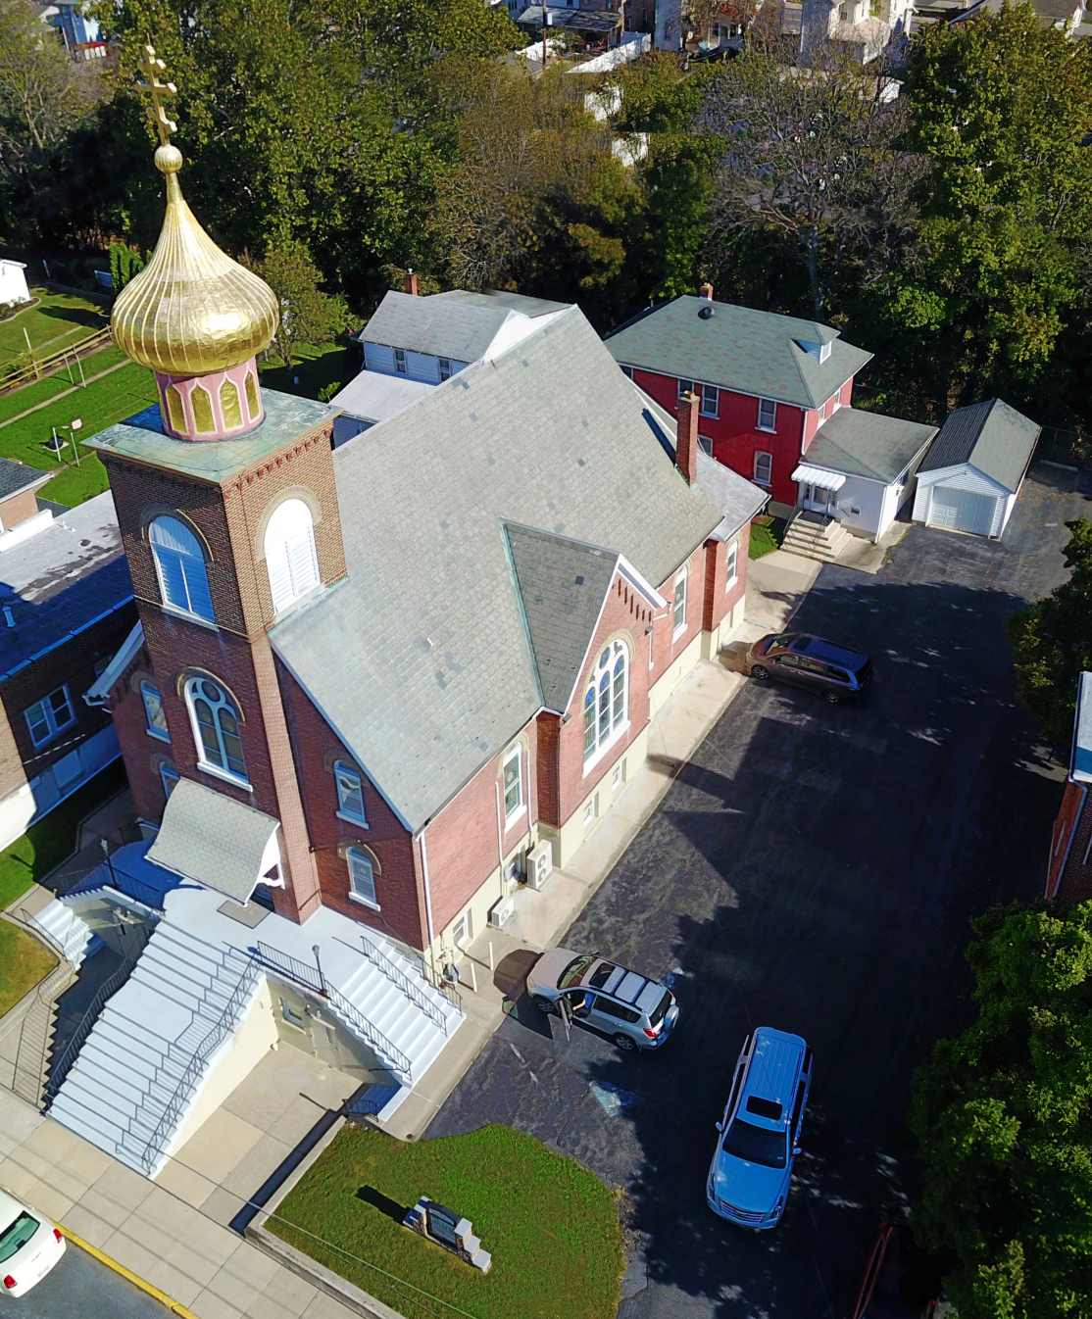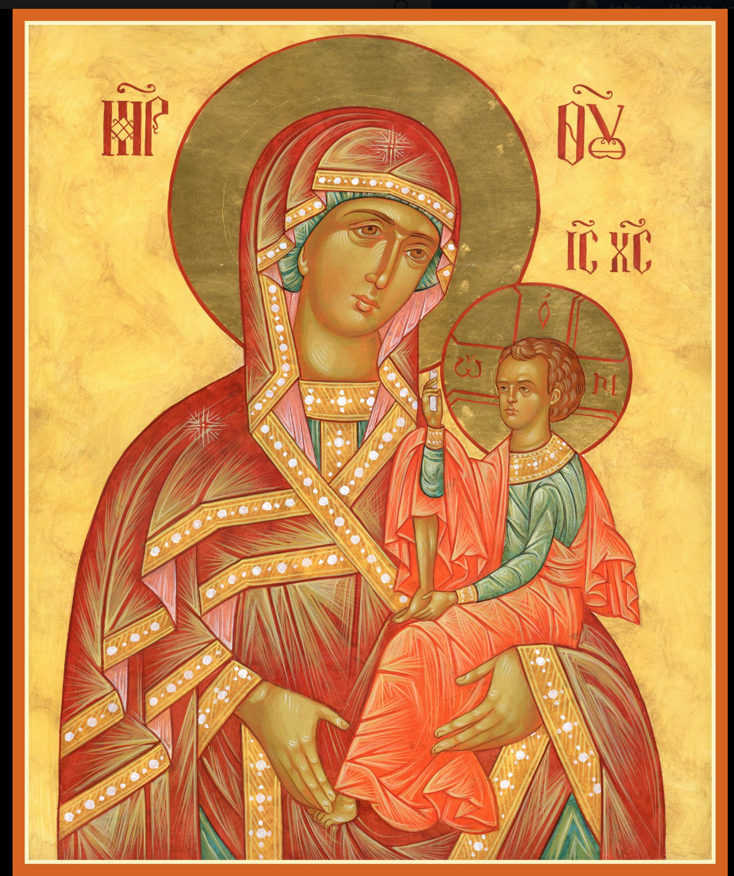

ASSUMPTION OF THE VIRGIN MARY
UKRAINIAN ORTHODOX CHURCH
ECUMENICAL PATRIARCHATE OF CONSTANTINOPLE AND NEW ROME
1301 Newport Avenue
Northampton, Pennsylvania 18067
Mitered Archpriest Myron Oryhon
Protodeacon Mychail Sawarynski, Attached

Telephones: Church Office… (610) 262-2882
Church Fax/Kitchen/Hall… (610) 262-0552
Fr. Myron Oryhon – (607) 752-1999
Protodeacon Mychail’s Residence… (610) 262-3876
Websites: holyassumption.org
ukrainianorthodoxchurchusa.org
lvorthodox.wordpress.com
E-mail: Parish… avmuoc@gmail.com
Protodeacon Mychail…pravoslavni@rcn.com
Webmaster, John Hnatow… john.hnatow@gmail.com
==============================================================
27th January, (14th Jan.) 2019

Thirty-Fifth Sunday after Pentecost. Tone 2. Leave-taking
of Theophany. HOLY FATHERS of SINAI and RAITHU.
Ven. JOSEPH ANALYTINUS of Raithu Monastery. Ven.
THEODULUS (5th C.). Ven. STEPHEN, Abbot of Khenolakkos Monastery. SAVA, Archbishop of Serbia (1236). HILARY,
Bishop of Poitiers (367). NINA, Enlightener of Georgia (335)

Colossians 3: 12-16 Luke 18: 18-27

CHRIST IS BAPTIZED! IN THE RIVER JORDAN!
PROPERS FOR LITURGY OF ST. JOHN CHRYSOSTOM
Tropar of the Resurrection, Tone 2
When You descended to death, Life Immortal, You slayed Hell with the splendor of Your Divinity. And when from the depths You raised the dead, all the Powers of Heaven cried out: Giver of Life, Christ our God, glory to You.
Tropar of Theophany, Tone 1
At Your Baptism in the Jordan, Lord, the worship of the Trinity was made manifest. For the voice of the Father bore witness to You and called You His Beloved Son. The Spirit, in the form of a dove, con-firmed the truthfulness of His word. Christ our God, Who has revealed Himself and enlightened the world, glory to You.
Glory to the Father and to the Son and to the Holy Spirit…
Kondak of the Resurrection, Tone 2
Hell became fearful, Almighty Savior, seeing the miracle of Your Resurrection from the tomb. The dead arose and all creation with Adam, beheld this and rejoiced with You and the world, my Savior, praises You forever.
Now and ever and to the ages of ages. Amen.
Kondak of Theophany, Tone 4

Today, Lord, You have appeared to the universe and Your Light has shone on us who with understanding praise You: Unapproachable Light, You have come and revealed Yourself.

Prokimen of the Resurrection, Tone 2
The Lord is my strength and my song. He has become my salvation.

Verse: The Lord has chastened me sorely, but He has not given me over to death.

Prokimen of Theophany, Tone 4
Blessed is He Who comes in the Name of the Lord. God is the Lord and has revealed Himself to us.

Verse: Give thanks to the Lord, for He is Good, for His mercy endures forever.

Alleluia Verses, Tone 2
May the Lord answer you in the day of trouble. May the Name of the God of Jacob protect you.

Lord, save the king and hear us on the day we call out to You.

Bring to the Lord, children of God, Bring to the Lord glory and honor.

The voice of the Lord is upon the waters. The God of glory thundered, the Lord is upon many waters.

Instead of “It is right in truth…”
Magnify my soul, the Most Pure Virgin Birth-Giver of God who is greater in honor and more glorious than the hosts on high.

Irmos, Tone 2
No tongue is capable of praising you worthily. The angelic mind is overawed in exalting you, Birth-Giver of God. But, accept our faith since you are good and know our divinely inspired love. You are the Protectress of Christians and we magnify you.

Communion Hymn:
Praise the Lord from the heavens, praise Him in the highest.
The grace of God that brings salvation to all has appeared.
Alleluia (3X)

ANNUAL PARISH MEETING TODAY FOLLOWING LITURGY.
A Continental Breakfast will be served @ $5.00. Proceeds will go to St. Andrew’s Society benefiting the soup kitchens in Ukraine.
LITURGICAL MENEION & SCRIPTURE READINGS
36th WEEK AFTER PENTECOST

Mon. 28 Jan. Ven. PAUL of Thebes (341) and JOHN CALABYTES. Monk-martyr PANSOPHIUS (251).
Hebrews 11:17-31 Mark 9:42-10:1
Tue. 29 Jan. Veneration of the Precious Chains of St. PETER.
Hebrews 12:25-26, 13:22-25 Mark 10:2-12

Wed. 30 Jan. Ven. ANTHONY the Great (356).
Fast Day: Hebrews 13:17-21 Luke 6:17-23
Fish

Thur. 31 Jan. ATHANASIUS the Great (373) & CYRIL (444),
Archbishops of Alexandria. MARCIAN in Syria.
James 1:19-27 Mark 10:17-27

Fri. 01 Feb. MACARIUS the Great of Egypt (390). Virgin-
Fast Day: martyr EUPHRASIA of Nicomedia (303).
Fish James 2:1-13 Mark 10:23-32

Sat. 02 Feb. Ven. EUTHYMIUS the Great (473). Martyrs INNA,
PINNA, & RIMMA. Martyrs BASSUS, EUSEBIUS,
EUTYCHIUS & BASILIDES of Nicomedia (303).
Hebrews 13:17-21 Luke 6:17-23
5:00 PM GREAT VESPERS

SUN. 03 Feb. 36th Sunday after Pentecost. Tone 3. Ven. MAXIMOS the Confessor. Martyr NEOPHYTUS.
8:30 AM THIRD & SIXTH HOUR; Mystery of Penance
9:00 AM DIVINE LITURGY OF JOHN CHRYSOSTOM

Sean Nehmeh and Elivonne Mendez will be united in the Sacrament
of Holy Matrimony on Saturday, Feb. 9th at 1:30 in our church. If
there is any reason why this couple should not be wed according to
the rules of the Orthodox Church please contact Fr. Myron Oryhon.
NEXT SUNDAY HAS BEEN DESIGNATED BY THE IOCC as
“SOUPER BOWL OF CARING” to feeding the poor and caring for
those in need around the world. Please bring a box or can of a non-
perishable food to church for the Food Bank or make a generous
contribution to the OCMC CANISTER in the back of the church.

NECROLOGY:
27 January… Protopresbyter Joseph Bodnar ’55, Izzat Azar ’06.
Marcelene Azar ’06, Gracielly Azar ‘06
28 January… John Bochnock ’89, Priest Isidore Kostiuk ’42, Pro-
topresbyter Juriy Huley ’90, Stephania Broda ‘31
29 January… Anna Kaarpenko ‘06
31 January… Zachary Kuts ‘37
01 February.. Michael Plotsko ’59. Stephen Kotoris ‘88
02 February.. Maxim Lubianecky ’33, Jennifer Melton ’88,
Protopresbyter Andrew Beck ‘90

VICHNAYA PAMYAT! MEMORY ETERNAL!

BIRTHDAYS:
28 January… Karen Seremula
30 January… Stephen Burk, John Yost
03 February.. Reader Maximos (Darryl) Meashock

MNOHAYA LITA! MANY YEARS!

WE PRAY FOR THE HEALTH AND WELL-BEING of the ill afflicted: Rosemarie Pypiuk, Sandra Meashock, Ariel Weiller and the child born to her, Anne Lelo, William Savitz, Catherine Kochenash, Fr. Vasyl Dovgan, Vladimir & Emma Krasnopera, Tessie Kuchinos, Brendan Phillips, Jessie Hnatow, Jessica Meashock, Wasyl Hewko, Adam Hewko, Betty Hendrickson, Andrew Thaxton, Michelle Pierzga, Susan Ferretti, Carole Zarayko, William Fischer, Ekaterina Seremula, Fr. Nicholas Dilendorf, Deacon Nicholas Zachary, Priest Silouan Rolando, Maria Levko

NEXT PIEROHI SALE WILL BE ON FEBRUARY 7th. Order by Feb. 3rd. Call Helen at 610-261-4575 or 484-239-5731. Additional dates: February 21, March 7 & 21, April 4 & 18.

RELIGIOUS INSTRUCTION CLASS FOR PARISH CHILDREN:
Mrs. Mary Ost – Sundays 9:00-9:30
Mrs. Linda Winters –Jan. 27th no class; Feb. 3-11 AM; Feb. 10-9AM; Feb. 17-11 AM
Ms. Bettyann Woyewoda – Sundays at 8:40-9:15; January 27; February 3, 10, 17, 24; March 3, 17, 24, 31; April 7, 14, 21

NORTHAMPTON FOODBANK continues to be in need of non-perishables for the needy, especially baby foods. Use pantry in hall.

We continue to collect receipts from the “REDNER’S SAVE A TAPE PROGRAM” Proceeds help the church. Use your Reward’s Card

Today, the Church commemorates St. Nina, Equal of the Apostles and Enlightener of Georgia. Born in Cappadocia in the 4th C. to a widely respected and honorable couple. She was a relative of St. George the Great Martyr and Patriarch Juvenal of Jerusalem from whom she received her education after her parents were tonsured into the monastic state. She had a vision of the Holy Mother of God, who urged her to carry the Gospel message to the Georgian people. She gained the love of the people and succeeded in baptizing King Mirian, his wife Nana and their son Bakar, who later assisted Nina in her missionary work. She converted the entire nation to the Christian Faith, even during the terrible persecutions of Emperor Diocletian. She reposed in the village of Bodbe in 335 and her body was entombed in the Church of St. George in the Bodbe Convent.

