JANUARY 26, 2020

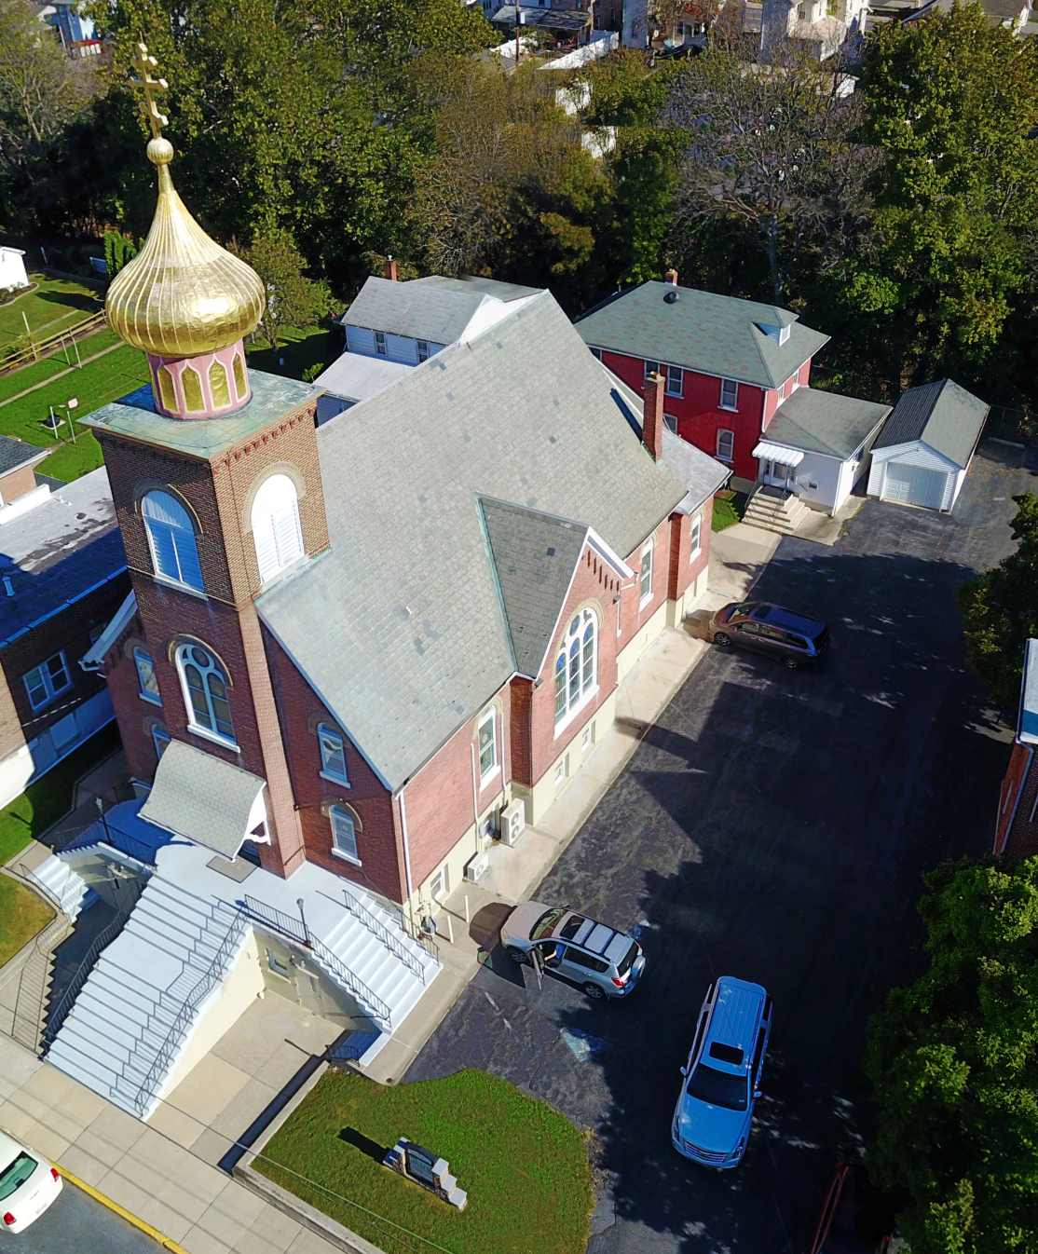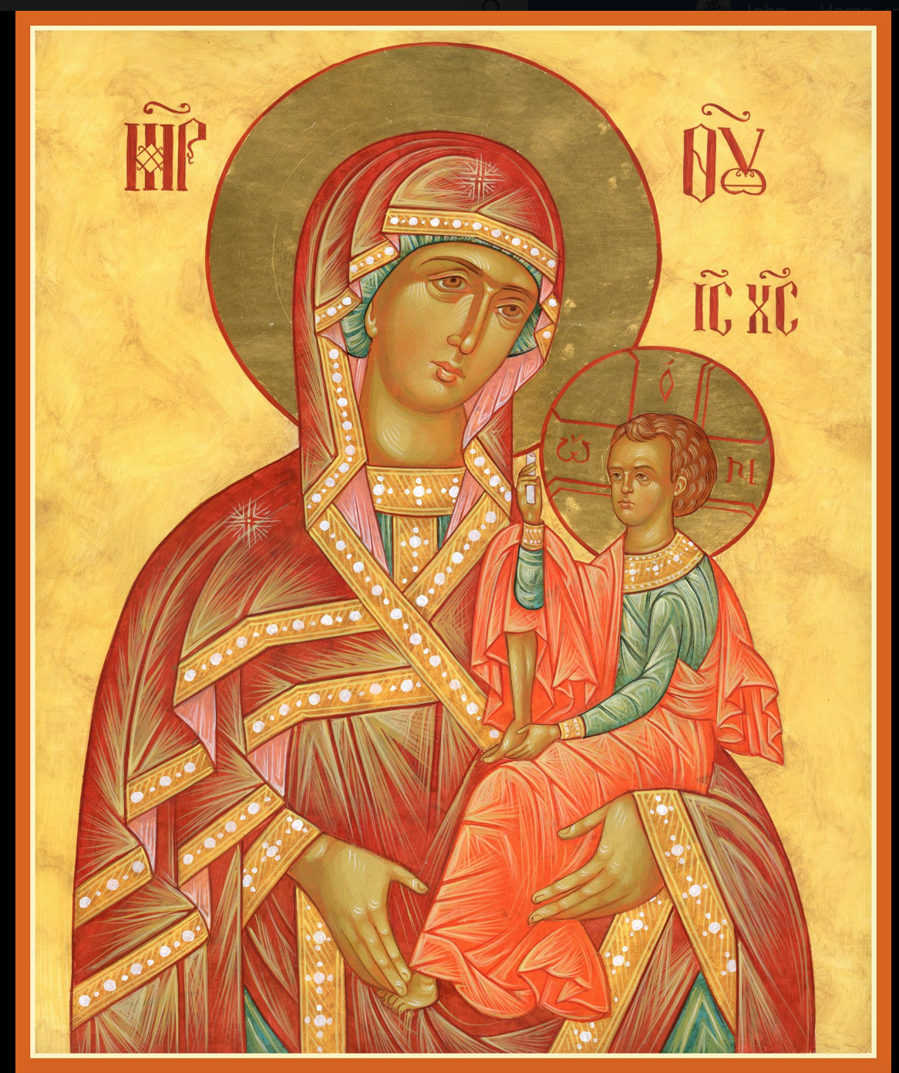

ASSUMPTION OF THE VIRGIN MARY
UKRAINIAN ORTHODOX CHURCH
ECUMENICAL PATRIARCHATE OF CONSTANTINOPLE AND NEW ROME
1301 Newport Avenue
Northampton, Pennsylvania 18067
Rev. Fr. Oleg Kravchenko, Rector
Protodeacon Mikhail Sawarynski, Attached
Telephones: Church Office… (610) 262-2882
Fr. Oleg Kravchenko – (732) 507-2274
Protodeacon Mikhail’s Residence - (610) 262-3876
Websites: holyassumption.org
ukrainianorthodoxchurchusa.org
Facebook: https://www.facebook.com/Assumption-of-the-Virgin-Mary-Ukrainian-Orthodox-Church-113456096722198/?modal=admin_todo_tour
E-mail: Parish… avmuoc@gmail.com
Fr. Oleg…olegkravchenko2212@gmail.com
Protodeacon Mikhail…pravoslavni@rcn.com
Webmaster, John Hnatow… john.hnatow@gmail.com
==============================================================
26th January (13th Jan.) 2020

Thirty Second Sunday after Pentecost. Tone 7. SUNDAY after
THEOPHANY Martyrs HERMYLUS & STRATONICUS at
Belgrade (315) Martyr PETER of Anium (1st C.) Ven. JAMES, Bishop of Nisibis (350). “SANCITITY OF LIFE SUNDAY”

Ephesians 4:7-13 Matthew 4: 12-17
1 Timothy 1:15-17 Matthew 15:21-28

PROPERS FOR LITURGY OF ST. JOHN CHRYSOSTOM

Tropar of the Resurrection, Tone 7
By Your Cross, You destroyed Death. To the Thief, You opened Paradise. For the Myrrh-bearers, You changed weeping into joy. Christ God, You commanded Your disciples to proclaim that You are risen, granting the world great mercy.

Tropar of Theophany, Tone 1
When in the Jordan, You were baptized, Lord, the worship of the Trinity was made manifest. For the voice of the Father bore witness unto You and called You His Beloved Son. And the Spirit, in the form of a dove, confirmed the truth of His Word. O Christ our God, Who has revealed Yourself and enlightened the world, glory to You.

Tropar of the Dormition, Tone 1
In giving birth, you preserved your virginity. In falling asleep, you did not forsake the world, Birth-Giver of God. You were translated to life, Mother of Life, and through your prayers you deliver our souls from death.

Kondak of the Resurrection, Tone 7
The dominion of death can no longer hold humanity captive, for Christ descended shattering and destroying its power. Hell is bound while the prophets rejoice with one voice: The Savior has come to those in faith, saying: “Enter, you faithful, into the Resurrection.”

Glory to the Father and to the Son and to the Holy Spirit.

Kondak of the Feast, Tone 4
Today, Lord, You have appeared to the universe and Your Light has shone on us who with understanding praise You. You have come, Unapproachable Light and revealed Yourself to us.

Now and ever and unto ages of ages. Amen.

Kondak of the Dormition, Tone 2
Neither the tomb nor death had power over the Birth-Giver of God; she is ever watchful in her prayers and in her intercession lies un-failing hope. For as the Mother of Life, she has been translated to life by the One Who dwelt within her ever-virginal womb.

Prokimen, Tone 1
Let Your mercy, Lord, be upon us as we have put our hope in You.

Verse: Rejoice in the Lord, you Righteous. Praise befits the upright.

Prokimen of the Feast, Tone 4
Blessed is He Who comes in the Name of the Lord. God is the Lord and has revealed Himself to us.

Alleluia Verses in Tone 5
Lord, I will chant of Your mercies forever. With my mouth I will proclaim Your Truth from generation to generation.

You have said: Mercy will be established forever and my truth will be prepared in the heavens.

Bring to the Lord, children of God. Bring to the Lord glory and honor.

The voice of the Lord is upon the waters. The God of glory thundered. The Lord is upon many waters.

In place of “It is right in truth…”
Magnify, my soul, the Most pure Virgin Birth-Giver of God who is greater in honor than the Hosts on High.

Irmos, Tone 2: No tongue is capable of praising you worthily. The angelic mind if overawed in exalting you, Birth-Giver of God. But accept our faith since you are good and know our divinely inspired love. You are the Protectress of Christians and we magnify you.

Communion Hymn:
The grace of God that brings salvation to all has appeared.
Praise the Lord from the heavens, praise Him in the Highest.
Alleluia (3X)

The BLESSING OF HOMES will continue today and this week.

LITURGICAL MENEION & SCRIPTURE READINGS
FOR THE THIRTY THIRD WEEK AFTER PENTECOST

Mon. 27 Jan. Leaving-taking of Theophany. Holy Fathers slain at
Sinai & Raithus. Ven. JOSEPH ANALYTINUS.
James 2:14-26 Mark 10:46-52

Tue. 28 Jan. Venn. PAUL of Thebes (341) & JOHN CALABYTES
(450). Monk-martyr PANSOPHIUS (251).
James 3:1-10 Mark 11:11-23

Wed. 29 Jan. Veneration of the Precious Chains of APOSTLE
FAST DAY: PETER. Martyrs SPEUSIPPUS, ELEUSIPPUS,
Fish, wine, & MELEUSIPPUS & LEONILLA. Reader DANAX.
Oil allowed James 3:11-4:6 Mark 11:23-26

Thurs. 30 Jan. Ven. ANTHONY the Great (356). ANTHONY,
Abbot of Dymsk (1224) Monk ANTHONY of Chernoezersk. ANTHONY in Macedonia (11th C.).
Hebrews 13:17-21 Luke 6:17-23

Fri. 31 Jan. ATHANSIUS the Great & CYRIL, Archbishops of
FAST DAY: Alexandria. Ven. MARCIAN of Cyrrhus, Syria.
Fish, wine, oil 1 Peter 1:1-2, 10-12-2:10 Mark 12:1-12

Sat. 01 Feb. MACARIUS the Great of Egypt. Virgin-martyr
EUPHRASIA of Nicomedia. Ven. MACARIUS of
Alexandria. ARSENIUS, Archbishop of Corfu.
Hebrews 11:17-23; 27-31 Mark 9:42:-10:1
5:00 PM GREAT VESPERS
Sun. 02 Feb. 33rd Sunday after Pentecost. ZACCHAEUS
SUNDAY. Tone 8. Ven. EUTHYMIUS the Great.
Martyrs INNA, PINNA, & RIMMA.
8:30 AM THIRD & SIXTH HOURS
9:00 AM DIVINE LITURGY of JOHN CHRYSOSTOM

NECROLOGY:
27 Jan…Izzat Azar ’06, Marcelene Azar ’06, Gracielly Azar ‘06
28 Jan…John Bochnock ’89, Stephania Broda ‘31
29 Jan…Anna Karpenko ‘06
31 Jan…Zachary Kuts ‘37
01 Feb…Michael Plotsko ’59, Stephen Kotoris ‘88

VICHNAYA PAMYAT! MEMORY ETERNAL!

BIRTHDAYS:
28 Jan…Karen Seremula
30 Jan…Stephen Burk, John Yost

ANNIVERSARIES:
25 Jan…Dennis & Linda Schmall

MNOHAYA LITA! MANY YEARS!

BENE NOTE: ON HOLY COMMUNION
Please be advised that according to the Canons of the Orthodox Church, the Sacrament of Holy Communion may only be administered to Orthodox Christians (Baptized & Chrismated, making them living members of the Body of Christ). One must be prepared to approach the Holy Chalice by fasting, prayer and confession.

OCMC “AGAPE CANISTER” DONATIONS: $29.00. Thank you for supporting our missions around the globe.

Fr. Oleh provides PROSFORAS for commemorations of the living and dead at the Divine Liturgy. Available in the vestibule.

A special petition in the Litany of Fervent Supplication for the right to life in our nation and a prayer for all the victims of abortion.

WE PRAY FOR THE HEALTH AND WELL-BEING of the ill-afflicted: Chet Bohanek, William Savitz, Catherine Kochenash, Vladimir & Emma Krasnopera, Brendan Phillips, Jessie Hnatow, Jessica Meashock, Adam Hewko, Betty Hendrickson, Andrew Thaxton, Michelle Pierzga, Susan Ferretti, Carole Zaayko, Mariana Goshow, Judy Albright, Rob Hewko, Daniel Kochenash, Evan Hartnett, Christopher Mack, Norman Betrous, Thomas Orlovsky

NORTHAMPTON AREA FOODBANK is still in need of foodstuffs
Especially tuna, canned potatoes, baby food, pasta, and sauce.

Your Redner’s receipts is a very successful fund raiser. Please use your “REDNER’S REWARDS CARD” for purchases. Put receipts in box in Vestibule. Thank you, Helen Crayosky for supervising it.

SUNDAY SCHOOL SCHEDULE
Mrs. Mary Ost – Pre-K to 3rd grade. All Sundays at 9 AM.
Mrs. Linda Winters – 4th to 6th grade. Jan. 26th- 9 AM;
Feb. 2nd – 11 AM; Feb, 9th – 9 AM.
Ms. Bettyann Woyewoda – 7th to 12th grade. All Sundays @ 9 AM

DONATION of $1,000 to the church received from the Jr. UOL.

NEXT DAY for sale of Pierohi is FEB. 6th. Please put orders in by Feb. 2nd. Call Helen at 610-261-4575. Pick-up 10:00 to 11:30 AM in the church hall.

ICON OF HOLY THEOPHANY

The season of Theophany lasts until January 27th. Many of the Church’s hymns rejoice in the Manifestation of God in the Jordan River. The Voice of the Father is heard as the Son
enters the Water. And the Holy Spirit appears in the form of a dove.

