JANUARY 20, 2019

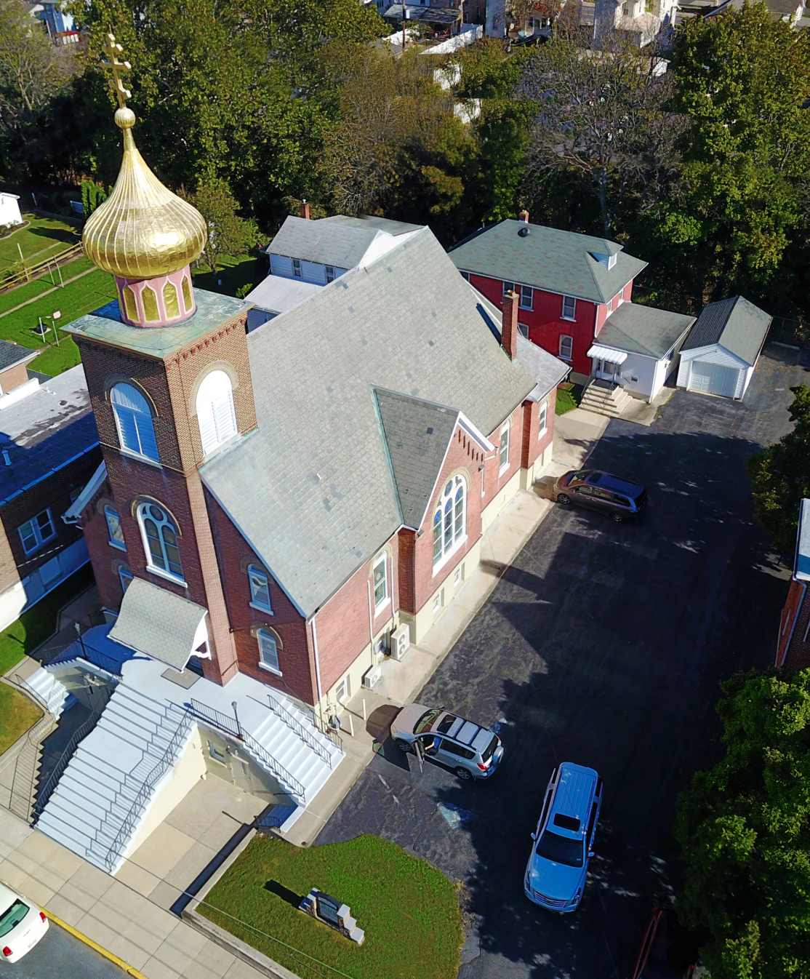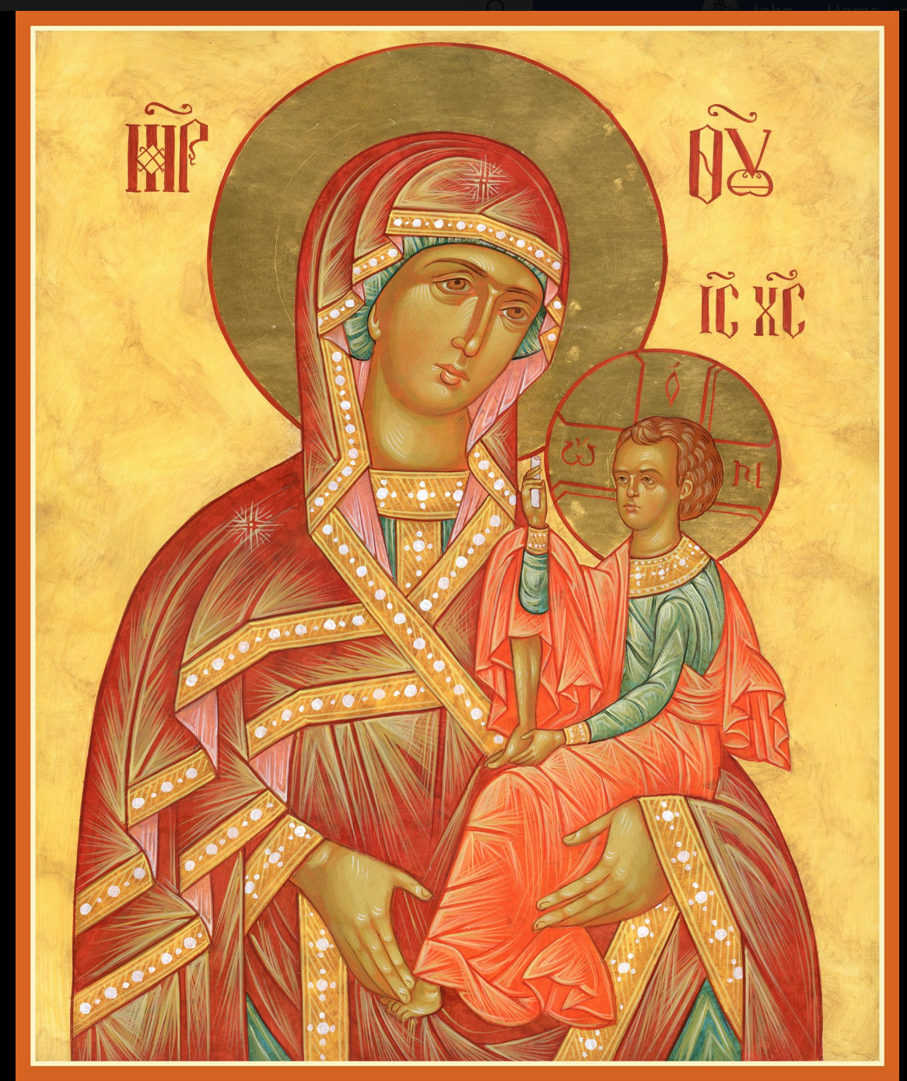

ASSUMPTION OF THE VIRGIN MARY
UKRAINIAN ORTHODOX CHURCH
ECUMENICAL PATRIARCHATE OF CONSTANTINOPLE AND NEW ROME
1301 Newport Avenue
Northampton, Pennsylvania 18067
Mitered Archpriest Myron Oryhon
Protodeacon Mychail Sawarynski, Attached

Telephones: Church Office… (610) 262-2882
Church Fax/Kitchen/Hall… (610) 262-0552
Fr. Myron Oryhon – (607) 752-1999
Protodeacon Mychail’s Residence… (610) 262-3876
Websites: holyassumption.org
ukrainianorthodoxchurchusa.org
lvorthodox.wordpress.com
E-mail: Parish… avmuoc@gmail.com
Protodeacon Mychail…pravoslavni@rcn.com
Webmaster, John Hnatow… john.hnatow@gmail.com
==============================================================
20th January, (07th Jan.) 2019

Thirty-Fourth Sunday after Pentecost. Tone 1. Afterfeast of Theophany. SYNAXIS of the HOLY, GLORIOUS PROPHET, FORERUNNER and BAPTIST, JOHN.

Ephesians 4: 7-13 Matthew 4: 12-17 Acts 19: 1-8 John 1: 29-34
CHRIST IS BAPTIZED! IN THE RIVER JORDAN!

PROPERS FOR LITURGY OF ST. JOHN CHRYSOSTOM
Tropar of the Resurrection, Tone 1
When the stone had been sealed by the Jews, while the soldiers were guarding Your Most Pure Body, You arose on the third day, Savior, granting life to the world. Therefore, the Powers of Heaven cried to You the Giver of Life: Glory to Your Resurrection, Christ. Glory to Your Kingdom. Glory to Your Divine Plan, only Lover of Mankind.
Tropar of Theophany, Tone 1
At Your Baptism in the Jordan, Lord, the worship of the Trinity was made manifest. For the voice of the Father bore witness to You and called You His Beloved Son. The Spirit, in the form of a dove, con-firmed the truth of His word. Christ our God, Who has revealed Yourself and enlightened the world, glory to You.
Tropar to the Forerunner, Tone 2
The memory of the righteous is praised, but you are well pleased, Forerunner, with the testimony of the Lord. For you have truly been revealed as more honorable than the prophets since you were deemed worthy to baptize in the stream the One they foretold. Therefore, having fought and suffered for the Truth, you have also joyfully preached the good tidings of God revealed in the flesh to those in Hades. He takes away the sins of the world and grants us great mercy.
Glory to the Father and to the Son and to the Holy Spirit…
Kondak to the Forerunner, Tone 6
The Jordan was filled with fear when You came in the flesh. It was driven back trembling and John, fulfilling the ministry of the Spirit, drew back in fear. The hosts of angels stood amazed beholding You in the stream and baptized in the flesh. And all those in darkness were filled with Light, chanting the praises of the One Who is revealed and gives Light to all.
Now and ever and to the ages of ages. Amen.
Kondak of Theophany, Tone 4

Today, Lord, You have appeared to the universe and Your Light has shone on us who with understanding praise You: Unapproachable Light, You have come and revealed Yourself.

Prokimen, Afterfeast of Theophany, Tone 1
Let Your mercy, Lord, be upon us as we have put our hope in You.

Verse: Rejoice in the Lord, you Righteous. Praise befits the upright.

Prokimen of the Forerunner, Tone 7
The Righteous shall rejoice in the Lord and hope in Him.

Verse: God, hear my voice in my lament; from the dread enemy preserve my life.

Alleluia Verses, Tone 5
Lord, I will chant of Your mercies forever; with my mouth I will proclaim Your Truth from generation to generation.

You have said: Mercy will be established forever and my truth will be prepared in the heavens.

Light dawns for the righteous and joy for the upright of heart.

Be glad in the Lord, you Righteous and give thanks for the memory of His Holiness.

Instead of “It is right in truth…”
Magnify my soul, the Most Pure Virgin Birth-Giver of God who is greater in honor and more glorious than the hosts on high.

Irmos, Tone 2
No tongue is capable of praising you worthily. The angelic mind is overawed in exalting you, Birth-Giver of God. But, accept our faith since you are good and know our divinely inspired love. You are the Protectress of Christians and we magnify you.

Communion Hymn:
Praise the Lord from the heavens, praise Him in the highest.
The grace of God that brings salvation to all has appeared.
The Righteous shall be in everlasting remembrance. They shall not be afraid of any evil report. Alleluia (3X)

LITURGICAL MENEION & SCRIPTURE READINGS
35th WEEK AFTER PENTECOST

Mon. 21 Jan. Ven. GEORGE the Chozebite and EMILIAN,
Bishop of Cyzicus. Ven. DOMNICA of Constan-
tinople. Hieromartyr CARTERIUS of Caesarea.
Hebrews 8:7-13 Mark 8:11-21

Tue. 22 Jan. Martyr POLYEUCTUS. Prophet SHEMAIAH.
PETER, Bishop of Sebaste. Ven. EUSTRATIUS.
Hebrews 9:8-10, 15-23 Mark 8:22-26

Wed. 23 Jan. GREGORY of Nyssa. Ven. DOMETIAN, Bishop
Fast Day: of Melitene. Ven. MACARIUS of the Kyiv Caves.
Fish Hebrews 10:1-18 Mark 8:30-34

Thur. 24 Jan. Ven. THEODOSIUS the Great, Cenobiarch (529).
Ven. THEODOSIUS of Antioch (412).
Hebrews 10:35-11:7 Mark 11:27-30

Fri. 25 Jan. Martyr TATIANA of Rome. Martyr MERTIUS of
Fast Day: of Mauretania. SAVA, Archbishop of Serbia (1237).
Fish Hebrews 11:8-16 Mark 9:33-41

Sat. 26 Jan. Afterfeast of Theophany. Martyrs HERMYLUS & STRATONICUS of Belgrade. Martyr PETER of
Anium. Ven. JAMES, Bishop of Nisibis (350).
Ephesians 4:7-13 Matthew 4:12-17

5:00 PM GREAT VESPERS

SUN. 27 Jan. 35th Sunday after Pentecost. Leave-Taking of
Theophany. HOLY FATHERS slain at Sinai &
Raithu. Ven. THEODULUS. Ven. STEPHEN (716).

8:00 AM THIRD & SIXTH HOUR; Mystery of Penance
8:30 AM DIVINE LITURGY OF JOHN CHRYSOSTOM

NECROLOGY:
21 January… John Bodnyk ’80, Anna Plotsko ’59,
Nagib Azar ‘15, Leonid Frolov ‘13
22 January… Mary Kudrick (infant) ’23, Joseph Hanzarick ‘83
23 January… Mary Nazar ’76, Mary Bach ‘83
25 January… Dmytro Czuba ’91, George Kulchycki ‘89
26 January… Protopresbyter Alexander Dovhal ‘26

VICHNAYA PAMYAT! MEMORY ETERNAL!

ANNIVERSARIES;
25 January… Dennis & Linda Schmall

MNOHAYA LITA! MANY YEARS!

January 22nd marks the 46th anniversary of Roe v. Wade. We shall pray for all the unborn children who have been aborted since this decision. The March for Life took place in Washington, D.C. Friday.
WE PRAY FOR THE HEALTH AND WELL-BEING OF: Dennis & Linda, the ill afflicted: Sandra Meashock, Anne Lelo, William Savitz, Catherine Kochenash, Fr. Vasyl Dovgan, Vladimir & Emma Krasnopera, Tessie Kuchinos, Brendan Phillips, Jessie Hnatow, Jessica Meashock, Wasyl Hewko, Adam Hewko, Betty Hendrickson, Andrew Thaxton, Michelle Pierzga, Susan Ferretti, Carole Zarayko, William Fischer, Ekaterina Seremula, Fr. Nicholas Dilendorf, Deacon Nicholas Zachary, Helen Crayosky

ANNUAL PARISH MEETING WILL BE HELD NEXT SUNDAY following DIVINE LITURGY, which will begin at 8:30 AM. Every-one is urged to stay. The major issue to be discussed will be the appointment of a new priest as pastor of the parish.

MEMORIAL CANDLES ON THE LITYNIK TABLE
For commemorating the departed have been replaced with glass vigils due to wax melting. Please make your donations in the candle tray in the Vestibule. They are 2 for $1.00 and burn for one Liturgy.

PIEROHI SALES WILL RESUME ON JANURY 24TH. Order by Jan. 20th. Call Helen at 610—261-4575 or 484-239-5731. Additional dates: February 7 & 21, March 7 & 21, April 4 & 18.

RELIGIOUS INSTRUCTION CLASS FOR PARISH CHILDREN:
Mrs. Mary Ost – Sundays 9:00-9:30
Mrs. Linda Winters – Sunday, Jan. 20 -11 AM Jan. 27th no class; Feb. 3-11 AM; Feb. 10-9AM; Feb. 17-11 AM
Ms. Bettyann Woyewoda – Sundays at 8:40-9:15; January 20, 27; February 3, 10, 17, 24; March 3, 17, 24, 31; April 7, 14, 21

Church Envelopes & Calendars for 2019 are available in the hall.

NORTHAMPTON FOODBANK continues to be in need of non-perishables for the needy, especially baby foods. Use pantry in hall.

OCMC “AGAPE CANISTER” DONATIONS for last Sunday were $37.00. Thank you for your support of Missions around the globe.
MEETING of the SISTERHOOD TODAY, JANUARY 20th.

We continue to collect receipts from the “REDNER’S SAVE A TAPE PROGRAM” Proceeds help the church. Use your Reward’s Card.

SINCERE GRATITUDE to all the workers and donors who made our HOLY SUPPER a most blessed event. Also many thanks to those who participated in the Church services providing us with a deep spiritual atmosphere during the Nativity season: choir members, readers, altar servers and church workers. MANY YEARS!

SYNAXIS OF ST. JOHN THE BAPTIST

In the Orthodox Church, the day following a Great Feast, we remember those saints who participated directly in the sacred event. Today, we honor St. John the Forerunner, who placed his own hand upon the head of our Savior. Jesus called him the greatest of the prophets. He concludes the history of the Old Testament and opens the era of the New Testament. The son of the Priest Zachariah and the Righteous Elizabeth, St. John was born 6 months before Christ. At the age of 30, he came forth preaching repentance on the banks of the Jordan to prepare his people for the coming of the Savior. Having baptized the sinless Lamb of God, Jesus Christ, he soon died a martyr’s death at the hands of King Herod and was buried in the city of Sevaste. When the Evangelist Luke came to the city, they gave him the right hand of the Holy Prophet which Luke took to Antioch and was then transferred to Constantinople until that city fell to the Turks in 1453. It was given to the Knights of Rhodes who transferred it to the island of Malta where it remained until 1799 and then presented to Tsar Paul I of Russia, Grand Master of the Maltese Order, and brought to the Church of the “Icon of the Savior Not Made by Hands” in St. Petersburg. It was carried into exile by refugees fleeing communism in 1917 and wound up in a monastery in Cetinije, Montenegro.

