JANUARY 19, 2020

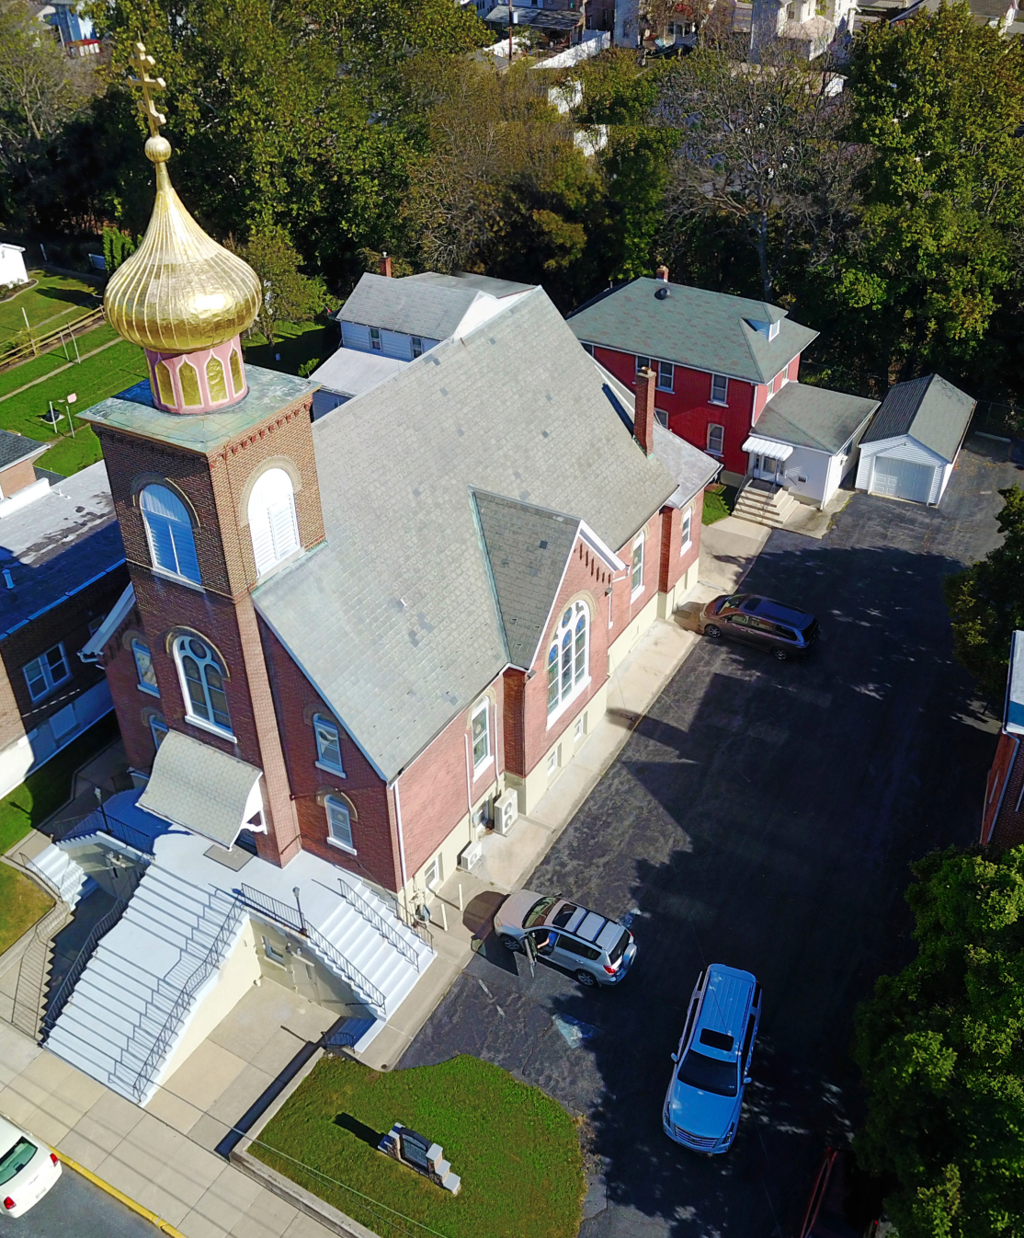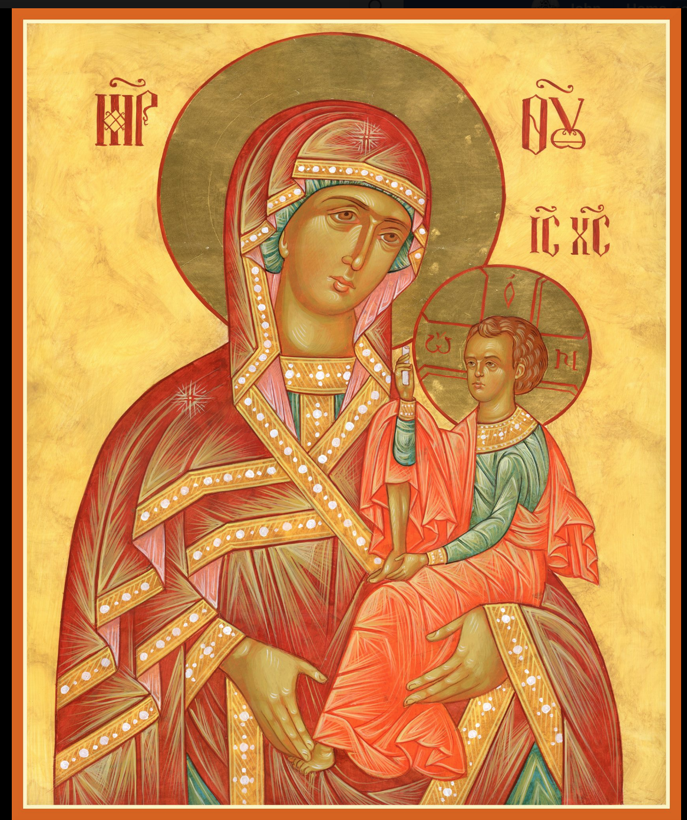

ASSUMPTION OF THE VIRGIN MARY
UKRAINIAN ORTHODOX CHURCH
ECUMENICAL PATRIARCHATE OF CONSTANTINOPLE AND NEW ROME
1301 Newport Avenue
Northampton, Pennsylvania 18067
Rev. Fr. Oleg Kravchenko, Rector
Protodeacon Mikhail Sawarynski, Attached
Telephones: Church Office… (610) 262-2882
Fr. Oleg Kravchenko – (732) 507-2274
Protodeacon Mikhail’s Residence… (610) 262-3876
Websites: holyassumption.org
ukrainianorthodoxchurchusa.org
Facebook: https://www.facebook.com/Assumption-of-the-Virgin-Mary-Ukrainian-Orthodox-Church-113456096722198/?modal=admin_todo_tour
E-mail: Parish… avmuoc@gmail.com
Fr. Oleg...olegkravchenko2212@gmail.com
Protodeacon Mikhail…pravoslavni@rcn.com
Webmaster, John Hnatow… john.hnatow@gmail.com

19th January (6th Jan.) 2020

31st Sunday after Pentecost. Tone 3. HOLY THEOPHANY of Our Lord, GOD and SAVIOR JESUS CHRIST. BAPTISM of the LORD

Christ is Baptized! In the River Jordan!
Hristos Okhreshuyetsa! V Ritsye Iordani
LITURGICAL MENEION & SCRIPTURE READINGS
FOR THE THIRTY SECOND WEEK AFTER PENTECOST

Mon. 20 Jan. SYNAXIS OF ST. JOHN THE BAPTIST
Acts 19:1-8 John 1:29-34

Tue. 21 Jan. Ven. GEORGE the Chozebite. EMILIAN, Bishop
of Cyzicus. Ven. DOMNICA of Constantinople.
Hebrews 12:25-26, 13:22-25 Mark 10:2-12

Wed. 22 Jan. Martyr POLYEUCTUS (259) Prophet SHEMAIAH.
FAST DAY PETER, Bishop of Sebaste. Ven. EUSTRATUS.
James 1:1-18 Mark 10:11-16

Thur. 23 Jan. GREGORY of Nyssa (395). Ven. DOMETIAN,
Bishop of Melitene. Ven. MACARIUS of the Caves.
James 1:19-27 Mark 10:17-27

Fri. 24 Jan. Ven. THEODOSIUS the Cenobiarch (529). Ven.
FAST DAY THEODOSIUS of Antioch (412).
James 2:1-13 Mark 10:23-32

Sat. 25 Jan. Martyr TATIANA of Rome (235). Martyr
MERTIUS of Mauretania (305). Ven. EUPRAXIA
of Egypt. SAVA I, Archbishop of Serbia (1237).
Ephesians 6:10-17 Matthew 4:1-11

5:00 PM GREAT VESPERS

Sun. 26 Jan. 32nd Sunday after Pentecost. Tone 7. SUNDAY
after THEOPHANY.

8:00 AM THIRD & SIXTH HOURS
8:30 AM DIVINE LITURGY OF JOHN CHRYSOSTOM

CONTINENTAL BREAKFAST (Donation of $5.00) & ANNUAL PARISH MEETING WILL FOLLOW THE LITURGY.
NECROLOGY:
19 Jan…Mary Ziatyk ‘74
20 Jan…Pauline Bollent ‘15
21 Jan…John Bodnyk ’80, Anna Plotsko ’58, Nagib Azar ‘15
22 Jan…Mary Kudrick (infant) ’23, Joseph Hanzarick ‘83
23 Jan…Mary Nazar ’76, Mary Bach ‘83
25 Jan…Dmytro Czuba ’91, George Kulchycki ‘89
VICHNAYA PAMYAT! MEMORY ETERNAL

BIRTHDAYS:
20 Jan…Jessica Meashock
MNOHAYA LITA! MANY YEARS!

WE PRAY for the health and well-being of the ill-afflicted: William Savitz, Catherine Kochenash, Vladimir & Emma Krasnopera, Brendan Phillips, Jessie Hnatow, Jessica Meashock, Adam Hewko, Betty Hendrickson, Andrew Thaxton, Michelle Pierzga, Susan Ferretti, Carole Zarayko, Marianna Goshow, Judy Albright, Rob Hewko, Daniel Kochenash, child Christopher Mack, Evan Hartnett, Chet Bohanek, Norman Betrous, Thomas Orlovsky.

DONATION to the Church in Memory of +TESSIE KUCHINOS
$100 was received from John & Jessie Hnatow.

TRAVELOGUE of the Holy Land will be presented on Sunday, FEB. 9th by John & Jessie Hnatow following the Coffee Hour.

Thank you to the Schisler Family for their Nativity gifts to the parish of poinsettia plants and a donation of $500. God Bless!

OCMC Agape Canister Donations - $30.00. Thank you.

BLESSING OF HOMES
Will begin today at 1 PM. Fr. Oleg will call to make an appointment. If you would like to re-schedule let him know. Have all pets secured. Turn off tv and radio. Have a candle and icon with a bowl on your table & a list of those whom you wish to be commemorated.
Jan. 19th & 20th (Northampton)
Crayosky, Helen
Craysoky, Kathy
Jan. 22nd (Danielsville, Lehigh Township.
Hallman
Dworakivsky Family Hnatow, John
Kerick Hnatow, Michael
Kochenash, Catherine Krasnopera
Kroboth Kochenash, Paul
Leindecker Seremula, Joe
Misko, Michael Vitushinsky, John
Paukovitz Vitushinsky, Nicholas
Savitz
Jan. 23rd (Allentown & West)
Sawarynski, Matthew Busch
Sawarynski, Deacon Dorosh
Sawarynski, Paul Dowling
Semenovych Family Ketterer
Seremula, Walter Osmun
Schubert Ost Family
Truss Parchomenko
Unger Plotsko
Pypiuk, Taras
Jan 21st (Bethlehem Area) Rippey
Schmall
Alexander Vitushinsky, Juanita
Baird Yarchak Family
Khromenko Family
Mauser
Jan. 24th (Hellertown & Easton)
Meashock Kuchinos. Kathleen
Misko, David Pozzetta
Pavlinsky Lelo
Pypiuk, Gregory Woyewoda Family
Reichl
Seremula, John
Jan. 25th & 26th (missed homes &
Winters Family re-scheduled ones)

If your name was missed and you wish to have your home blessed, please call Fr. Oleg.

