JANUARY 13, 2019

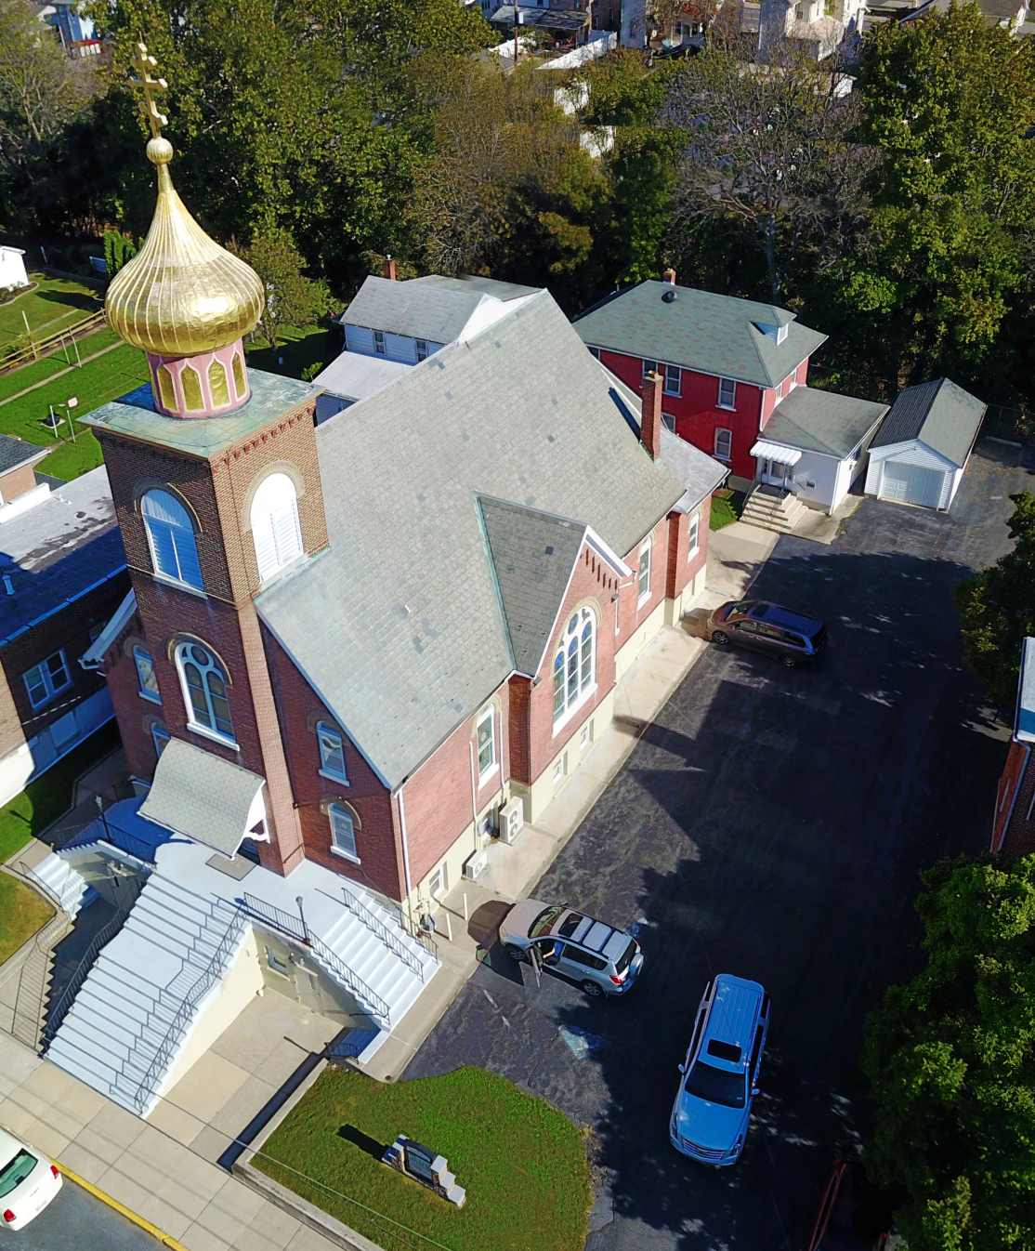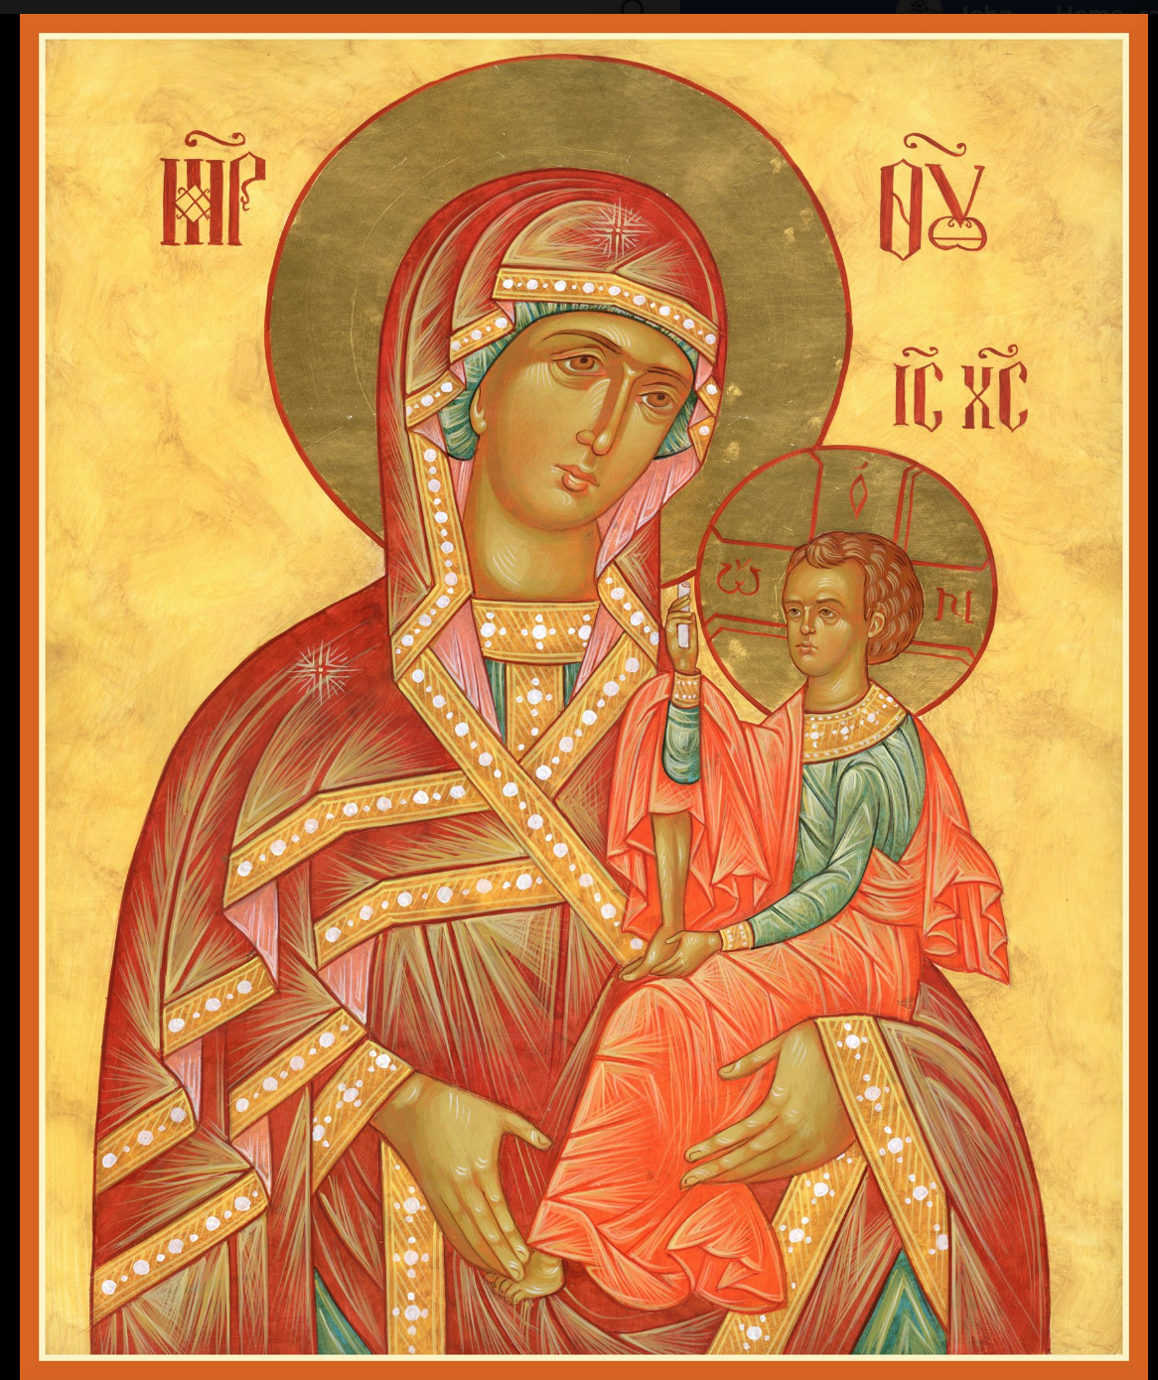

ASSUMPTION OF THE VIRGIN MARY
UKRAINIAN ORTHODOX CHURCH
ECUMENICAL PATRIARCHATE OF CONSTANTINOPLE AND NEW ROME
1301 Newport Avenue
Northampton, Pennsylvania 18067
Mitered Archpriest Myron Oryhon
Protodeacon Mychail Sawarynski, Attached

Telephones: Church Office… (610) 262-2882
Church Fax/Kitchen/Hall… (610) 262-0552
Fr. Myron Oryhon – (607) 752-1999
Protodeacon Mychail’s Residence… (610) 262-3876
Websites: holyassumption.org
ukrainianorthodoxchurchusa.org
lvorthodox.wordpress.com
E-mail: Parish… avmuoc@gmail.com
Protodeacon Mychail…pravoslavni@rcn.com
Webmaster, John Hnatow… john.hnatow@gmail.com
==============================================================
13th January, (31st Dec.) 2019

Thirty-Third Sunday after Pentecost. Tone 8. Leave Taking of the Nativity of Christ. Sunday before Theophany. Ven. MELANIA the Younger of Rome (439). PETRO MOHYLA, Metropolitan of Kyiv.

Galatians 1: 11-19 Matthew 2: 13-23
CHRIST IS BORN! GLORIFY HIM!
LITURGY OF ST. JOHN CHRYSOSTOM
PROPERS OF THE DIVINE LITURGY
Tropar of the Resurrection, Tone 8
You descended from on High, Merciful One. You accepted the three day burial to free us from our passions. Lord, our Life and Resurrection. Glory to You.
Tropar of the Nativity of our Savior, Tone 4
Your Nativity, Christ our God, has shown to the world the Light of Wisdom. For by it, those who worshipped the stars, were taught by a star, to adore You the Sun of Righteousness and to know You the Orient from on High. Lord, glory to You.
Tropar of the Righteous Ones, Tone 2
Joseph, proclaim the great miracles you have witnessed to David the Ancestor of God; for you have seen the Virgin with Child, given glory with the shepherds, worshipped with the Magi, and an angel of the Lord appeared to you. Pray to Christ our God to save our souls.
Glory to the Father and to the Son and to the Holy Spirit…
Kondak of the Righteous Ones, Tone 6
Today, David the Holy One is filled with Joy. Joseph and James offer their hymns of praise to the One born on earth in a manner beyond description and cry out: Merciful One, save those who honor You.
Now and ever and to the ages of ages. Amen.
Kondak of the Nativity, Tone 3

Today the Virgin gives birth to the Transcendent One and the earth offers a cave to the Unapproachable God. Angels with shepherds glorify Him. The Magi journey with the star. Since for our sake the Eternal God was born as a little Child.

Prokimen of the Nativity, Tone 8
Let all the earth worship You and sing to You. Let them sing to Your Name.

Verse: Make a joyful noise to the Lord all the earth. Sing forth the glory of His Name. Make His praise glorious.

Prokimen for the Righteous Ones, Tone 4
God is wonderful in His saints, the God of Israel.

Verse: God grants strength and might to His people. Blessed be God.

Alleluia Verses, Tone 1
The heavens declare the glory of God. And the firmament shows His handiwork.

Day speaks to the day and night shows knowledge to the night.

Lord remember David and all his meekness.

Instead of “It is right in truth…”
Magnify my soul, the Most Pure Virgin Birth-Giver of God who is greater in honor and more glorious than the hosts on high.

Irmos, Tone 1
It is a strange and most wonderful mystery that I see; the cave is heaven; the Virgin, the throne of the Cherubim; the manger, a room, in which Christ, the Uncontainable God, is laid. Him do we praise and magnify.

Communion Hymn:
Praise the Lord from the heavens, praise Him in the highest.
Rejoice in the Lord, you Righteous, praise befits the upright.
Alleluia (3X)

FAST FREE PERIOD JAN. 13TH TO JAN. 18TH NO KNEELING
LITURGICAL MENEION & SCRIPTURE READINGS
34th WEEK AFTER PENTECOST

Mon. 14 Jan. CIRCUMCISION OF OUR LORD. St. BASIL the
Great, Archbishop of Caesarea in Cappadocia (379).
Colossians 2:8-12 Luke 2:20-21, 40-52

Tue. 15 Jan. SYLVESTER, Pope of Rome (335). Hieromartyr
THEOGENES, Bishop of Parium (320).
2 Peter 2:9-22 Mark 13:14-23

Wed. 16 Jan. Prophet MALACHIAS (400 B.C.) Martyr GORDIUS at Caesarea, Cappadocia (314).
2 Peter 3:1-18 Mark 13:24-31

Thur. 17 Jan. SYNAXIS OF THE 70 APOSTLES. Ven.
THEOCTISTUS, Abbot at Cucomo, Sicily (800).
1 John 1:8-2:6 Mark 13:31-14:2

Fri. 18 Jan. EVE OF THEOPHANY. Martyr THEOPEMPTUS,
Strict Fast Bishop of Nicomedia(303). Ven. SYNCIETICA(350).
1 Corinthians 9:19-27 Luke 3: 1-18

5:00 PM GREAT COMPLINE OF THEOPHANY

Sat. 19 Jan. HOLY THEOPHANY; BAPTISM OF OUR LORD.

8;30 AM THIRD & SIXTH HOUR
9:00 AM LITURGY OF ST. JOHN CHRYSOSTOM followed by THE GREAT SANCTIFICATION OF WATER

5:00 PM GREAT VESPERS

SUN. 20 Jan. 34rd Sunday after Pentecost. SYNAXIS OF THE
HOLY PROPHET & BAPTIST JOHN.
8:30 AM THIRD & SIXTH HOUR; Mystery of Penance 9:00 AM DIVINE LITURGY OF JOHN CHRYSOSTOM
NECROLOGY:
13 January… Priest Gregory Wolkonynsky ’96, Michael
Sawarynski ’95, Kathryn Crayosky ‘76
14 January… Michael Chudyk ‘46
17 January… William Molnar ’76, Priest Tyt Melnychuk ’96,
Michael Radchuk ’57, Jennie Kowalchuk ‘01
18 January… Pauline Seremula ‘50
19 January… Mary Ziatyk ’74, Priest Mykola Hodynsky ’99,
Jack Holland ’02, Viktor Poshter ‘73
20 January… Archbishop Volodymyr (Didovycz) ’90,
Pauline Bollent ‘15

VICHNAYA PAMYAT! MEMORY ETERNAL!

BIRTHDAYS:
16 January… Melanie Unger, Justin Hnatow
17 January… Anastasia Seremula
20 January… Jessica Measchock

MNOHAYA LITA! MANY YEARS!

WE PRAY FOR THE HEALTH AND WELL-BEING OF:
Anne Lelo, William Savitz, Catherine Kochenash, Fr. Vasyl Dovgan, Vladimir & Emma Krasnopera, Tessie Kuchinos, Brendan Phillips, Jessie Hnatow, Jessica Meashock, Wasyl Hewko, Adam Hewko, Betty Hendrickson, Andrew Thaxton, Michelle Pierzga, Susan Ferretti, Carole Zaryako, William Fischer, Ekaterina Seremula, Fr. Nicholas Dilendorf, Deacon Nicholas Zachary, Helen Crayosky

ANNUAL PARISH MEETING WILL BE HELD ON SUNDAY, JANUARY 27th FOLLOWING DIVINE LITURGY. Everyone is urged to participate. The major issue to be discussed will be the appointment of a new priest as pastor of the parish.

The child, Ekaterina Seremula, is resting at home. To help defray costs of her treatment you can go to www.gofundme.com/katerina - neuroblastoma-cancer-care. to make a contribution or to the church.

MEMORIAL CANDLES ON THE LITYNIK TABLE
For commemorating the departed have been replaced with glass vigils due to wax melting. Please make your donations in the candle tray in the Vestibule. They are 2 for $1.00 and burn for one Liturgy.

PIEROHI SALES WILL RESUME ON JANURY 24TH. Order by Jan. 20th. Call Helen at 610—261-4575 or 484-239-5731. Additional dates: February 7 & 21, March 7 & 21, April 4 & 18.

RELIGIOUS INSTRUCTION CLASS FOR PARISH CHILDREN:
Mrs. Mary Ost – Sundays 9:00-9:30
Mrs. Linda Winters – Sunday, Jan. 13 no class; Jan. 20 -11 AM
Jan. 27th no class; Feb. 3-11 AM; Feb. 10-9AM; Feb. 17-11 AM Ms. Bettyann Woyewoda – Sundays at 8:40-9:15; January 13, 20, 27; February 3, 10, 17, 24; March 3, 17, 24, 31; April 7, 14, 21

Church Envelopes & Calendars for 2019 are available in the hall.

NORTHAMPTON FOODBANK continues to be in need of non-perishables for the needy, especially baby foods. Use pantry in hall.

OCMC “AGAPE CANISTER” DONATIONS for last Sunday were $18.00. Thank you for your support of Missions around the globe.

NEXT MEETING of the SISTERHOOD SUNDAY, JANUARY 20th.

We continue to collect receipts from the “REDNER’S SAVE A TAPE PROGRAM” Proceeds help the church. Use your Reward’s Card.

SINCERE GRATITUDE to all the workers and donors who made our HOLY SUPPER a most blessed event. Also many thanks to those who participated in the Church services providing us with a deep spiritual atmosphere during the Nativity season: choir members, readers, altar servers and church workers. MANY YEARS!

VENERABLE MELANIA THE YOUNGER

Today, the Church commemorates the Venerable Nun, Melania. St. Melania was born in Rome into a devout Christian family of wealth and property. At 14, she was married to the illustrious Apinianus. First, they had a daughter and then a son, who was born premature, had complications. He was baptized and departed to the Lord. Then their young daughter died soon after and they left Rome, dedicating their life to the service of God. They visited the sick, took in the homeless, sold their properties and built hospitals and churches.
They spent 7 years in Carthage where they befriended Archbishop Cyril of Alexandria and then went to Jerusalem where they distributed their remaining money to the destitute and spent their days in poverty and prayer. St. Melania became a nun on the Mt. of Olives, founded a monastery for 90 virgins and then a men’s monastery. She visited her uncle, Volusianus, in Constantinople, who was a pagan. Through her efforts he became a Christian on his deathbed. She converted many Nestorians back to Orthodoxy from their heresy. She returned to her own monastery, received the Holy Mysteries and peacefully gave up her soul in the year 439.

