January 12, 2020

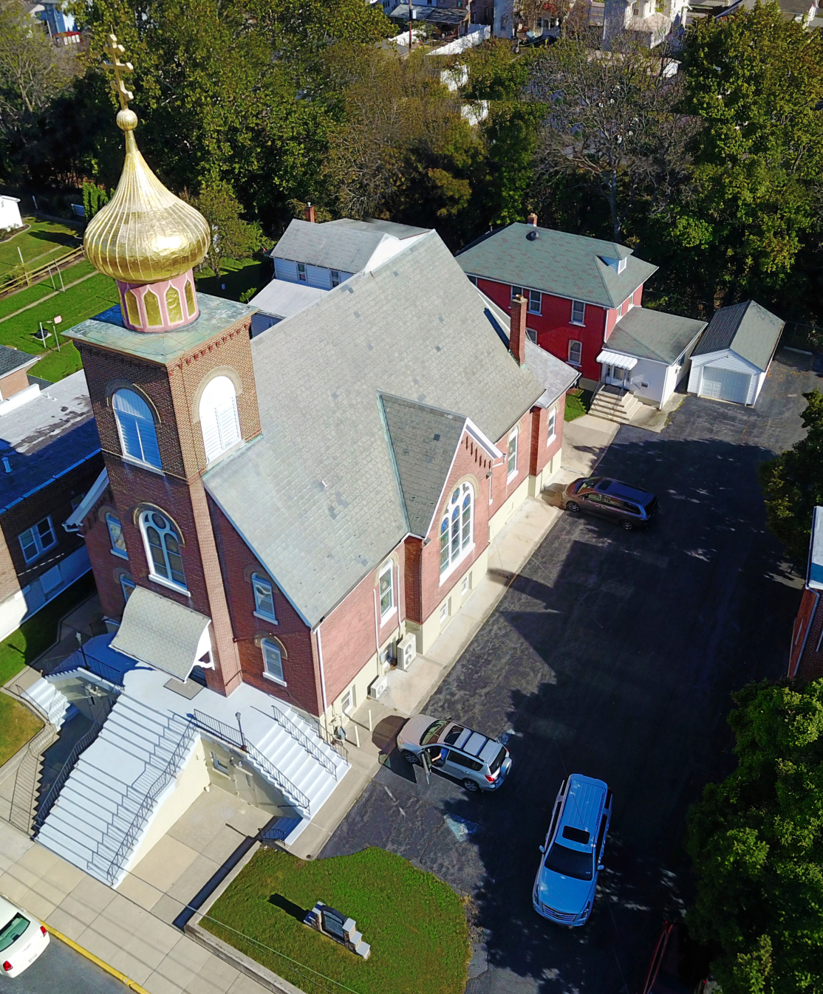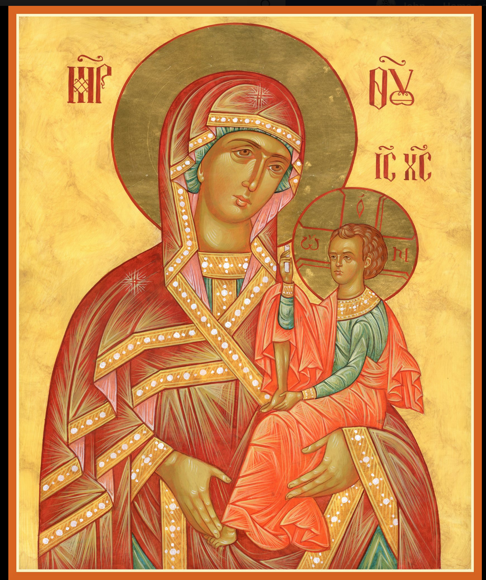

ASSUMPTION OF THE VIRGIN MARY
UKRAINIAN ORTHODOX CHURCH
ECUMENICAL PATRIARCHATE OF CONSTANTINOPLE AND NEW ROME
1301 Newport Avenue
Northampton, Pennsylvania 18067
Rev. Fr. Oleg Kravchenko, Rector
Protodeacon Mikhail Sawarynski, Attached
Telephones: Church Office… (610) 262-2882
Fr. Oleg Kravchenko – (732) 507-2274
Protodeacon Mikhail’s Residence… (610) 262-3876
Websites: holyassumption.org
ukrainianorthodoxchurchusa.org
Facebook: https://www.facebook.com/Assumption-of-the-Virgin-Mary-Ukrainian-Orthodox-Church-113456096722198/?modal=admin_todo_tour
E-mail: Parish… avmuoc@gmail.com
Fr. Oleg...olegkravchenko2212@gmail.com
Protodeacon Mikhail…pravoslavni@rcn.com
Webmaster, John Hnatow… john.hnatow@gmail.com

12th January (30th Dec.) 2020

30th Sunday after Pentecost. Tone 5. Sunday after the Nativity. Holy Righteous JOSEPH the Betrothed, DAVID the King, & JAMES the Brother of the Lord. Virgin Martyr ANYSIA at Thessalonica (298).
Galatians 1: 11-19 Matthew:2:13-23

PROPERS FOR LITURGY OF ST. JOHN CHRYSOSTOM

Tropar of the Resurrection, Tone 5
Let us the faithful, praise and worship the Word, co-eternal with the Father and the Spirit, born for our salvation of the Virgin. In His Good Will He was lifted up on the Cross in the flesh to suffer death and to raise the dead by His glorious Resurrection.

Tropar of the Nativity of Christ, Tone 4
Your Nativity, Christ our God, has shone to the world the Light of Wisdom. For by it those who worshipped the stars were taught by a star to adore You, the Sun of Righteousness, and to know You the Orient from on High. Lord, glory to You.

Tropar of Righteous Joseph, David the King and James, Tone 2
Joseph, proclaim the great miracles you have witnessed to David, the Ancestor of God; you have seen the Virgin with Child, given glory with the shepherds, worshipped with the Magi and an angel of the Lord has appeared to you. Pray to Christ our God, to save our souls.

Glory to the Father and to the Son and to the Holy Spirit.

Kondak of the Righteous Ones, Tone 6
Today, David the Holy One is filled with joy. Joseph and James offer their hymns of praise to the One born on earth in a manner beyond description and cry out: Merciful One, save those who honor You.

Now and ever and unto ages of ages. Amen.

Kondak of the Feast, Tone 3
Today, the Virgin gives birth to the Transcendent One and the earth offers a cave to the Unapproachable One. Angels, with shepherds glorify Him. The Magi journey with the star. Since for our sake the Eternal God was born as a little Child.

Prokimen of the Resurrection, Tone 5
You, O Lord, shall protect us and preserve us from this generation forever.

Verse: O Lord, save me for there is no longer any righteous man.

Prokimen of the Righteous Ones, Tone 4
God is wondrous in His saints, the God of Israel.

Verse: God grants strength and might to His people. Blessed be God.

Alleluia Verses in Tone 5
Of Your mercies, O Lord, I will sing forever; unto generation and generation I will proclaim Your truth with my mouth.

You have said: Mercy will be established forever and My truth will be prepared in the heavens.

Lord, remember David and all his meekness.

“In place of It is right in truth…”
Magnify, my soul, the Most Pure Virgin Birth-Giver of God who is greater in honor and more glorious than the hosts on high.

“Irmos, Tone 1
It is a strange and most wonderful mystery that I see: the cave in heaven; the Virgin the throne of the Cherubim; the manger a room, in which Christ, the Uncontainable God, is laid. Him do we praise and magnify.

Communion Hymn:
Praise the Lord from the heavens, praise Him in the Highest. Rejoice in the Lord, you righteous; praise befits the upright. Alleluia (3X)

LITURGICAL MENEION & SCRIPTURE READINGS
FOR THE THIRTY FIRST WEEK AFTER PENTECOST

Mon. 13 Jan. LEAVE TAKING of the NATIVITY. MELANIA,
Nun of Rome. Metropolitan PETRO (MOHYLA).
Hebrews 7: 26-8:2 John 10: 9-16

5:00 PM GREAT VESPERS & LITYA

Tue. 14 Jan. CIRCUMCISION of the LORD. BASIL the Great,
Archbishop of Caesarea in Cappadocia (379).
Col. 2:8-12 Lk. 2:20-21,40-52 Heb. 7:26-8:2 Lk. 6:17-23

9:00 AM DIVINE LITURGY of ST. BASIL the GREAT

Wed. 15 Jan. SYLVESTER, Pope of Rome (335). Hieromartyr
NO FAST THEOGENES, Bishop of Parium, Hellespont (320).
Galatians 5:22-6:2 Luke 6:17-23

Thurs. 16 Jan. Prophet MALACHIAS (400 BC). Martyr GORDIUS
at Caesarea in Cappadocia (314).
James 1:19-27 Mark 12:38-44

Fri. 17 Jan. SYNAXIS of the 70 APOSTLES. THEOCTISTUS,
NO FAST Abbot of Cucomo, Sicily (800). Martyr ZOSIMAS.
Titus 2:11-14 Matthew 3:13-17

Sat, 18 Jan. THEOPEMPTUS, Bishop of Nicomedia (303). Ven.
STRICT FAST SYNCLETICA of Alexandria. Prophet MICAH.
FAST DAY 1 Timothy 3:14-4:5 Matthew 3:1-11

5:00 PM GREAT COMPLINE & LITYA on Eve of Feast

Sun. 19 Jan. THEOPHANY of our LORD JESUS CHRIST.

8:30 AM THIRD & SIXTH HOURS
9:00 AM DIVINE LITURGY of BASIL the GREAT &
GREAT SANCTIFICATION of WATER
1:00 PM BLESSING OF HOUSES will begin in the Northampton Area. Fr. Oleg will call ahead of time.
NECROLOGY:
12 Jan… Anna Hul ’22, Olha Machibroda ‘23
13 Jan… Michael Sawarynski ’95, Kathryn Crayosky ‘76
14 Jan… Michael Chudyk ‘46
17 Jan… William Molnar ’76, Michael Radchuk ’57,
Jennie Kowalchuk ‘01
18 Jan… Pauline Seremula

VICHNAYA PAMYAT! MEMORY ETERNAL

BIRTHDAYS:
16 Jan…Melania Unger, Justin Hnatow
17 Jan…Anastasia Seremula

MNOHAYA LITA! MANY YEARS!

WE PRAY for the health and well-being of the ill-afflicted: William Savitz, Catherine Kochenash, Vladimir & Emma Krasnopera, Brendan Phillips, Jessie Hnatow, Jessica Meashock, Adam Hewko, Betty Hendrickson, Andrew Thaxton, Michelle Pierzga, Susan Ferretti, Carole Zarayko, Marianna Goshow, Judy Albright, Rob Hewko, Daniel Kochenash, child Christopher Mack, Evan Hartnett, Chet Bohanek, Norman Betrous, Thomas Orlovsky

BENE NOTE: ON HOLY COMMUNION
Please be advised that according to the Canons of the Orthodox Church, the Sacrament of Holy Communion can only be administered to Orthodox Christians ( Baptized & Chrismated, making them living members of the Body of Christ). One must be prepared to approach the Holy Chalice by fasting, prayer and confession.
FR. OLEG is providing PROSFORAS for commemoration of the living and the dead at the Divine Liturgy. Please fill out your lists before the Reading of the Gospel and leave a donation on the tray.

OCMC “Agape Canister” DONATIONS: $17.00. Thank you.

SUNDAY SCHOOL SCHEDULE
Mrs. Mary Ost – Pre-K to 3rd grade. Every Sunday at 9 AM.
Mrs. Linda Winters – 4th to 6th grade. Jan. 12th @ 9AM; Jan. 19 – 11 AM; Jan. 26th – 9 AM; Feb. 2nd – 11 AM; Feb. 9th – 9 AM.
Ms. Bettyann Woyewoda – 7th to 12th grade. Every Sunday at 9 AM.

Our deepest appreciation to the SISTERHOOD of FAITH, HOPE AND LOVE for their generous NATIVITY DONATION of $10,000 to the Church this year. MANY, BLESSED YEARS!

The SISTERHOOD AND PYROHONYA MEETING will be held at ASANTE’S RESTAURANT TODAY, JANUARY 12th at 12 NOON.

NEXT DATES FOR PIEROHI SALES; JAN. 16th & FEB. 06th. Call Helen at 610-261-4575 to order. Sales on FEB-20th & MAR. 05th call Linda Vitushinsky at 610-262-0265. Pick-Up between 10 & 11:30 AM. Deadline for orders is the Sunday before production.

ANNUAL PARISH MEETING JANUARY 26th following Liturgy. A continental Breakfast is being hosted by the SR. UOL Chapter. All proceeds will go to the soup kitchens in Ukraine. $5 donation.

We are still collecting Redner’s receipts. Use “Redner’s Rewards Card.”

NORTHAMPTON FOODBANK is still in need of foodstuffs, especially baby food, canned potatoes, tuna, pasta, & meats.

MANY THANKS TO Melania Unger & Kathy Crayosky for organizing and setting up the HOLY SUPPER on Christmas Eve and to all who contributed Lenten foods for the event.

