ASSUMPTION OF THE VIRGIN MARY UKRAINIAN ORTHODOX CHURCH
ECUMENICAL PATRIARCHATE OF CONSTANTINOPLE AND NEW ROME
1301 Newport Avenue, Northampton, Pennsylvania 18067
Rev. Fr. Oleg Kravchenko, Rector
Protodeacon Mikhail Sawarynski, Attached
Websites: holyassumption.org and ukrainianorthodoxchurchusa.org
Facebook: Assumption of the Virgin Mary Ukrainian Orthodox Church
YouTube: AVM UOC Church
Contacts:
Fr. Oleg Kravchenko - (484) 834-7261; olegkravchenko2212@gmail.com
Protodeacon Mikhail – (H) (610) 262-3876); pravoslavni@rcn.com
Office – (610) 262-2882; avmuoc@gmail.com
Webmaster, John Hnatow – john.hnatow@gmail.com

Click HERE for Prayer in Time of Corona Virus
Tune in to our news, announcements, and online Facebook Livestream Liturgies HERE!

Fri. 07 Jan. THE NATIVITY ACCORDING TO THE FLESH OF OUR LORD, GOD AND SAVIOUR JESUS CHRIST.
Gal. 4:4-7 Mt. 2:1-12
9:00 AM Festal Divine Liturgy.
6:30 PM Christmas Carol Flashmob (Bethlehem City Hall Christmas Tree)
Second Collection Today – for Altar servers
Sat. 08 Jan. Synaxis of the Most Holy Theotokos
1 Tim. 6:11-16 Mt. 12:15-21
9:00 AM Divine Liturgy
5:00 PM Great Vespers
Sun. 09 Jan. 9:00 AM Divine Liturgy
(Please pick up calendars and envelops downstairs in the hall)

CHRIST IS BORN! ХРИСТОС НАРОДИВСЯ!BLESSED NATIVITY OF OUR LORD JESUS CHRIST TO THE WHOLE CHRISTIAN FAMILY, TO ALL OUR PARISHIONERS, PARISH BOARD, SISTERHOOD AND UOL MEMBERS, CHOIR, ALTAR SERVERS, ALL WHO DONATE THEIR TIME AND RESOURCES TO OUR CHURCH AND ALL OUR GUESTS.
UNDERSTANDING THE NATIVITY ICON. Orthodox Christians do not celebrate the birth of baby Jesus, we celebrate the Incarnation. It means God becomes Man. The birth of Jesus was that moment in history when God sent His only begotten Son to become like us, taking on human flesh for our healing. God with His divine will became man, taking on a human will in human flesh so Man could unite his human will with God’s divine will. From the time of Adam and Eve, man was separated from God, unable to follow God’s law. The Incarnation is the beginning of the transformation of mankind so we can be reunited with God.
Nativity Icon. The Star. In the top center there is a bluish light, which represents the star which guided people to witness the Incarnation. It points to the Christ Child who is lying in a manger.
The birthplace. Christ was born in a cave, which is shown as a dark place. This was a reality as well as symbolic. Christ came to bring the light of knowledge to overcome the darkness of our ignorance. The star symbolizes this as well. It brings bright light to the dark cave, showing us the way to Christ. It is a light pointing us to the Truth. In the area where Christ was born, it was common to have a stable in caves carved in the hills of that region. But why did he choose a stable? Stables are where animals are kept and you can see the animals looking at the Christ child in the icon. Christ could have chosen to be born in a palace if he wanted to, but he chose the most humble of places, a stable. This is a message for us, to be humble like Him.
Christ’s clothing. He is wrapped in linen. This is how a person was wrapped in those days for burial after his death. This is showing us that He is destined to the same fate after His Crucifixion where He was able to claim victory over death in His Resurrection.
Mary, The Theotokos. She is shown in the center of the icon to show her importance in this event. She was the instrument of God to bring about His incarnation. She gave her ascent to bear the Son of God. Surely an awesome responsibility. She is looking away to show her humility and wonder at this wondrous event.
Joseph and the devil. In the lower left corner of the icon there are two men. An old man and one with a cane. The old man with the halo is Joseph. He was old because he was appointed as a mature man to protect Mary so she could remain a virgin. Some say he was 70 – 80 years old. Since he was not the father of the baby, he is being tempted by the man with the cane who is Satan. He is trying to raise Joseph’s doubts about the possibility of a virgin birth. This shows how difficult it is for all of us to accept things that are beyond our reason.
Angels. Near the top you can see angles. Angels are from heaven and they glorify God. You see them here to glorify the Christ Child and herald the good news to the entire world, because it is not just a child who has been born, but God himself who has become man.
Shepherds. On the upper right there are shepherds with their sheep below. An angel is telling them about this miraculous birth calling them to come and glorify Christ. Why shepherds? Shepherds are among the simplest of people. This indicates that God did not become Man for those who are privileged, but for the simplest of people. He calls all to follow Him so all people can be united with God in eternal life.
The wise men or Magi. To the left there are three men on horses. These were men who came long way fallowing the star. They were probably astronomers, scientists of their day. They saw the star which was a symbol for them of a great cosmic event. They followed it to find the Incarnation of God. Knowing how important this was they brought gifts of the highest value in appreciation of what God had done.
Midwives. In the lower right we have the women who are preparing the font for the cleansing of the Baby after He was born. This shows the humanity of Jesus. This too is symbolic of the baptism we are to undergo, to be united with Christ, cleansing us of our sins and receiving a transformation in our heart with the Holy Spirit, which is sealed with our Chrismation.
The two animals. The ox and the donkey fulfill the prophecy of Isaiah. “The ox knows its owner, and the donkey its master’s crib; but Israel does not know, my people do not understand”. Isaiah 1:3

EPISTLE READING: GALATIANS 4: 4-7
ALLELUIA VERSES, TONE 1: The heavens declare the glory of God and the firmament shows His handiwork.
VERSE: Day speaks to the day and night shows knowledge to the night.
HOLY GOSPEL: ST. MATTHEW 2: 1-12
IN PLACE OF "IT IS RIGHT IN TRUTH": Magnify, my soul, the most pure Virgin Birth-Giver of God, who is greater in honor and more glorious than the hosts on high.
IRMOS, TONE 1: A strange and wonderful mystery do I see. The cave is heaven, the Virgin and the Throne of the Cherubim and the manger a room in which Christ, the Uncontainable God, is laid. Him do we praise and magnify.
COMMUNION VERSE: The Lord has sent deliverance to His people. (Alleluia 3X)
(On Holy Communion Please be advised that according to the Canons of the Orthodox Church, the Sacrament of Holy Communion may only be administered to Orthodox Christians, Baptized and Chrismated into the faith. One must be prepared to approach the Holy Chalice by fasting, prayer, and confession).

PROPERS FOR THE DIVINE LITURGY OF
ST. JOHN CHRYSOSTOM ON THE FEAST OF THE NATIVITY OF OUR LORD AND SAVIOR JESUS CHRIST
Christ is Born! Glorify Him!
ANTIPHON ONE, TONE 2
VERSE: I will praise You, Lord, with my whole heart: I will speak of all Your marvelous works.
REFRAIN: Through the prayers of the Birth-Giver of God, Savior, save us.
VERSE: In the assembly of the upright and in the congregation: The works of the Lord are great. REFRAIN
VERSE: Great are the works of the Lord; precious to those who love them. REFRAIN
VERSE: His work is honorable and glorious: And His righteousness endures forever. REFRAIN
Glory to the Father and to the Son and to the Holy Spirit, now and ever and to the ages of ages. Amen. REFRAIN
ANTIPHON TWO, TONE 2
VERSE: Blessed is the man who fears the Lord: Who delights greatly in His commandments.
REFRAIN: Son of God, born of the Virgin, save us who sing to You: Alleluia.
VERSE: His seed shall be mighty upon the earth: The generation of the upright shall be blessed. REFRAIN
VERSE: Abundance and riches shall be in His house; and His righteousness endures forever. REFRAIN
VERSE: To the upright there arises light in the darkness; He is gracious, full of compassion and righteousness. REFRAIN
Glory to the Father and to the Son and to the Holy Spirit now and ever and to the ages of ages. Amen.
Only Begotten Son and Word of God...
ANTIPHON THREE, TONE 4
VERSE: The Lord said to my Lord; sit at My right hand, until I make Your enemies Your footstool.
TROPAR: Your Nativity, O Christ our God, has shone to the world the Light of Wisdom. For by it, those who worshipped the stars, were taught by a star to adore You, the Sun of Righteousness and to know You the Orient from on High. Lord, glory to You.
VERSE: The Lord shall send you a rod of strength out of Zion, rule in the midst of your enemies. TROPAR
VERSE: With You is dominion in the day of Your Power; in the splendor of Your saints. TROPAR
THE LITTLE ENTRANCE HYMN: From the womb before the morning star have I begotten You. The Lord has sworn and will not repent; You are a priest forever according to the order of Melchizedek.
TROPAR, TONE 4: Your Nativity, O Christ our God... Glory to the Father... now and ever. Amen.
KONDAK, TONE 3: Today, the Virgin gives birth to the Transcendent One and the earth offers a cave to the Unapproachable God. Angels with shepherds glorify Him. The Magi journey with the star. Since for our sake the Eternal God was born as a little Child.
IN PLACE OF THE THRICE-HOLY HYMN: As many as have been baptized into Christ, have put on Christ. Alleluia.
PROKIMEN, TONE 8: Let all the earth worship You and sing to You. Let them sing to Your Name.
VERSE: Make a joyful noise to the Lord, all the earth. Sing forth the glory of His Name; make His praise glorious.

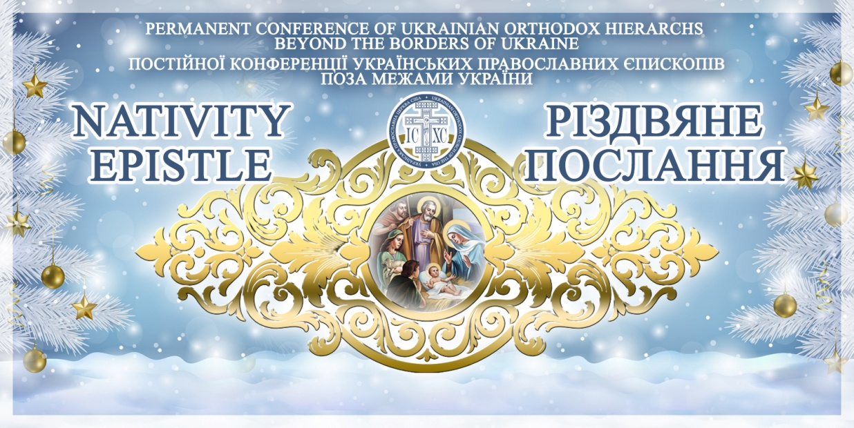
Nativity of our Lord Archpastoral Letter
PERMANENT CONFERENCE
OF UKRAINIAN ORTHODOX BISHOPS BEYOND THE BORDERS OF UKRAINE
of the Venerable and Christ-loving clergy and laity of the Ukrainian Orthodox Church in Australia, New Zealand, Canada, Europe, South America, the United States of America and in Ukraine
May the Grace of our Lord and God and Savior Jesus Christ, the Love of God the Father and the Fellowship of the Holy Spirit be with you all!
Dear and beloved brothers and sisters in the Lord!
Christ is Born! Let us Glorify Him!
Humanity is the Masterpiece of God’s Creation. Humanity was meant to live eternally in communion and pure love with God in the Holy Trinity and to be stewards of all the rest of the Creation. Humanity was given the incredible gift of free will in order to image the will of God – and in particular His unfailing Love - to all the Creation. Man and woman experienced the beauty and bounty of eternal life in Paradise and then they abused the gift of free will under the temptation to know ALL that their Creator knew. What a failure, what a distortion of the image, what consumption with ego. Humanity would now know the death that was never intended for it. Humanity was banished from Paradise and would have to prove itself over the millennia to be faithful to its Creator. Teachers, Prophets and Rulers were sent repeatedly to assist in this effort, promising the coming of the Messiah, the One who would lead it to salvation. And alas, the Creator, to prove His unending and unbending Love for His Masterpiece, sends His Only-Begotten Son, our Lord and Savior Jesus Christ to be Incarnate – to become one of us uniting Humanity and Divinity – to bring His Masterpiece home – returned again to the possibility of eternal life, once and for all time.
And so, CHRIST IS BORN – “GOD IS WITH US, understand all ye nations and submit yourselves for God is with us”. (Isaiah 8:9) Submitting ourselves…so foreign in today’s very secularized world, something so out of line with our devotion to ourselves and all our desires that have little or nothing to do with the “God with us”. Let us make conscious decisions to turn back from our insatiable self-satisfaction. We pray before the Eucharist that we comprehend the fact that “no human sin is bad enough to overcome our Lord’s Love for us”. Let us live in that reality today! Let us allow ourselves to be embraced with His All-Encompassing Love so all that distracts us might be converted into that, which makes us whole. Let us open our hearts, minds and souls to the Christ Child Who seeks a place to lay His Head. Let us open ourselves to the reality of “God with us” and for us. For this were we created. This is our true reality!
The Christ Child – the Son of God Incarnate…Lifting our humanity up to His Divinity…Love defined, and Love fulfilled…May your homes and lives be filled with this Love throughout this Holy Nativity Season and the New Year! May this Love flow from you into the lives of all around you, inspiring their thoughts and deeds – lifting them up to His Divinity. This is the image of God…
May the Grace of the Christ Child – our Lord and Savior Jesus Christ, the Love of God the Father and the Communion of the Holy Spirit be with you always. We assure you of our prayers daily.
Христос Рождається! Славіто Його!
+ ANTONY – Metropolitan (Ukrainian Orthodox Church of the USA, South America and Diaspora)
+ JEREMIAH – Archbishop (Ukrainian Orthodox Eparchy of South America)
+ DANIEL – Archbishop (Ukrainian Orthodox Church of the USA and Diaspora)
+ ILARION – Bishop (Locum Tenens of the Ukrainian Orthodox Church of Canada)
+ ANDRIY – Bishop (Ukrainian Orthodox Church of Canada)

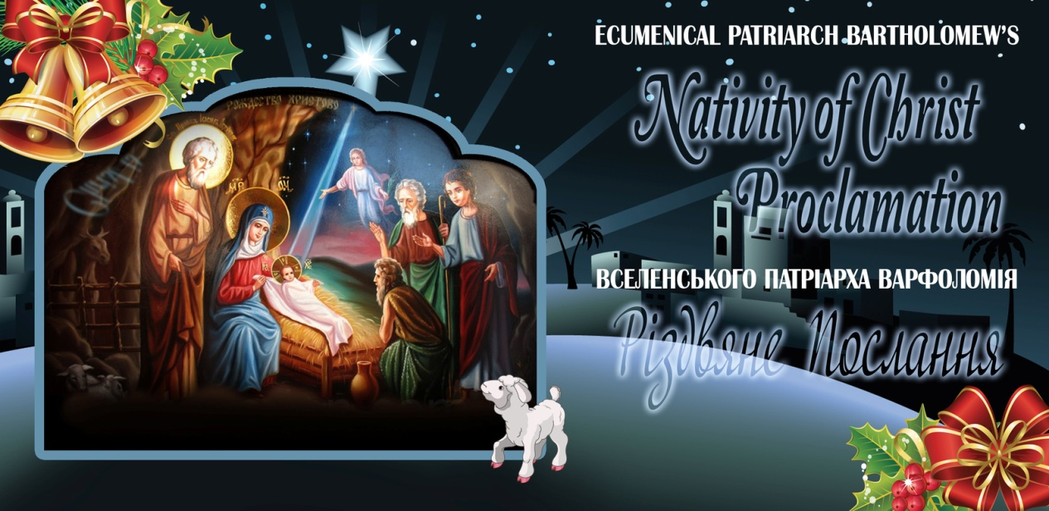
PATRIARCHAL ENCYCLICAL FOR CHRISTMAS
+ B A R T H O L O M E W
BY GOD’S MERCY ARCHBISHOP OF CONSTANTINOPLE-NEW ROME AND ECUMENICAL PATRIARCH TO ALL THE PLENITUDE OF THE CHURCH GRACE, MERCY AND PEACE FROM THE SAVIOR CHRIST BORN IN BETHLEHEM
Brother concelebrants and blessed children,
Having once again arrived at the splendid feast of the Nativity in the flesh of our Savior Christ , who visited us from the heights, we glorify with psalms and hymns His all-heavenly name. The Incarnation of the pre-eternal Word of God is “the crowning of our salvation,” the “eternal mystery” of divine-human communion that transcends all reason. As St. Maximus the Confessor says so eloquently, “as a loving God, He truly became human assuming the essence of humankind, although the manner in which He became human will always remain ineffable; He became human in a manner that transcends humanity.”
The divine Incarnation, along with the manifestation of the truth about God also reveals the truth and ultimate destination of man, our deification by grace. St. Nicholas Cabasilas proclaims so theologically that Christ “is the first and only One to show us the true and perfect man.” Since that time, anyone who honors God must also honor man, and whoever undermines man also dishonors God, who assumed our nature. In Christ, speaking theologically about God we speak at the same time about man. The incarnate Divine Economy definitively abolishes the image of God as tyrannical, punitive, and adversary to man. Christ is everywhere, always and in all things the denial of the denial of man and the defender of human freedom. The life of the Church, as the flesh assumed by the incarnate Son and Word of God, represents, expresses and serves this all-saving mystery of divine-humanity.
With this “other fashioning” of man and renewal of all creation in Christ as its banner, the Church today offers the good witness before every development that threatens the sacredness of the human person and the integrity of creation. It lives and preaches the truth of authentic spiritual life and the culture of love and solidarity. Offering testimony “about the hope that lies within us” (1 Pet 3.15), the Church does not in any way regard contemporary civilization as another sinful Nineveh by invoking like Jonah the divine wrath on it and its abolition, but rather the Church struggles for the culture’s transformation in Christ. In our age we need pastoral imagination, dialogue and not argumentation, participation and not abstention, specific deeds and not abstract theory, creative reception and not general rejection. All these do not function at the expense of our spirituality and liturgical life, but reveal the inviolable unity of what we call the “vertical” and “horizontal” dimensions of the Church’s presence and witness. Faithfulness to the tradition of the Church is not entrapment to the past, but employment of the experience of the past in a creative way for the present.
In this past year, too, the pandemic of the Covid-19 coronavirus has troubled humankind. We give glory to the God of mercy, who strengthened the specialists and scientists to develop effective vaccines and other medications in order to confront this crisis, and we encourage all faithful who have yet to be vaccinated to do so and everyone to adhere to the protective measures by the health authorities. Science, to the extent that operates as a minister of man, is a priceless gift by God. We must gratefully accept this gift and not be misled by irresponsible voices of ignorant and self-proclaimed as representatives of God and of the authentic faith “spiritual advisors,” who, nevertheless, lamentably invalidate themselves through the absence of love for their brethren, whose lives they expose to grave danger.
With unshakable conviction that the life of each of us and the journey of all humanity is directed by the God of wisdom and love, we look forward to a happy 2022, which despite external factors and developments will be for everyone a year of salvation, inasmuch as during its course as well, the movement of history is guided by Christ, who loves mankind and cares for all things, “who desires that all people will be saved and come to the knowledge of truth.” (1 Tm 2.4)
With these sentiments, respectfully worshiping the child Jesus born in Bethlehem, we orient our thought to our Christian brothers there and we pray for the peaceful and harmonious coexistence of all those residing in the Holy Land.
In this spirit, we wish to all of you, those near and afar, a blessed Twelve tide, as well as a healthy, fruitful in good deeds and filled with divine gifts new year in the Lord’s favor, to Whom belong the glory and might to the endless ages. Amen.
Christmas 2022 +Bartholomew of Constantinople

