Jan. 07, 2021
ASSUMPTION OF THE VIRGIN MARY UKRAINIAN ORTHODOX CHURCH
ECUMENICAL PATRIARCHATE OF CONSTANTINOPLE AND NEW ROME
1301 Newport Avenue, Northampton, Pennsylvania 18067
Rev. Fr. Oleg Kravchenko, Rector
Protodeacon Mikhail Sawarynski, Attached
Websites: holyassumption.org and ukrainianorthodoxchurchusa.org
Facebook: Assumption of the Virgin Mary Ukrainian Orthodox Church
YouTube: AVM UOC Church
Contacts: Fr. Oleg Kravchenko – (732) 507-2274; olegkravchenko2212@gmail.com
Protodeacon Mikhail – (H) (610) 262-3876); pravoslavni@rcn.com
Office – (610) 262-2882; avmuoc@gmail.com
Webmaster, John Hnatow; john.hnatow@gmail.com

Second Collection Today – for Altar servers
Fri. 08 Jan. Synaxis of the Most Holy Theotokos
9:00 AM Divine Liturgy
Sat. 09 Jan. Holy Protomartyr and Archdeacon Stephen (34)
9:00 AM Divine Liturgy
5:00 PM Great Vespers
Sun. 10 Jan. 9:00 AM Divine Liturgy

CHRIST IS BORN! ХРИСТОС НАРОДИВСЯ!

BLESSED HOLIDAY OF THE NATIVITY OF OUR LORD JESUS CHRIST TO THE WHOLE OUR CHRISTIAN FAMILY, TO ALL OUR PARISHIONERS, MEMBERS OF THE PARISH BOARD, SISTERHOOD MEMBERS, UOL MEMBERS, ALTAR SERVERS, ALL WHO DONATE THEIR TIME AND RESOURCES TO OUR CHURCH AND ALL THE GUESTS.

'Little Child So Sweet'

"Bethlehem hath opened Eden,
Come let us behold:
Sweetness we have found once hidden,
Pearl of price untold.
Gifts of Paradise all precious,
Stored within the cave refresh us.
"Now the Maid her Infant bearing
Hasten we to greet.
He are worlds the Godhead sharing,
Little Child so sweet,
Born within this lowly place
Stays the thirst of Adam's race." (By St. Ramanos the Melodist)

In The Wild Knight.
The Christ-child lay on Mary's lap,
His hair was like a light.
(O weary, weary is the world,
But here is all aright.)

The Christ-child lay on Mary's breast,
His hair was like a star.
(O stern and cunning are the kings,
But here the true hearts are.)

The Christ-child lay on Mary's heart,
His hair was like a fire.
(O weary, weary is the world,
But here the world's desire.)

The Christ-child stood at Mary's knee,
His hair was like a crown.
And all the flowers looked up at Him,
And all the stars looked down. (G. K. Chesterton)

Christmas Suggestions
The best thing to give an enemy is forgiveness;
To an opponent, Tolerance; To a Friend, your Ear;
To your child, a good Example; To a Father, Reverence;
To your Mother, Conduct that will make her proud of you;
To Yourself, Respect; And to all, Charity. (by Benjamin Franklin)

The Unopened Gift
There's One Gift still under the Christmas tree
That some will ignore and others won't see.
In the flurry of unwrapping ribbons and bows
It's a gift that most hear of but few come to know.
It's the present that tells how this time came to be.
It tells of a love that's so full and so free
And it quietly waits to be found and enjoyed
Though in most homes it's buried ‘neath mountains of toys
It looks to the manger and yet looks beyond
It looks to a cross and a bright Easter morn.
The first Christmas present, and still the best one
For it was on Christmas God gave us his Son.
His Son and our Savior still comes to us here
Not only at Christmas, but throughout the year.
If you'll open your heart he will come to you too
And you will have peace and a life that is new
And then for the first time you will understand
Why Christmas is still kept in every land.
He came as a gift that was sent from above

the unopened gift is the gift of God's love. (By Jeffrey Allyn Collins)

Christmas is a time of rebirth, renewal, a fresh start; a time to set our minds on spiritual things, and all the unseen things are kept alive by those that are seen:
Trees — green emblem of the life that clothed God in flesh to show men Someone beyond their own understanding.
Lights — symbol of the heavens ablaze in glory which the shepherds saw the night that Christ was born.
Bells — echo the angels' voices, telling the matchless message of Christ's love.
Wreaths — symbol of God's unending love for us.
Greeting Cards — spreading the good news of the Savior's birth and multiplying love for others.
Gifts — symbol of God's unspeakable love toward us; expression of love and service to God and others.
Family Gatherings — Jesus was born into a family. Even Babies' Smiles at Christmas time remind us that Christ was also human as well as divine. All these are glad tidings of the Newborn King! And they keep alive the unseen spiritual things like faith, hope, peace, joy, love, gentleness, long suffering, meekness, temperance, and goodness which make life real and full of mystery and wonder.

PROPERS FOR THE DIVINE LITURGY OF ST. JOHN CHRYSOSTOM ON THE FEAST OF THE NATIVITY OF OUR LORD AND SAVIOR JESUS CHRIST
Christ is Born! Glorify Him!
ANTIPHON ONE, TONE 2
VERSE: I will praise You, Lord, with my whole heart: I will speak of all Your marvelous works.
REFRAIN: Through the prayers of the Birth-Giver of God, Savior, save us.
VERSE: In the assembly of the upright and in the congregation: The works of the Lord are great. REFRAIN
VERSE: Great are the works of the Lord; precious to those who love them. REFRAIN VERSE: His work is honorable and glorious: And His righteousness endures forever. REFRAIN
Glory to the Father and to the Son and to the Holy Spirit, now and ever and to the ages of ages. Amen. REFRAIN
ANTIPHON TWO, TONE 2
VERSE: Blessed is the man who fears the Lord: Who delights greatly in His commandments.
REFRAIN: Son of God, born of the Virgin, save us who sing to You: Alleluia.
VERSE: His seed shall be mighty upon the earth: The generation of the upright shall be blessed. REFRAIN
VERSE: Abundance and riches shall be in His house; and His righteousness endures forever. REFRAIN
VERSE: To the upright there arises light in the darkness; He is gracious, full of compassion and righteousness. REFRAIN
Glory to the Father and to the Son and to the Holy Spirit now and ever and to the ages of ages. Amen.
Only Begotten Son and Word of God...
ANTIPHON THREE, TONE 4
VERSE: The Lord said to my Lord; sit at My right hand, until I make Your enemies Your footstool.
TROPAR: Your Nativity, O Christ our God, has shone to the world the Light of Wisdom. For by it, those who worshipped the stars, were taught by a star to adore You, the Sun of Righteousness and to know You the Orient from on High. Lord, glory to You.
VERSE: The Lord shall send you a rod of strength out of Zion, rule in the midst of your enemies. TROPAR
VERSE: With You is dominion in the day of Your Power; in the splendor of Your saints. TROPAR
THE LITTLE ENTRANCE HYMN: From the womb before the morning star have I begotten You. The Lord has sworn and will not repent; You are a priest forever according to the order of Melchizedek.
TROPAR, TONE 4: Your Nativity, O Christ our God... Glory to the Father... now and ever... Amen.
KONDAK, TONE 3: Today, the Virgin gives birth to the Transcendent One and the earth offers a cave to the Unapproachable God. Angels with shepherds glorify Him. The Magi journey with the star. Since for our sake the Eternal God was born as a little Child.
IN PLACE OF THE THRICE-HOLY HYMN: As many as have been baptized into Christ, have put on Christ. Alleluia.
PROKIMEN, TONE 8: Let all the earth worship You and sing to You. Let them sing to Your Name.
VERSE: Make a joyful noise to the Lord, all the earth. Sing forth the glory of His Name; make His praise glorious.
EPISTLE READING: ST. PAUL TO THE GALATIANS 4: 4-7
ALLELUIA VERSES, TONE 1: The heavens declare the glory of God and the firmament shows His handiwork.
VERSE: Day speaks to the day and night shows knowledge to the night.
HOLY GOSPEL: ST. MATTHEW 2: 1-12
IN PLACE OF "IT IS RIGHT IN TRUTH": Magnify, my soul, the most pure Virgin Birth-Giver of God, who is greater in honor and more glorious than the hosts on high.
IRMOS, TONE 1: A strange and wonderful mystery do I see. The cave is heaven, the Virgin and the Throne of the Cherubim and the manger a room in which Christ, the Uncontainable God, is laid. Him do we praise and magnify.
COMMUNION VERSE: The Lord has sent deliverance to His people. (Alleluia 3X)
(On Holy Communion Please be advised that according to the Canons of the Orthodox Church, the Sacrament of Holy Communion may only be administered to Orthodox Christians, Baptized and Chrismated into the faith. One must be prepared to approach the Holy Chalice by fasting, prayer, and confession).
I will honor Christmas in my heart and try to keep it all the year. Charles Dickens

Christmas means that Christ:
He descended that we might ascend (John 6:38, 14:3).
He became poor that we might become rich (2 Cor. 8: 9, Jas. 2:5).
He was born that we might be born again (John 1:14, 3:2,7).
He became a servant that we might become sons
(Phil. 2:7; Gal. 4:6, 7).
He had no home that we might have a home in heaven
(Matt. 8:20; John 14:2).
He was hungry that we might be fed (Matt. 4:2; John 6:50).
He was thirsty that we might be satisfied (John 19:26).
He was stripped that we might be clothed (Matt. 27:28; Gal. 3:27).
He was forsaken that we might not be forsaken (Matt. 27:26; 28:20).
He was sad that we might become glad (Isa.53:3; Phil. 4:4).
He was bound that we might go free (Matt.27:2; John 8:32-36).
He was made sin that we might be made righteous (2 Cor.5:21).
He died that we might live (John 5:24, 25).
He came down that we might be caught up (1 Thess.4:16, 17).
(By Larry Farthing)
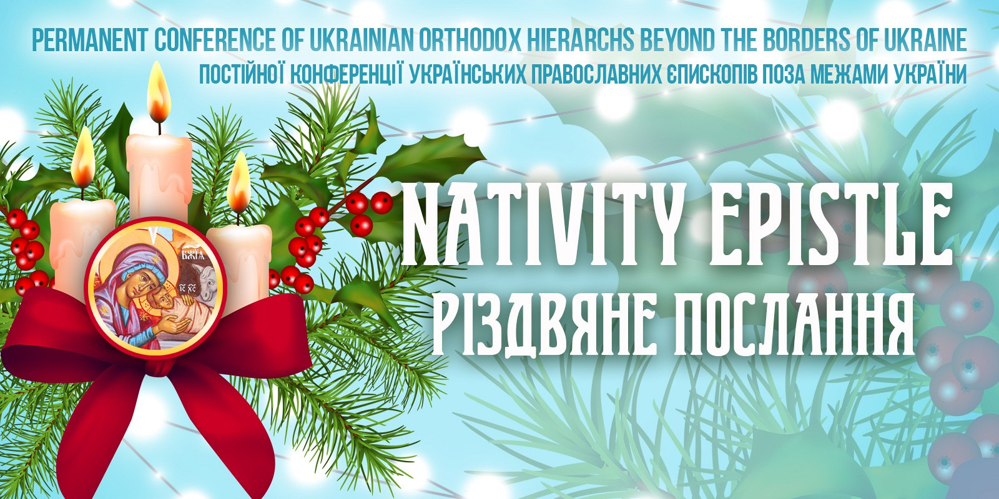
Nativity Epistle of the Permanent Conference of Ukrainian Orthodox Bishops Beyond the Borders of Ukraine
To the God-beloved Pastors, Venerable Monastics,
and all Faithful Children of the Ukrainian Orthodox Church in the Diaspora and in Ukraine

“Today Christ is born from a Virgin in Bethlehem, today the Eternal One is born and the Word is incarnated: the powers of heaven rejoice, the earth and all mankind rejoice” (Festal Stykhyra)
Christ is Born!
Today the Orthodox Church again celebrates the Nativity of Christ, commemorating the advent into the world of the Son of God. The entire Christian world glorifies and magnifies the New-born God-child, Christ the Lord.
St. Paul calls the Nativity of Christ “A mystery of great piety: God appeared in the flesh. (I Tiim. 3:16). The mystery of the incarnation of the Son of God is the greatest and deepest mystery of the Christian faith. The Pre-eternal God becomes man without ceasing to be God. The Holy Evangelist John the Theologian says “The Word became flesh and dwelt among us” (Jn. 1:14).
In our contemporary anxious and confused world, where terror and uncertainty reign, the quiet and joyful angelic hymn rings out: “Glory to God in the highest, His peace is on earth, and His good-will among men” (Lk. 2:14).
Today the entire world is anxious, just as the residents of Jerusalem were aforetime (Mt. 2:3), and so the angelic song about peace on earth and good-will among men fills every Christian soul with peace and hope for a better future. For today the Saviour of the world lies in a manger, He who “does not break the bent reed and does not snuff out the smoldering flax” (Is. 42:3). “He is our peace, Who tore down the dividing wall” (Eph. 2:14) between heaven and earth, which had been erected by human unrighteousness.
Mankind has contemplated this Divine Infant for over two thousand years, and from Him many derive life-giving strength which transforms their life for the better. The Holy Fathers say that Christ came to the earth in order to raise us up to heaven, that he became man, that we might become sons of God, that He became poor that we might be rich, and humble so that we might be glorified.
It is a great sorrow to us all, that this year during the celebration of the Nativity holidays we experience a great trial as a result of the coronavirus pandemic. Today our temples are affected by particular restrictions which prevent our faithful from receiving necessary pastoral care. But the great feast which we celebrate, the Nativity of Christ, reminds us of God’s immeasurable love for the human person. “God so loved the World, that He gave His Only-begotton Son, that all who beleive in Him should not perish, but have eternal life” (Jn. 3:16).
Out of His great love for His creation, He made this world beautiful. But people often break their unity with God through their sinful life and bring misfortune, sickness, and evil into the world. This pandemic, which has shaken the entire world, calls us as Christians to meditate upon our own personal lives. God would not have permitted this pandemic to attain such world-wide development if it were not a reminder to all the people of the earth.
It is precisely the feast of the Nativity of Christ which witnesses to the fact that God does not leave us without His care. God not only looks after the world as a whole, but after each person individually.
And so may the One born in Bethlehem, the Lord resting in the manger, spur each of us on to consider why we live and what path we are following - the straight path of God, or the crooked path of sin. Faith in God calls all of us to battle with all manner of evil and before anything else with our own personal sin.
During these holy days of the Nativity season let us prayerfully call upon the God-child Christ - our Saviour - so that He might protect all of us from this terrible sickness.
We greet all of you with a sincere heart, dear brothers and sisters, with the great and salvific feasts of the Nativity of Christ, the New Year, and the Holy Theophany. We especially greet our youth and children, and all of you God-beloved Christians in the diaspora and in Ukaine.
May the coming new year be for all of us a year of spiritual growth, peace, good health, familial good fortune, and a God-blessed year of good fortune for all people throughout the world.
Christ is Born! Glorify Him!
With Archpastoral Blessings,
+YURIJ, Metropolitan of the Ukrainian Orthodox Church of Canada
+ANTONY, Metropolitan of the Ukrainian Orthodox Church of the USA and in the Diaspora
+JEREMIAH, Archbishop of the Ukrainian Orthodox Eparchy of Brazil and South America
+DANIEL, Archbishop of the Ukrainian Orthodox Church in the USA and Western Europe
+ILARION, Bishop of the Ukrainian Orthodox Church of Canada
+ANDRIY, Bishop of the Ukrainian Orthodox Church of Canada

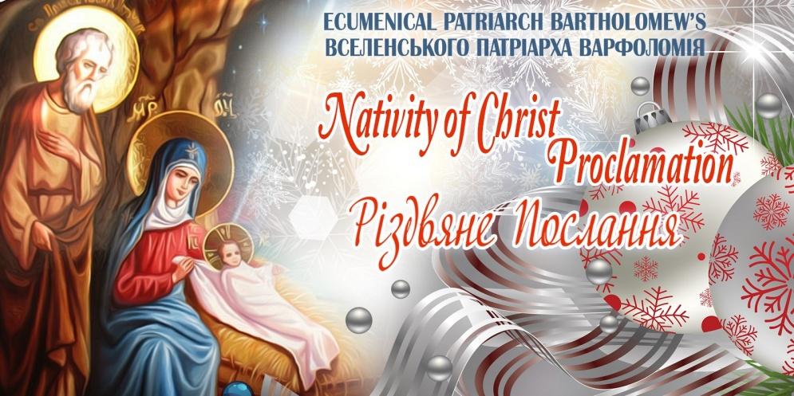
PATRIARCHAL PROCLAMATION FOR CHRISTMAS ✠ BARTHOLOMEW
BY GOD’S MERCY ARCHBISHOP OF CONSTANTINOPLE-NEW ROME AND ECUMENICAL PATRIARCH TO THE PLENITUDE OF THE CHURCH GRACE, MERCY AND PEACE FROM THE SAVIOR CHRIST BORN IN BETHLEHEM

Most venerable brothers in Christ and beloved children,
As we journey with the All-Holy Virgin, who comes “to give birth ineffably” to the pre-eternal Word, and as we gaze upon Bethlehem, which prepares itself to receive the holy infant, behold we have once more reached Christmas filled with sentiments of gratitude to the God of love.

The journey to this great feast of the nativity in the flesh of the world’s Savior was different this year with regard to the outward conditions, resulting from the current pandemic. Our church life and the participation of our faithful in the sacred services, as well as the church’s pastoral care and good witness in the world were all affected by the repercussions of the related health restrictions. However, all this does not affect the innermost relationship of the faithful with Christ or of our faith in His providence and our devotion to “the one thing that is necessary.”

In secularized societies, Christmas has lost its original identity and has been reduced to a celebration of ostentatious consumption and worldliness, without any suspicion that on this holy day we commemorate the “eternal mystery”of the divine incarnation. Today, the proper Christian celebration of Christmas is an act of resistance to the secularization of life and to the dilution or demise of the sense of mystery.

The incarnation of the Word reveals the content, direction, and purpose of human existence. The all-perfect God subsists as perfect man, so that we may be able to exist “in the manner of God.” “For God became human in order that we might become deified.” In the profound formulation of St. Gregory the Theologian, man is “commanded to become God,” “a divinized being.” Such is the supreme dignity afforded to humankind, which renders our existence an insurmountable honor. In Christ, all people are called to salvation. Before God, “there is neither Jew nor Greek, neither slave nor free man, neither male nor female; for everyone is one in Christ Jesus,” according to the divinely inspired theology of the Apostle Paul. This is a decisive reversal in the field of anthropology, the hierarchy of values, and the perception of ethos. Since that time, whosoever insults humankind also defies God. “For there is nothing as sacred as man, in whose nature God participated.”

Christmas constitutes the entire divine-human life of the Church, where Christ is constantly experienced as the One who was, is and will come. The One “in His Mother’s embrace” is the One “in the bosom of the Father,” the child Jesus is the One who was crucified, resurrected and ascended in glory into the heaven, the righteous judge and the King of glory. It is this inexpressible mystery that we glorify with psalms and hymns, unto which we minister, while at the same time having been and being ministered by Him. This is what the Fourth Ecumenical Council of Chalcedon was divinely inspired to define “following the Holy Fathers.” The “doctrine of Chalcedon,” which describes the way – beyond reason and comprehension – that the Word of God assumed the flesh of the world, is “chanted” by the all-sacred Church of Haghia Sophia in the City of Cities, the pride of Orthodoxy and the glory of the oikoumene, through the architectural expression, the organization of sacred space, the impressive dome, which reflects how the divine philanthropy unites all things, the heavenly with the earthly, but also through the icons and decorations, as well as through the unique theological language of splendid lighting.

In the midst of many circumstances and sorrows, we hear today the resounding voice of the “Lord’s angel,” who “brings the good news of a great joy . . . to all people, for to us is born this day a Savior, who is Christ Jesus.” We celebrate Christmas, praying for our brothers and sisters in danger and illness. We admire the self-sacrifice of the doctors and nurses and all those who contribute to confronting the pandemic. We rejoice as we discover that the patient is approached as sacred person and is not reduced to a number, a case, an object, or an impersonal biological unit. As it has been said so eloquently, “the white gown” of the physicians is “a white cassock” that expresses surrender from what is “mine” for the sake of my brother, “seeking the interests of the other” and the complete commitment to the suffering one. For this “white cassock” – just as for the clergyman’s cassock, since both are symbols of a spirit of sacrifice and service – the inspiration and driving force is love, which is always a gift of divine grace and never exclusively our own achievement.

The perilous pandemic has shattered much of what we have taken for granted, revealing the limits of the “titanism” of the contemporary “man-god” and demonstrating the power of solidarity. Alongside the indisputable truth that our world comprises a whole, that our problems are common, and that their solution demands a joint action and agenda, what was supremely manifested was the value of the personal contribution, the love of the Good Samaritan, which surpasses every human standard. The Church actively supports – in deed and in word – our suffering brothers and sisters, while praying for them, their relatives and all those responsible for their care, and at the same time proclaiming that the healing of the sick – as a temporary victory over death – pertains to transcendence and to the ultimate abolition of death in Christ.

Unfortunately, the healthcare crisis has not allowed the development of activities foreseen for 2020, as “the year of pastoral renewal and due concern for the youth.” We hope that the coming year will render possible the realization of planned initiatives for the new generation. We know from experience that, when our young men and women are approached with understanding and love, they reveal their creative talents and enthusiastically contribute to such initiatives. In the end, youth is a particularly “religious” time in our life – filled with dreams, visions and deep existential pursuits, with a vibrant hope for a new world of fraternity. It is this “new creation” – the “new heavens and new earth . . . where righteousness dwells” that the Church of Christ proclaims as good news and reflects in its journey to the Kingdom.
VenerablBeloved brothers and blessed children,
In the Church, man is completely renewed and not just “assisted.” There, man “lives in the truth” and experiences his divine destiny. As the Holy and Great Council of Orthodoxy declared, in the Church “every person constitutes a unique entity, destined for personal communion with God.” We share the divinely-given conviction that our present life is not our entire life, that evil and negativity do not have the final word in history. Our Savior is not a deus ex machinathat intervenes and annihilates troubles, while simultaneously abolishing our freedom, as if this was a “condemnation” from which we need to be delivered. For us Christians, the unparalleled Patristic words hold true: “The mystery of salvation pertains to those who are willing to be saved, not to those who are coerced.” The truth of the freedom in Christ is tested through the Cross, which is the way to the Resurrection.

In this spirit, concelebrating Christmas and the other feasts of the sacred Twelvetide in a God-pleasing manner with all of you, we pray from our sacred Center of the Phanar that the Savior, who condescended to the human race, may grant you health, love for one another, progress in every good thing, and every blessing from above, on the occasion of the new year that dawns and in all the days of your life. Let it be so!
Christmas 2020
✠ Bartholomew of Constantinople
Fervent supplicant for all before God

