JULY 14, 2019

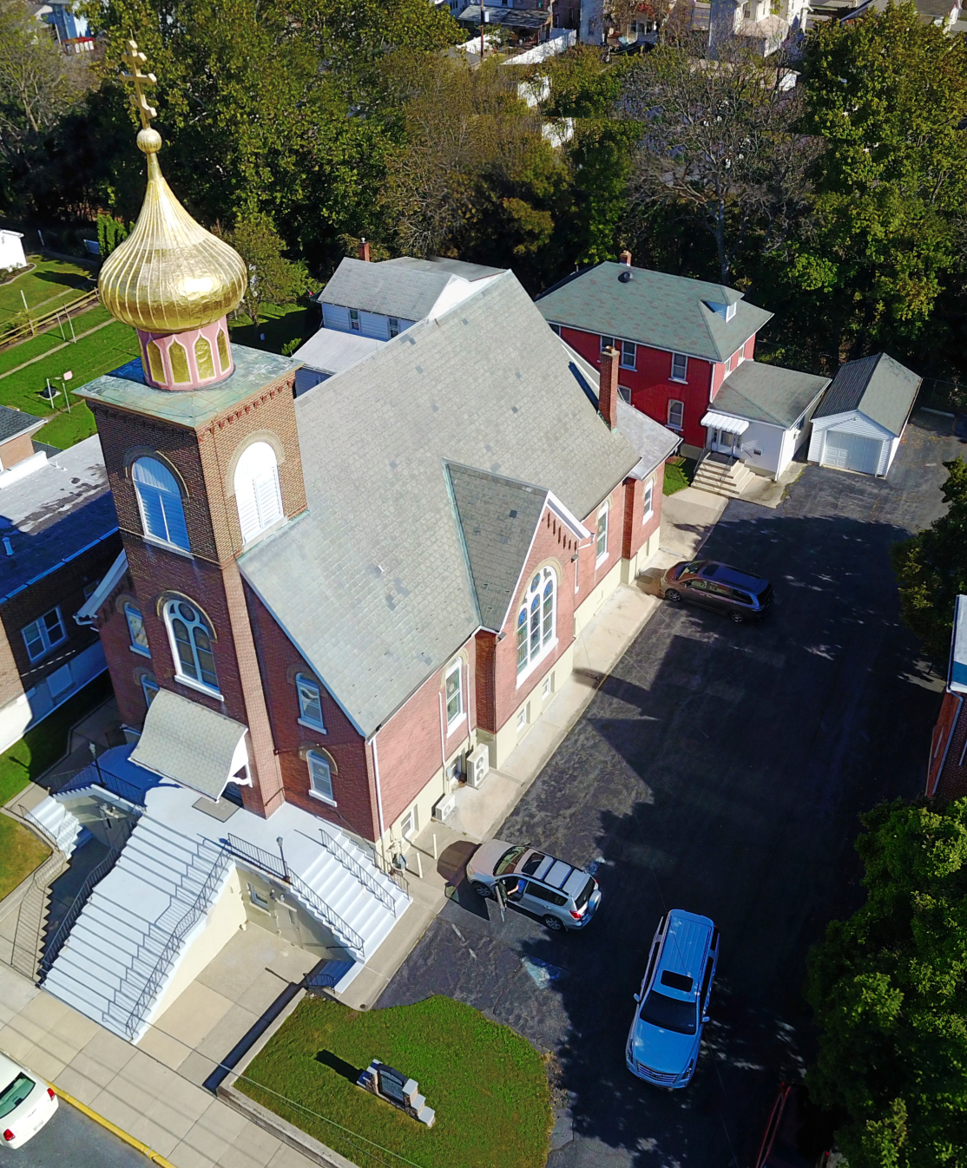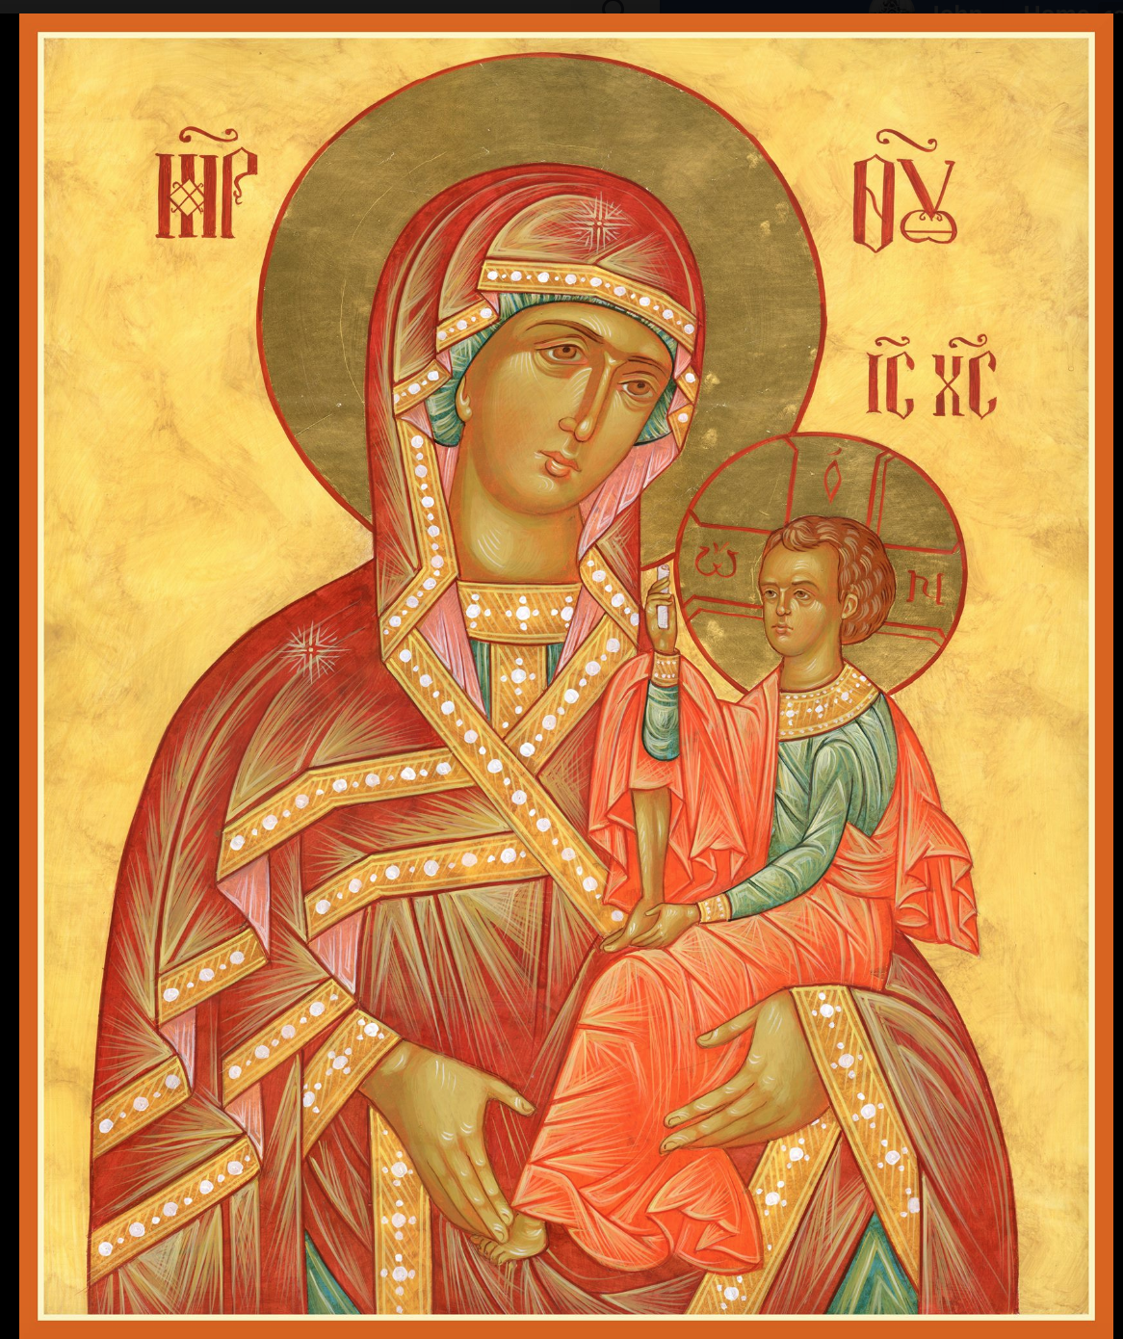

ASSUMPTION OF THE VIRGIN MARY
UKRAINIAN ORTHODOX CHURCH
ECUMENICAL PATRIARCHATE OF CONSTANTINOPLE AND NEW ROME
1301 Newport Avenue
Northampton, Pennsylvania 18067
Mitered Archpriest Myron Oryhon
Rev. Fr. Oleh Kravchenko, Attached
Protodeacon Mychail Sawarynski, Attached

Telephones: Church Office… (610) 262-2882
Church Fax/Kitchen/Hall… (610) 262-0552
Fr. Myron Oryhon – (607) 752-1999
Protodeacon Mychail’s Residence… (610) 262-3876
Websites: holyassumption.org
ukrainianorthodoxchurchusa.org
lvorthodox.wordpress.com
E-mail: Parish… avmuoc@gmail.com
Protodeacon Mychail…pravoslavni@rcn.com
Webmaster, John Hnatow… john.hnatow@gmail.com
==============================================================
14th July (1st July) 2019

Fourth Sunday after Pentecost. Tone 3. Holy Unmercenaries COSMAS & DAMIAN, martyrs at Rome. POTITUS. Ven. PETER the Patrician (854). ANGELINA, Despotina of Serbia (16th C.)
Romans 6: 18-23 Matthew 8: 5-13

PROPERS FOR LITURGY OF ST. JOHN CHRYSOSTOM

Tropar of the Resurrection, Tone 3
Let the heavens rejoice. Let the earth be glad. For the Lord has shown strength with His Arm. He has trampled down death by death. He has become the First-born of the Dead. He has delivered us from the depths of Hell, and has granted the world great mercy.

Tropar of the Dormition, Tone 1
In giving birth, you preserved your virginity. In falling asleep you did not forsake the world, Birth-Giver of God. You were translated to Life, Mother of Life, and through your prayers you deliver our souls from death.

Tropar to Wonderworking Physicians Cosmas & Damian, Tone 8
Holy unmercenaries and wonderworkers, Cosmas and Damian, visit our infirmities. Freely you have received; freely give to us.

Kondak of the Resurrection, Tone 3
On this day You rose from the tomb, Merciful One, leading us from the gates of death. On this day Adam exults and Eve rejoices. With the prophets and patriarchs, they unceasingly praise the divine majesty of Your Power.

Glory to the Father and to the Son and to the Holy Spirit.

Kondak to Saints Cosmas and Damian, Tone 2
Having received the grace of healing, you grant healing to those in need. Glorious wonderworkers and physicians, Cosmas and Damian, visit us and put down the insolence of our enemies, and bring healing to the world through our miracles.

Now and ever and unto ages of ages. Amen.

Kondak of the Dormition, Tone 2
Neither the tomb nor death had power over the Birth-Giver of God; she is ever watchful in her prayers and in her intercession lies un-failing hope. For as the Mother of Life, she has been translated to life by the One Who dwelt within her ever-virginal womb.

Prokimen of the Resurrection, Tone 3
Sing praises to our God, sing praises. Sing praises to our King, sing praises.

Verse: Clap your hands all you peoples, shout to God with a joyful voice.

Alleluia Verses in Tone 3
Lord, in You have I hoped; let me never be put to shame.

Be a God of protection for me, a house of refuge, to save me.

Communion Hymn:
Praise the Lord from the heavens, praise Him in the Highest.
Alleluia (3X)

LITURGICAL MENEION & SCRIPTURE READINGS
FOR THE FOURTH WEEK AFTER PENTECOST

Mon. 15 July PLACING OF THE ROBE OF THE MOTHER OF
GOD AT BLACHERNAE. JUVENAL, Patriarch of
Jerusalem (458). PHOTIUS, Metropolitan of Kyiv.
Romans 12:4-5, 15-21 Matthew 12:9-13

Tue. 16 July Martyrs HYACINTH, DIOMEDES, EULAMPIUS,
ASCIEPIODOTUS & GOLINDUC of Caesarea in
Cappadocia (108). Martyrs MOSCIUS & MARK.
Romans 14:9-18 Matthew 12:14-16, 22-30

Wed. 17 July ANDREW, Archbishop of Crete (726). MARTHA,
FAST DAY Mother of St. Symeon Stylite. Martyrs THEODOTUS & THEODOTA (108).
Romans 15;7-16 Matthew 12:38-45

Thur. 18 July ATHANASIUS of Mt. Athos (1000). Martyr ANNA
of Rome (304). Marytr CYRILLA of Cyrene, Libya
Romans 15:17-29 Matthew 12;46-13:3

Fri. 19 July SISOES the Great of Egypt (429). Martyrs
FAST DAY MARINUS & MARTHA and their children (269).
Romans 16:1-16 Matthew 13:3-9

Sat. 20 July Ven. THOMAS of Mt. Maleon (10th C.) Ven.
ACACIUS of Sinai. Martyr EVANGELUS.
Romans 8:14-21 Matthew 9:9-13

5:00 PM GREAT VESPERS

Sun. 21 July 5th Sunday after Pentecost. Great-martyr
PROCOPIUS of Caesarea, Palestine (303). Tone 4.

8:30 AM THIRD & SIXTH HOURS
9:00 AM DIVINE LITURGY of JOHN CHRYSOSTOM

NECROLOGY:
14 July… Katherine Smallen ‘88
15 July… Mary Lee Leszczuk ‘17
16 July… Anna Molnar ‘92
17 July… Justine Czepelak ‘50
18 July… Rosalia Chudyk ’67, Mykola Martyniuk ‘92
19 July… Mary Nieves ‘94
20 July… Michael Karypenko ’57, Mary Huryn ’72,
Ann Haas ‘14

VICHNAYA PAMYAT! MEMORY ETERNAL

BIRTHDAYS:
17 July… Mary Ann Dworakivsky
18 July… Brendan Phillips
20 July… William Hantz, Anthony Sawarynski

ANNIVERSARIES:
18 July… Matthew & Andrea Sawarynski
19 July… Roger & Karen Seremula

MNOHAYA LITA! MANY YEARS!

WE PRAY FOR THE HEALTH AND WELL-BEING of the ill afflicted: Pani Ol’ha Kravchenko and the child she is bearing, William Savitz, Catherine Kochenash, Fr. Vasyl Dovgan, Vladimir & Emma Krasnopera, Tessie Kuchinos, Brendan Phillips, Jessie Hnatow, Jessica Meashock, Wasyl Hewko, Adam Hewko, Betty Hendrickson, Andrew Thaxton, Michelle Pierzga, Susan Ferretti, Carole Zarayko, William Fischer, Ekaterina Seremula, Marianna Goshow, Judy Albright, Jerome Yankowy.

SAVE THE DATE: ANNUAL CHURCH PICNIC will held at Canal St. Park with a “PIG ROAST” catered by Fr. James Cairns on SATURDAY, SEPTEMBER 28th from 12 noon to 7 PM. Outdoor Vespers will be served beginning at 5 PM at the park.

OCMC “AGAPE CANISTER” DONATIONS were $.00; thank
you for your support of our Missions around the globe.

NORTHAMPTON FOODBANK is still in need of foodstuffs, especially tuna, canned potatoes and baby food.

VOLUNTEERS for SUMMER COFFEE HOUR are needed Sign-up sheet in Hall. Coffee will be prepared. You supply the baked goods.

Please continue to save Redner’s tapes; use your Reward’s Card.”

HOLY WONDERWORKING UNMERCENARY
PHYSICIANS COSMAS AND DAMIAN AT ROME

Brothers by birth, Cosmas and Damian and physicians by profession, they suffered in the reign of Emperor Carinus (283). They lived strict chaste lives and were granted the gift of healing of the sick by God. By their generosity and kindness they converted many to Christ and accepted no payment for their treatment of the infirm. They were arrested by Roman authorities and openly professed their faith in Christ even healing the Emperor of his
blindness and were set free. But an older physician who was envious of their fame murdered them and threw their bodies into a river; thus ending their lives in martyrdom. The Lord glorifies those who are pleasing to God and through their prayers, God grants healing to all who with faith have recourse to their heavenly intercession. They took no money for their services to the sick because they said our Lord commanded us, “Freely you have received, freely give.” (Mt. 10:8)

NEWS FROM THE ORTHODOX WORLD
A delegation of Orthodox hierarchs to the Vatican for the Feast of Ss. Peter & Paul, led by Archbishop Job of Telmessos, resulted in Pope Francis presenting His All Holiness Bartholomew, Patriarch of Constantinople with relics of St. Peter which the Pope said, “I thought to myself, these holy relics will be better in Constantinople.”

The 53rd Annual Pilgrimage to New Skete Monastery will be held on Saturday, August 10 in Cambridge, N.Y. beginning with Matins at 8:30 AM followed by Divine Liturgy. Guest speaker will be Dr. Gayle Woloschak, Professor of Radiation Oncology.

The Orthodox Mission continues to grow in Oceania. According to Bishop Myron of New Zealand the Church of St. George on the island of Tonga is nearing completion. At the Mission in Haiti, Fr. Paul Petit-Homme reports plans to build an orphanage for 24 children. Please support our OCMC mission outreach.

